RDB Catch and Effort Overview North Atlantic, 2020 

2022-02-06

Table of Contents

1 Introduction 3

1.1 Reading the graphs 4

1.1.1 Barplots 4

1.1.2 Maps 4

2 Overall fleet evolution (All RCGs) 5

2.1 Number of vessels 5

2.2 Power 5

2.3 Gross tonnage 6

3 Landings (CL) 7

3.1 Overall landings 7

3.1.1 Landings by species 7

3.1.2 Landings by catch_group 8

3.1.3 Landings by fleet 9

3.1.4 Landings by area 9

3.1.5 Landings by metier 11

3.1.6 Landings by harbour 13

3.1.7 Landings abroad 16

3.1.8 Spatial distribution of landings 17

3.2 Small pelagic landings 18

3.2.1 Landings by country, small pelagic 18

3.2.2 Landings by species, small pelagic 18

3.2.3 Landings by fleet, small pelagic 19

3.2.4 Landings by area, small pelagic 21

3.2.5 Landings by metier, small pelagic 25

3.2.6 Landings by harbour, small pelagic 27

3.2.7 Landings abroad, small pelagic 30

3.2.8 Spatial distribution of landings, small pelagic 31

3.3 Demersal landings (without flatfish) 32

3.3.1 Landings by country, demersal (without flatfish) 32

3.3.2 Landings by species, demersal (without flatfish) 32

3.3.3 Landings by fleet, demersal (without flatfish) 33

3.3.4 Landings by area, demersal (without flatfish) 35

3.3.5 Landings by metier, demersal (without flatfish) 39

3.3.6 Landings by harbour, demersal (without flatfish) 41

3.3.7 Landings abroad, demersal (without flatfish) 44

3.3.8 Spatial distribution of landings, demersal (without flatfish) 45

3.4 Flatfish landings 46

3.4.1 Landings by country, flatfish 46

3.4.2 Landings by species, flatfish 46

3.4.3 Landings by fleet, flatfish 47

3.4.4 Landings by area, flatfish 49

3.4.5 Landings by metier, flatfish 53

3.4.6 Landings by harbour, flatfish 55

3.4.7 Landings abroad, flatfish 58

3.4.8 Spatial distribution of landings, flatfish 59

4 Effort (CE) 60

4.1 Effort by country 60

4.1.1 Overall 60

4.2 Effort by fleet 62

4.2.1 Overall 62

4.3 Effort by area 63

4.3.1 Below 10 meters 63

4.3.2 10 meter and above 65

4.4 Effort by metier 66

4.4.1 Below 10 meters 66

4.4.2 10 meter and above 69

4.5 Effort by harbour 71

4.5.1 Below 10 meters 71

4.5.2 10 meter and above 73

4.6 Spatial distribution of effort 75

4.6.1 Below 10 meters 75

4.6.2 10 meter and above 76

Appendix A. Dates of data extraction 77

Appendix B. Catch groups 77

Appendix C. Mean Landings per stock, 2018-2020 89

**Disclaimer**

Tables, plots and graphs presented in this document and overviews are made for the coordination purposes of regional fisheries data collection and are not designed for any other use. Data used for the outputs are extracted from the Regional Database (RDB) and EU Fleet Register. Dates of data extractions are stated in Appendix A. Due to different aggregations and reporting authorities, data can differ to those e.g. used for assessments or technical reports. Member States (MS) are responsible for uploading latest data and the latest year should be viewed as provisional. Data can be resubmitted by a MS for more than one previous year so there might be differences in earlier year reports if countries update back in time. Responsibility for the quality of the data and comparability to other data sources lies with the MS that provided these data.

The respective scripts and calculations used for data displaying are publicly available via the RCG github (<https://github.com/ices-eg/RCGs>) and subject to change as the work of the group progresses.

# Introduction

The present Catch and Effort Overview displays summary information on the commercial landings (CL) and commercial effort (CE) statistics included in the Regional Data Base (RDB), which is used to store detailed commercial fisheries and sampling data.

Before the subgroup on Catch, effort and sampling overviews was set up, the different RCGs conducted data analysis and overviews separately with minimal exchange, resulting in redundancies and efficiency loss. Furthermore, a substantial part of the work was being carried out during the RCG meetings themselves and so not readily available to inform RCG preparation and meeting discussions. This group was established to streamline and facilitate the work on the fisheries and sampling data of the MS and prepare data overviews in advance of the RCG meetings.

The RDB is hosted at the International Council for Exploration of the Sea (ICES) and its data is property of EU Member States with usage governed by the RDB data policy (<https://www.ices.dk/data/Documents/Data_Policy_RDB.pdf>). It’s a regionally coordinated database platform covering fisheries in the North Atlantic Ocean, the North Sea and the Baltic Sea and is a main resource used by the Regional Coordination Groups to coordinate data collection of EU fisheries. This database aims also: 1) To ensure that data can be made available for the coordination of regional fisheries data sampling plans, in particular for the DCF Regional Coordination Groups (RCGs); 2) To provide a regional estimation system such that statistical estimates of quantities of interest can be produced from sample data, in order to deliver data for ICES stock assessments and advice, 3) To serve and facilitate the production of fisheries management advice and status reports, 4) To increase the awareness of fisheries data collected by the users of the RDB and the overall usage of these data. 5) Addresses fishery management needs related to the European Union Common Fisheries

However, it has been recognised for many years that there is a need to have a new version of the RDB which would also store details about how the sampling was performed and enable statistical estimations to be made.

In fact, the current Regional Data Base stores the commercial catch and sample data at detailed level, and here the data format and estimations does not support statistical estimations, even though most of the countries’ sampling are not done in a statistical way the countries never used the RDB for raising/estimating their data. The countries have raised/estimated the data nationally at the institutes and uploaded the data to InterCatch for the stock assessment Expert Groups. That means the stock assessment EG have no information of how the data have been raised/estimated until the data are uploaded into InterCatch, from that point and through the international raising the data and processes are fully documented. InterCatch does neither support statistical estimations. It has therefore been requested to write specifications for a new version of the RDB, which have been given the name ‘Regional DataBase and Estimation System’, RDBES, to make it more obvious that the major part of the RDB is the estimation part.

## Reading the graphs

### Barplots

In (bar)plots, subtitles indicate if all RDB data could be used and are displayed. Some data can not be displayed in the plots, e.g. due to missing or incorrect values or due to missing referring data (e.g. if no statistical rectangle is given or harbor names are missing, landings in the respective plots can’t be displayed). The factor x:% in subtitle indicates the percentage of RDB data that are displayed in the x-variable. y:% in subtitle indicates the percentage of RDB data in the respective y-variable. z:% in subtitle indicate the percentage of complete (i.e., non-missing) RDB rows in variable.

### Maps

The maps are generated based on complete and available data from the RDB. The subtitles of the header state the subselection that is displayed (e.g. “all Data”, “pelagics”, etc.). if data cannot be shown on a map (e.g. due to missing information on the area or harbor code), the missing values is given in the figure text below.

# Overall fleet evolution (All RCGs)

## Number of vessels

Number of vessels by flag country and length class in the EU vessel register (licence indicator == “Y” in 1st January 2020. Parentesis: variation relative to 2019; red = number decreases; green = number increases; white = number maintains).

| **name_row** | **BEL** | **DEU** | **DNK** | **ESP** | **EST** | **FIN** | **FRA** | **GBR** | **IRL** | **LTU** | **LVA** | **NLD** | **POL** | **PRT** | **SWE** |
| --- | --- | --- | --- | --- | --- | --- | --- | --- | --- | --- | --- | --- | --- | --- | --- |
| [0-8[ | 0 (=) | 811 (-15) | 1301 (-23) | 4673 (-52) | 1255 (-59) | 2419 (-19) | 2943 (-144) | 2966 (-24) | 1106 (-16) | 70 (=) | 153 (+9) | 212 (-5) | 331 (+2) | 2398 (+115) | 529 (-39) |
| [8-10[ | 0 (=) | 142 (-6) | 314 (-17) | 1204 (-8) | 219 (-20) | 517 (-13) | 1451 (-7) | 1430 (+3) | 373 (+1) | 4 (=) | 24 (-2) | 94 (+3) | 201 (-3) | 497 (+24) | 236 (-24) |
| [10-12[ | 1 (=) | 72 (=) | 98 (-2) | 627 (-3) | 61 (-7) | 144 (-3) | 904 (-2) | 384 (-8) | 232 (-1) | 9 (=) | 4 (-1) | 37 (=) | 132 (=) | 231 (=) | 170 (-19) |
| [12-18[ | 4 (=) | 133 (-5) | 217 (+1) | 1035 (-15) | 8 (-3) | 25 (-2) | 421 (-1) | 435 (-11) | 86 (-3) | 1 (=) | 8 (-2) | 46 (=) | 53 (-3) | 276 (+11) | 80 (+1) |
| [18-24[ | 29 (=) | 85 (=) | 64 (+3) | 648 (-3) | 6 (=) | 7 (=) | 256 (-12) | 212 (-5) | 80 (=) | 4 (=) | 3 (=) | 195 (+2) | 60 (+3) | 119 (+5) | 39 (-1) |
| [24-40[ | 34 (=) | 31 (-1) | 38 (-1) | 589 (-13) | 18 (-1) | 7 (=) | 154 (+2) | 173 (-4) | 87 (+5) | 23 (-2) | 40 (-2) | 151 (+1) | 46 (=) | 114 (+3) | 20 (-2) |
| [40+[ | 0 (=) | 16 (-1) | 28 (-5) | 106 (+3) | 4 (-1) | 1 (=) | 40 (-3) | 43 (-2) | 26 (+1) | 8 (-3) | 0 (-5) | 98 (+1) | 3 (=) | 16 (+3) | 6 (-2) |
| **Total** | **68 (=)** | **1290 (-28)** | **2060 (-44)** | **8882 (-91)** | **1571 (-91)** | **3120 (-37)** | **6169 (-167)** | **5643 (-51)** | **1990 (-13)** | **119 (-5)** | **232 (-3)** | **833 (+2)** | **826 (-1)** | **3651 (+161)** | **1080 (-86)** |

## Power

Power (1000*kW) by flag country and length class in the EU vessel register (licence indicator == “Y” in 1st January 2020. Parentesis: variation relative to 2019).

| **name_row** | **BEL** | **DEU** | **DNK** | **ESP** | **EST** | **FIN** | **FRA** | **GBR** | **IRL** | **LTU** | **LVA** | **NLD** | **POL** | **PRT** | **SWE** |
| --- | --- | --- | --- | --- | --- | --- | --- | --- | --- | --- | --- | --- | --- | --- | --- |
| [0-8[ | 0 (=) | 13.1 (-0.1) | 27.3 (-0.1) | 80.2 (-0.4) | 11.8 (-0.6) | 72.4 (+0.3) | 216.8 (-8.5) | 97.3 (-1.3) | 15.6 (-0.2) | 1.5 (=) | 0.4 (=) | 9.9 (-0.5) | 5.9 (+0.1) | 69 (+5.1) | 18 (-0.4) |
| [8-10[ | 0 (=) | 7.7 (-0.1) | 20.8 (-1) | 40.2 (-0.4) | 5.3 (-0.4) | 44 (-0.7) | 204.3 (+2.4) | 154.7 (+1.2) | 20.6 (-0.2) | 0.1 (=) | 0.7 (-0.1) | 11.9 (+0.6) | 8.6 (-0.1) | 24.3 (+1.3) | 22.9 (-1.7) |
| [10-12[ | 0.2 (=) | 6.3 (-0.1) | 10.4 (-0.1) | 32.6 (-0.2) | 3.1 (-0.4) | 23.3 (+0.1) | 137.9 (+1.8) | 54.1 (-1) | 18.5 (-0.1) | 0.5 (=) | 0.2 (=) | 5.2 (-0.2) | 8.8 (=) | 18.3 (+0.1) | 27.5 (-2.2) |
| [12-18[ | 0.8 (=) | 25.5 (-1) | 38.4 (+0.6) | 88.5 (-1.8) | 0.8 (-0.2) | 5.4 (-1.2) | 101.2 (+1) | 90.1 (-1.1) | 11.7 (-0.2) | 0.1 (=) | 1.5 (-0.3) | 6.9 (+0.2) | 6.8 (-0.4) | 34.6 (+1.2) | 19 (+0.4) |
| [18-24[ | 6.4 (=) | 18.7 (=) | 18.6 (+1.5) | 122.1 (-0.7) | 1.9 (=) | 2.9 (=) | 98.6 (-4.7) | 80.3 (-0.2) | 30.5 (+0.2) | 0.8 (=) | 0.7 (=) | 40.7 (+0.3) | 13.6 (+0.4) | 31.6 (+1.2) | 15.8 (=) |
| [24-40[ | 35.4 (+0.1) | 14.9 (-1.1) | 25.5 (+0.1) | 226.6 (-4.2) | 6.1 (-0.2) | 5 (=) | 85.2 (+1.4) | 107.7 (+1.1) | 44.1 (+1.7) | 6.3 (-0.5) | 13.9 (-0.6) | 78 (+0.9) | 18.5 (=) | 53.1 (+3.2) | 13.6 (-2.3) |
| [40+[ | 0 (=) | 37.6 (-0.1) | 61.2 (-12.3) | 187.1 (+6.5) | 10.7 (-4.7) | 1 (=) | 105.8 (-8.1) | 157.4 (+9.2) | 49.3 (+0.7) | 32.3 (-1) | 0 (-14.2) | 149 (-3.8) | 18.1 (=) | 29.3 (+7.8) | 15.7 (-6.3) |
| **Total** | **42.8 (+0.1)** | **123.9 (-2.4)** | **202.3 (-11.3)** | **777.3 (-1.2)** | **39.8 (-6.4)** | **154 (-1.4)** | **949.8 (-14.7)** | **741.6 (+7.9)** | **190.3 (+1.8)** | **41.7 (-1.5)** | **17.4 (-15.2)** | **301.6 (-2.5)** | **80.2 (-0.1)** | **260.3 (+19.8)** | **132.5 (-12.5)** |

## Gross tonnage

Gross Tonnage(1000*GT) by flag country and length class in the EU vessel register (licence indicator == “Y” in 1st January 2020. Parentesis: variation relative to 2019).

| **name_row** | **BEL** | **DEU** | **DNK** | **ESP** | **EST** | **FIN** | **FRA** | **GBR** | **IRL** | **LTU** | **LVA** | **NLD** | **POL** | **PRT** | **SWE** |
| --- | --- | --- | --- | --- | --- | --- | --- | --- | --- | --- | --- | --- | --- | --- | --- |
| [0-8[ | 0 (=) | 1.1 (=) | 1.9 (=) | 6.2 (-0.1) | 0.9 (=) | 3.1 (=) | 5.5 (-0.3) | 6.7 (+1.6) | 1.6 (=) | 0.1 (=) | 0.1 (=) | 0.3 (=) | 0.6 (=) | 3.6 (+0.2) | 0.7 (-0.1) |
| [8-10[ | 0 (=) | 0.7 (=) | 1.9 (-0.1) | 4.4 (=) | 0.7 (-0.1) | 2.6 (=) | 6.9 (=) | 10.2 (+0.1) | 2.1 (=) | 0 (=) | 0.1 (=) | 0.3 (=) | 0.9 (=) | 2.2 (+0.1) | 1.3 (-0.1) |
| [10-12[ | 0 (=) | 0.8 (=) | 1.2 (=) | 4.3 (=) | 0.4 (=) | 1.5 (=) | 10.9 (+0.1) | 6.1 (+0.5) | 2.5 (=) | 0.1 (=) | 0 (=) | 0.3 (=) | 1.4 (=) | 2.2 (=) | 2 (-0.2) |
| [12-18[ | 0.1 (=) | 4.2 (-0.2) | 8.3 (+0.1) | 19.6 (-0.3) | 0.1 (=) | 0.7 (-0.1) | 19.4 (+0.5) | 18.7 (-0.3) | 2.9 (-0.1) | 0 (=) | 0.2 (-0.1) | 1 (=) | 1.6 (-0.1) | 6.1 (+0.2) | 2.9 (=) |
| [18-24[ | 2.5 (=) | 6 (=) | 7.2 (+0.7) | 39.3 (-0.1) | 0.7 (=) | 0.6 (=) | 30.3 (-1.1) | 29.9 (=) | 11.3 (+0.1) | 0.4 (=) | 0.2 (=) | 13.2 (+0.2) | 3.5 (+0.1) | 8.3 (+0.5) | 4.6 (-0.1) |
| [24-40[ | 10.3 (=) | 7.3 (+0.3) | 11.7 (+0.1) | 114 (-2.8) | 2.5 (-0.1) | 1.7 (=) | 34 (+0.8) | 45.3 (+1) | 18.5 (+0.9) | 3.1 (-0.2) | 5.5 (-0.2) | 26.7 (+1.1) | 7.4 (=) | 21.8 (+1.1) | 4.8 (-0.6) |
| [40+[ | 0 (=) | 34.6 (-0.5) | 35.9 (-6.7) | 144.9 (+4.4) | 7.1 (-2.8) | 0.4 (=) | 65 (-5.1) | 79.8 (+5.3) | 26.4 (+0.5) | 32.4 (-0.7) | 0 (-11.5) | 74.2 (-5.8) | 16.9 (=) | 25.2 (+6.2) | 6.2 (-1.9) |
| **Total** | **12.9 (=)** | **54.8 (-0.4)** | **68 (-6)** | **332.6 (+1)** | **12.4 (-3.1)** | **10.6 (-0.1)** | **171.9 (-5)** | **196.7 (+8.2)** | **65.3 (+1.4)** | **36.2 (-1)** | **6.2 (-11.7)** | **116 (-4.5)** | **32.3 (=)** | **69.5 (+8.4)** | **22.6 (-3)** |

###### Page break

# Landings (CL)

## Overall landings

### Landings by species

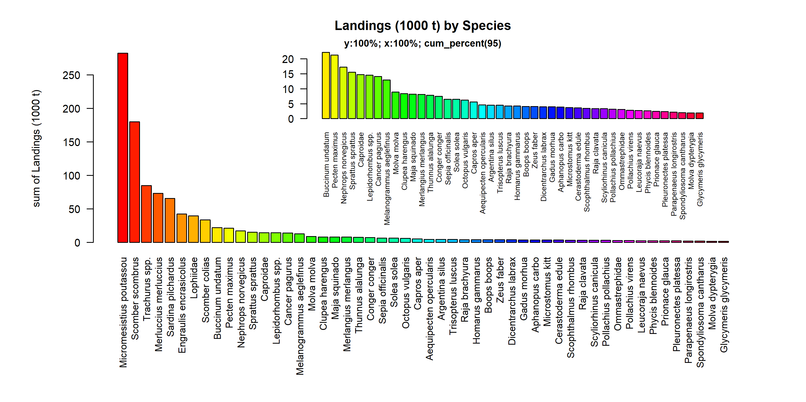 Figure 3.1.1.1. Landings (1000 t) by Species. Species displayed comprise 95% of the total Landings (1000 t).

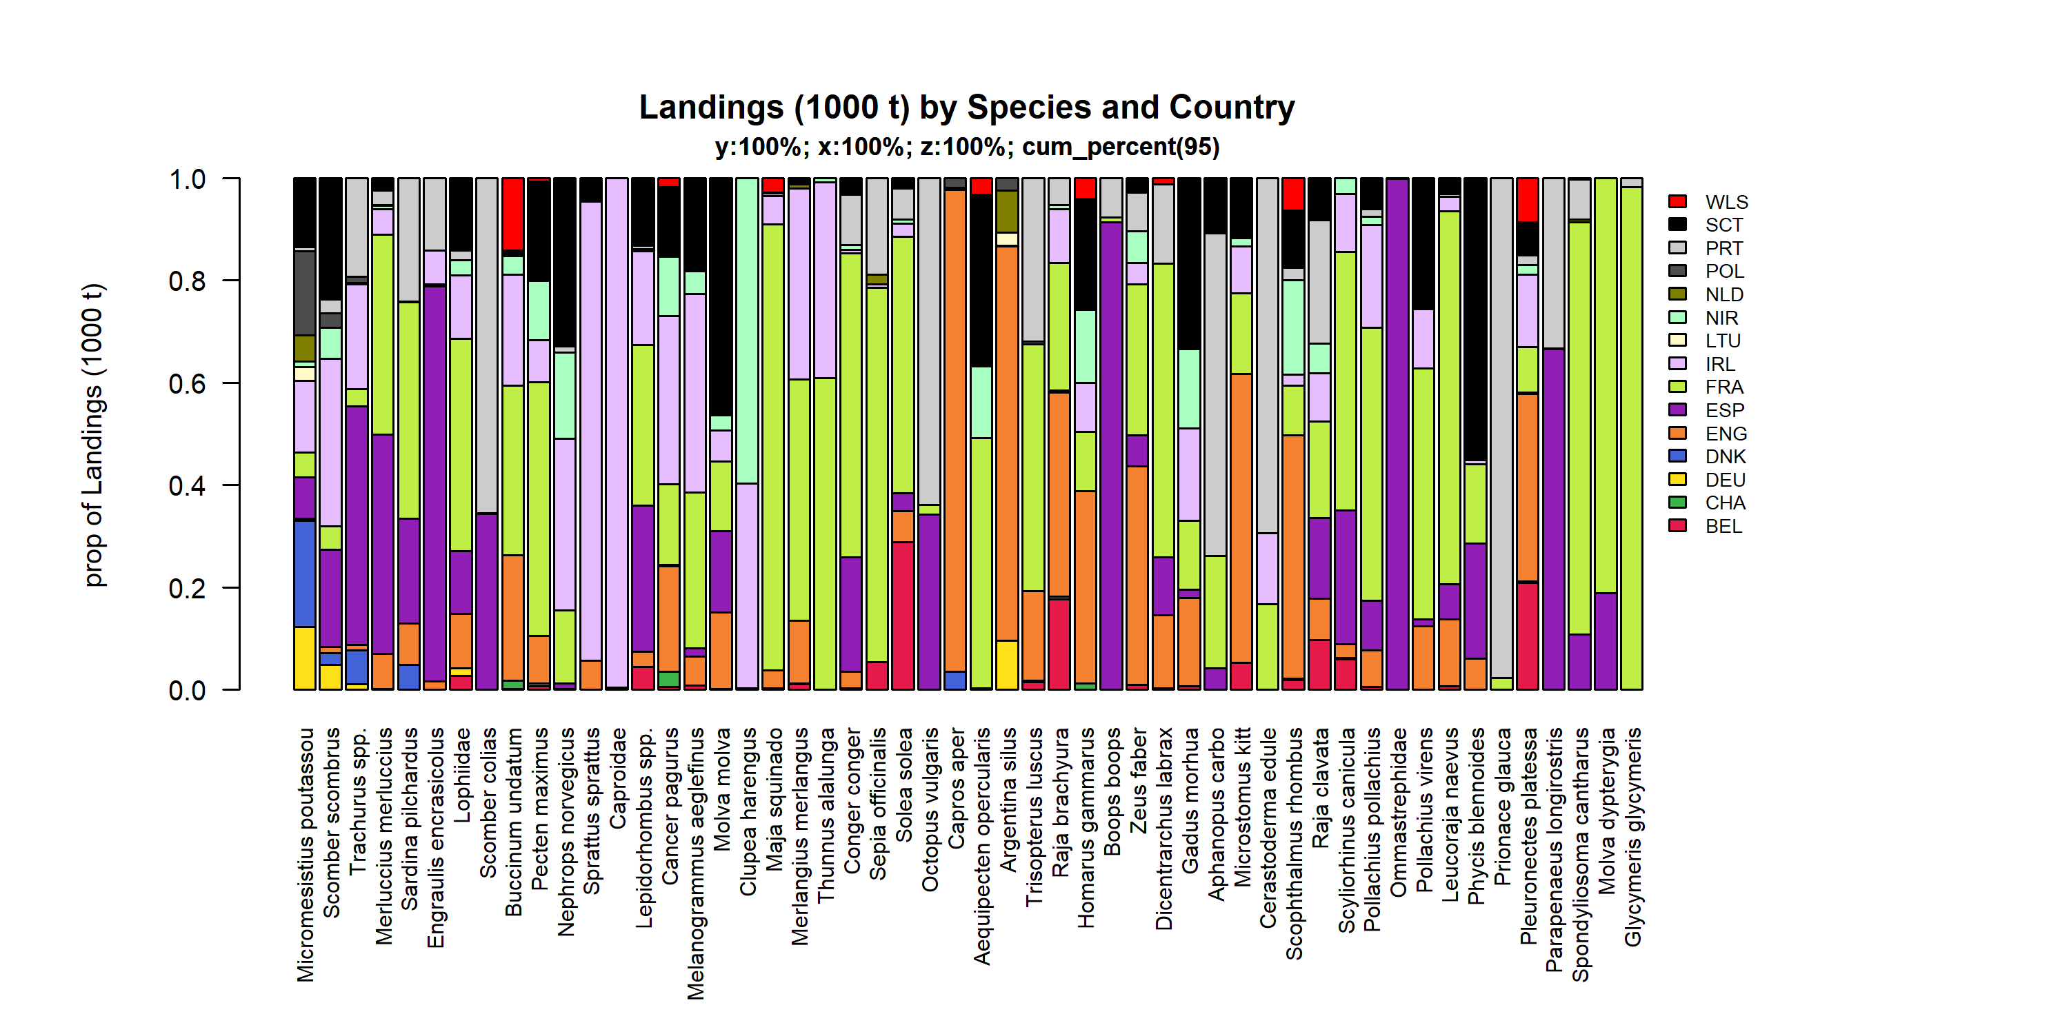 Figure 3.1.1.2. Landings (1000 t) by Species and Country . Species and Country displayed comprise 95 % of the total Landings (1000 t) .

### Landings by catch_group

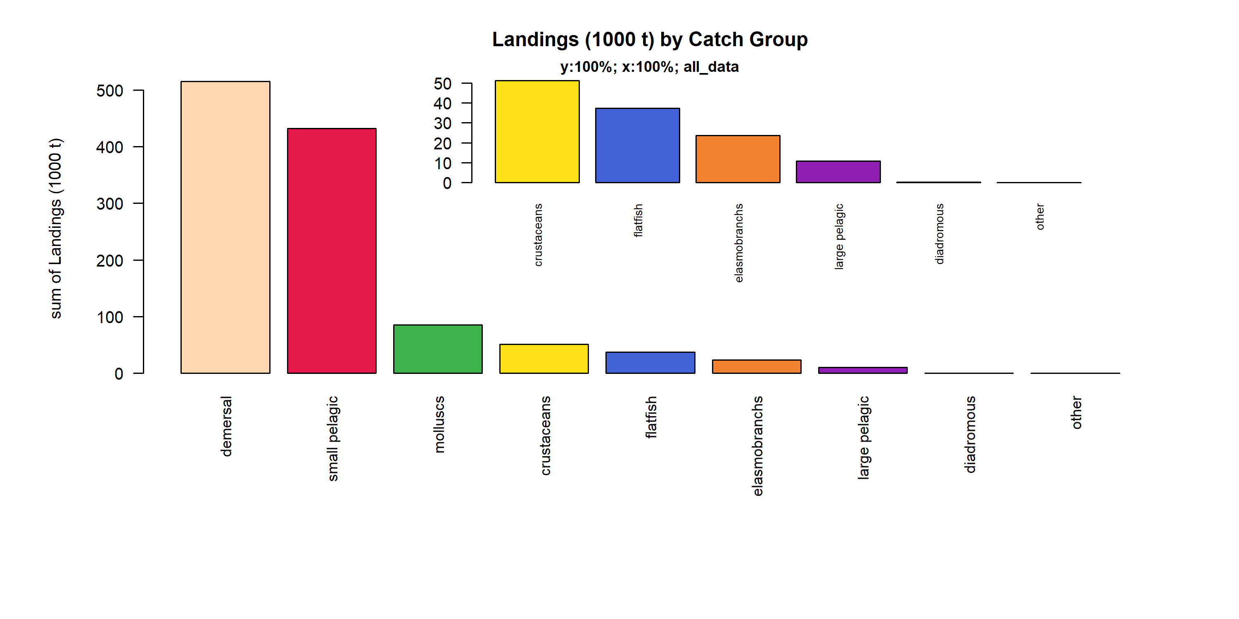 Figure 3.1.2.1. Landings (1000 t) by Catch Group.

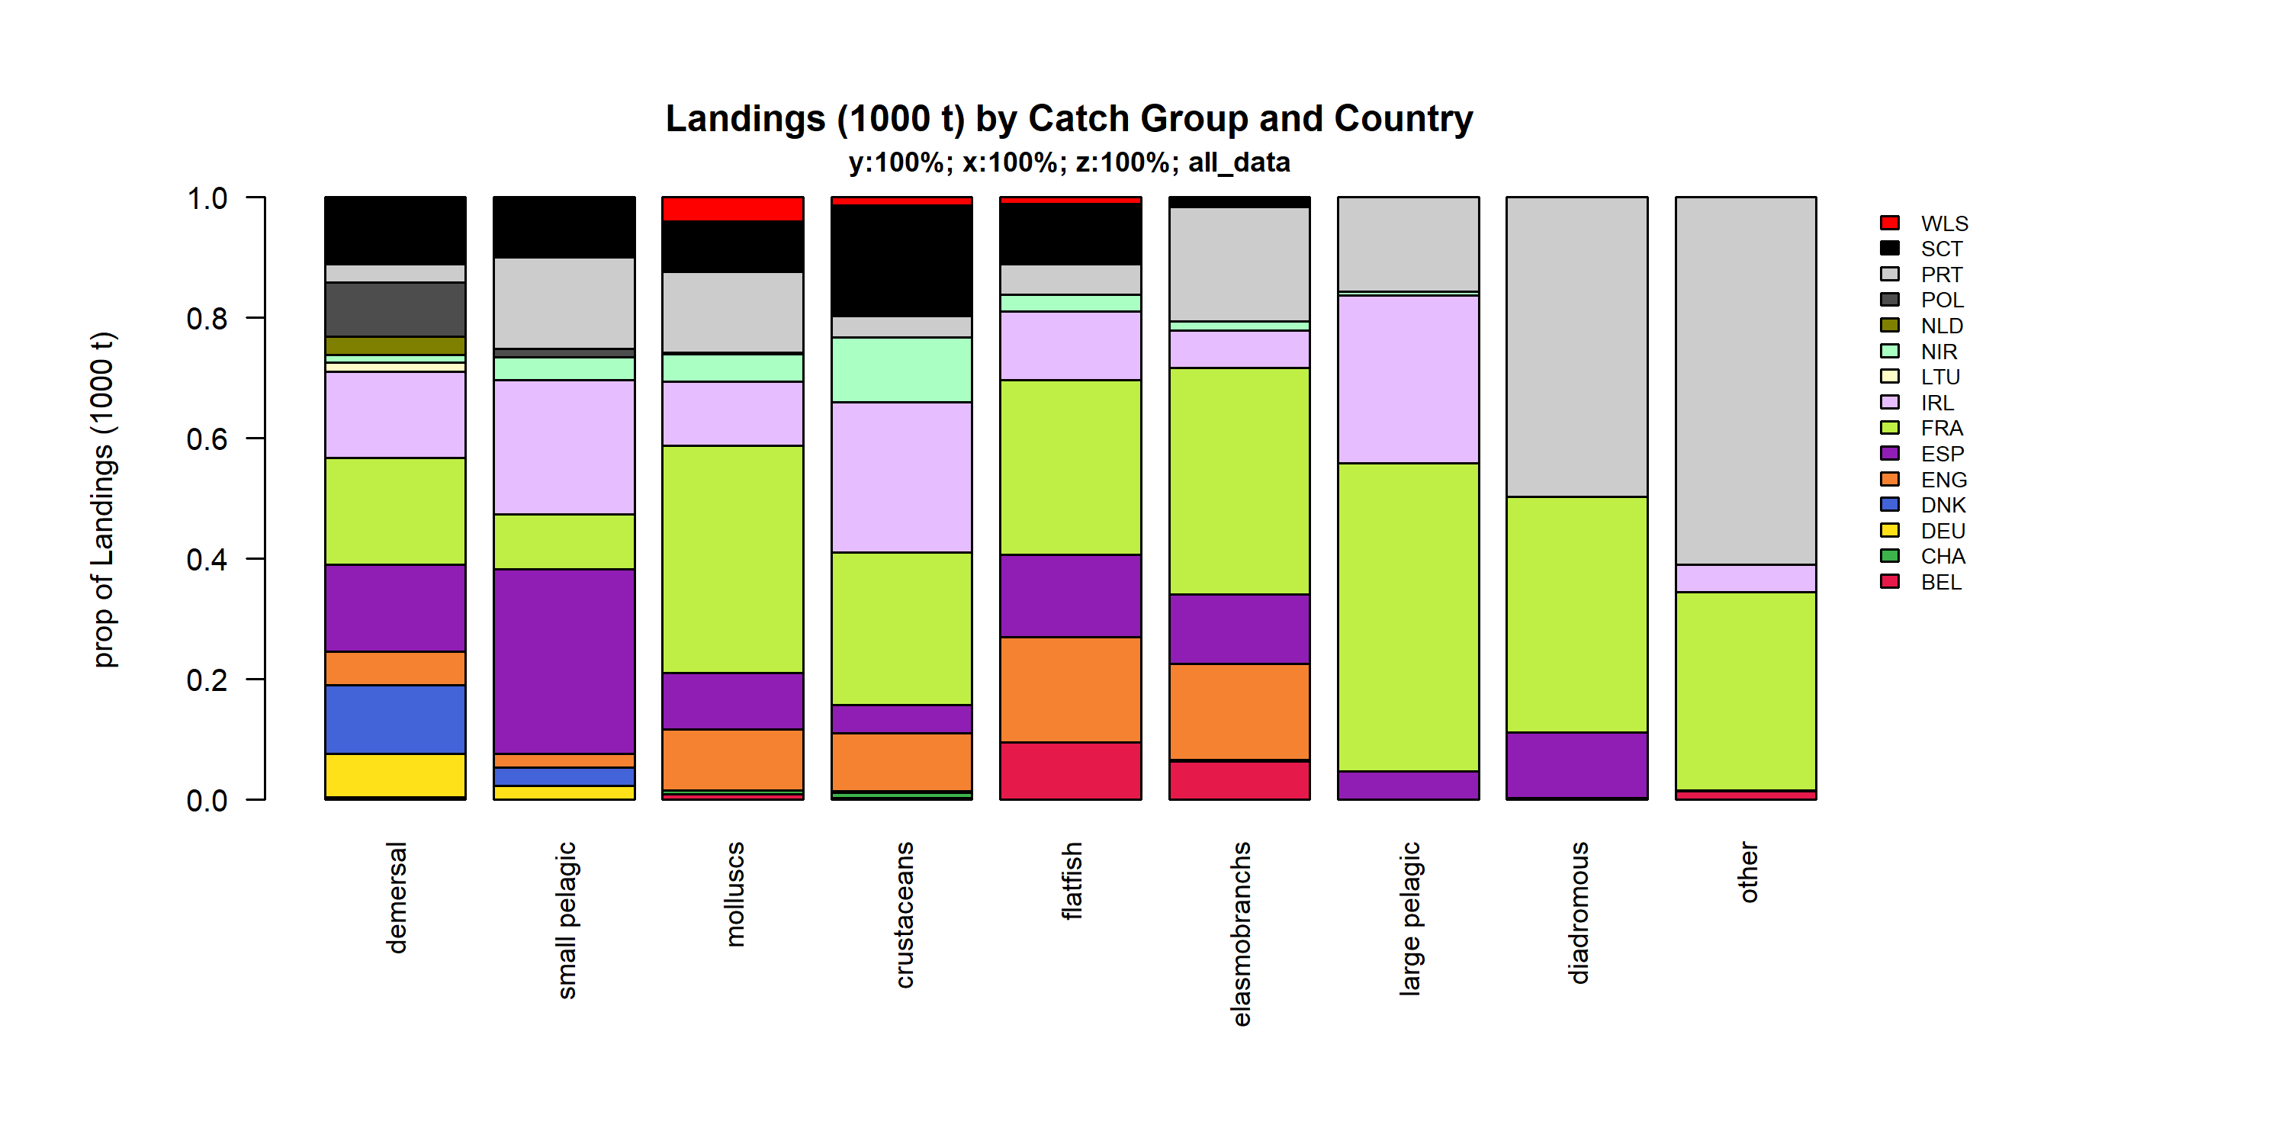 Figure 3.1.2.2. Landings (1000 t) by Catch Group and Country.

### Landings by fleet

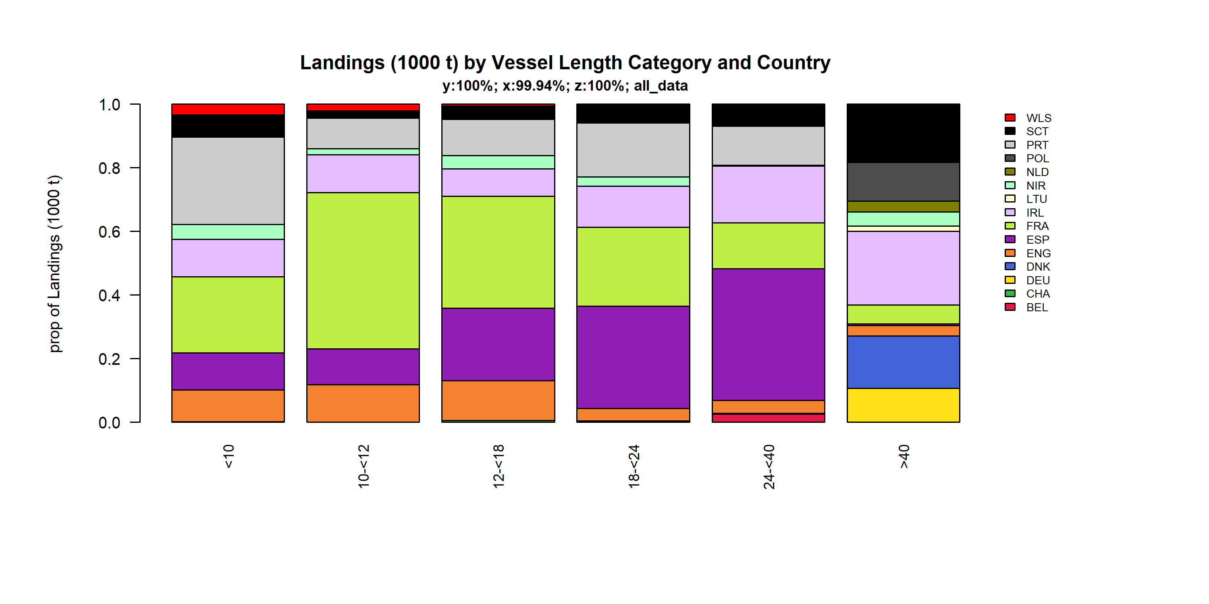 Figure 3.1.3.1. Landings (1000 t) by Vessel Length Category and Country. TheVessel Length Category was given for 99.94% of observations.

### Landings by area

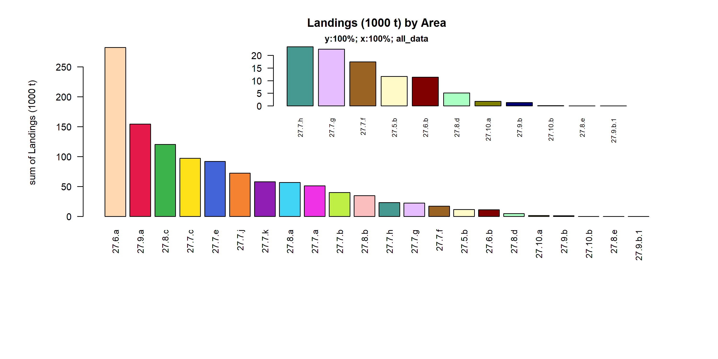 Figure 3.1.4.1. Landings (1000 t) by Area.

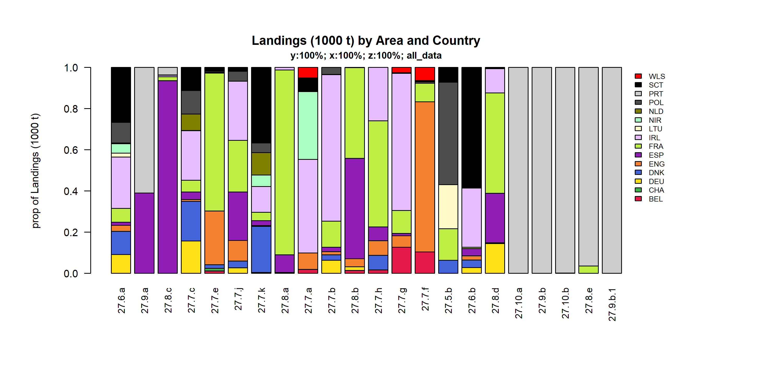 Figure 3.1.4.2. Landings (1000 t) by Area and Country.

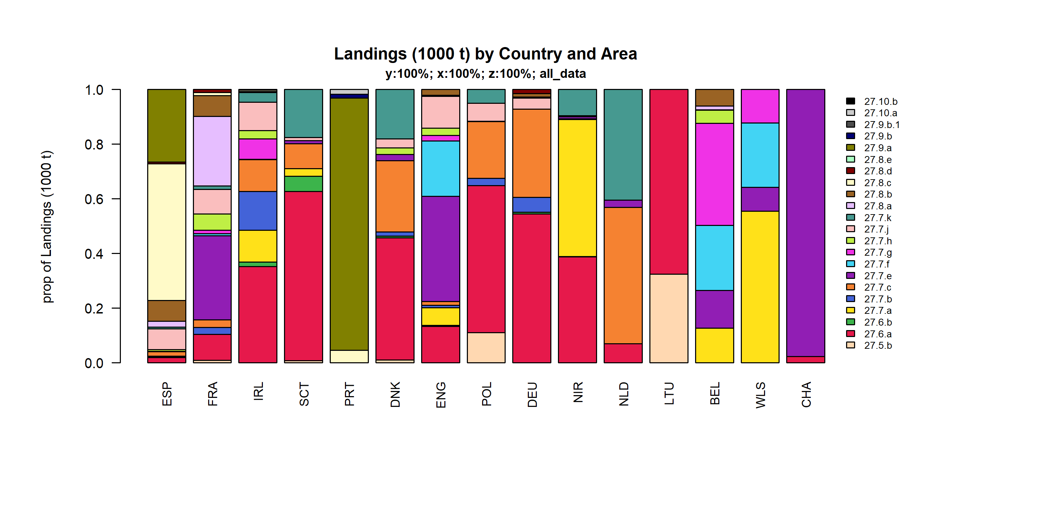 Figure 3.1.4.3. Landings (1000 t) by Country and Area.

### Landings by metier

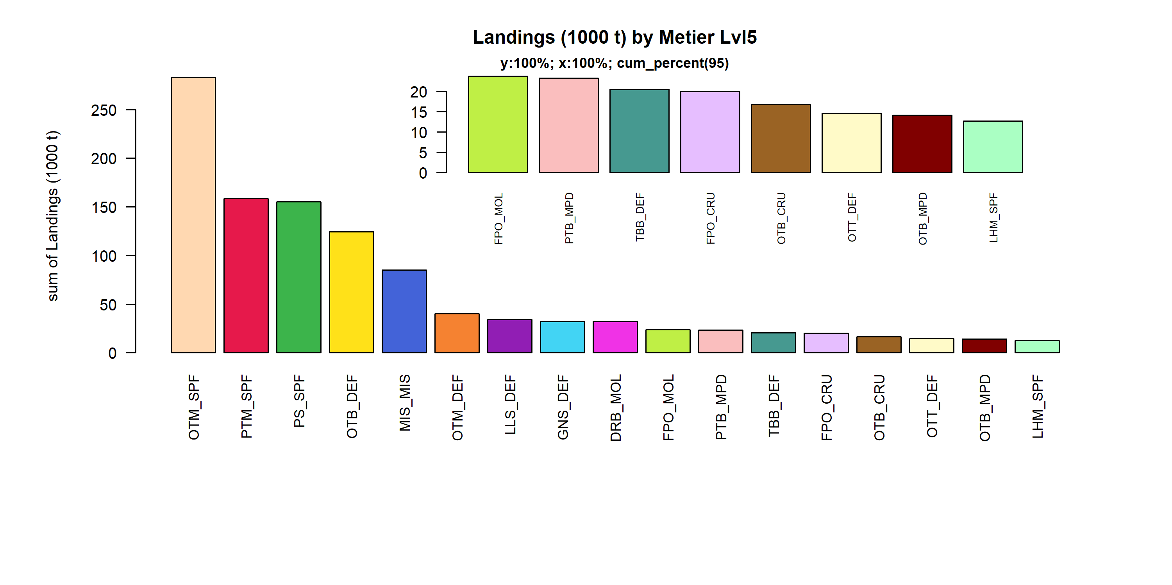 Figure 3.1.5.1. Landings (1000 t) by Metier Lvl5. Metier Lvl5 displayed comprise 95% of the total Landings (1000 t).

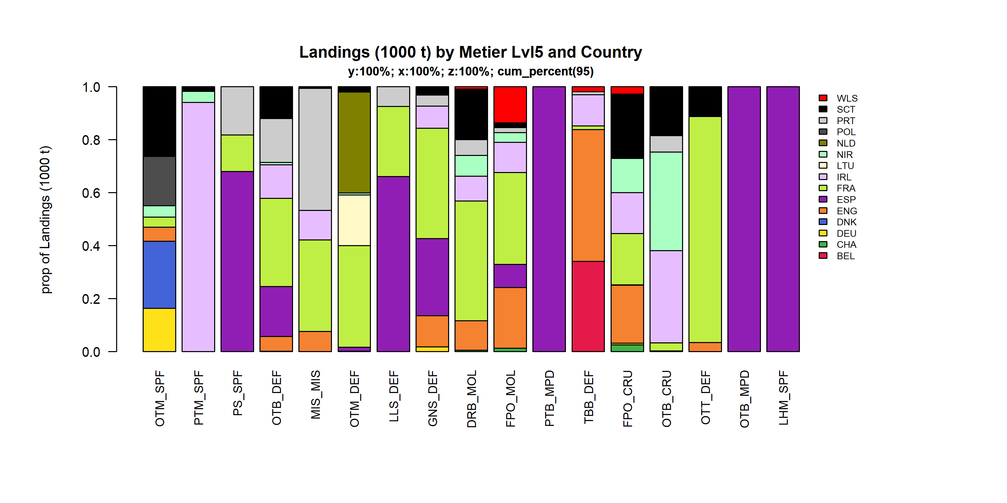 Figure 3.1.5.2. Landings (1000 t) by Metier Lvl5 and Country . Metier Lvl5 and Country displayed comprise 95 % of the total Landings (1000 t) .

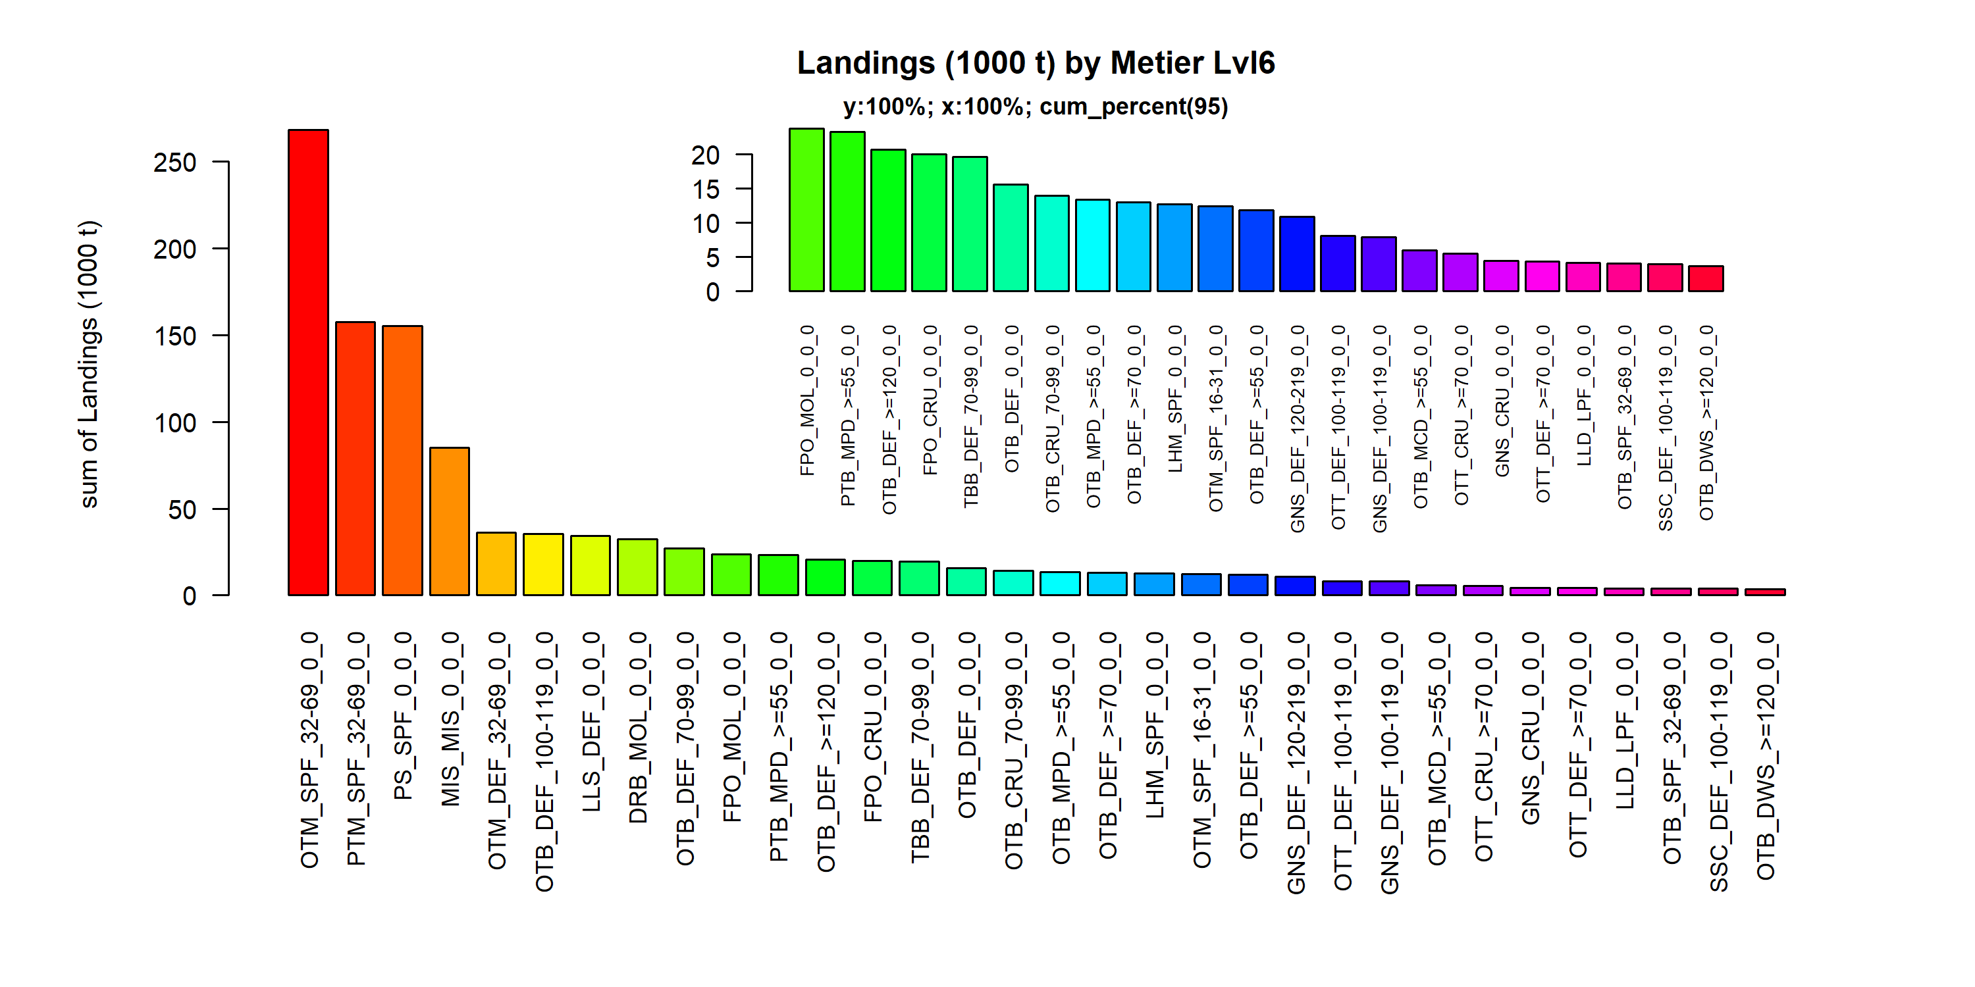 Figure 3.1.5.3. Landings (1000 t) by Metier Lvl6. Metier Lvl6 displayed comprise 95% of the total Landings (1000 t).

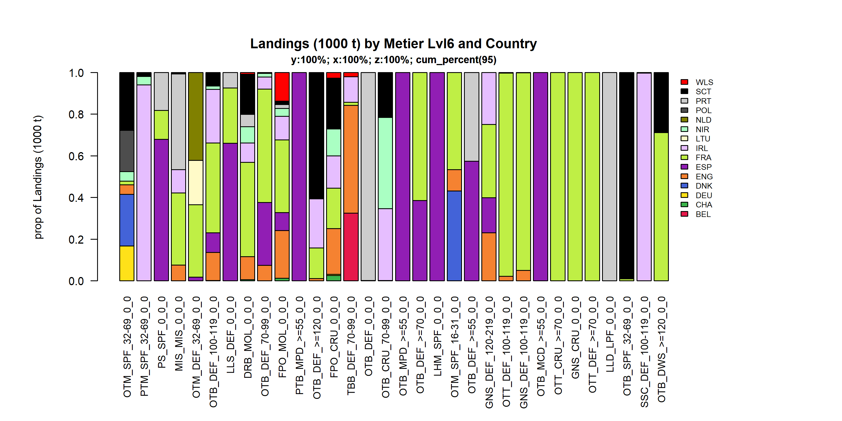 Figure 3.1.5.4. Landings (1000 t) by Metier Lvl6 and Country . Metier Lvl6 and Country displayed comprise 95 % of the total Landings (1000 t) .

### Landings by harbour

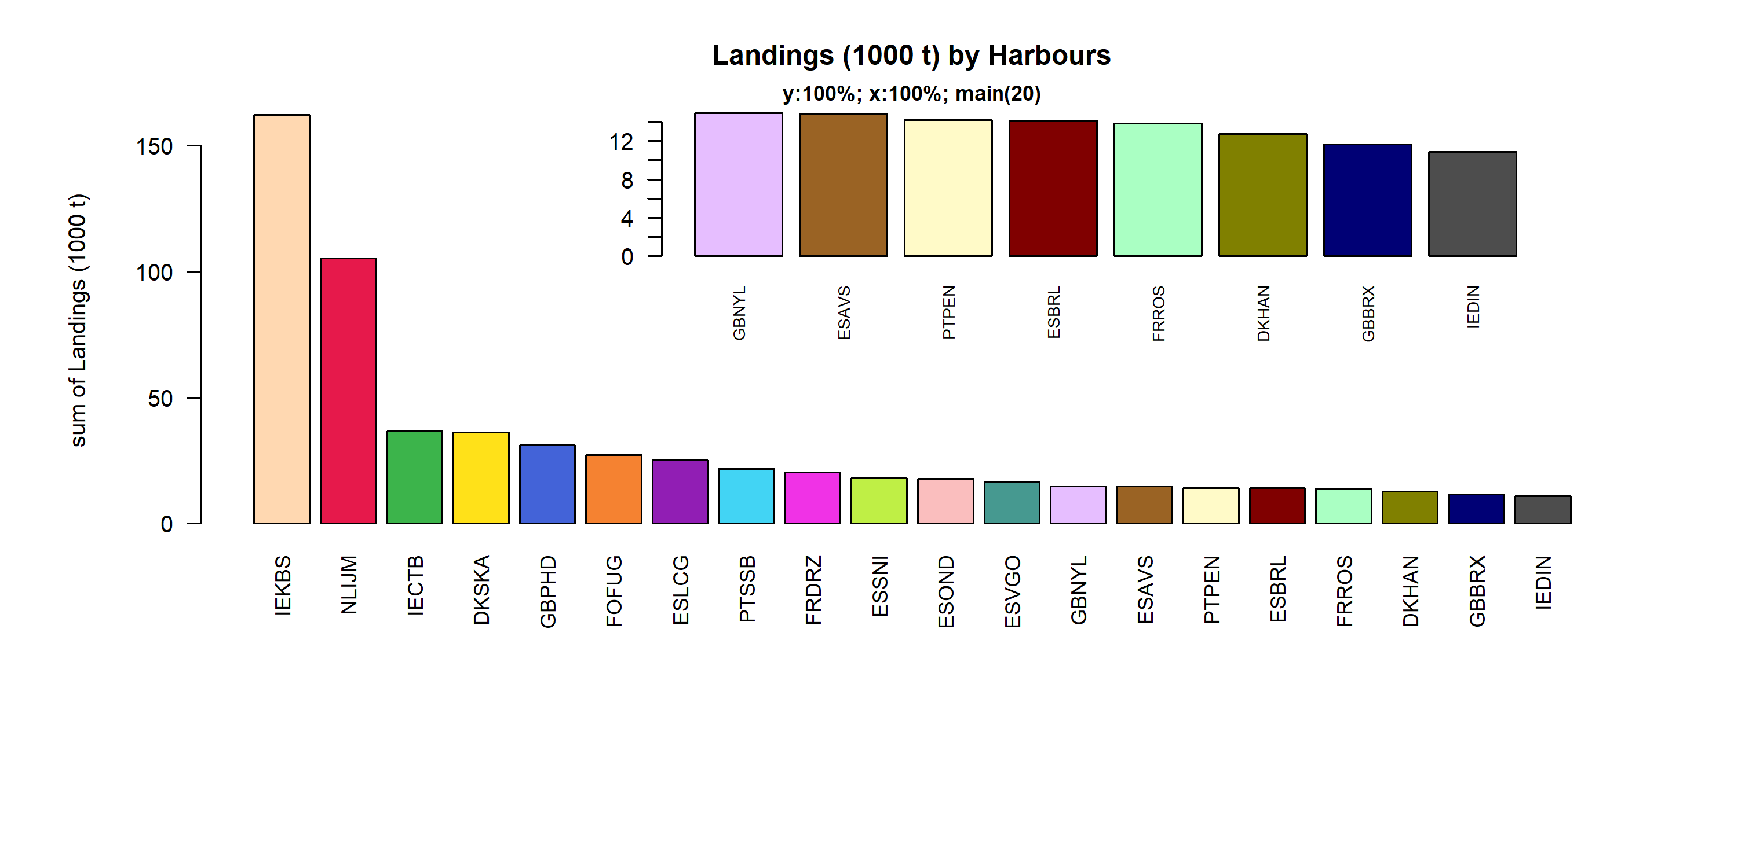 Figure 3.1.6.1. Landings (1000 t) in the 20 main Harbours ( 100% of rows entering analysis had known Harbours).

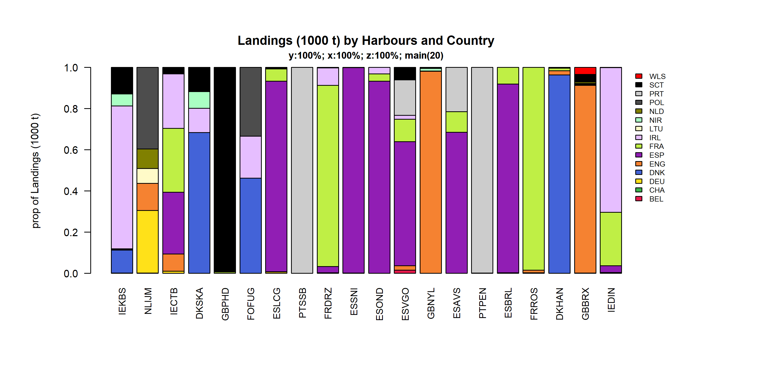 Figure 3.1.6.2. Landings (1000 t) by 20 main Harbours and Country .

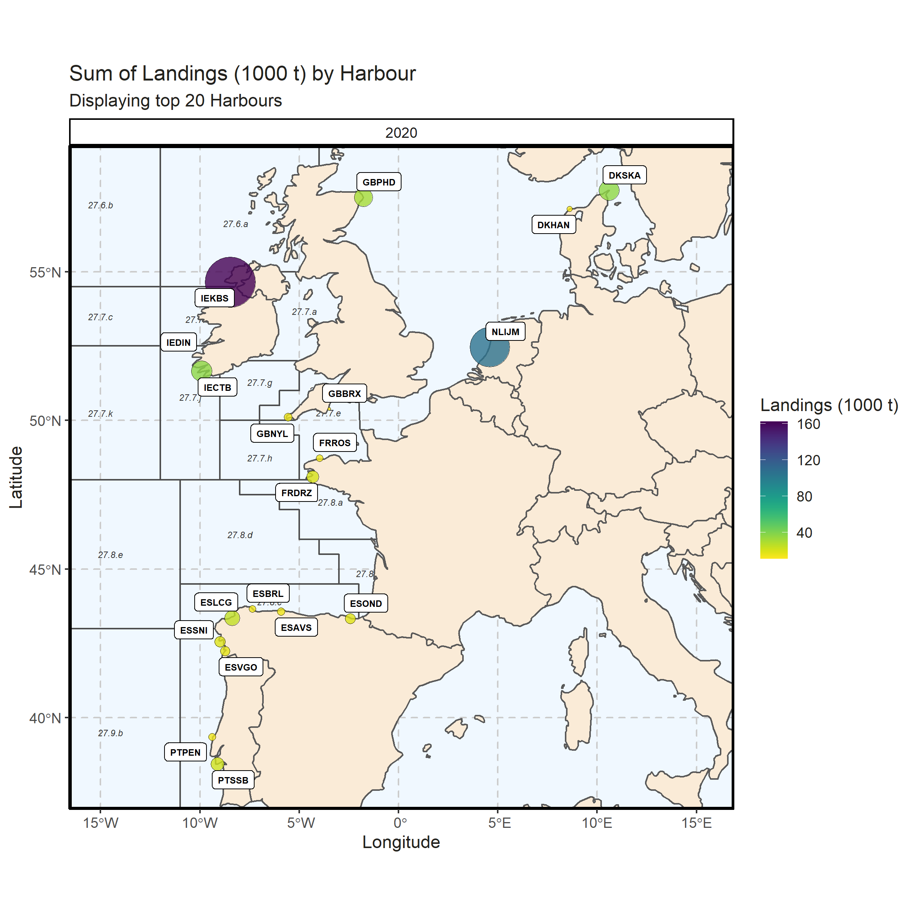 Figure 3.1.6.3. Sum of Landings (1000 t) by Harbour. Displaying top 20 Harbours. 0% of Landings (1000 t) - reported for missing Harbour 1 Harbour with missing coordinates (2.36% of Landings (1000 t)) - not presented on the map.

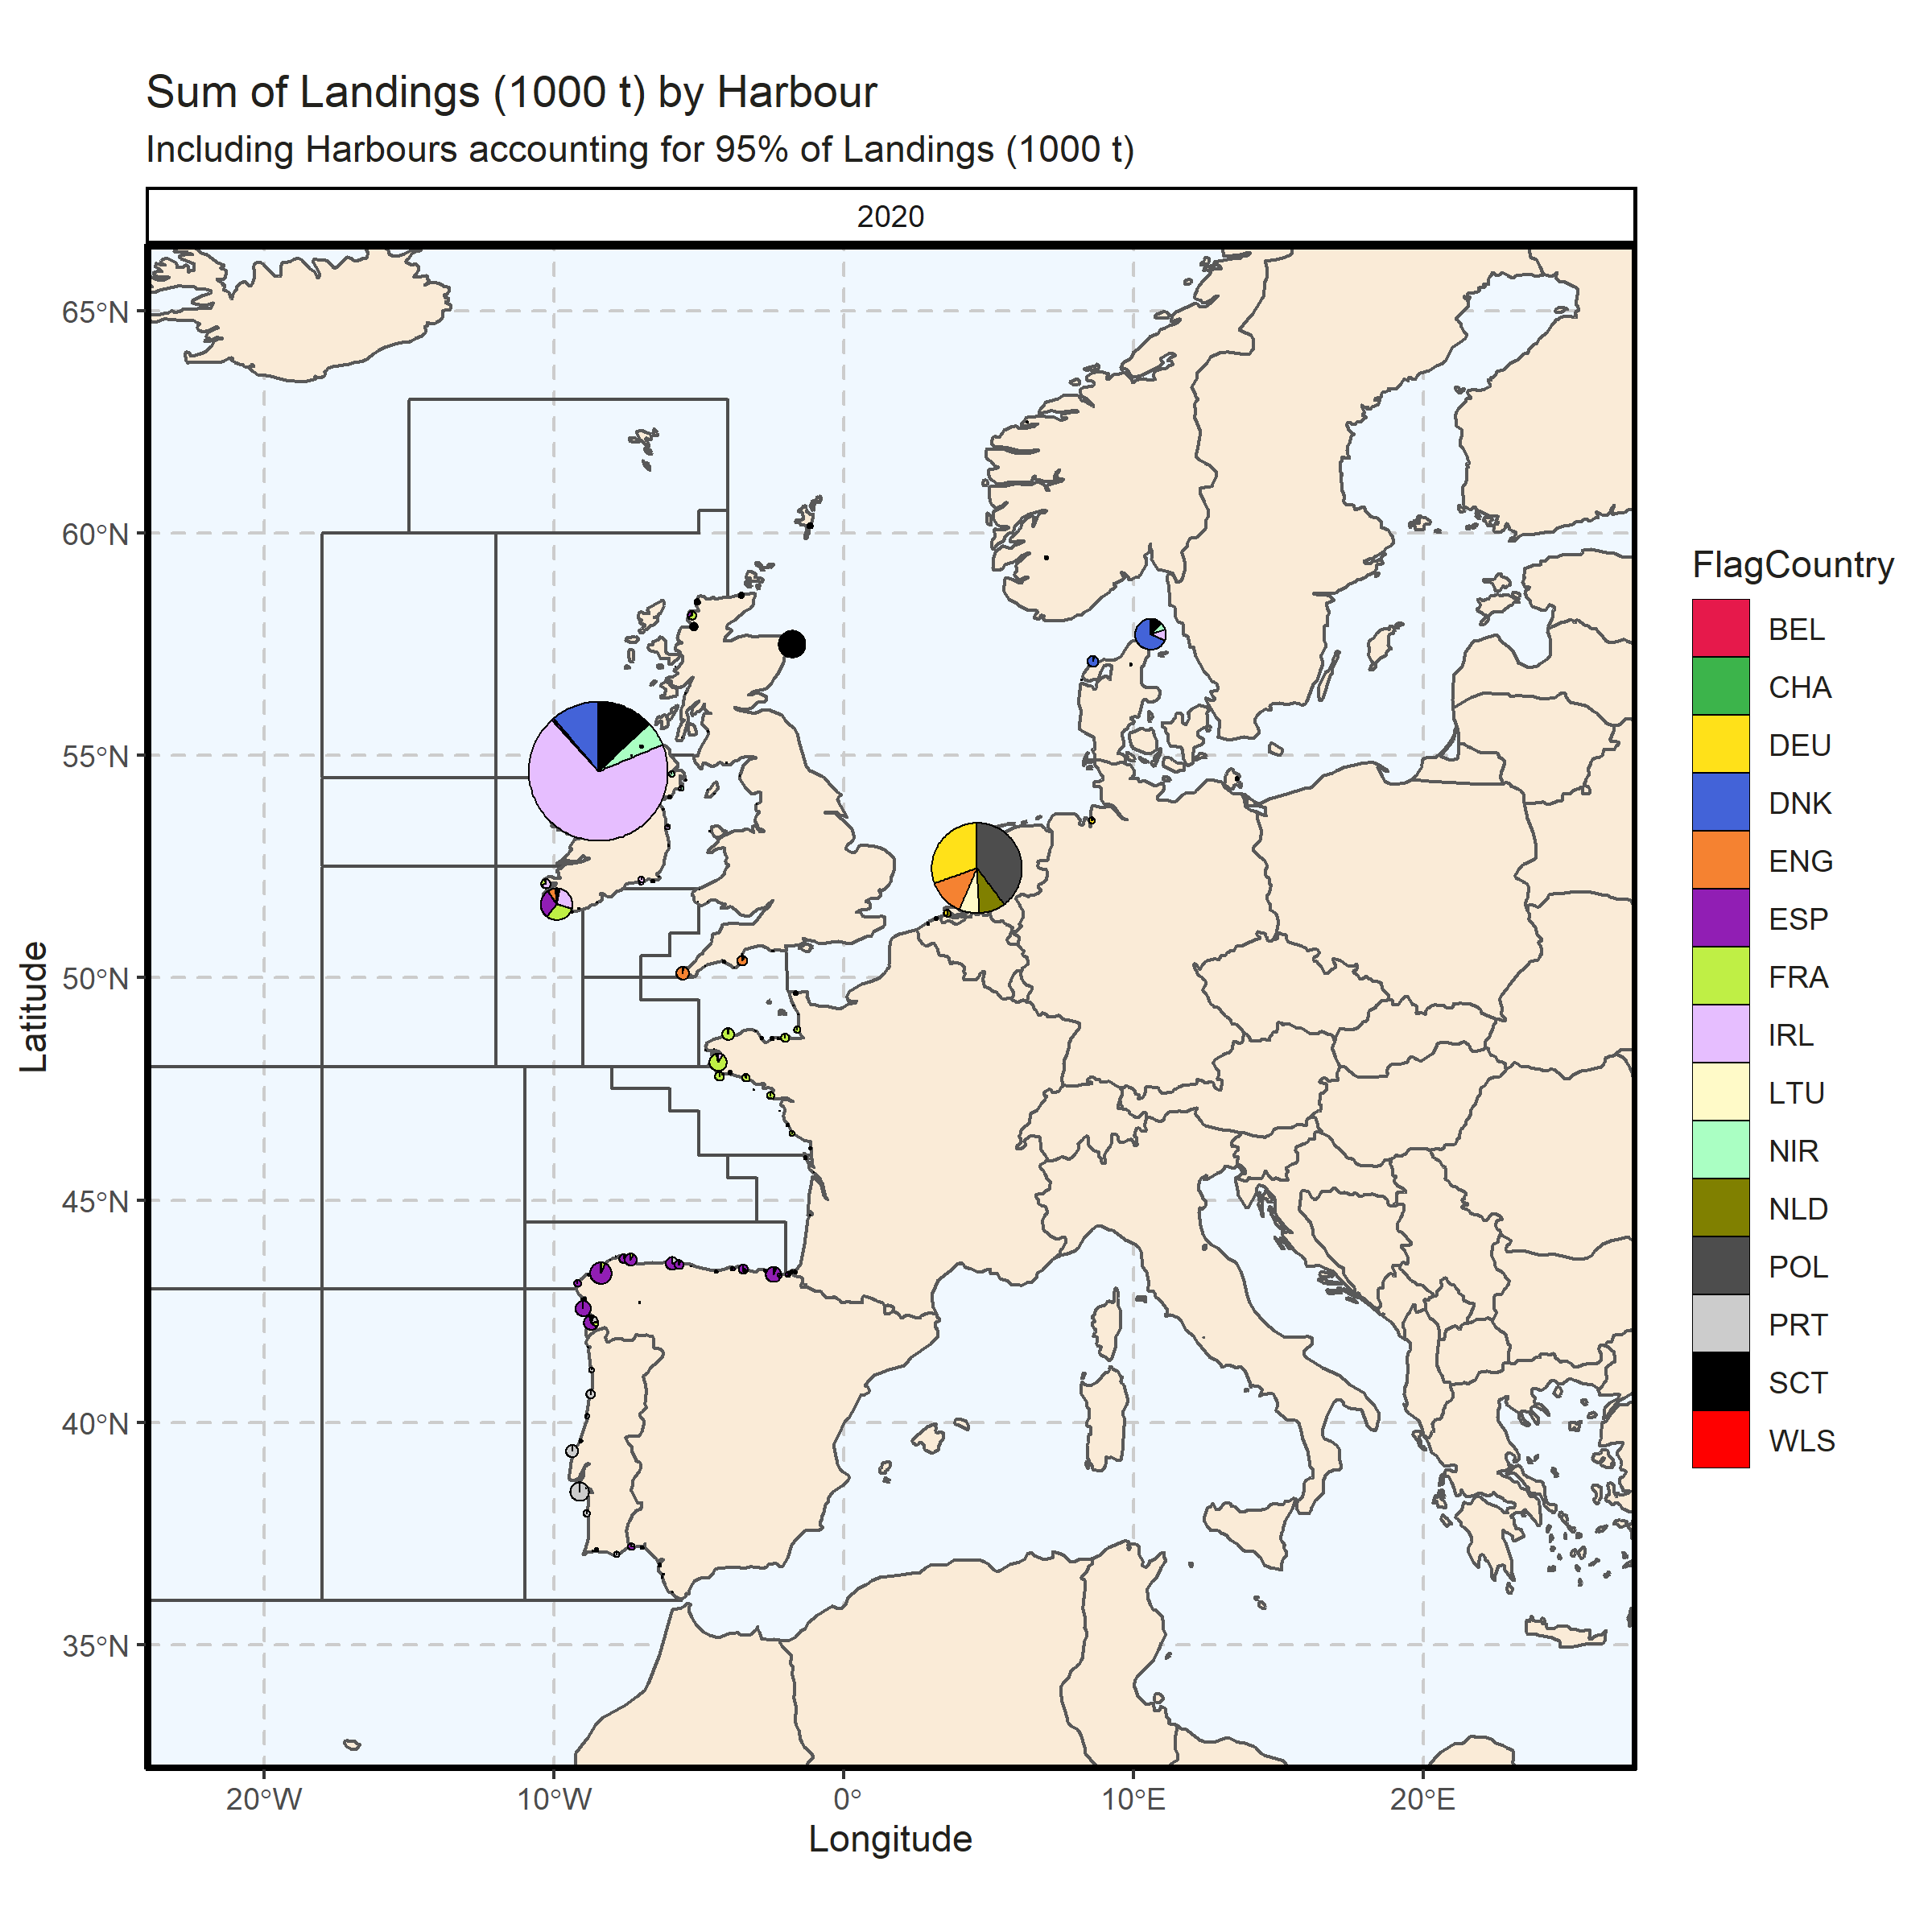 Figure 3.1.6.4. Sum of Landings (1000 t) by Harbour. Including Harbours accounting for 95% of Landings (1000 t). 0% of Landings (1000 t) - reported for missing Harbour. 12 Harbour with missing coordinates (4.36% of Landings (1000 t)) - not presented on the map.

### Landings abroad

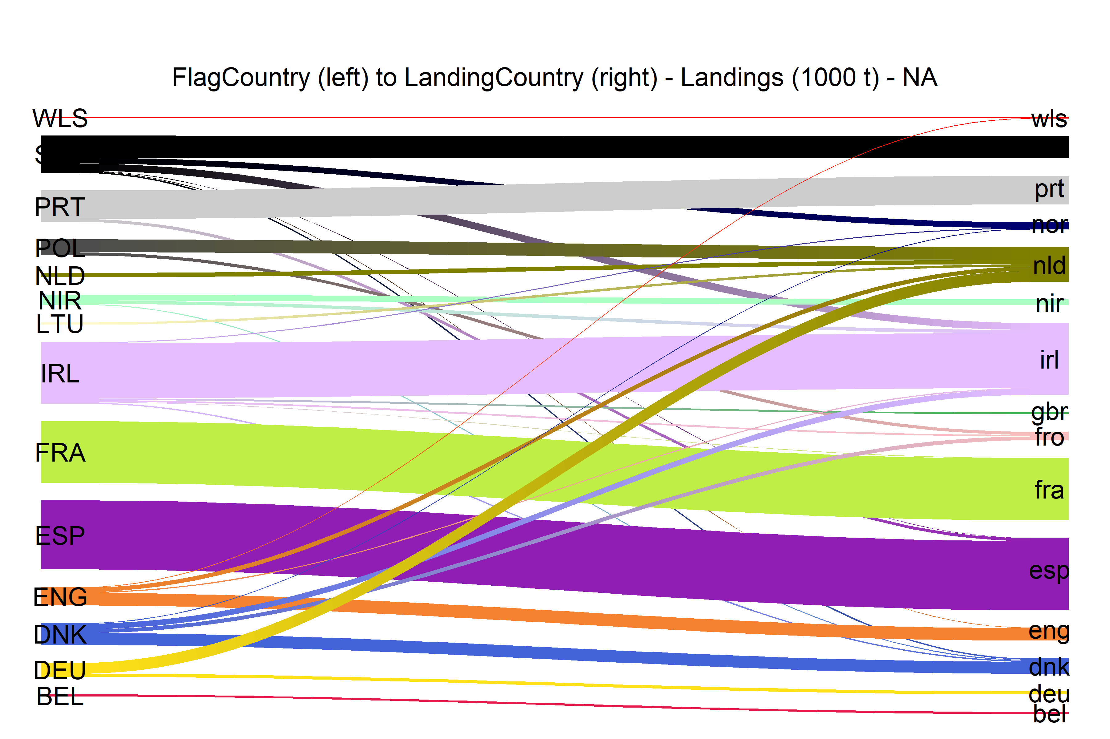  
Figure 3.1.7.1.River plot of Landings (1000 t) between Country (left) and Landing Country (right). Width of line is proportional to landings

### Spatial distribution of landings

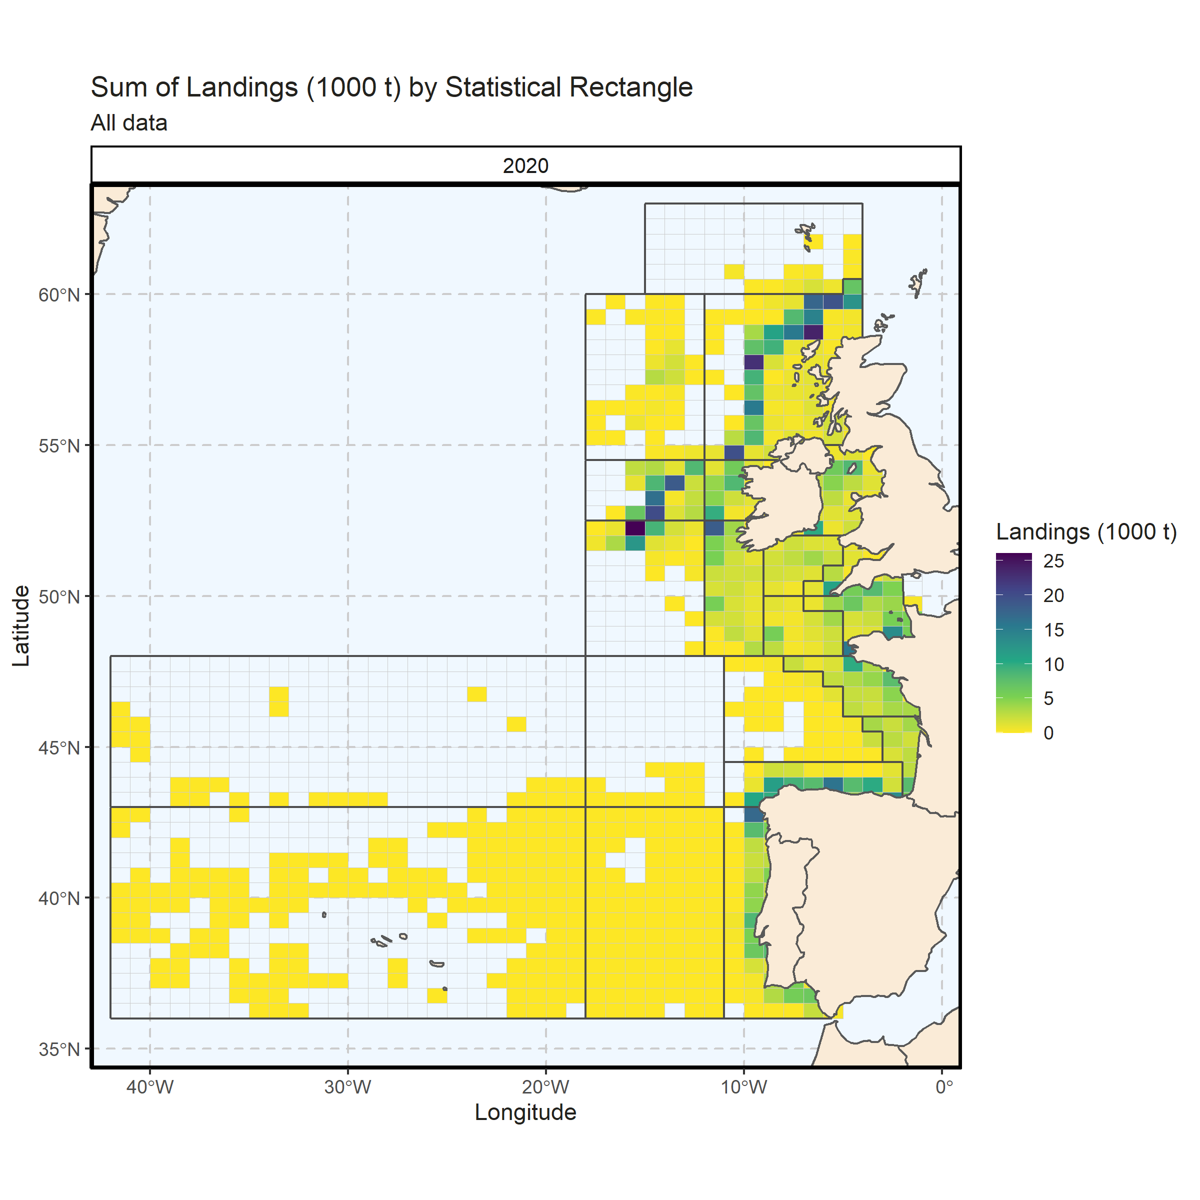 Figure 3.1.8.1. Sum of Landings (1000 t) by Statistical Rectangle. All data. 2.02% of Landings (1000 t) - reported for missing Statistical Rectangle. 2 Statistical Rectangle with missing coordinates (3.72% of Landings (1000 t)) - not presented on the map.

## Small pelagic landings

### Landings by country, small pelagic

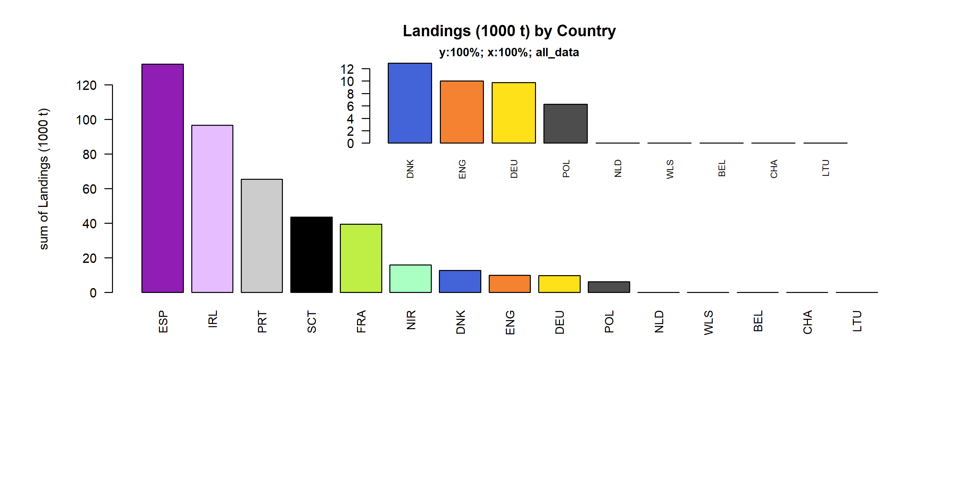 Figure 3.2.1.1. Landings (1000 t) of small pelagic by Country.

### Landings by species, small pelagic

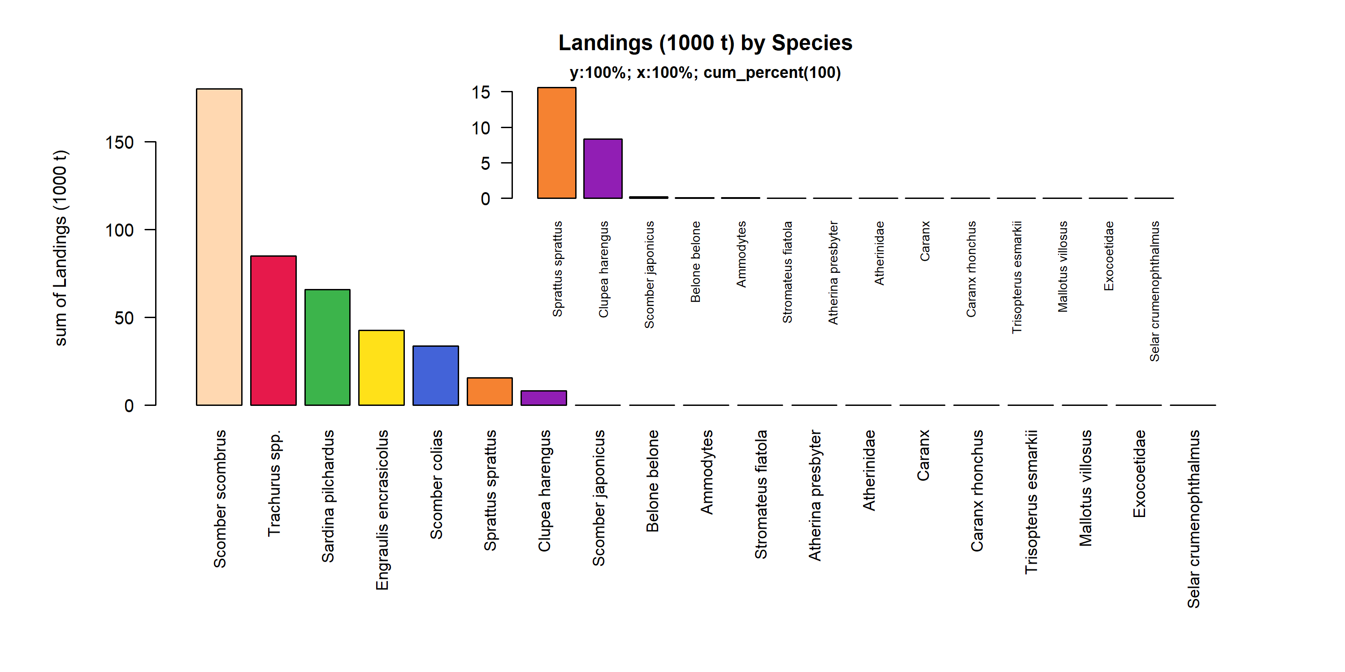 Figure 3.2.2.1. Landings (1000 t) of small pelagic by Species. Species displayed comprise 100% of the total Landings (1000 t).

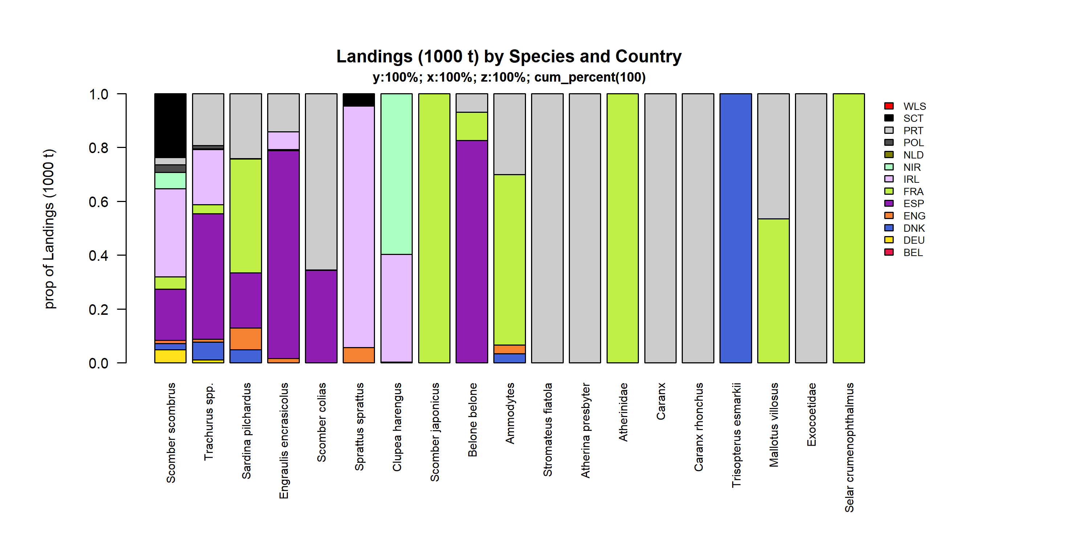 Figure 3.2.2.2. Landings (1000 t) of small pelagic by Species and Country . Species and Country displayed comprise 100 % of the total Landings (1000 t) .

### Landings by fleet, small pelagic

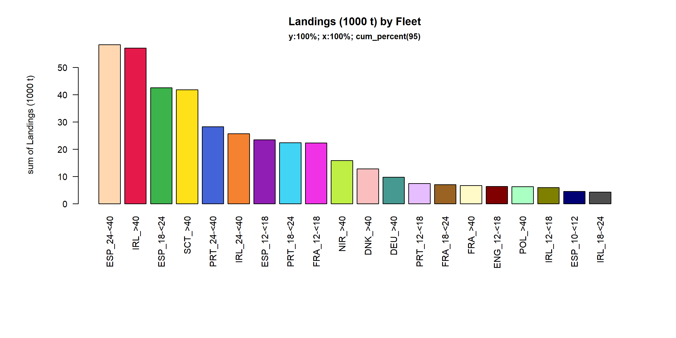 Figure 3.2.3.1. Landings (1000 t) of small pelagic by Fleet. Fleet displayed comprise 95% of the total Landings (1000 t).

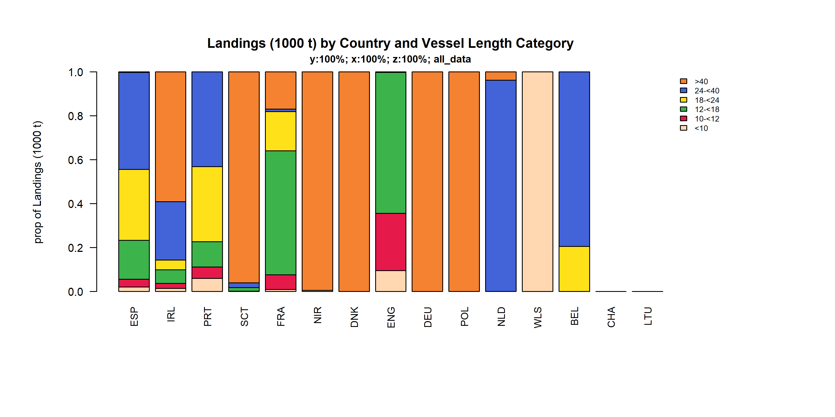 Figure 3.2.3.2. Landings (1000 t) of small pelagic by Country and Vessel Length Category.

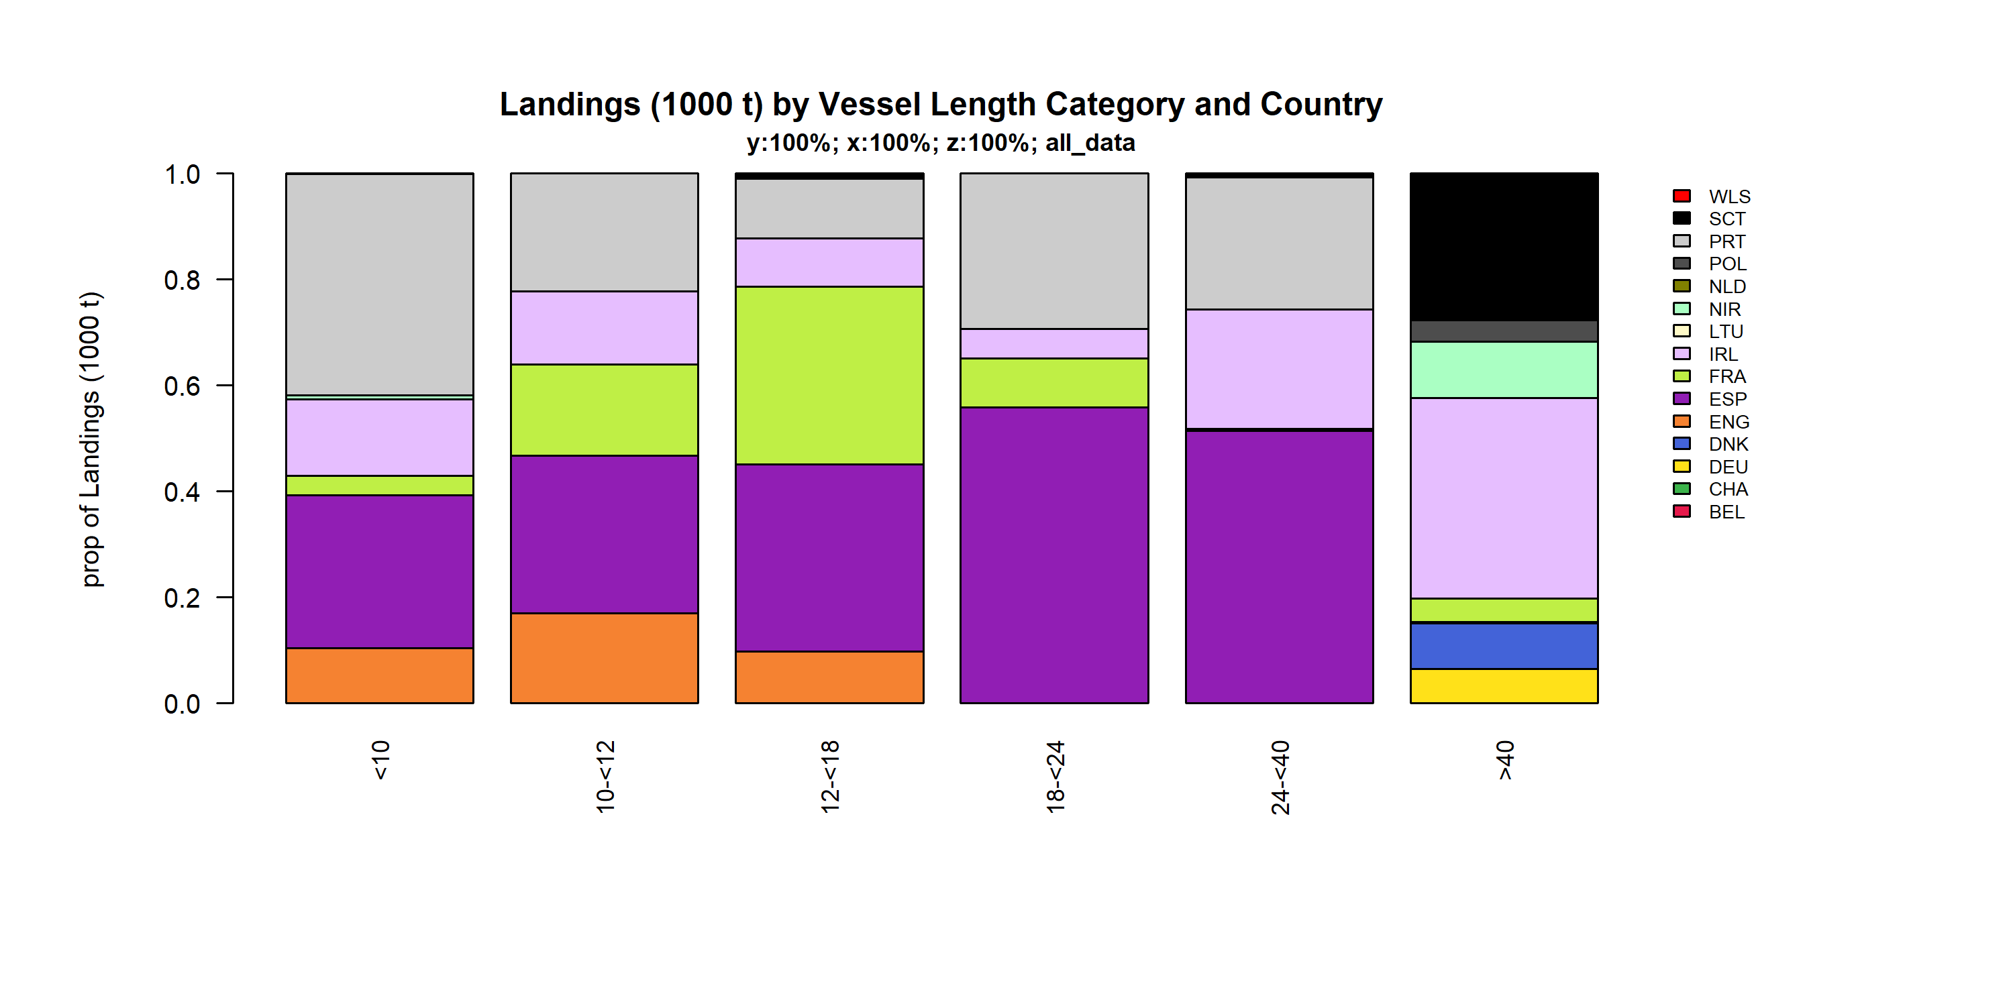 Figure 3.2.3.3. Landings (1000 t) of small pelagic by Vessel Length Category and Country.

### Landings by area, small pelagic

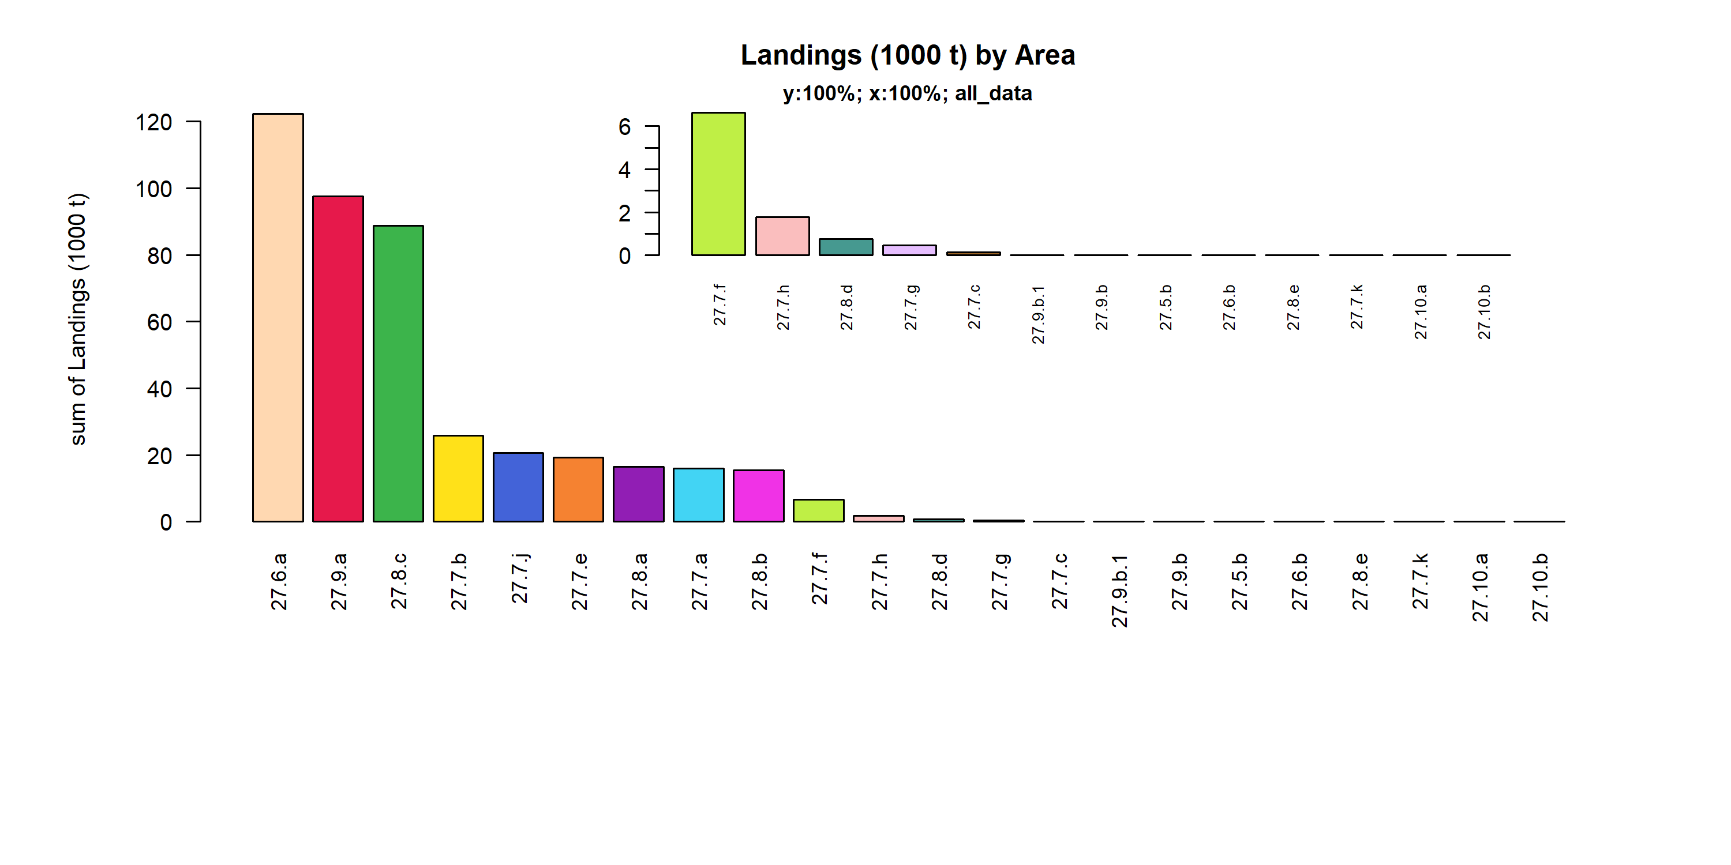 Figure 3.2.4.1. Landings (1000 t) of small pelagic by Area.

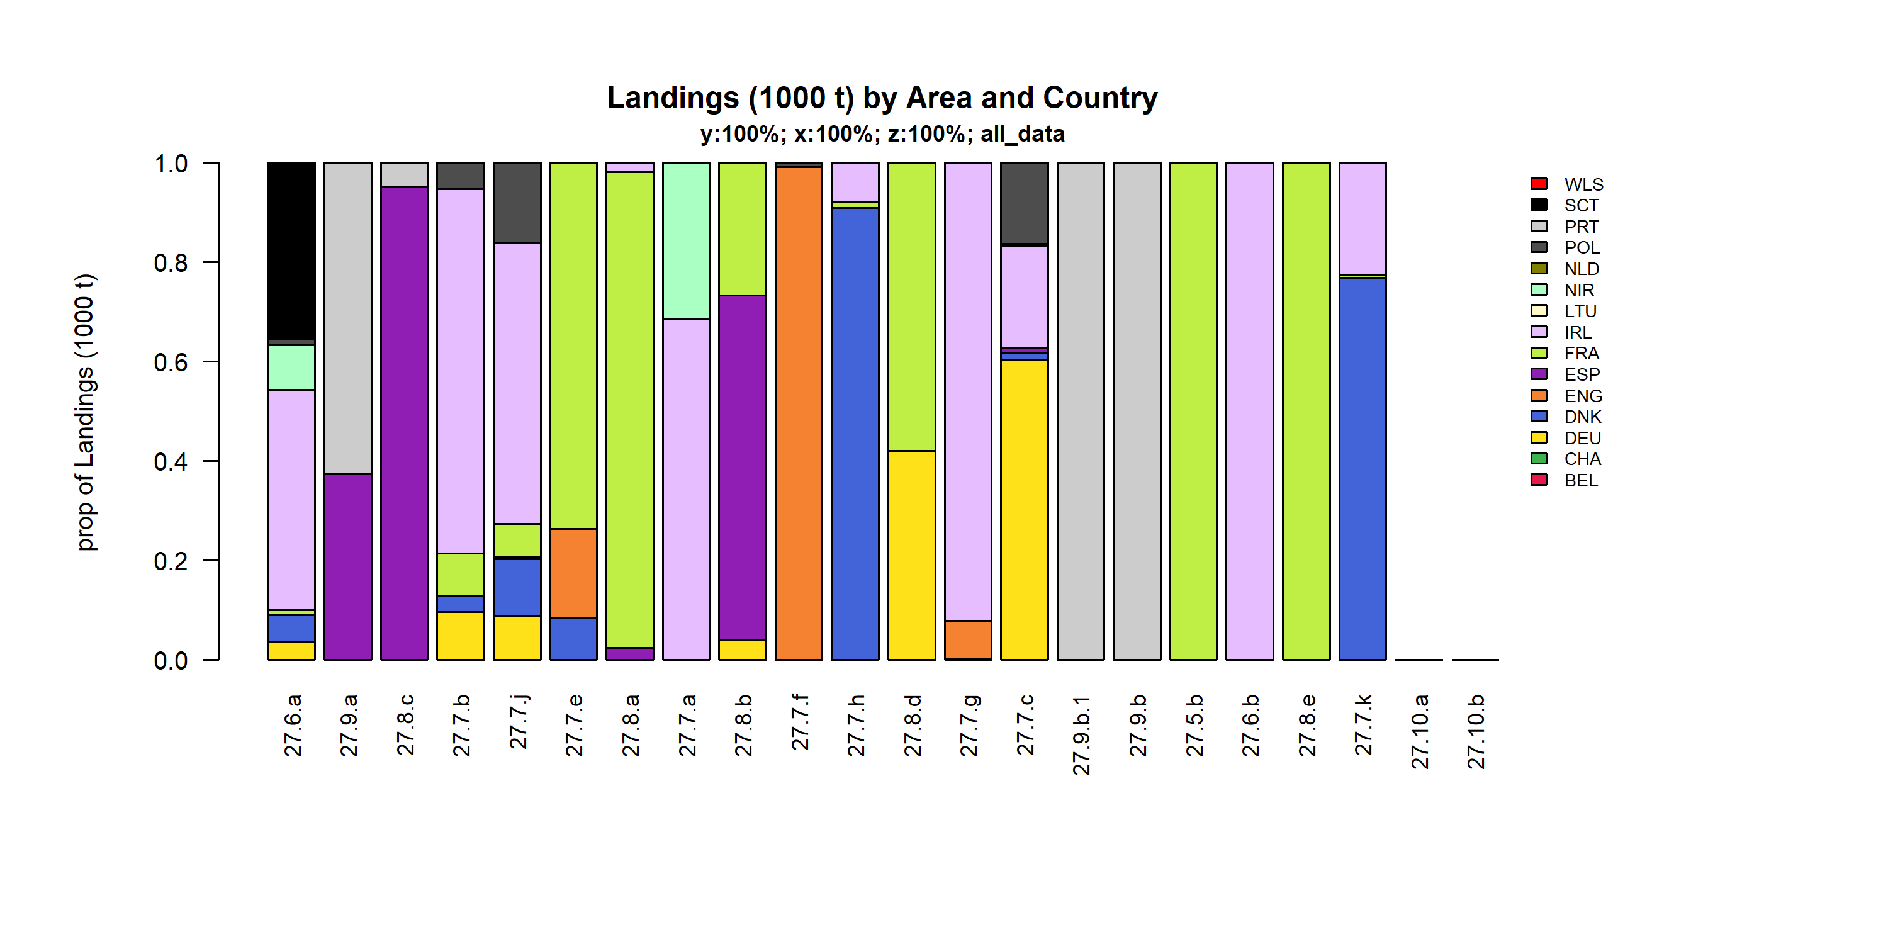 Figure 3.2.4.2. Landings (1000 t) of small pelagic by Area and Country.

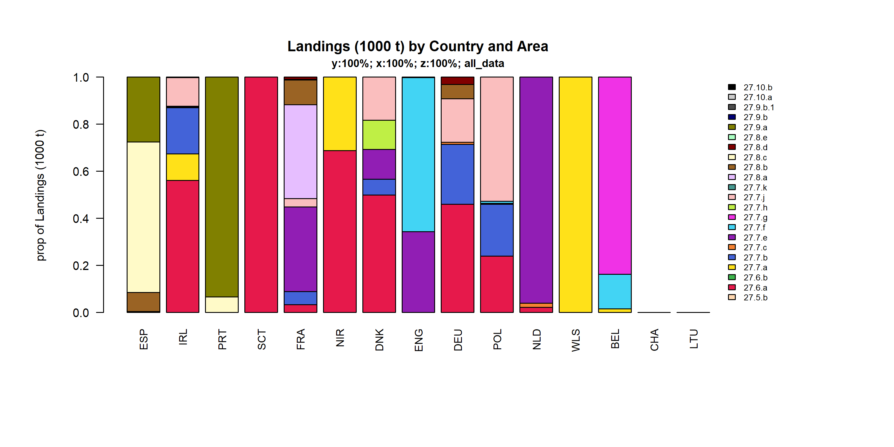 Figure 3.2.4.3. Landings (1000 t) of small pelagic by Country and Area.

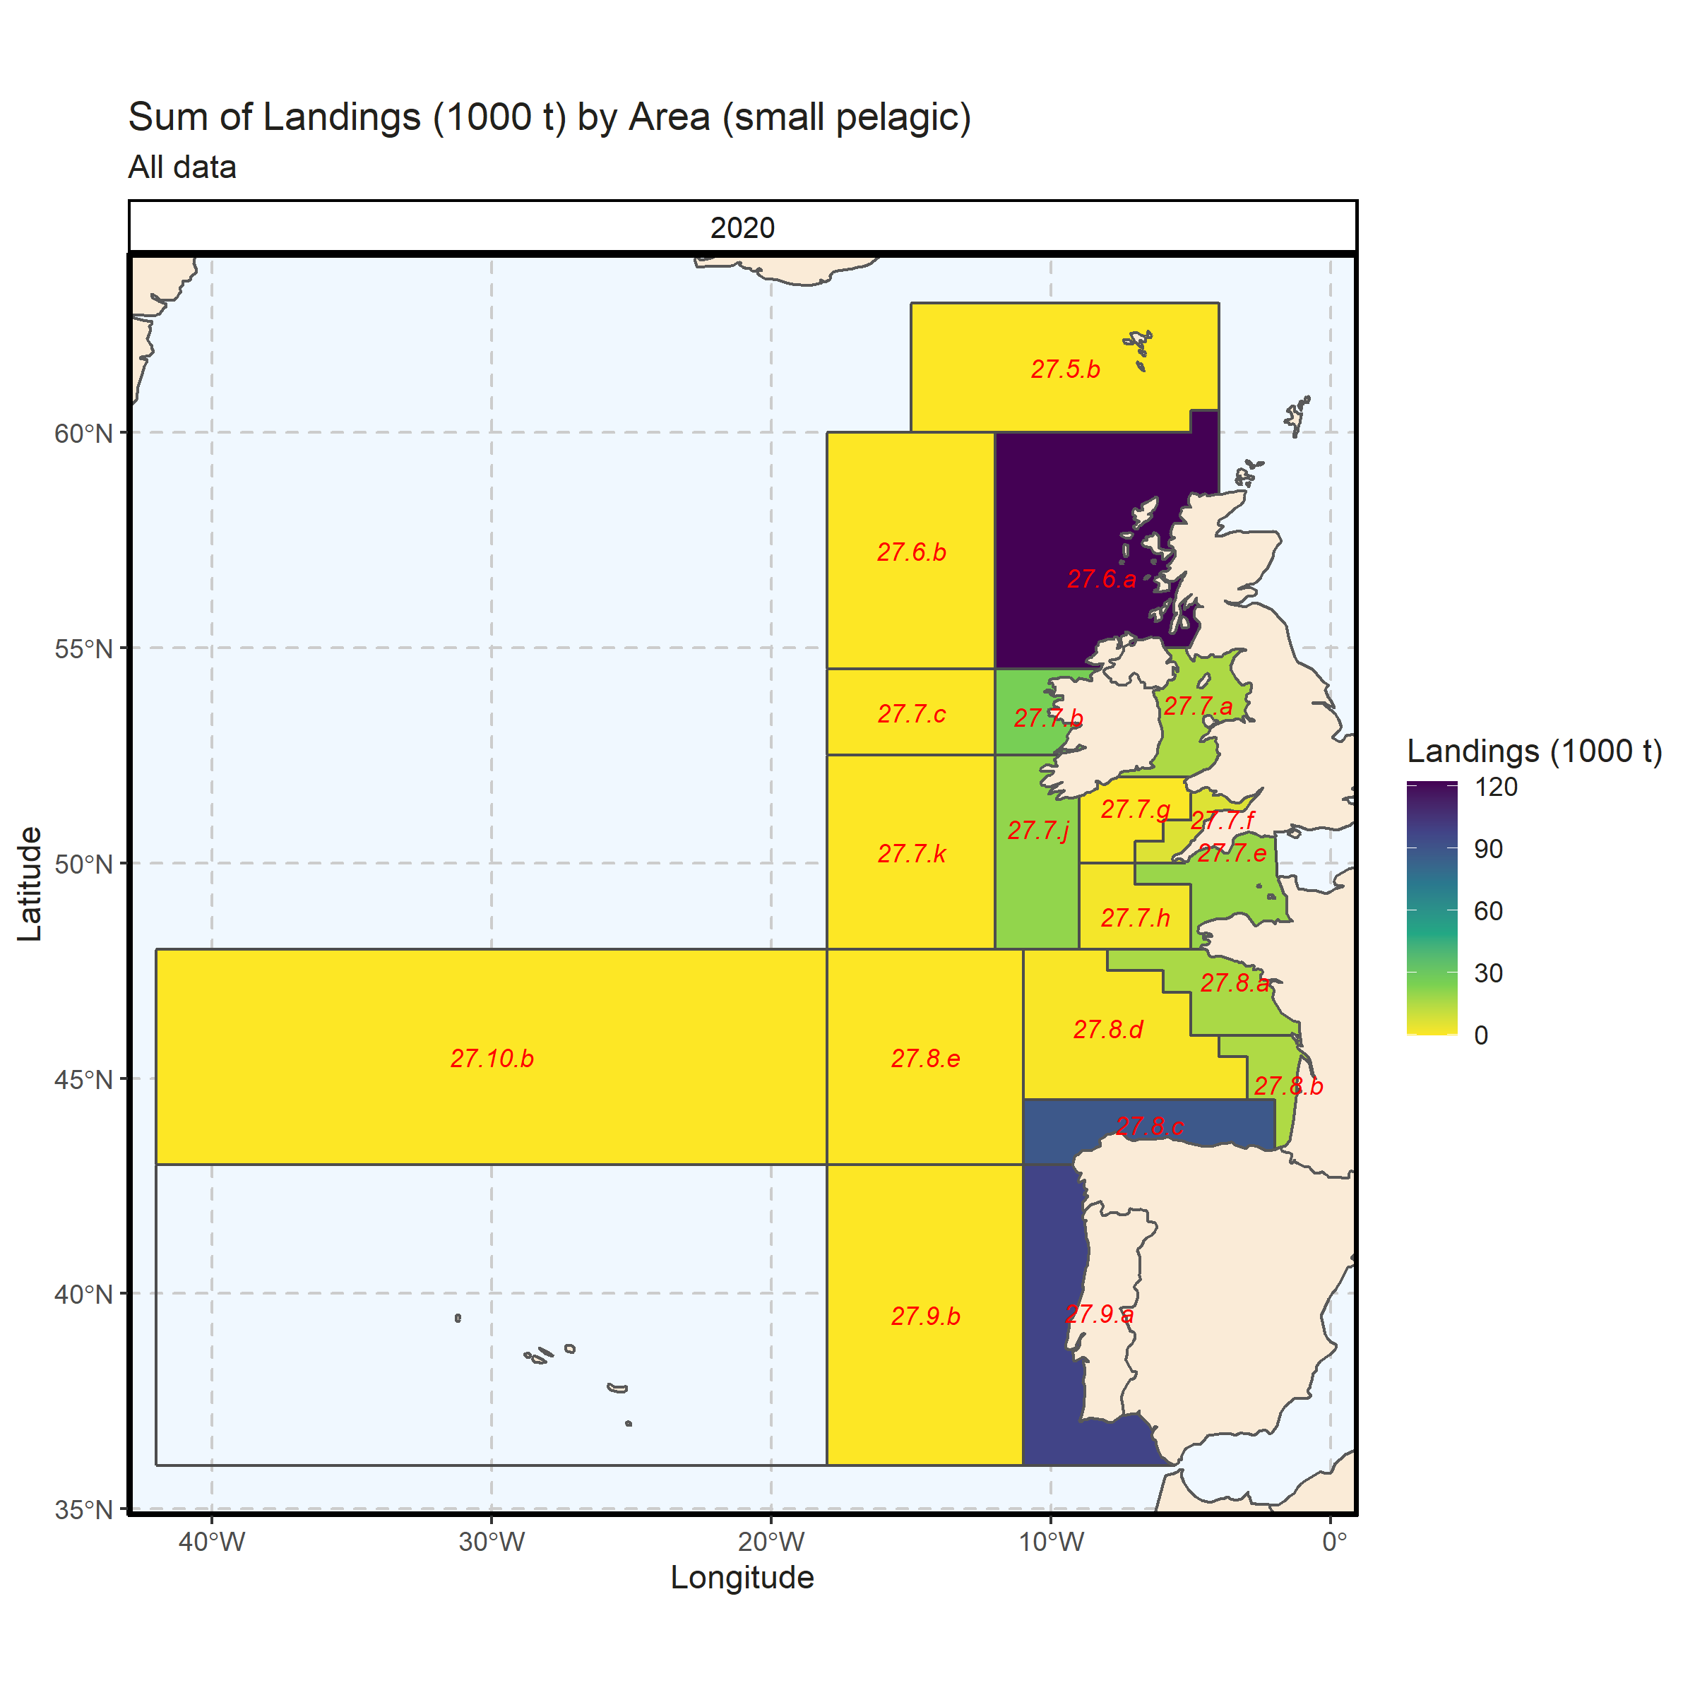 Figure 3.2.4.4. Sum of Landings (1000 t) by Area (small pelagic). All data. 0% of Landings (1000 t) - reported for missing Area.

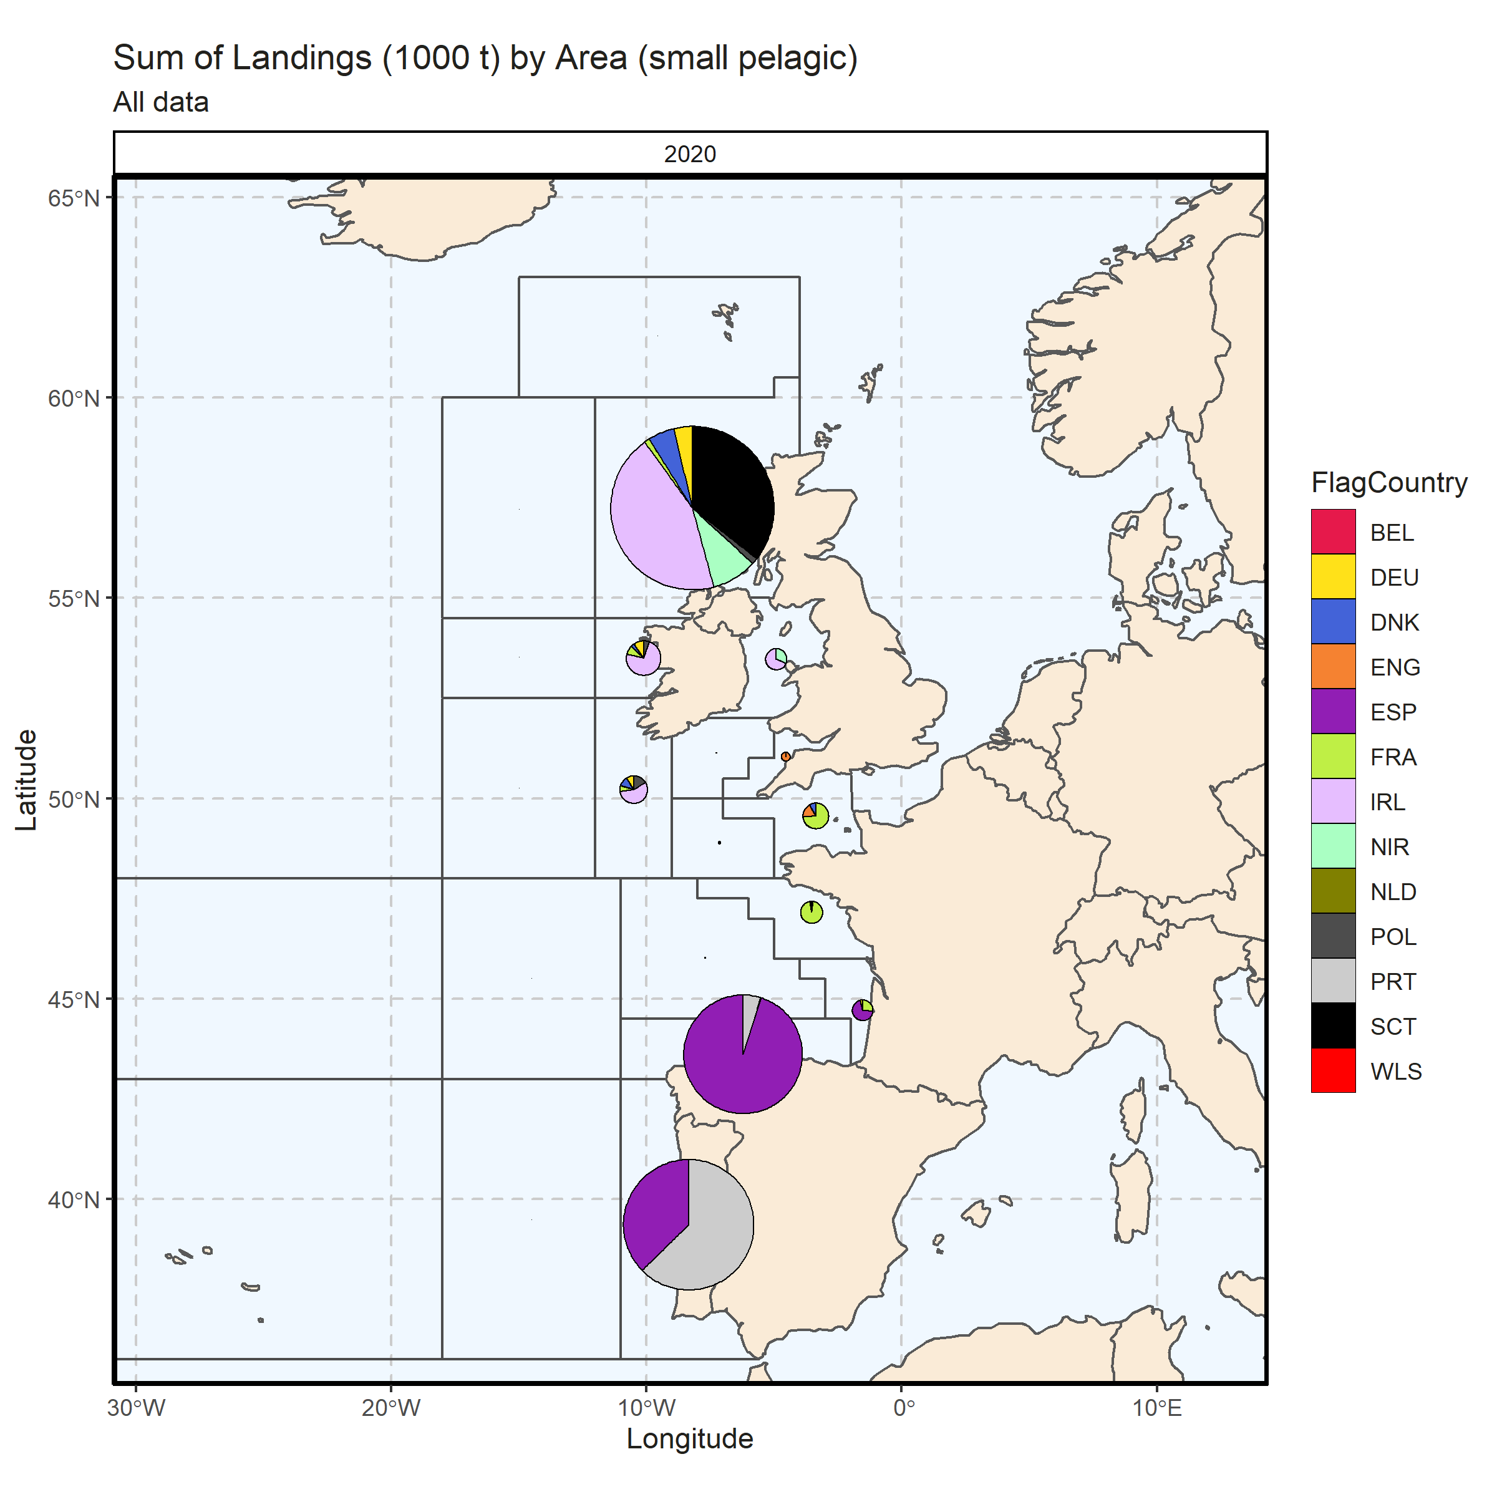 Figure 3.2.4.5. Sum of Landings (1000 t) by Area (small pelagic). All data. 0% of Landings (1000 t) - reported for missing Area.

### Landings by metier, small pelagic

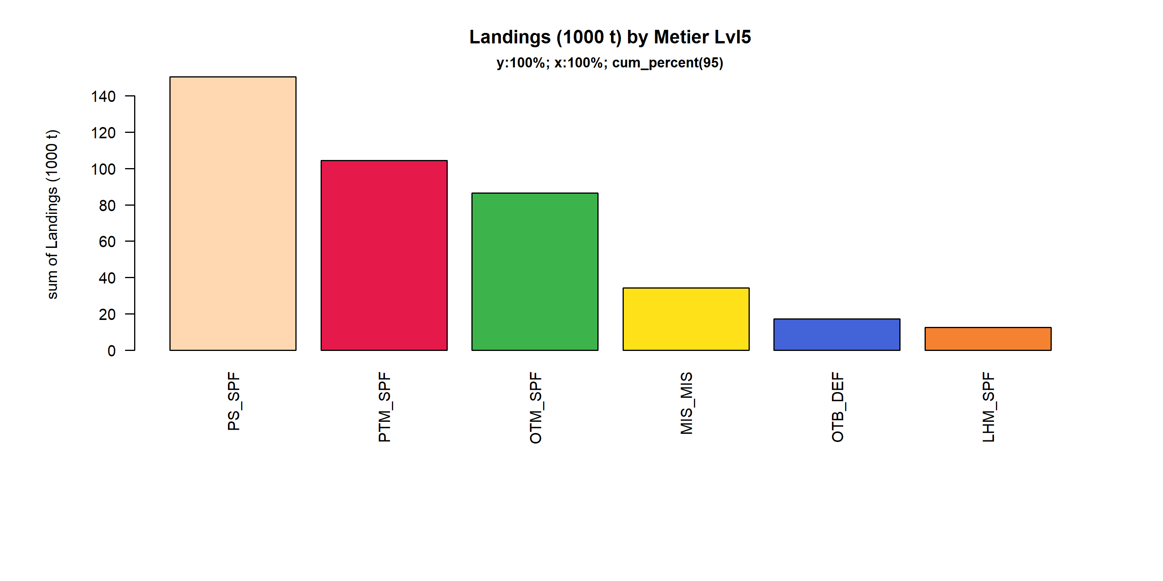 Figure 3.2.5.1. Landings (1000 t) of small pelagic by Metier Lvl5. Metier Lvl5 displayed comprise 95% of the total Landings (1000 t).

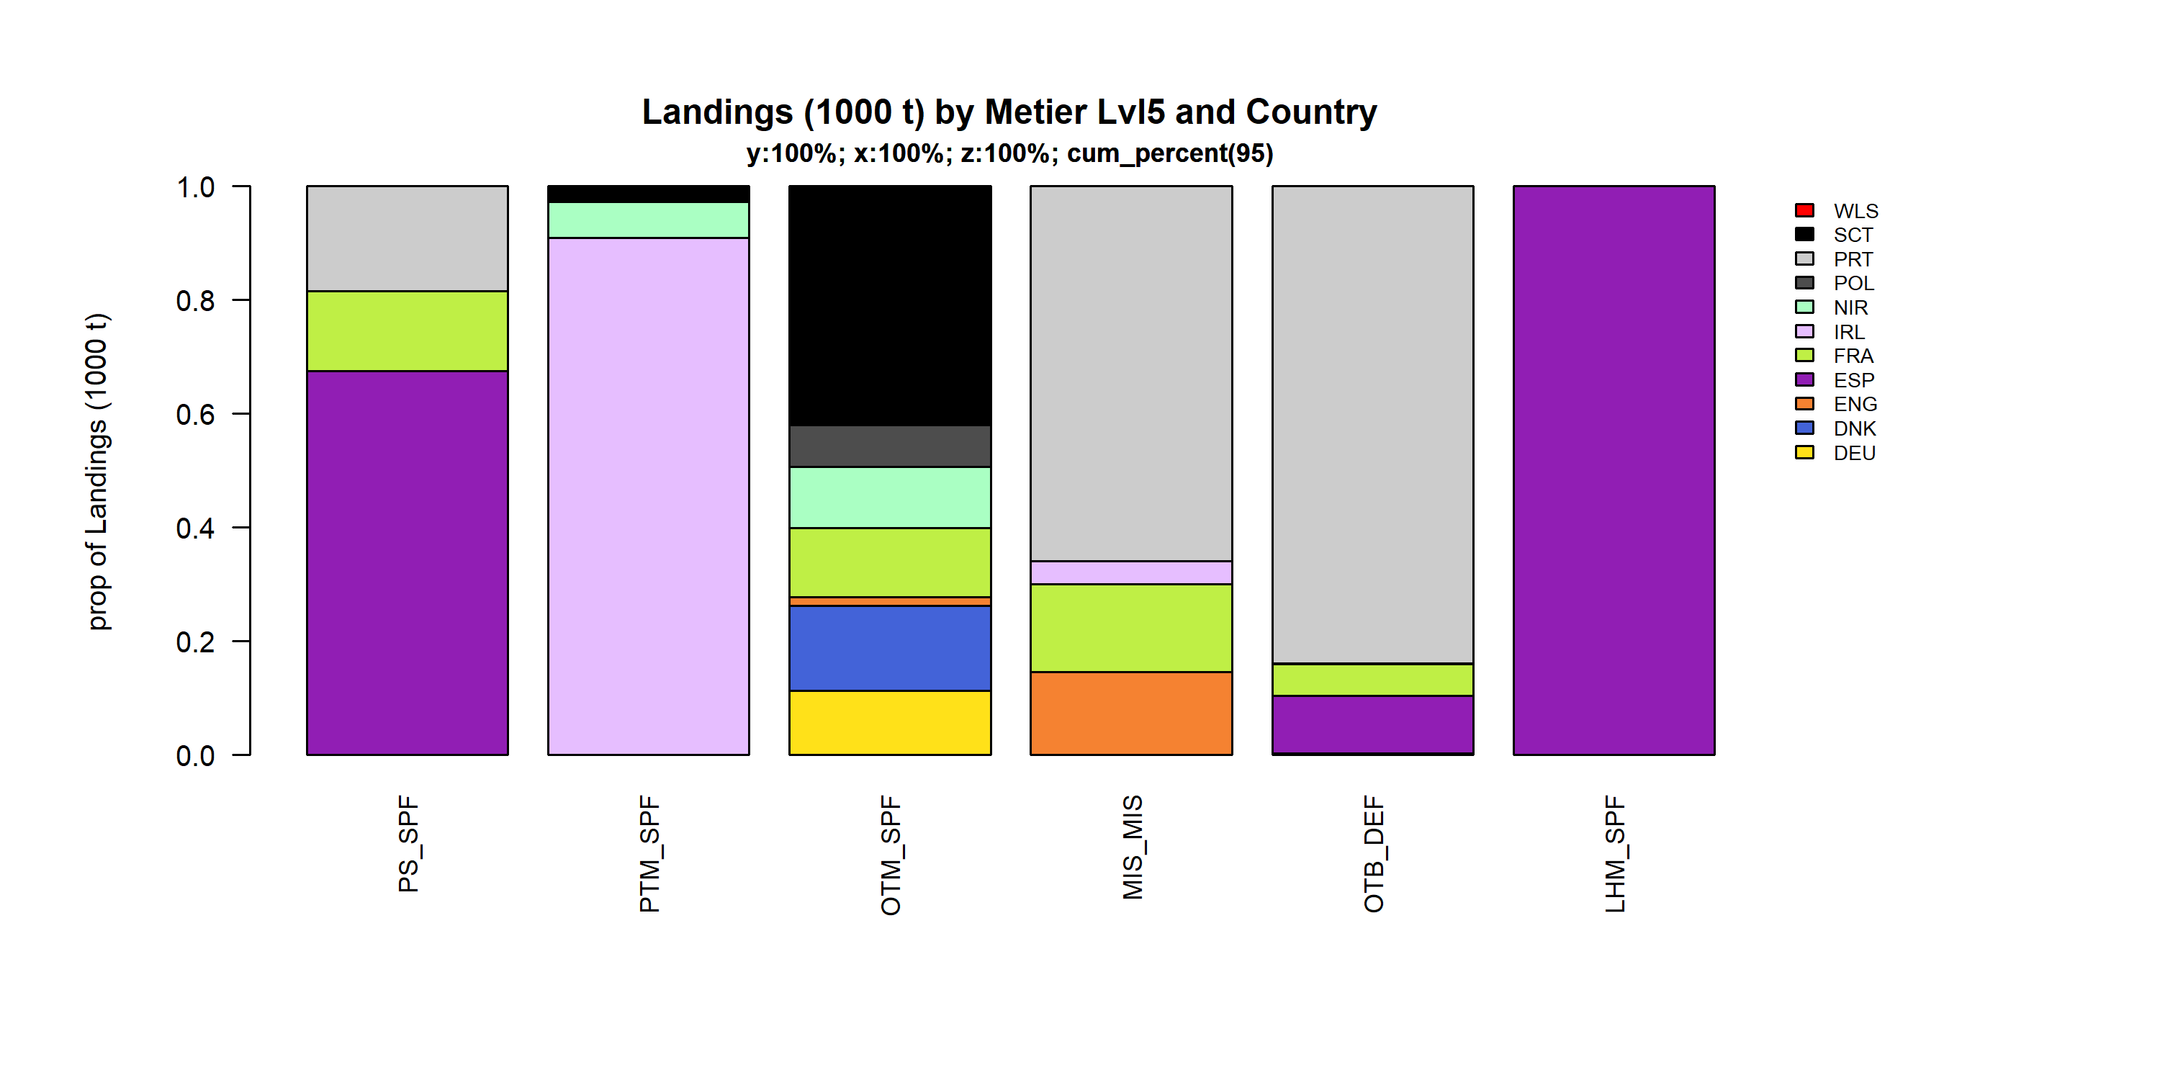 Figure 3.2.5.2. Landings (1000 t) of small pelagic by Metier Lvl5 and Country . Metier Lvl5 and Country displayed comprise 95 % of the total Landings (1000 t) .

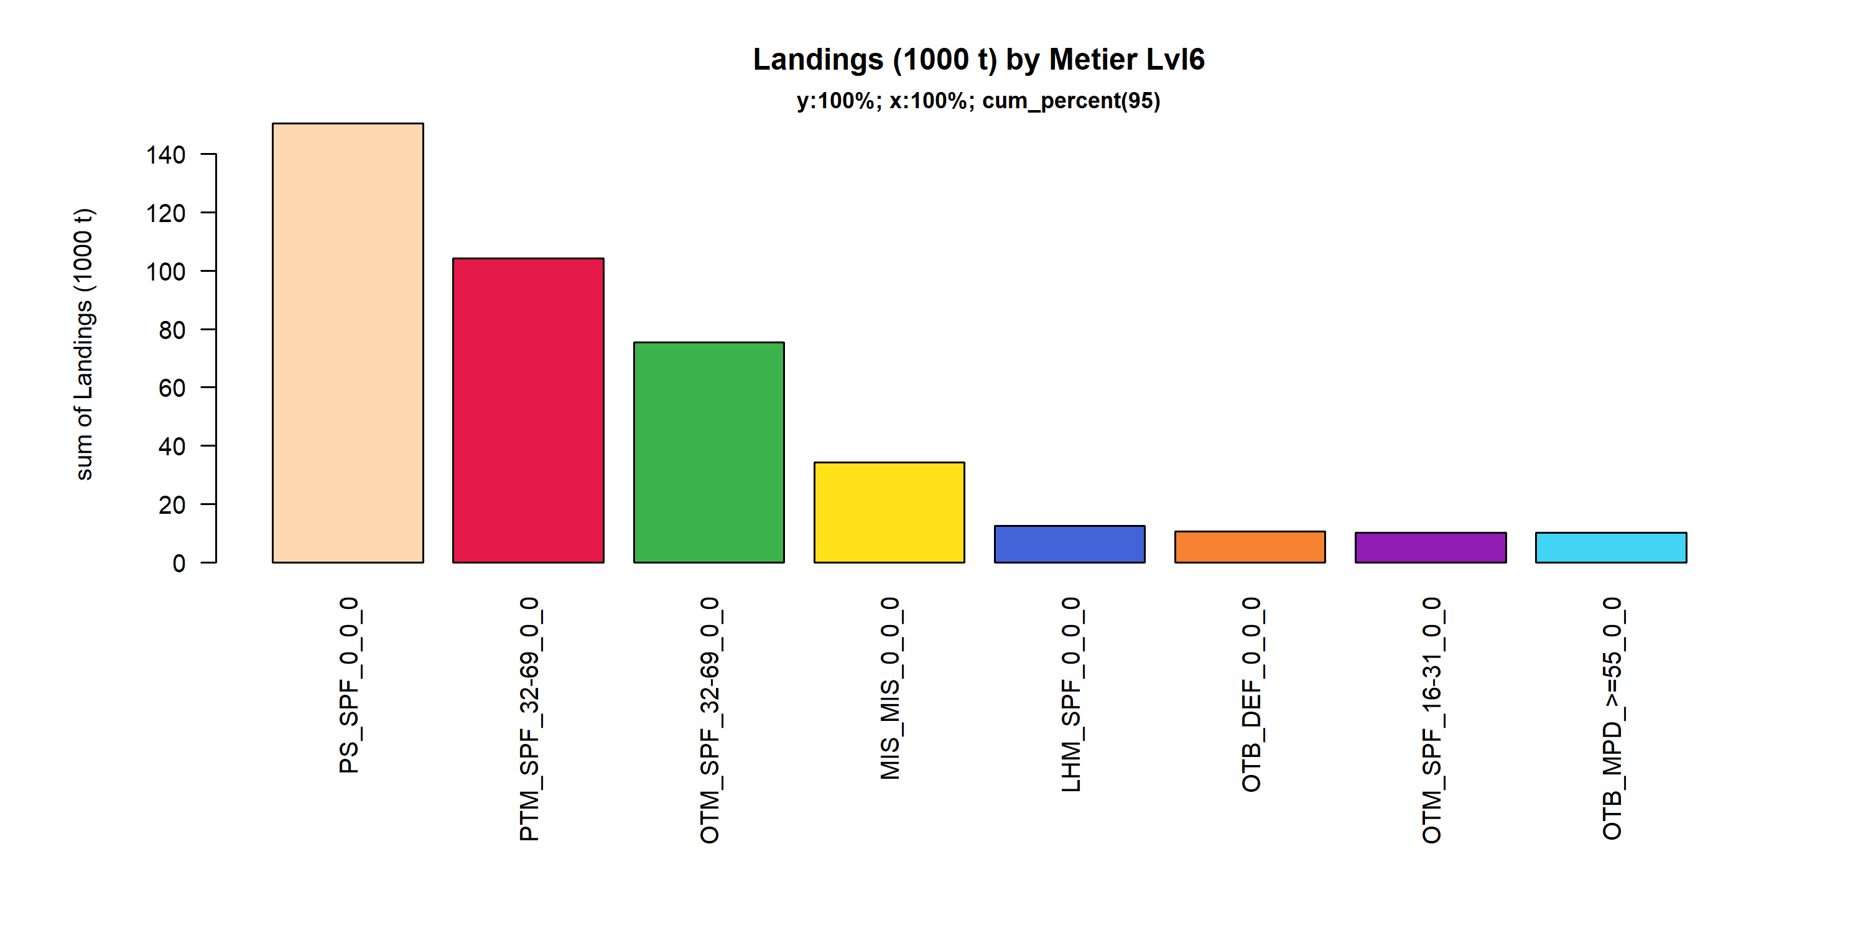 Figure 3.2.5.3. Landings (1000 t) of small pelagic by Metier Lvl6. Metier Lvl6 displayed comprise 95% of the total Landings (1000 t).

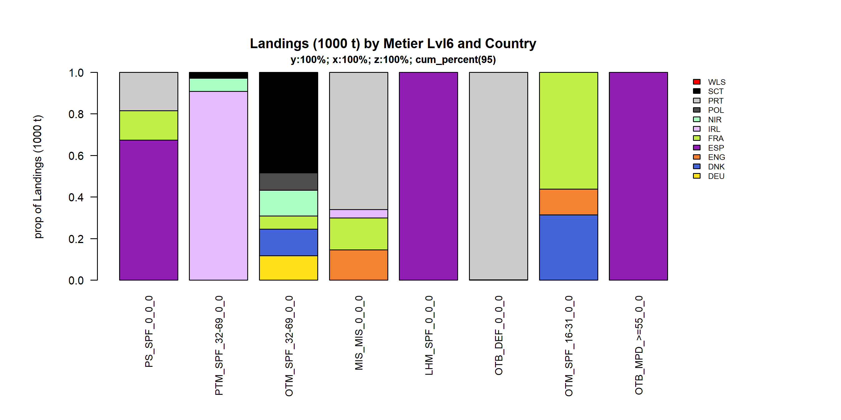 Figure 3.2.5.4. Landings (1000 t) of small pelagic by Metier Lvl6 and Country . Metier Lvl6 and Country displayed comprise 95 % of the total Landings (1000 t) .

### Landings by harbour, small pelagic

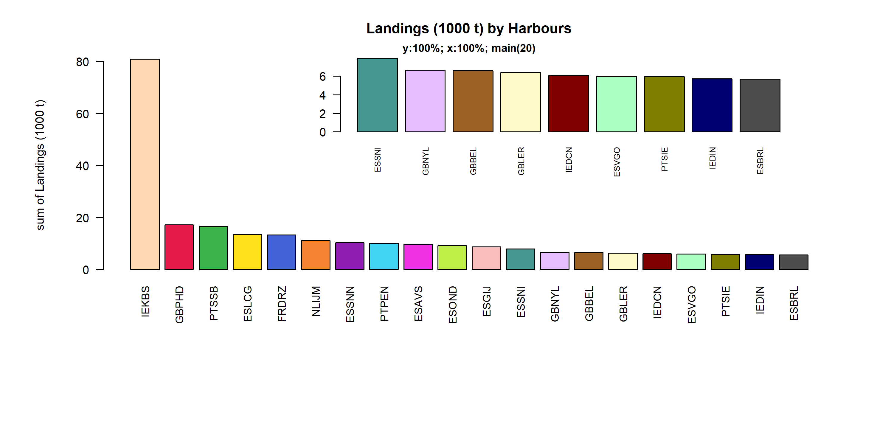 Figure 3.2.6.1. Landings (1000 t) of small pelagic in the 20 main Harbours (100% of rows entering analysis had known Harbours).

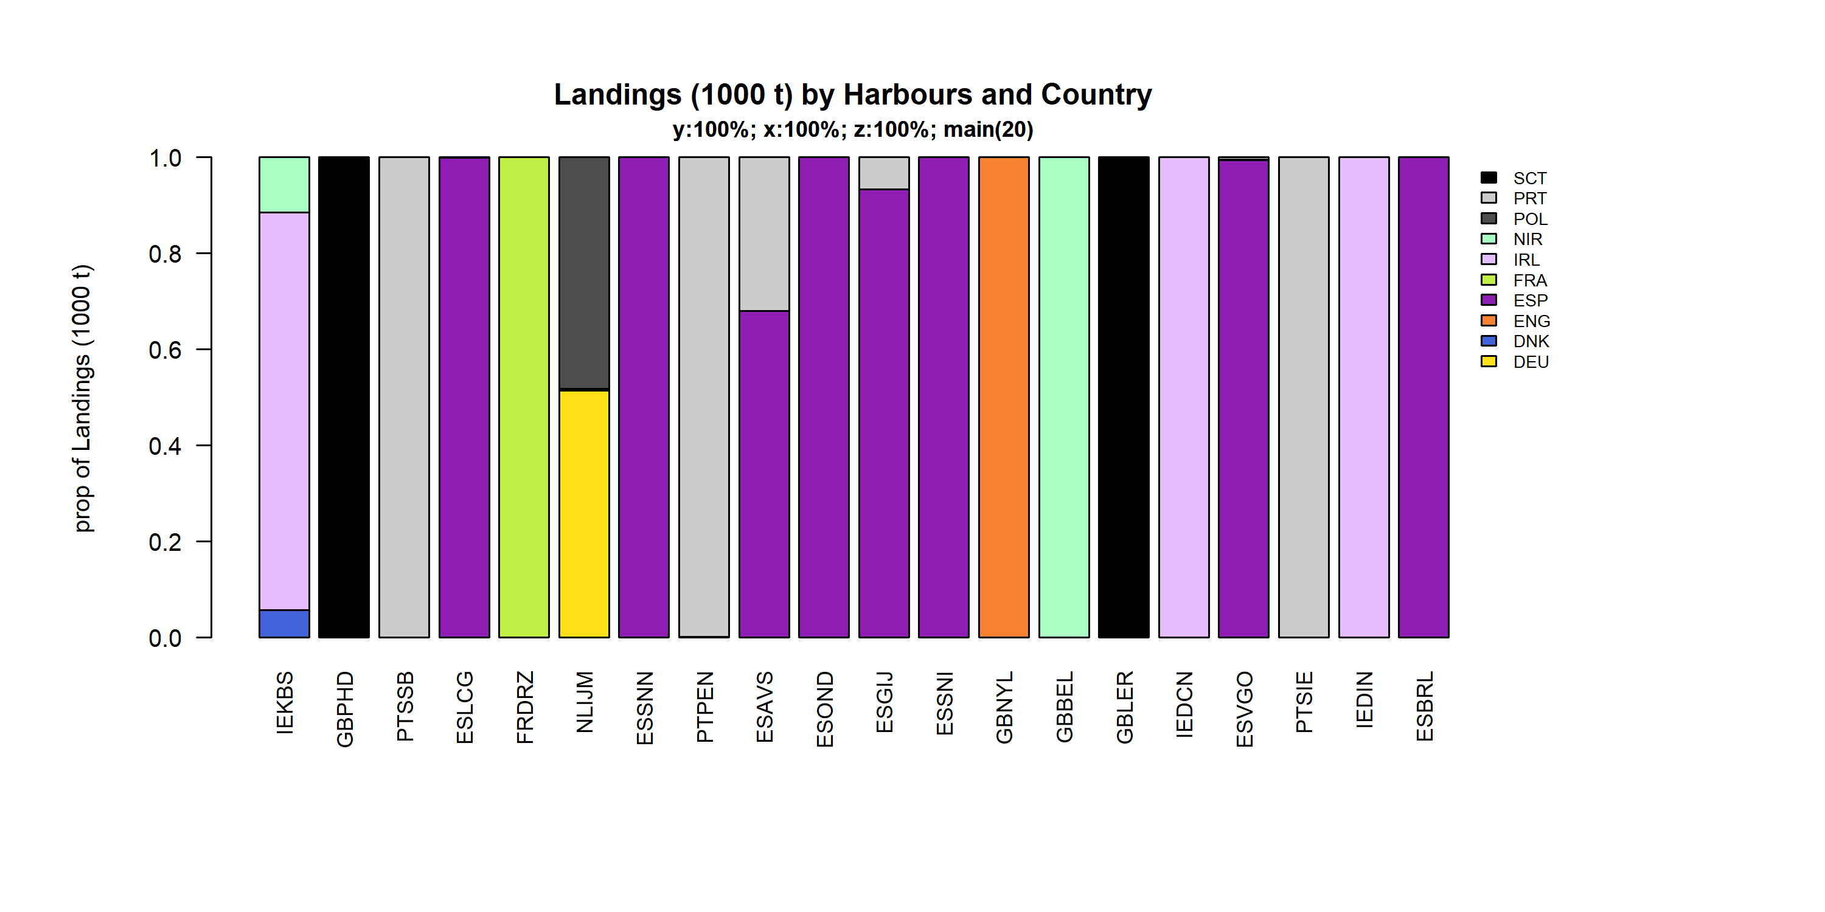 Figure 3.2.6.2. Landings (1000 t) of small pelagic by 20 main Harbours and Country .

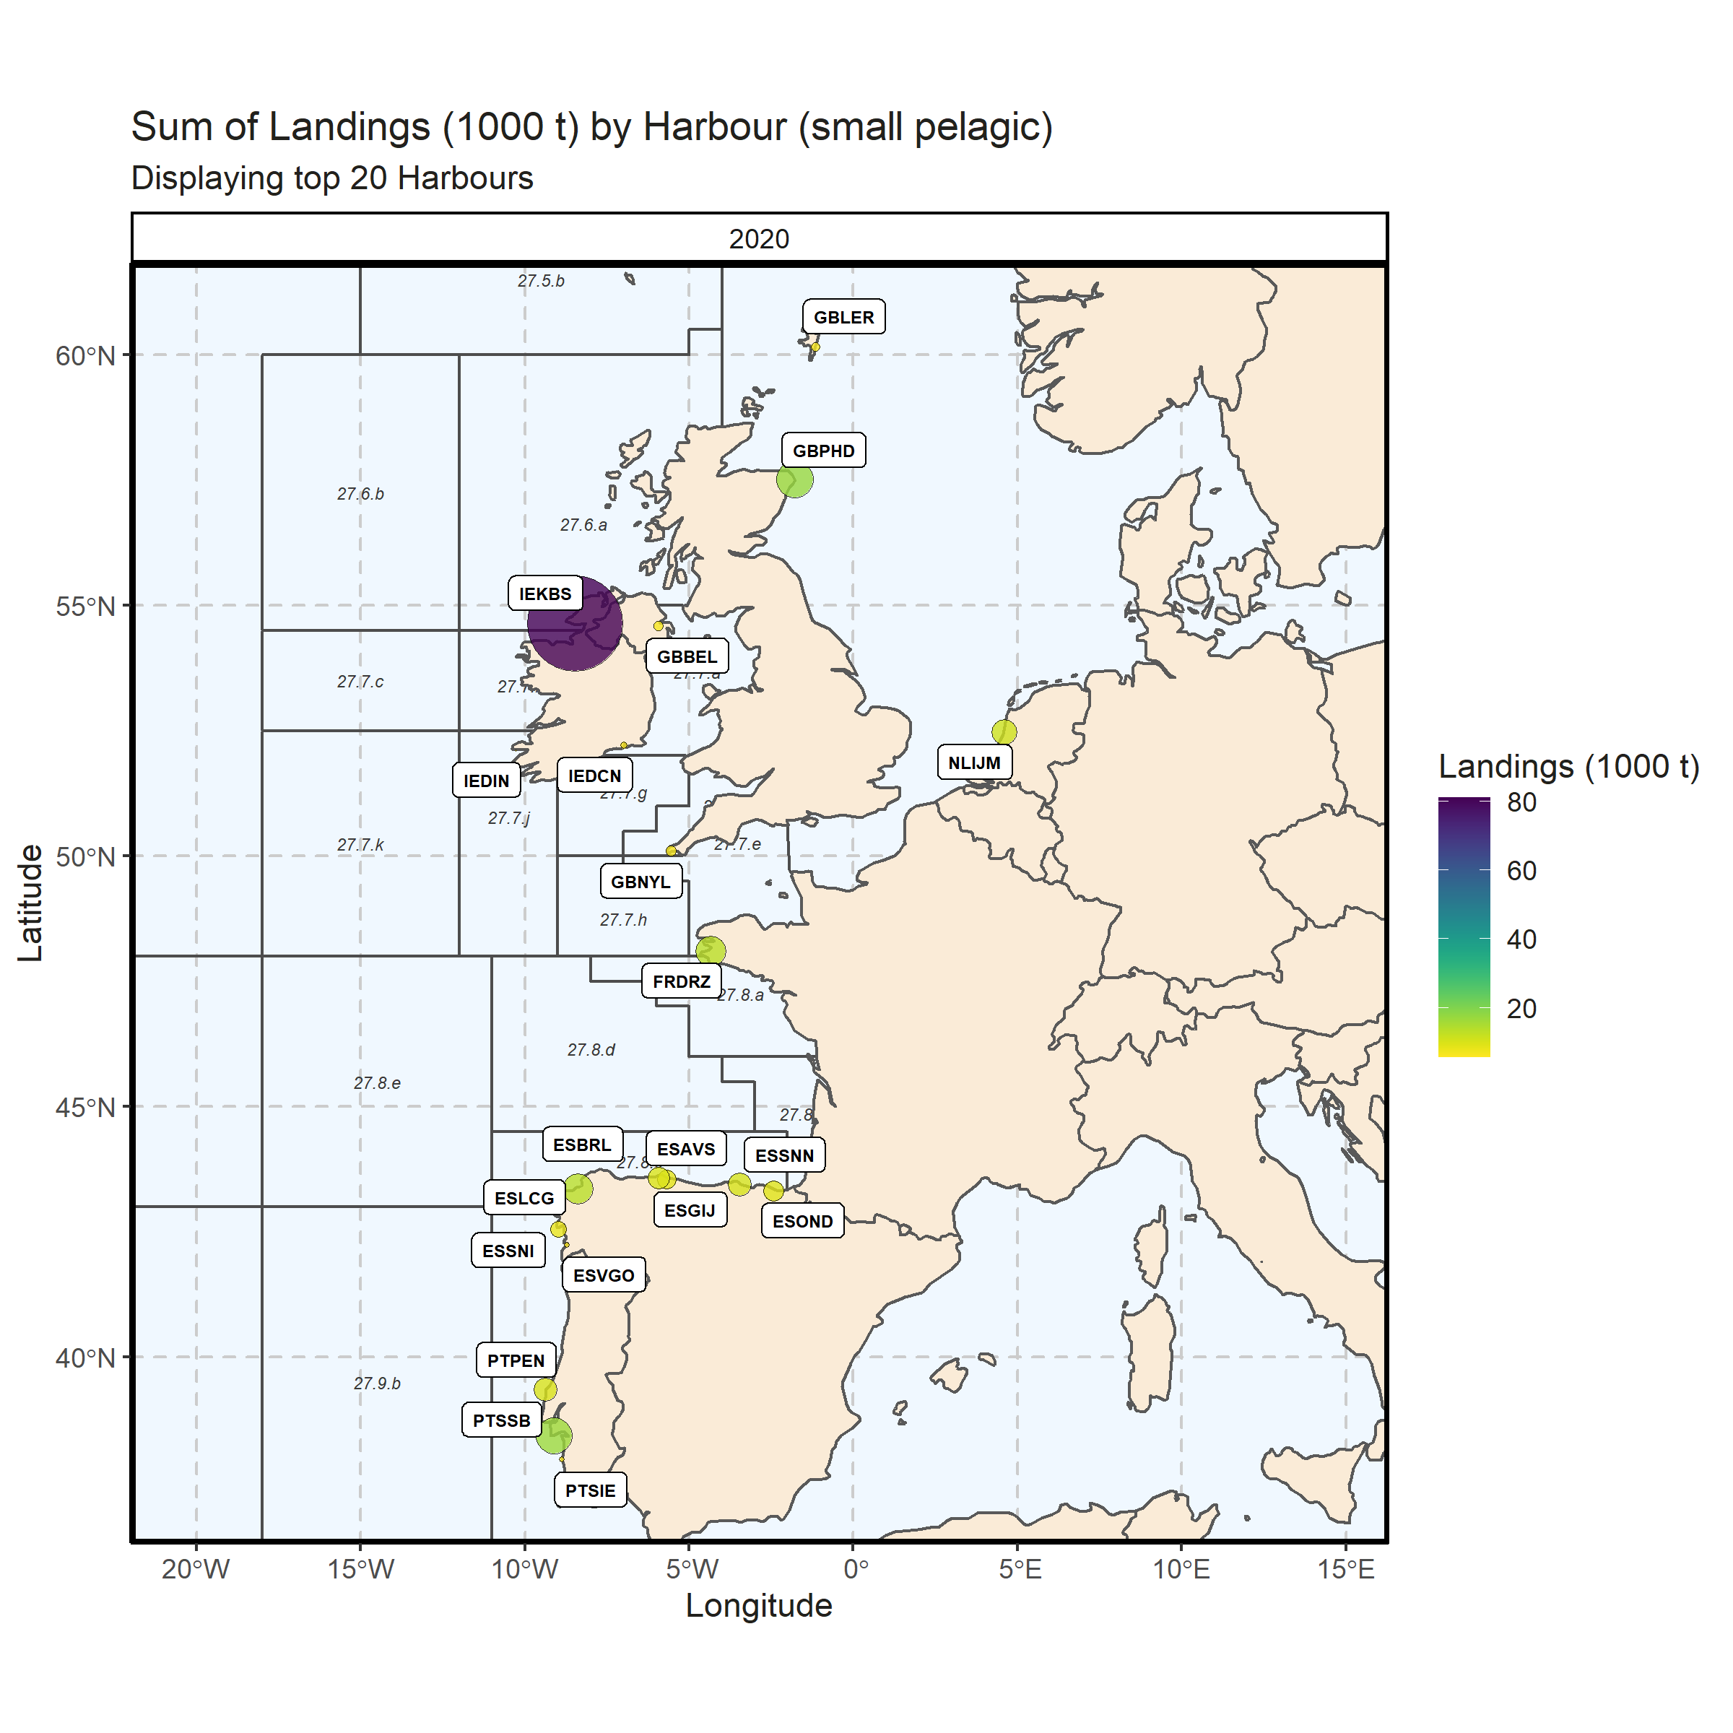 Figure 3.2.6.3. Sum of Landings (1000 t) by Harbour (small pelagic). Displaying top 20 Harbours. 0% of Landings (1000 t) - reported for missing Harbour

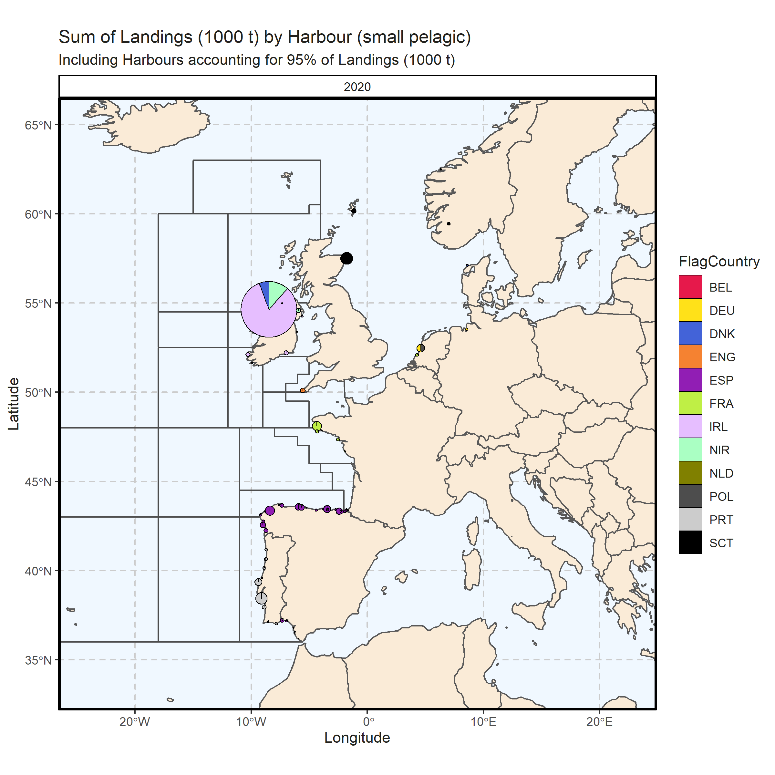 Figure 3.2.6.4. Sum of Landings (1000 t) by Harbour (small pelagic). Including Harbours accounting for 95% of Landings (1000 t). 0% of Landings (1000 t) - reported for missing Harbour. 10 Harbour with missing coordinates (5.26% of Landings (1000 t)) - not presented on the map.

### Landings abroad, small pelagic

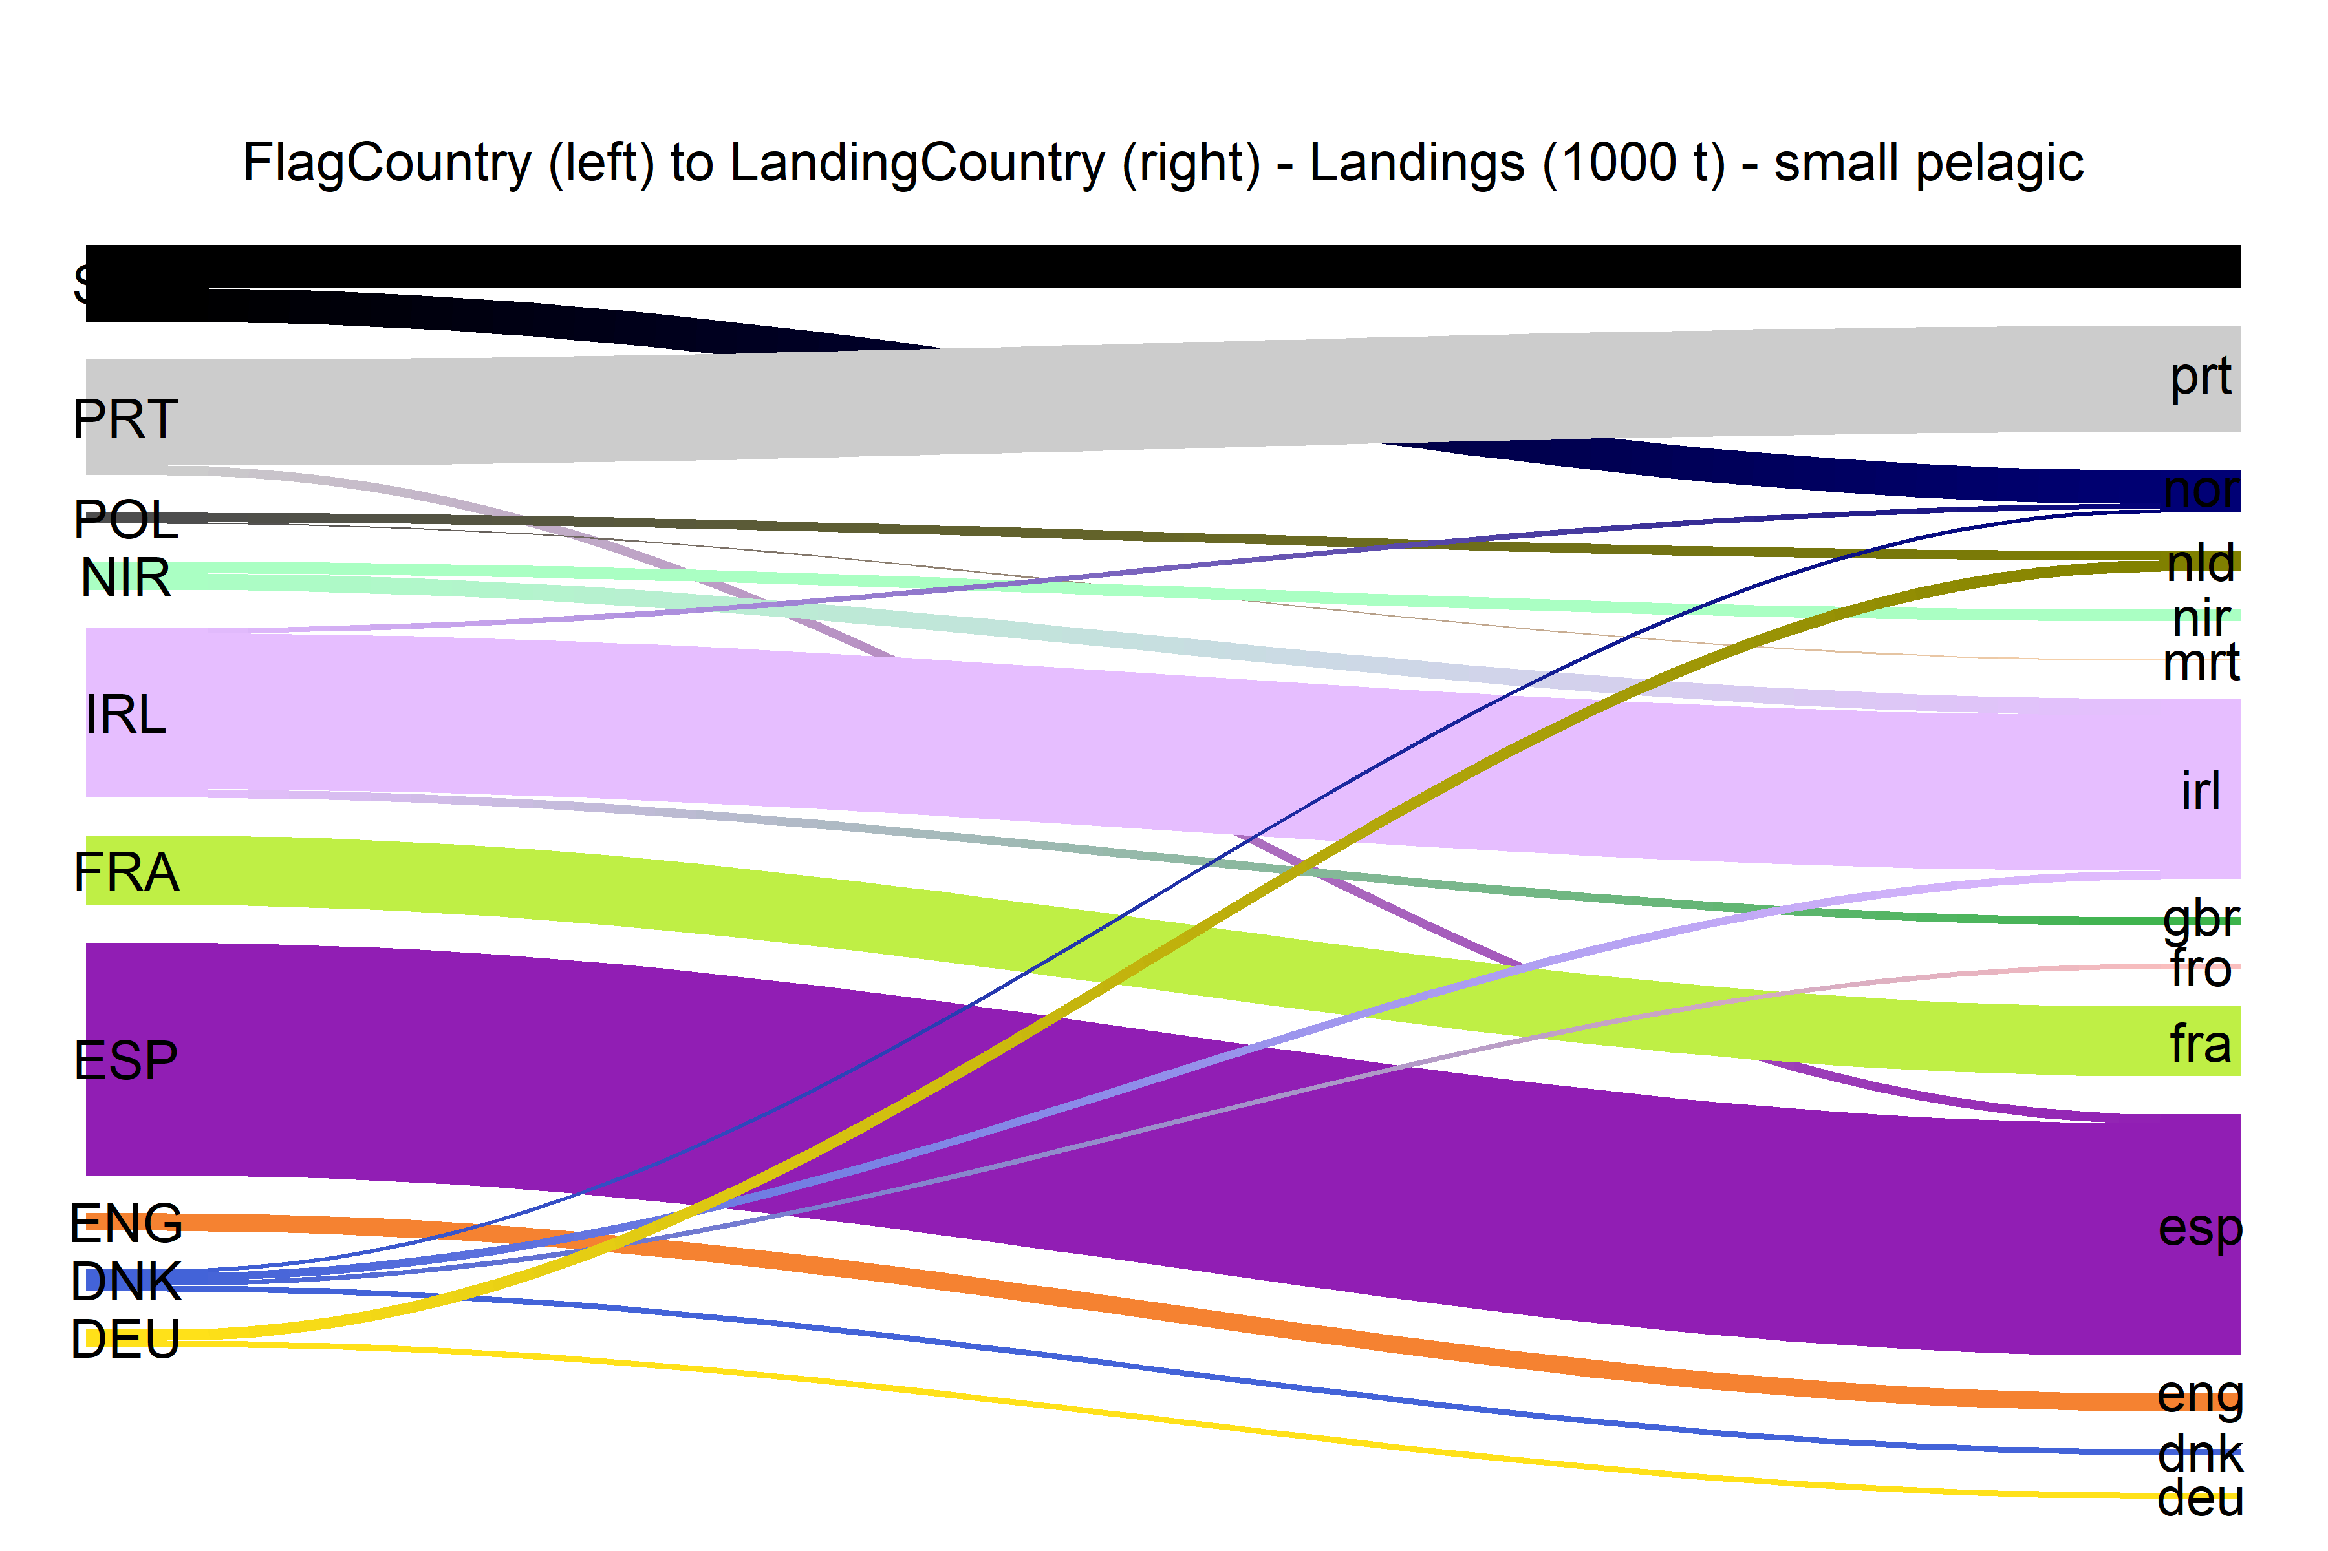  
Figure 3.2.7.1.River plot of Landings (1000 t) between Country (left) and Landing Country (right). Width of line is proportional to landings

### Spatial distribution of landings, small pelagic

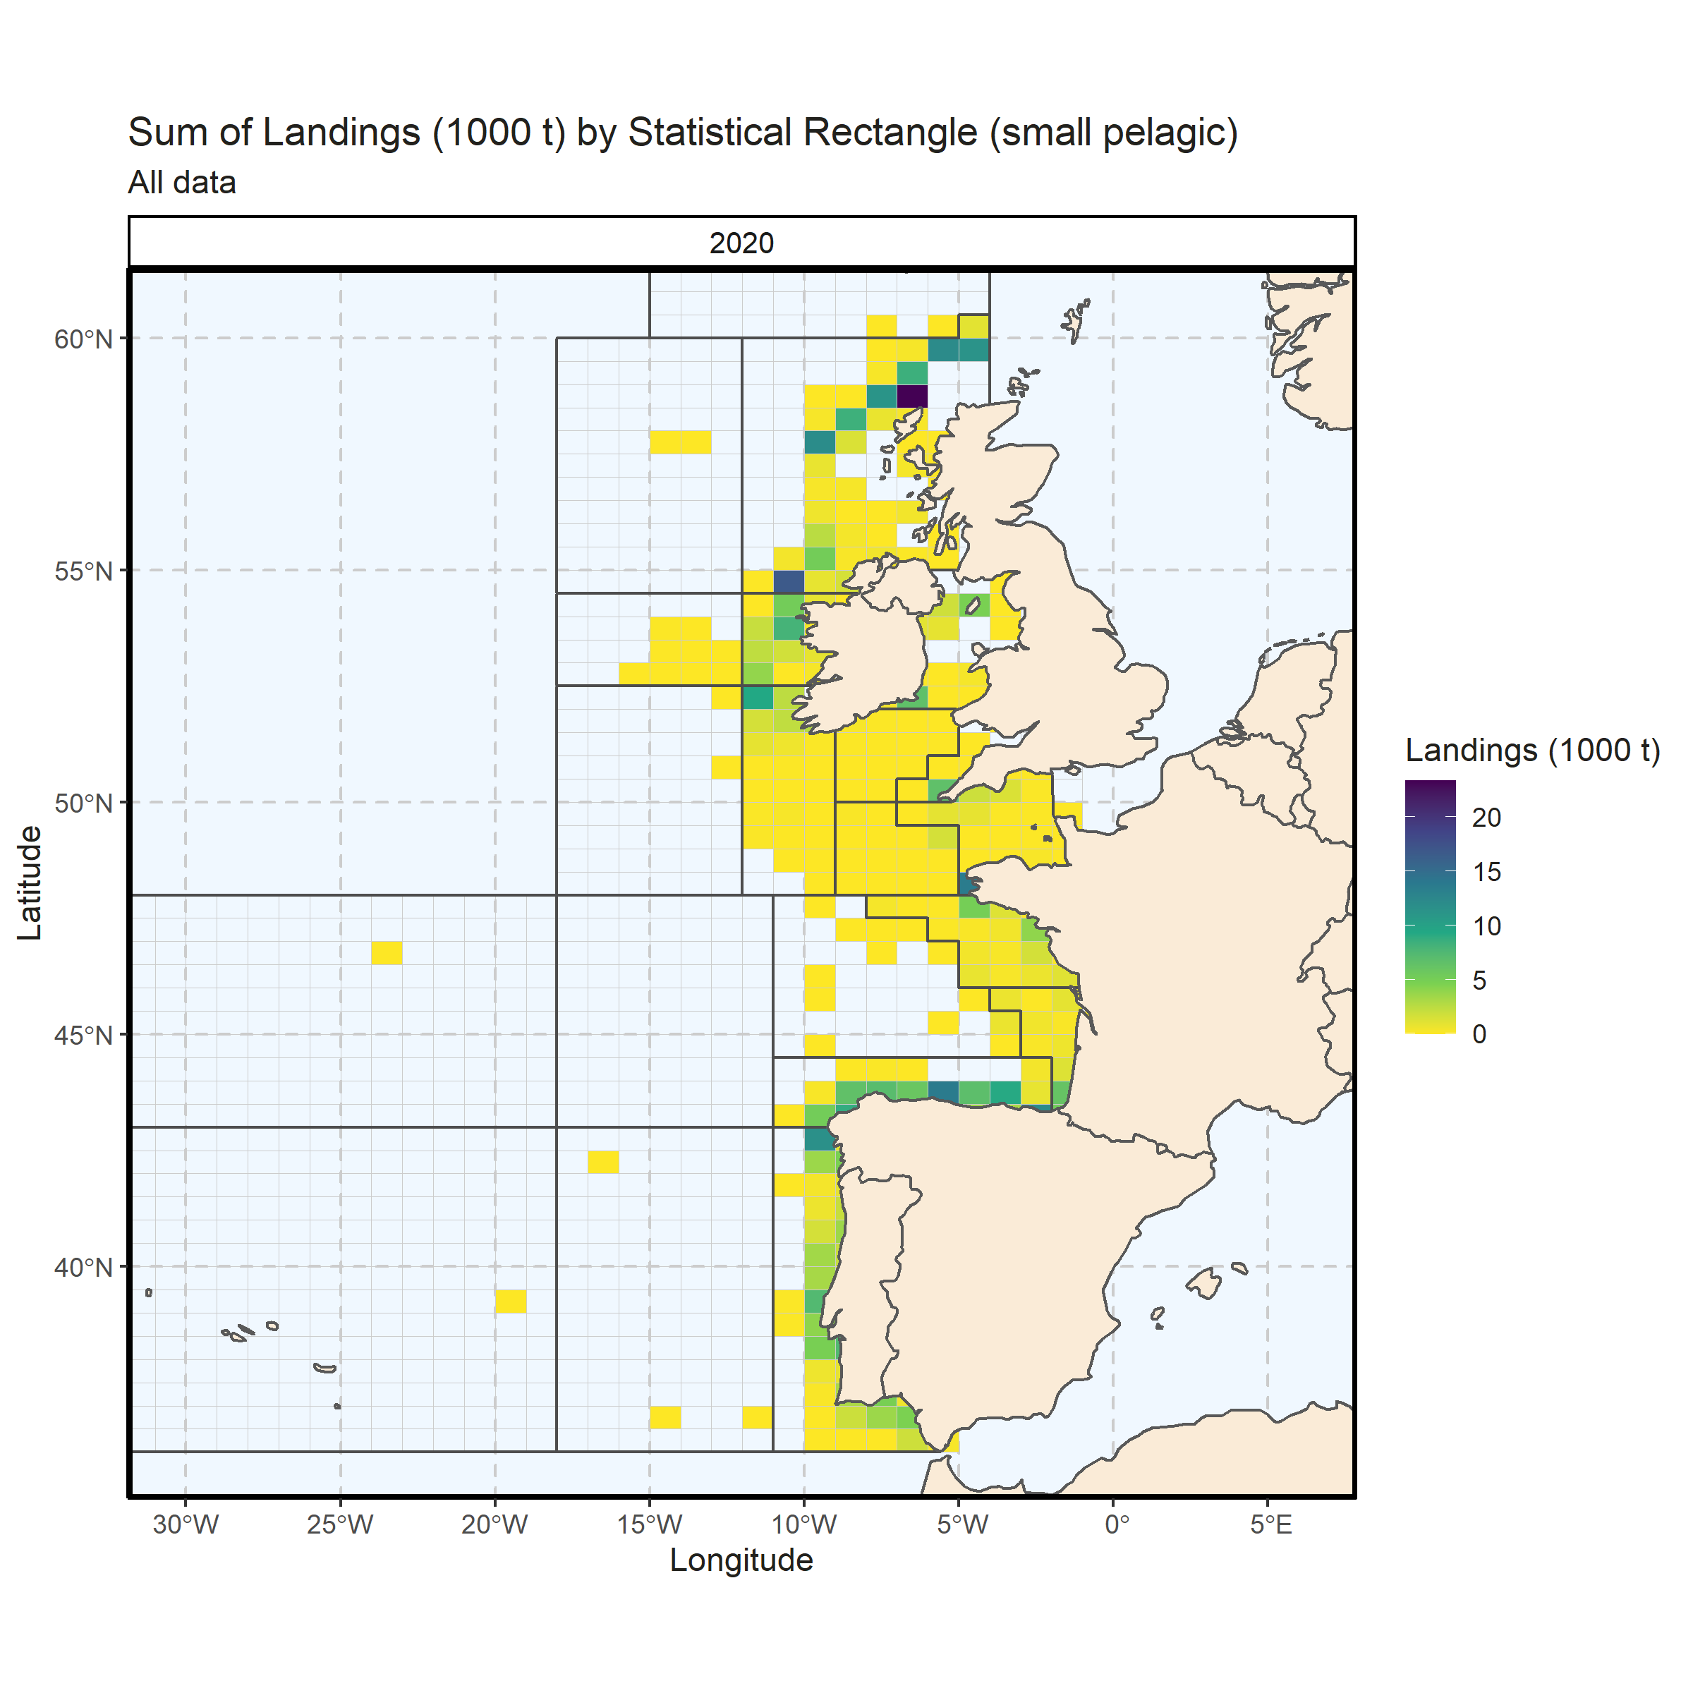 Figure 3.2.8.1. Sum of Landings (1000 t) by Statistical Rectangle (small pelagic). All data. 0.01% of Landings (1000 t) - reported for missing Statistical Rectangle. 2 Statistical Rectangle with missing coordinates (3.93% of Landings (1000 t)) - not presented on the map.

## Demersal landings (without flatfish)

### Landings by country, demersal (without flatfish)

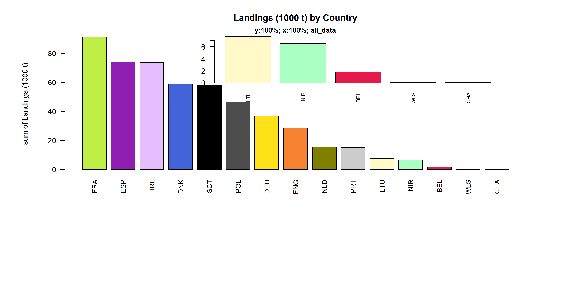 Figure 3.3.1.1. Landings (1000 t) of demersal by Country.

### Landings by species, demersal (without flatfish)

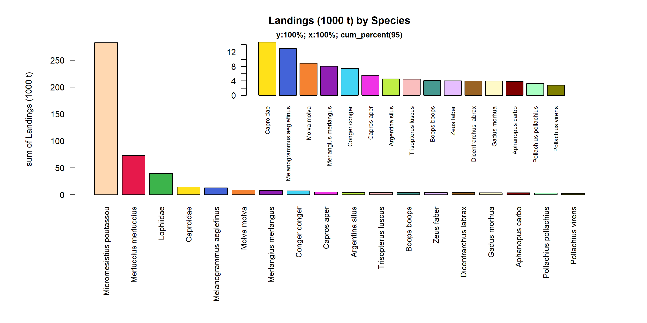 Figure 3.3.2.1. Landings (1000 t) of demersal by Species. Species displayed comprise 95% of the total Landings (1000 t).

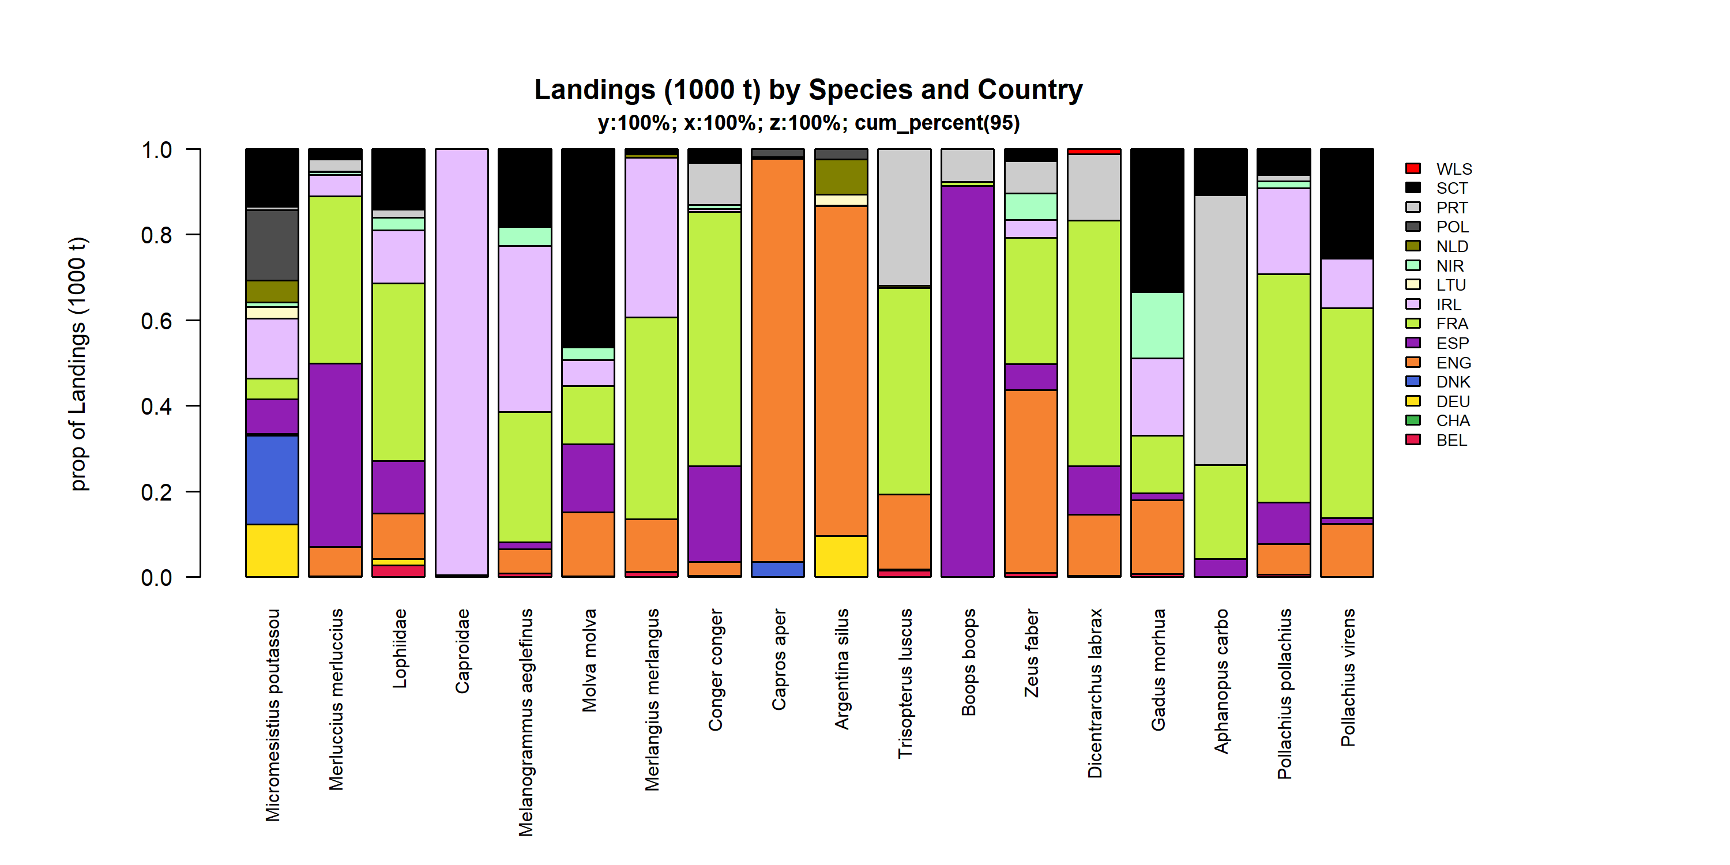 Figure 3.3.2.2. Landings (1000 t) of demersal by Species and Country . Species and Country displayed comprise 95 % of the total Landings (1000 t) .

### Landings by fleet, demersal (without flatfish)

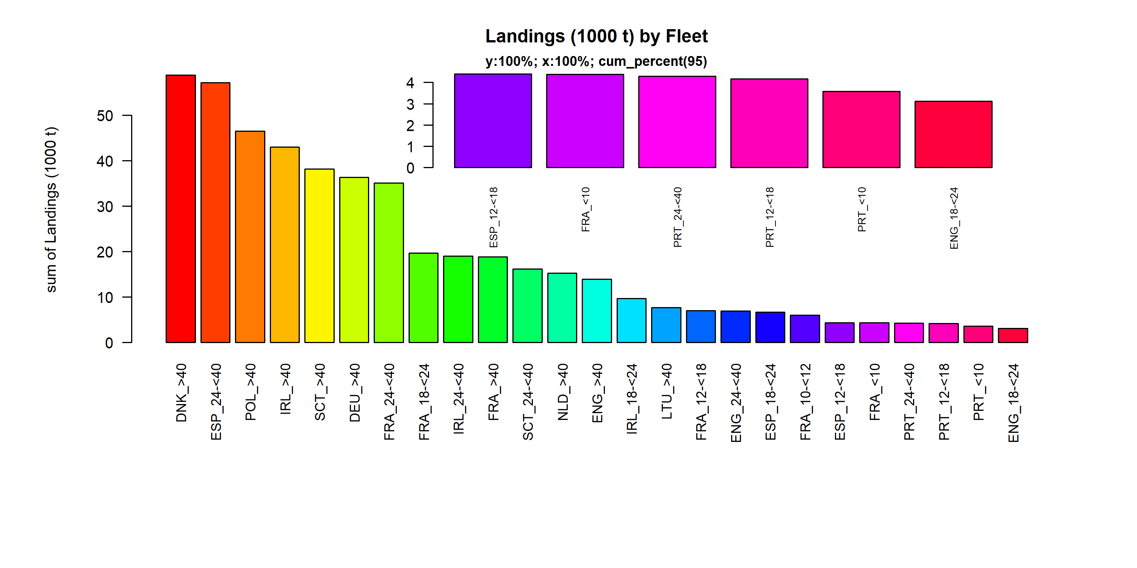 Figure 3.3.3.1. Landings (1000 t) of demersal by Fleet. Fleet displayed comprise 95% of the total Landings (1000 t).

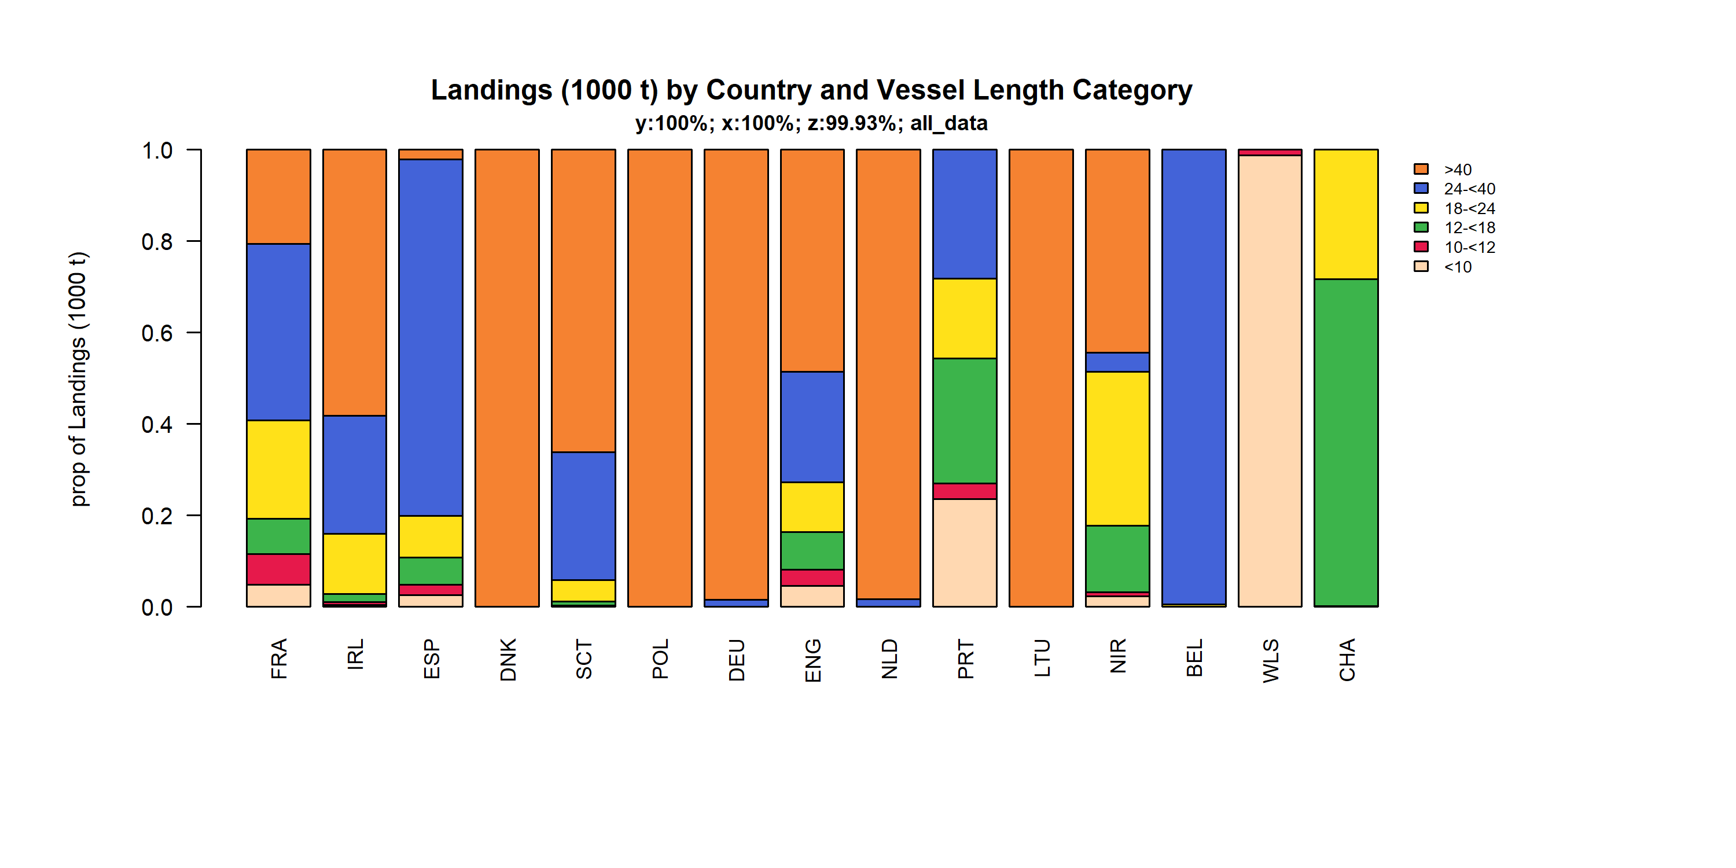 Figure 3.3.3.2. Landings (1000 t) of demersal by Country and Vessel Length Category. TheVessel Length Category was given for 99.93% of observations.

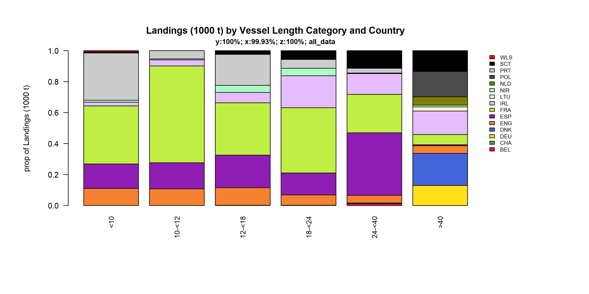 Figure 3.3.3.3. Landings (1000 t) of demersal by Vessel Length Category and Country. TheVessel Length Category was given for 99.93% of observations.

### Landings by area, demersal (without flatfish)

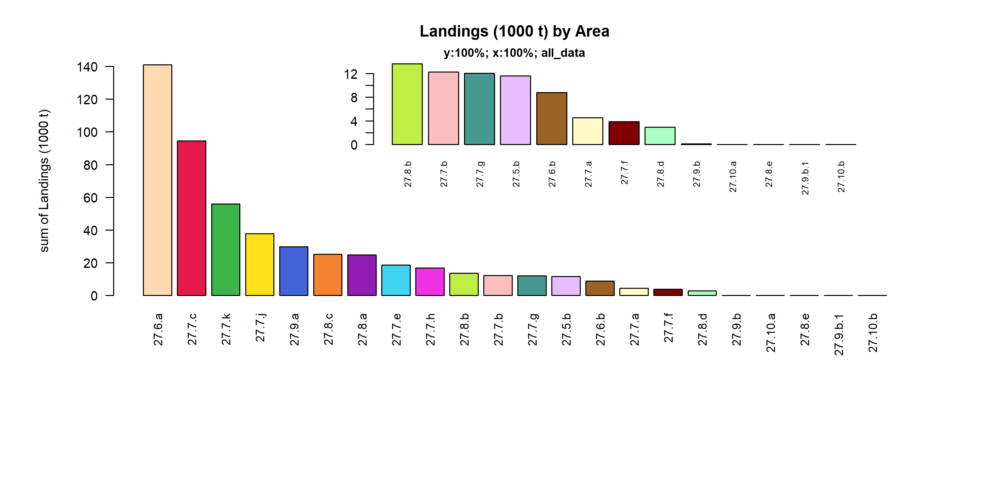 Figure 3.3.4.1. Landings (1000 t) of demersal by Area.

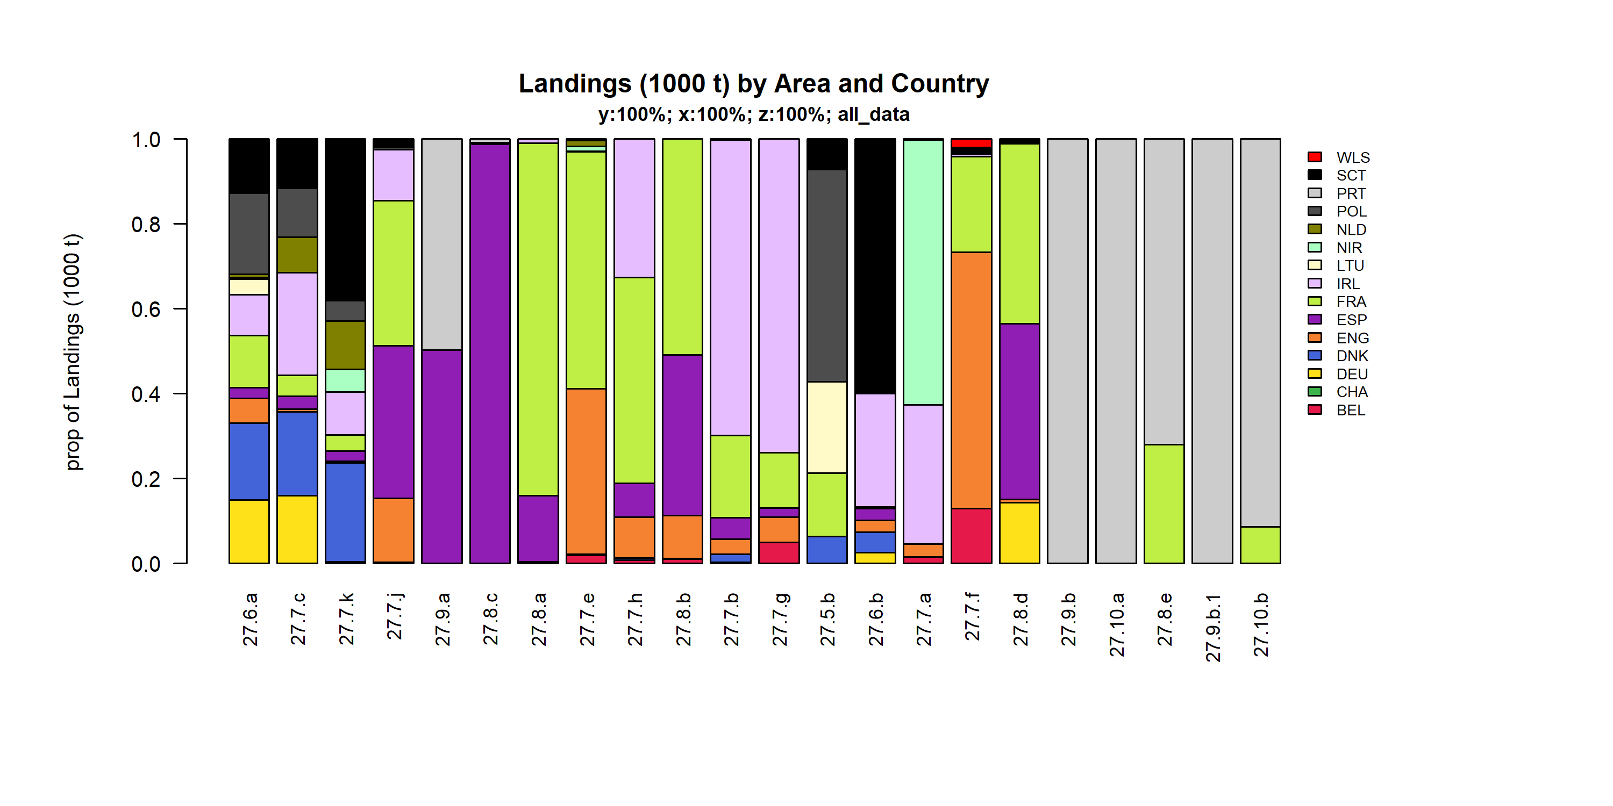 Figure 3.3.4.2. Landings (1000 t) of demersal by Area and Country.

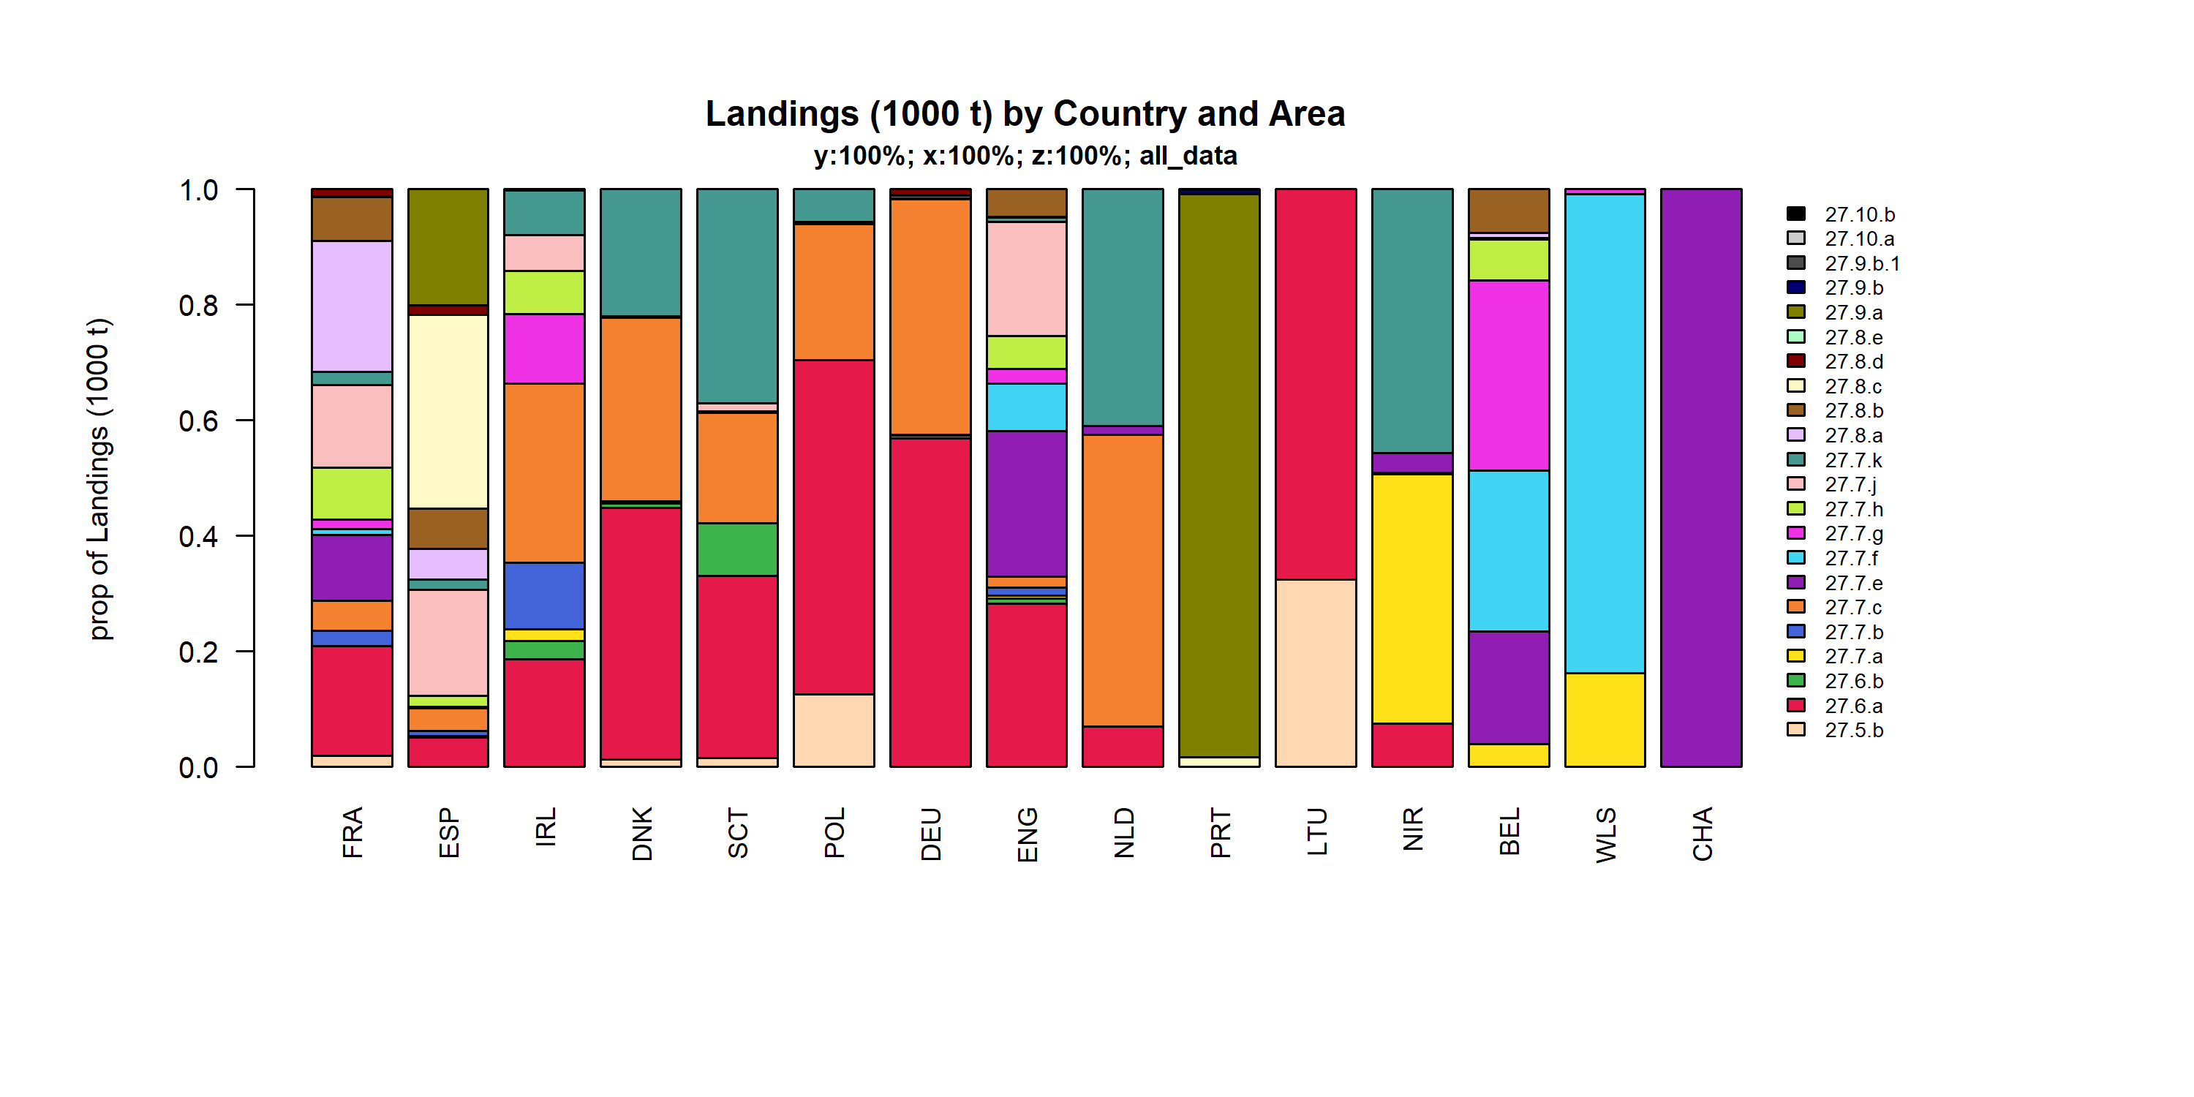 Figure 3.3.4.3. Landings (1000 t) of demersal by Country and Area.

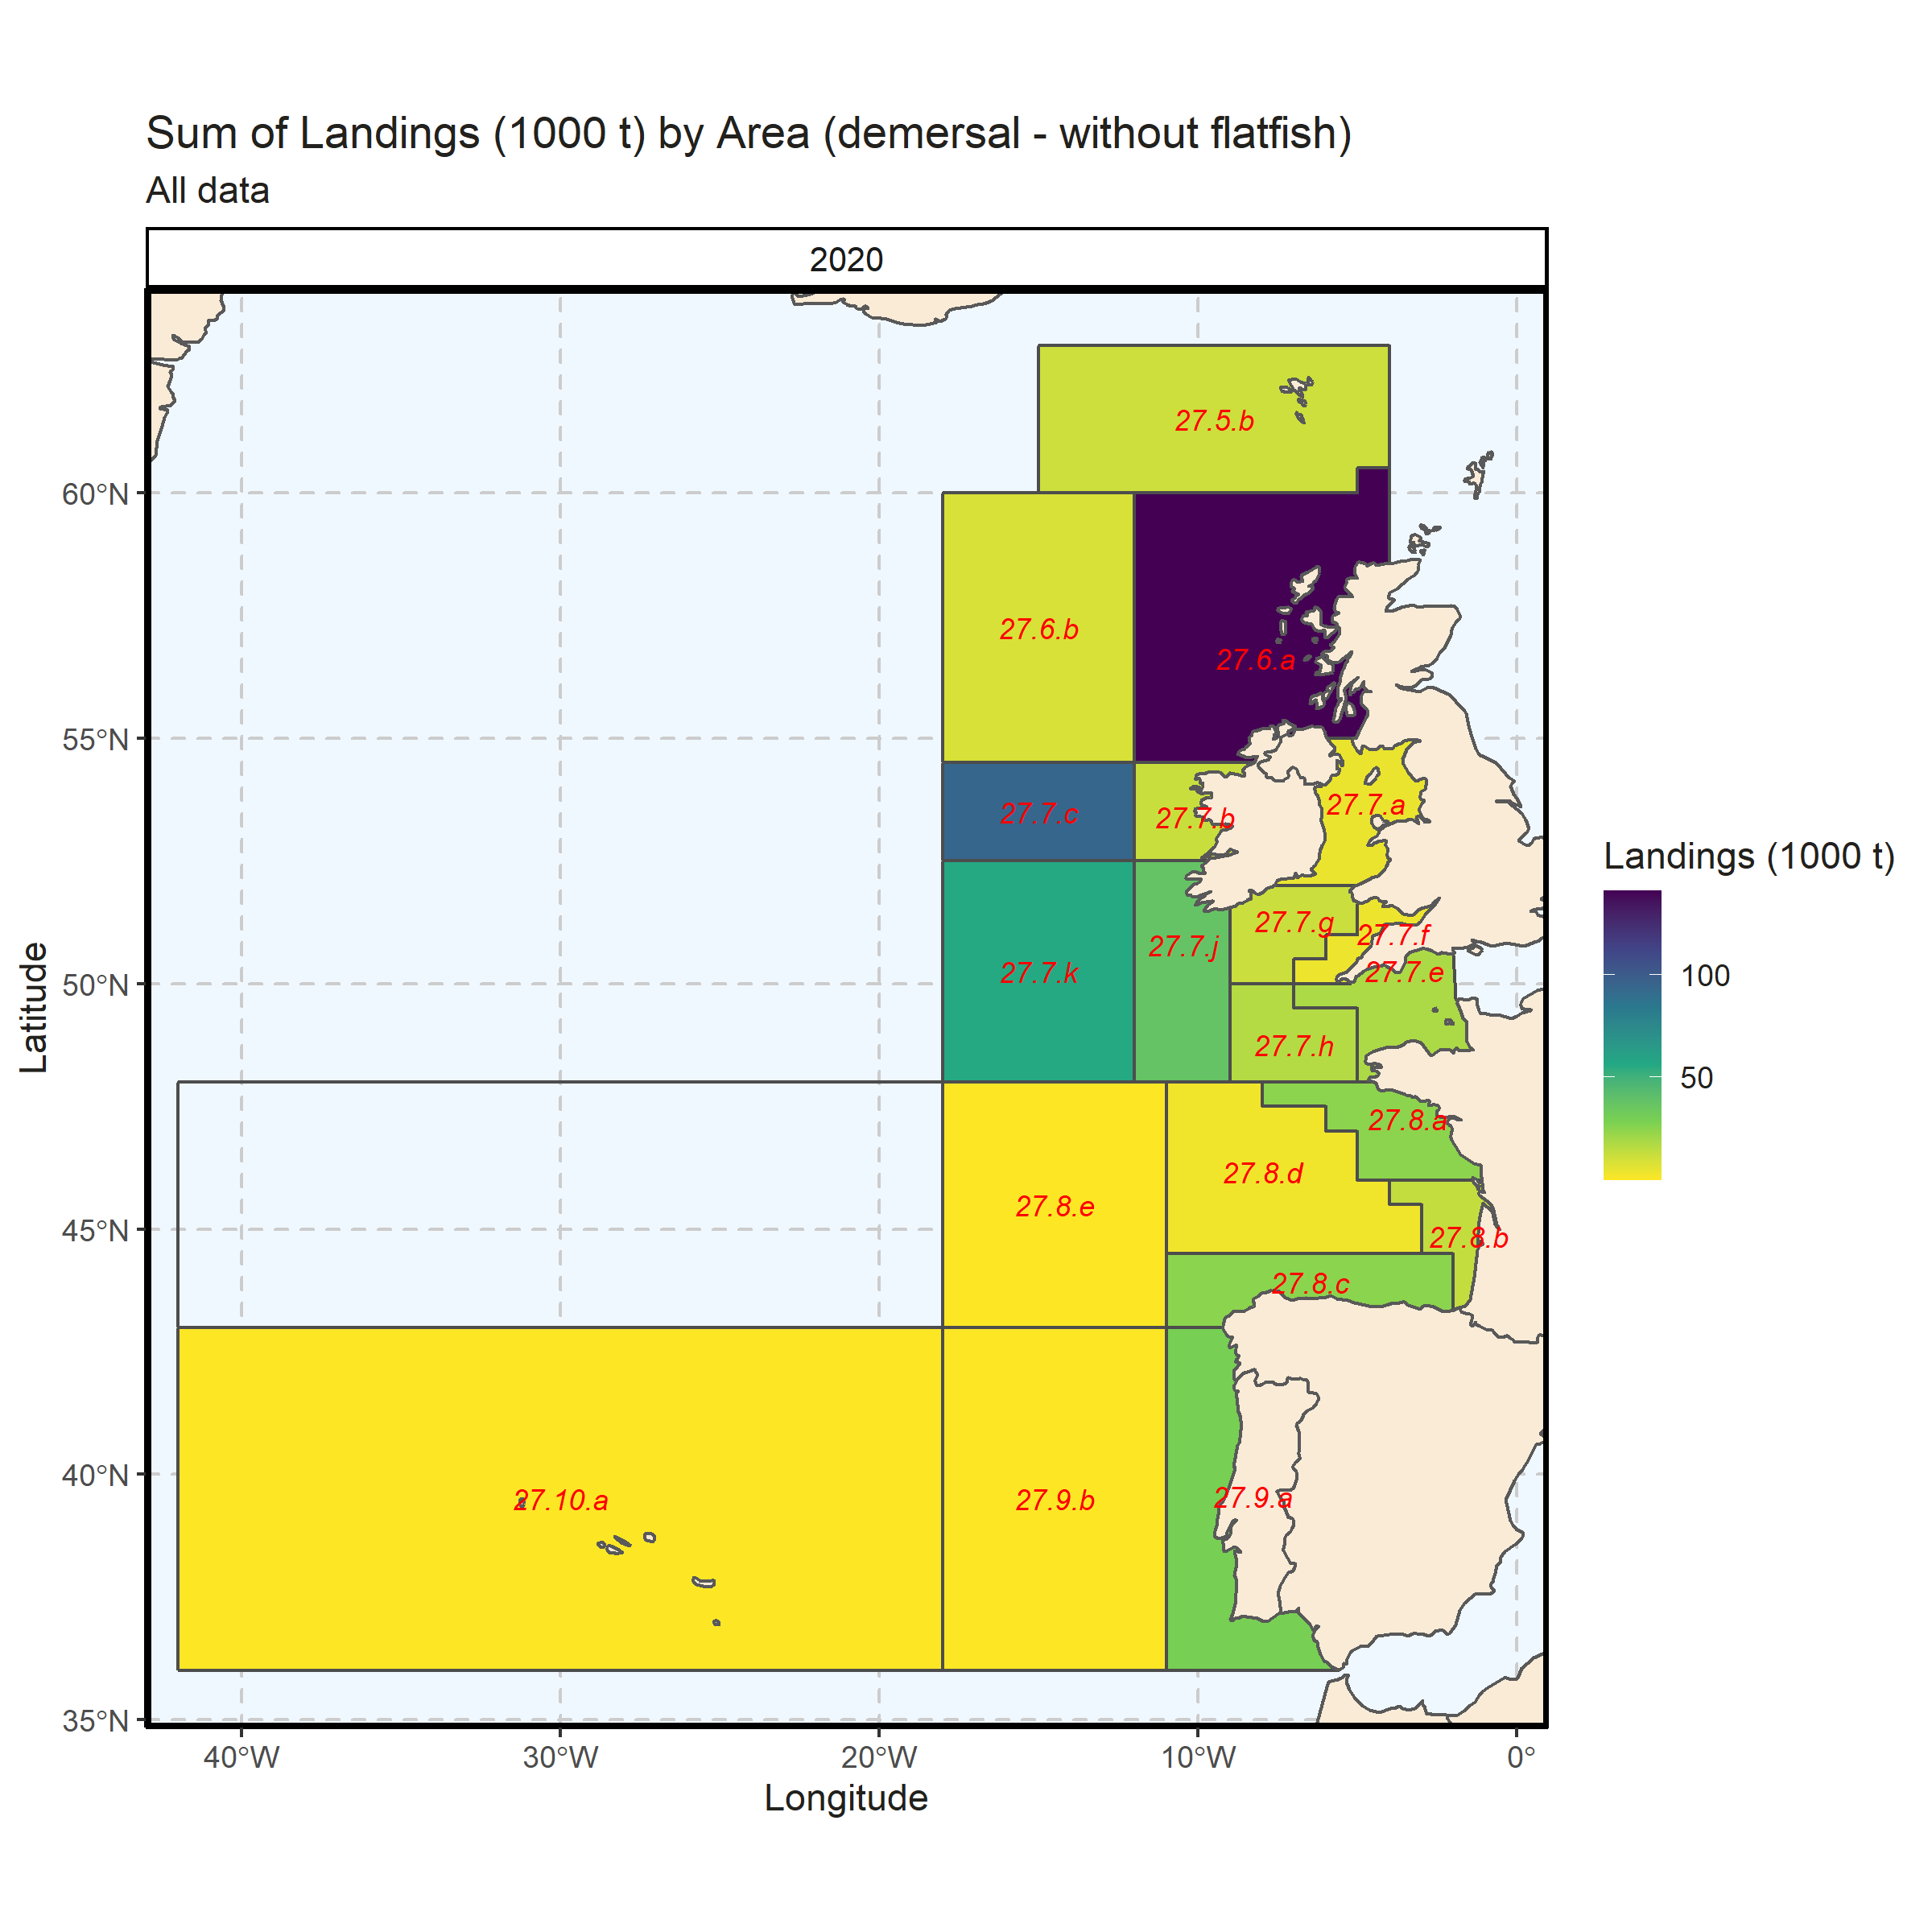 Figure 3.3.4.4. Sum of Landings (1000 t) by Area (demersal - without flatfish). All data. 0% of Landings (1000 t) - reported for missing Area.

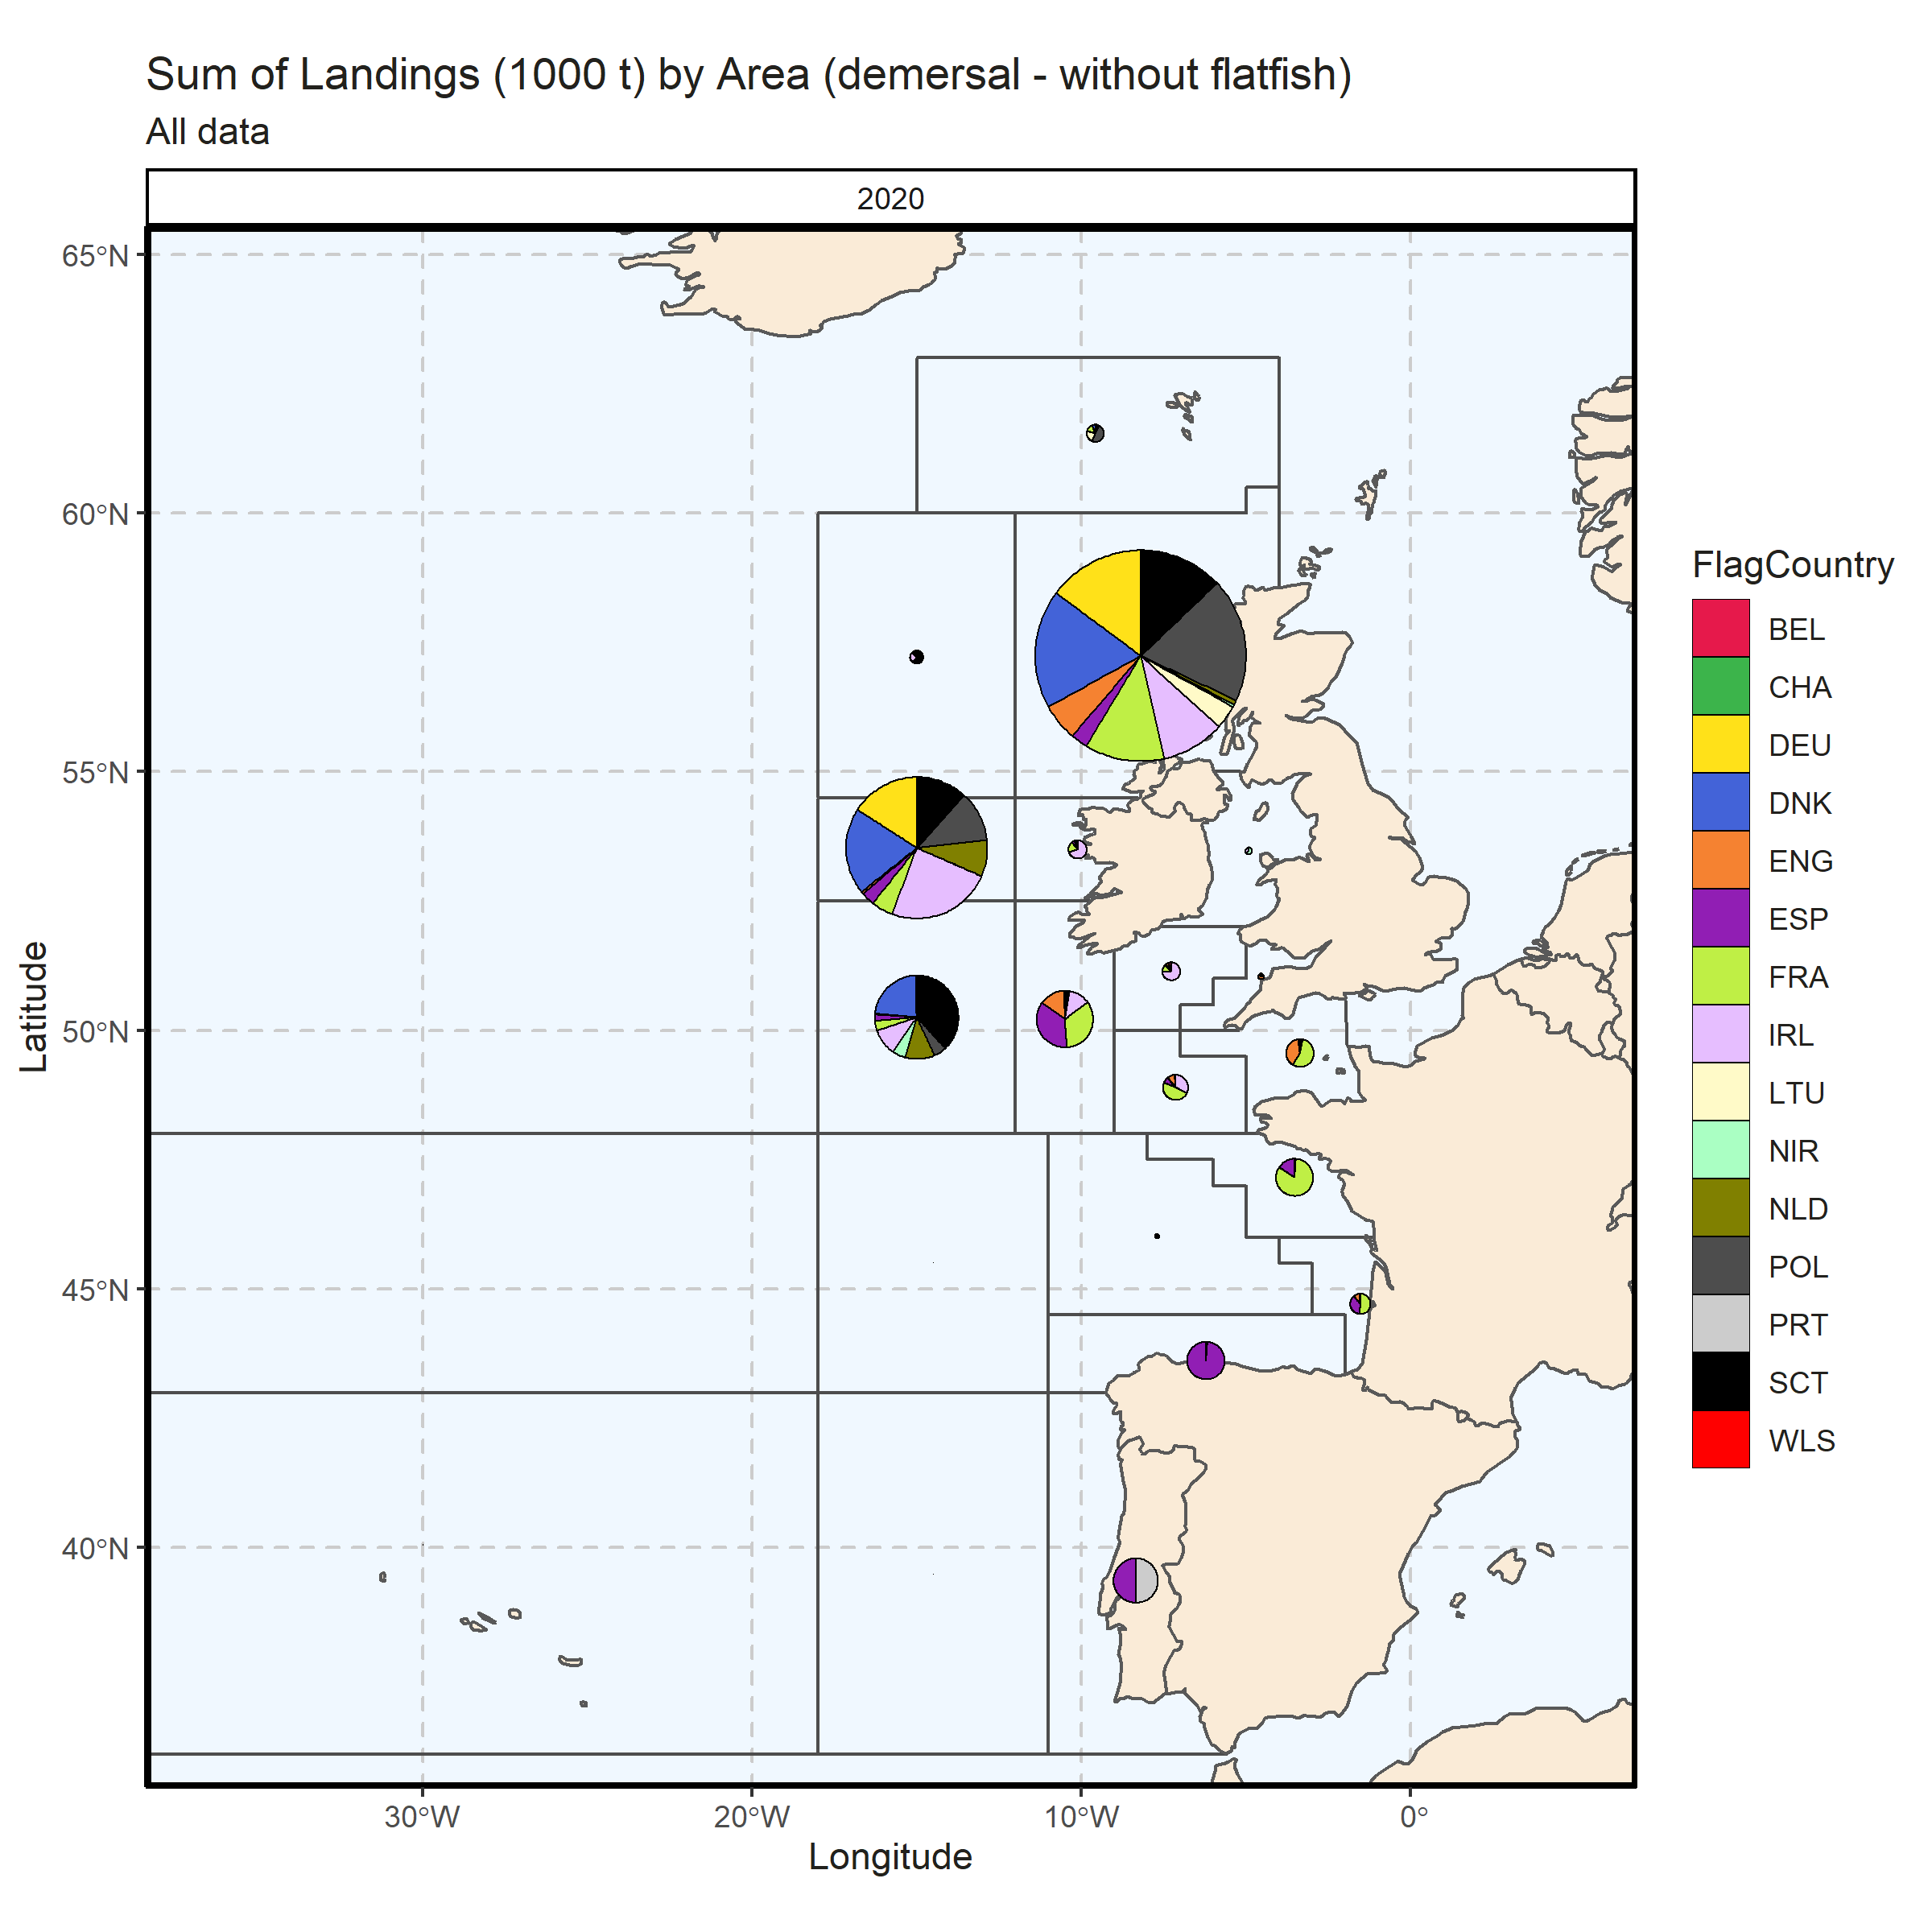 Figure 3.3.4.5. Sum of Landings (1000 t) by Area (demersal - without flatfish). All data. 0% of Landings (1000 t) - reported for missing Area.

### Landings by metier, demersal (without flatfish)

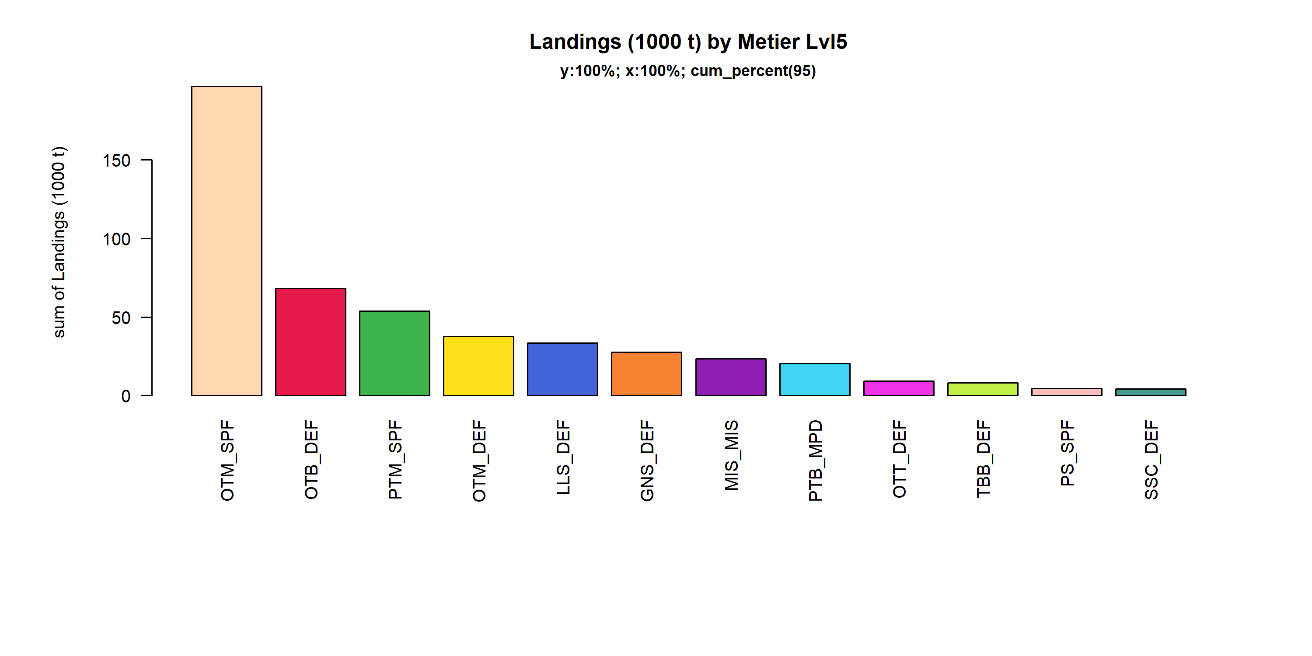 Figure 3.3.5.1. Landings (1000 t) of demersal by Metier Lvl5. Metier Lvl5 displayed comprise 95% of the total Landings (1000 t).

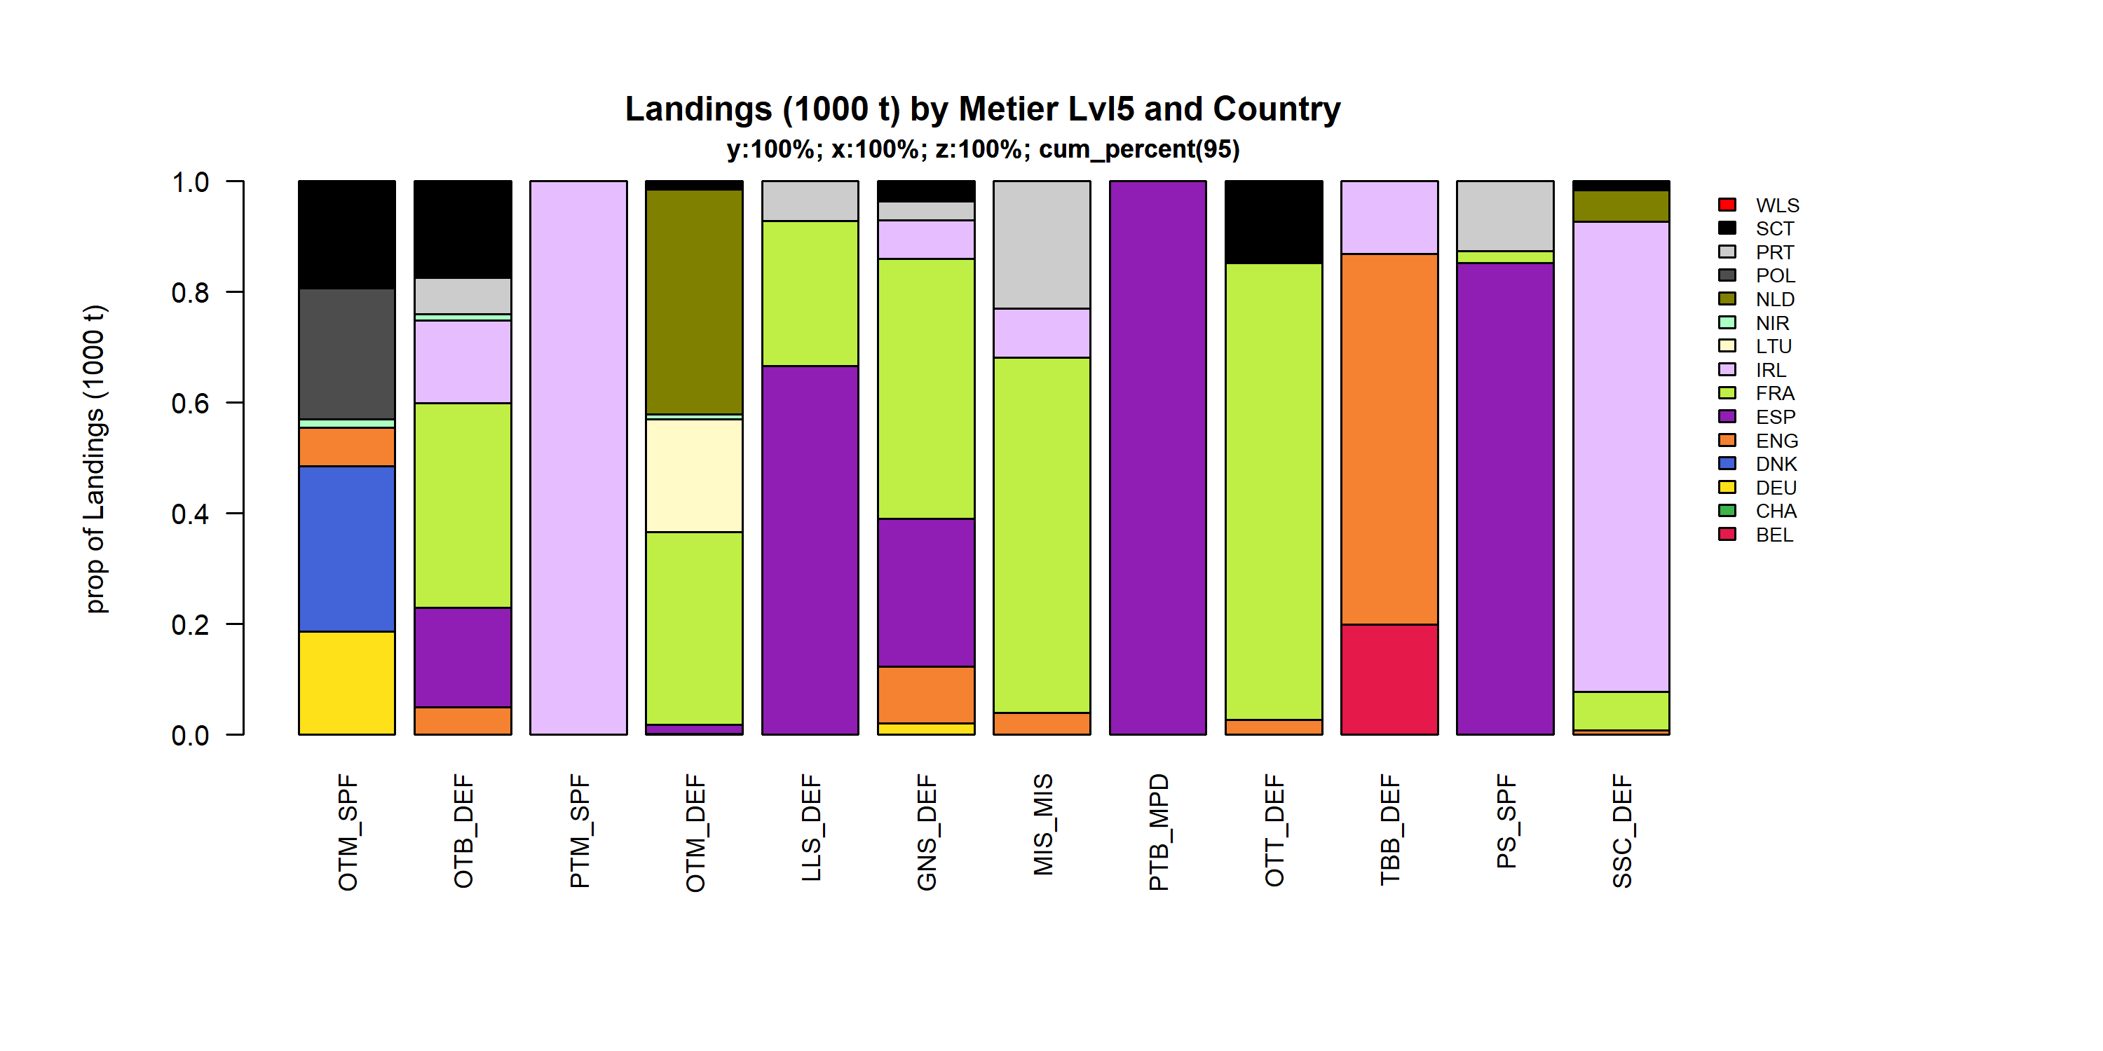 Figure 3.3.5.2. Landings (1000 t) of demersal by Metier Lvl5 and Country . Metier Lvl5 and Country displayed comprise 95 % of the total Landings (1000 t) .

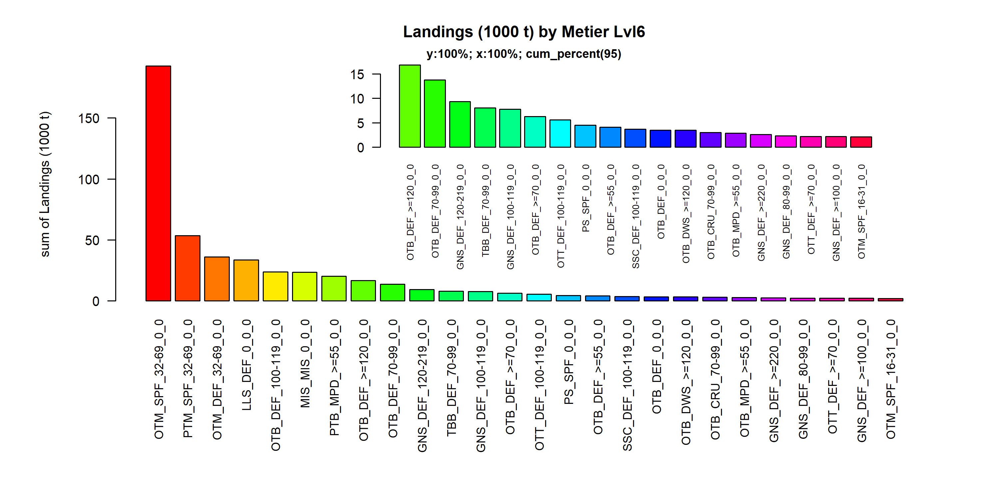 Figure 3.3.5.3. Landings (1000 t) of demersal by Metier Lvl6. Metier Lvl6 displayed comprise 95% of the total Landings (1000 t).

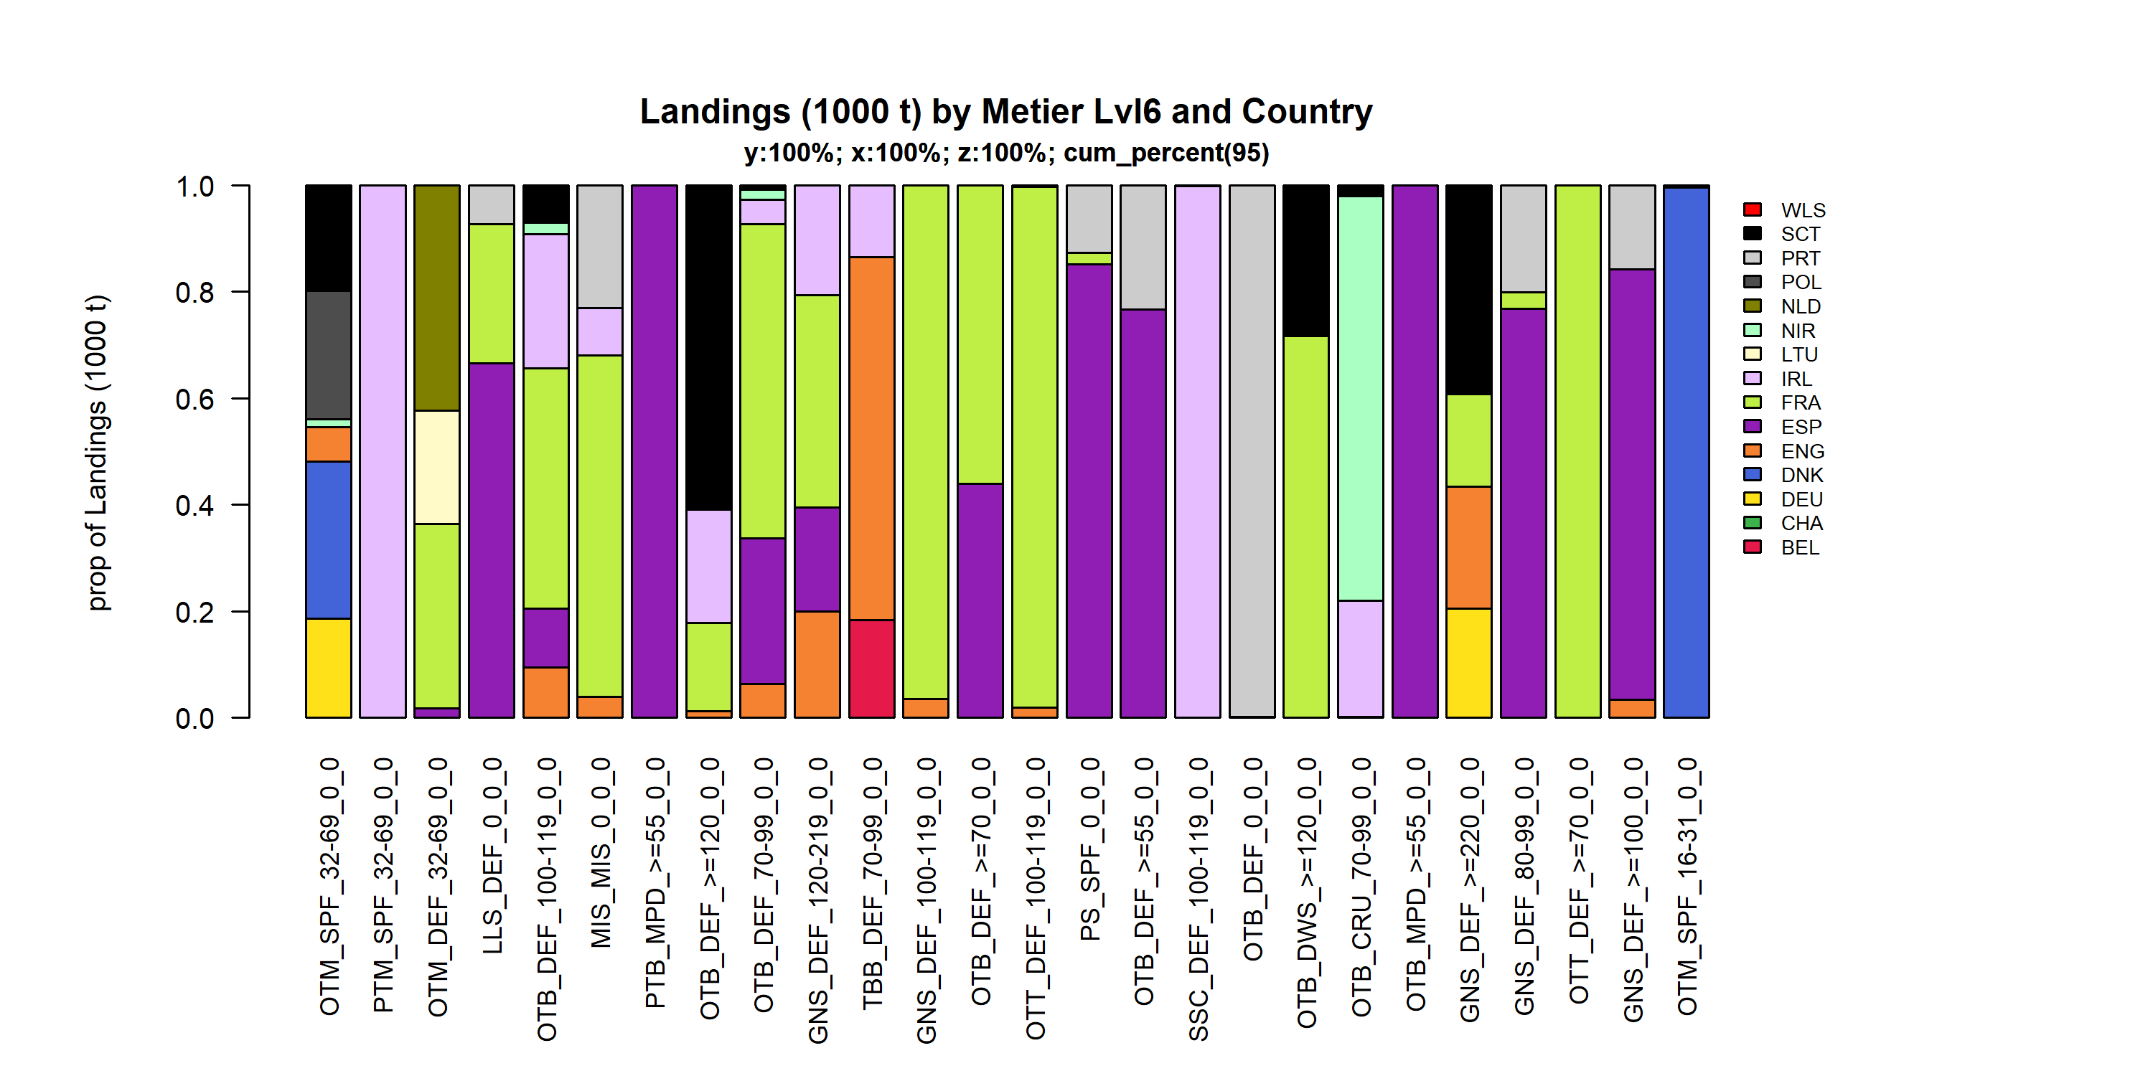 Figure 3.3.5.4. Landings (1000 t) of demersal by Metier Lvl6 and Country . Metier Lvl6 and Country displayed comprise 95 % of the total Landings (1000 t) .

### Landings by harbour, demersal (without flatfish)

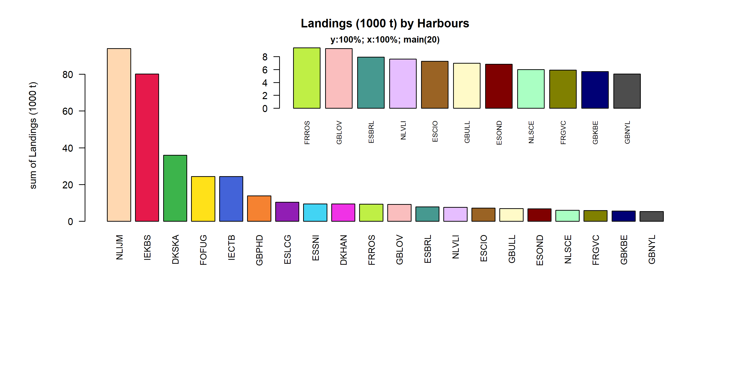 Figure 3.3.6.1. Landings (1000 t) of demersal in the 20 main Harbours (100% of rows entering analysis had known Harbours).

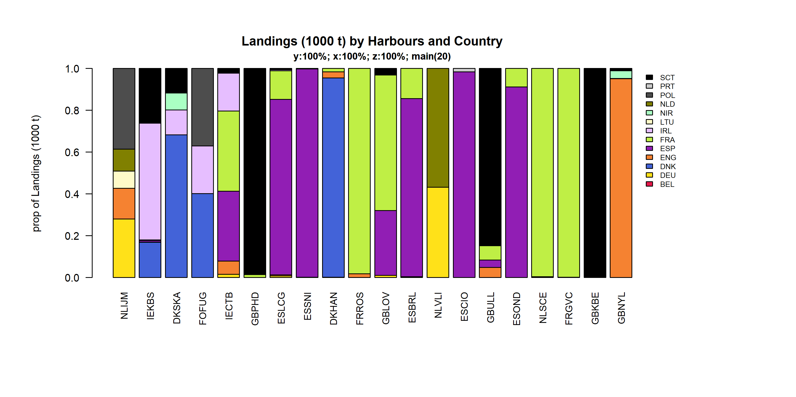 Figure 3.3.6.2. Landings (1000 t) of demersal by 20 main Harbours and Country .

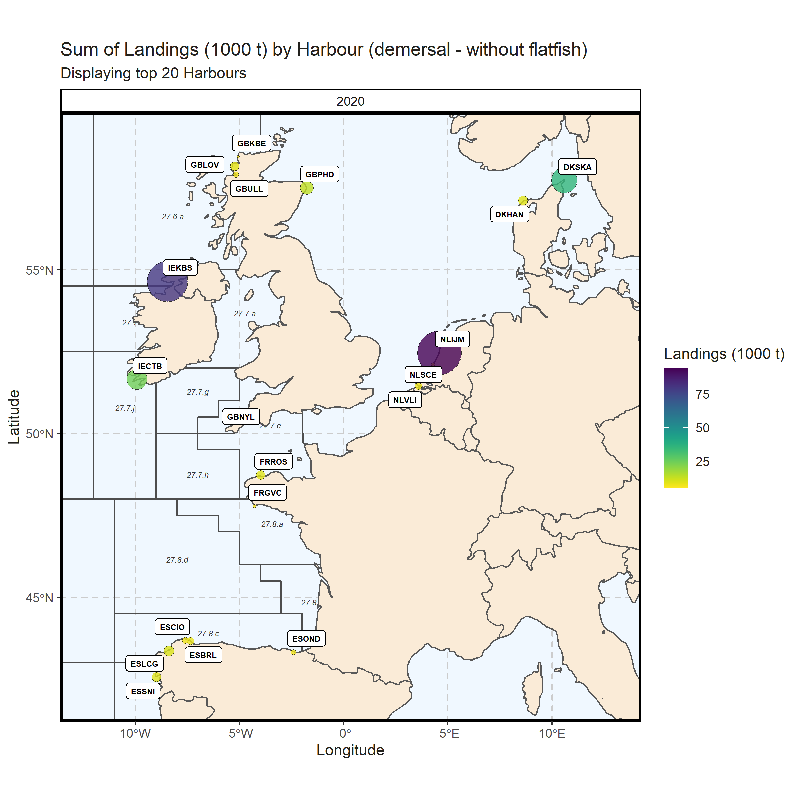 Figure 3.3.6.3. Sum of Landings (1000 t) by Harbour (demersal - without flatfish). Displaying top 20 Harbours. 0% of Landings (1000 t) - reported for missing Harbour 1 Harbour with missing coordinates (4.74% of Landings (1000 t)) - not presented on the map.

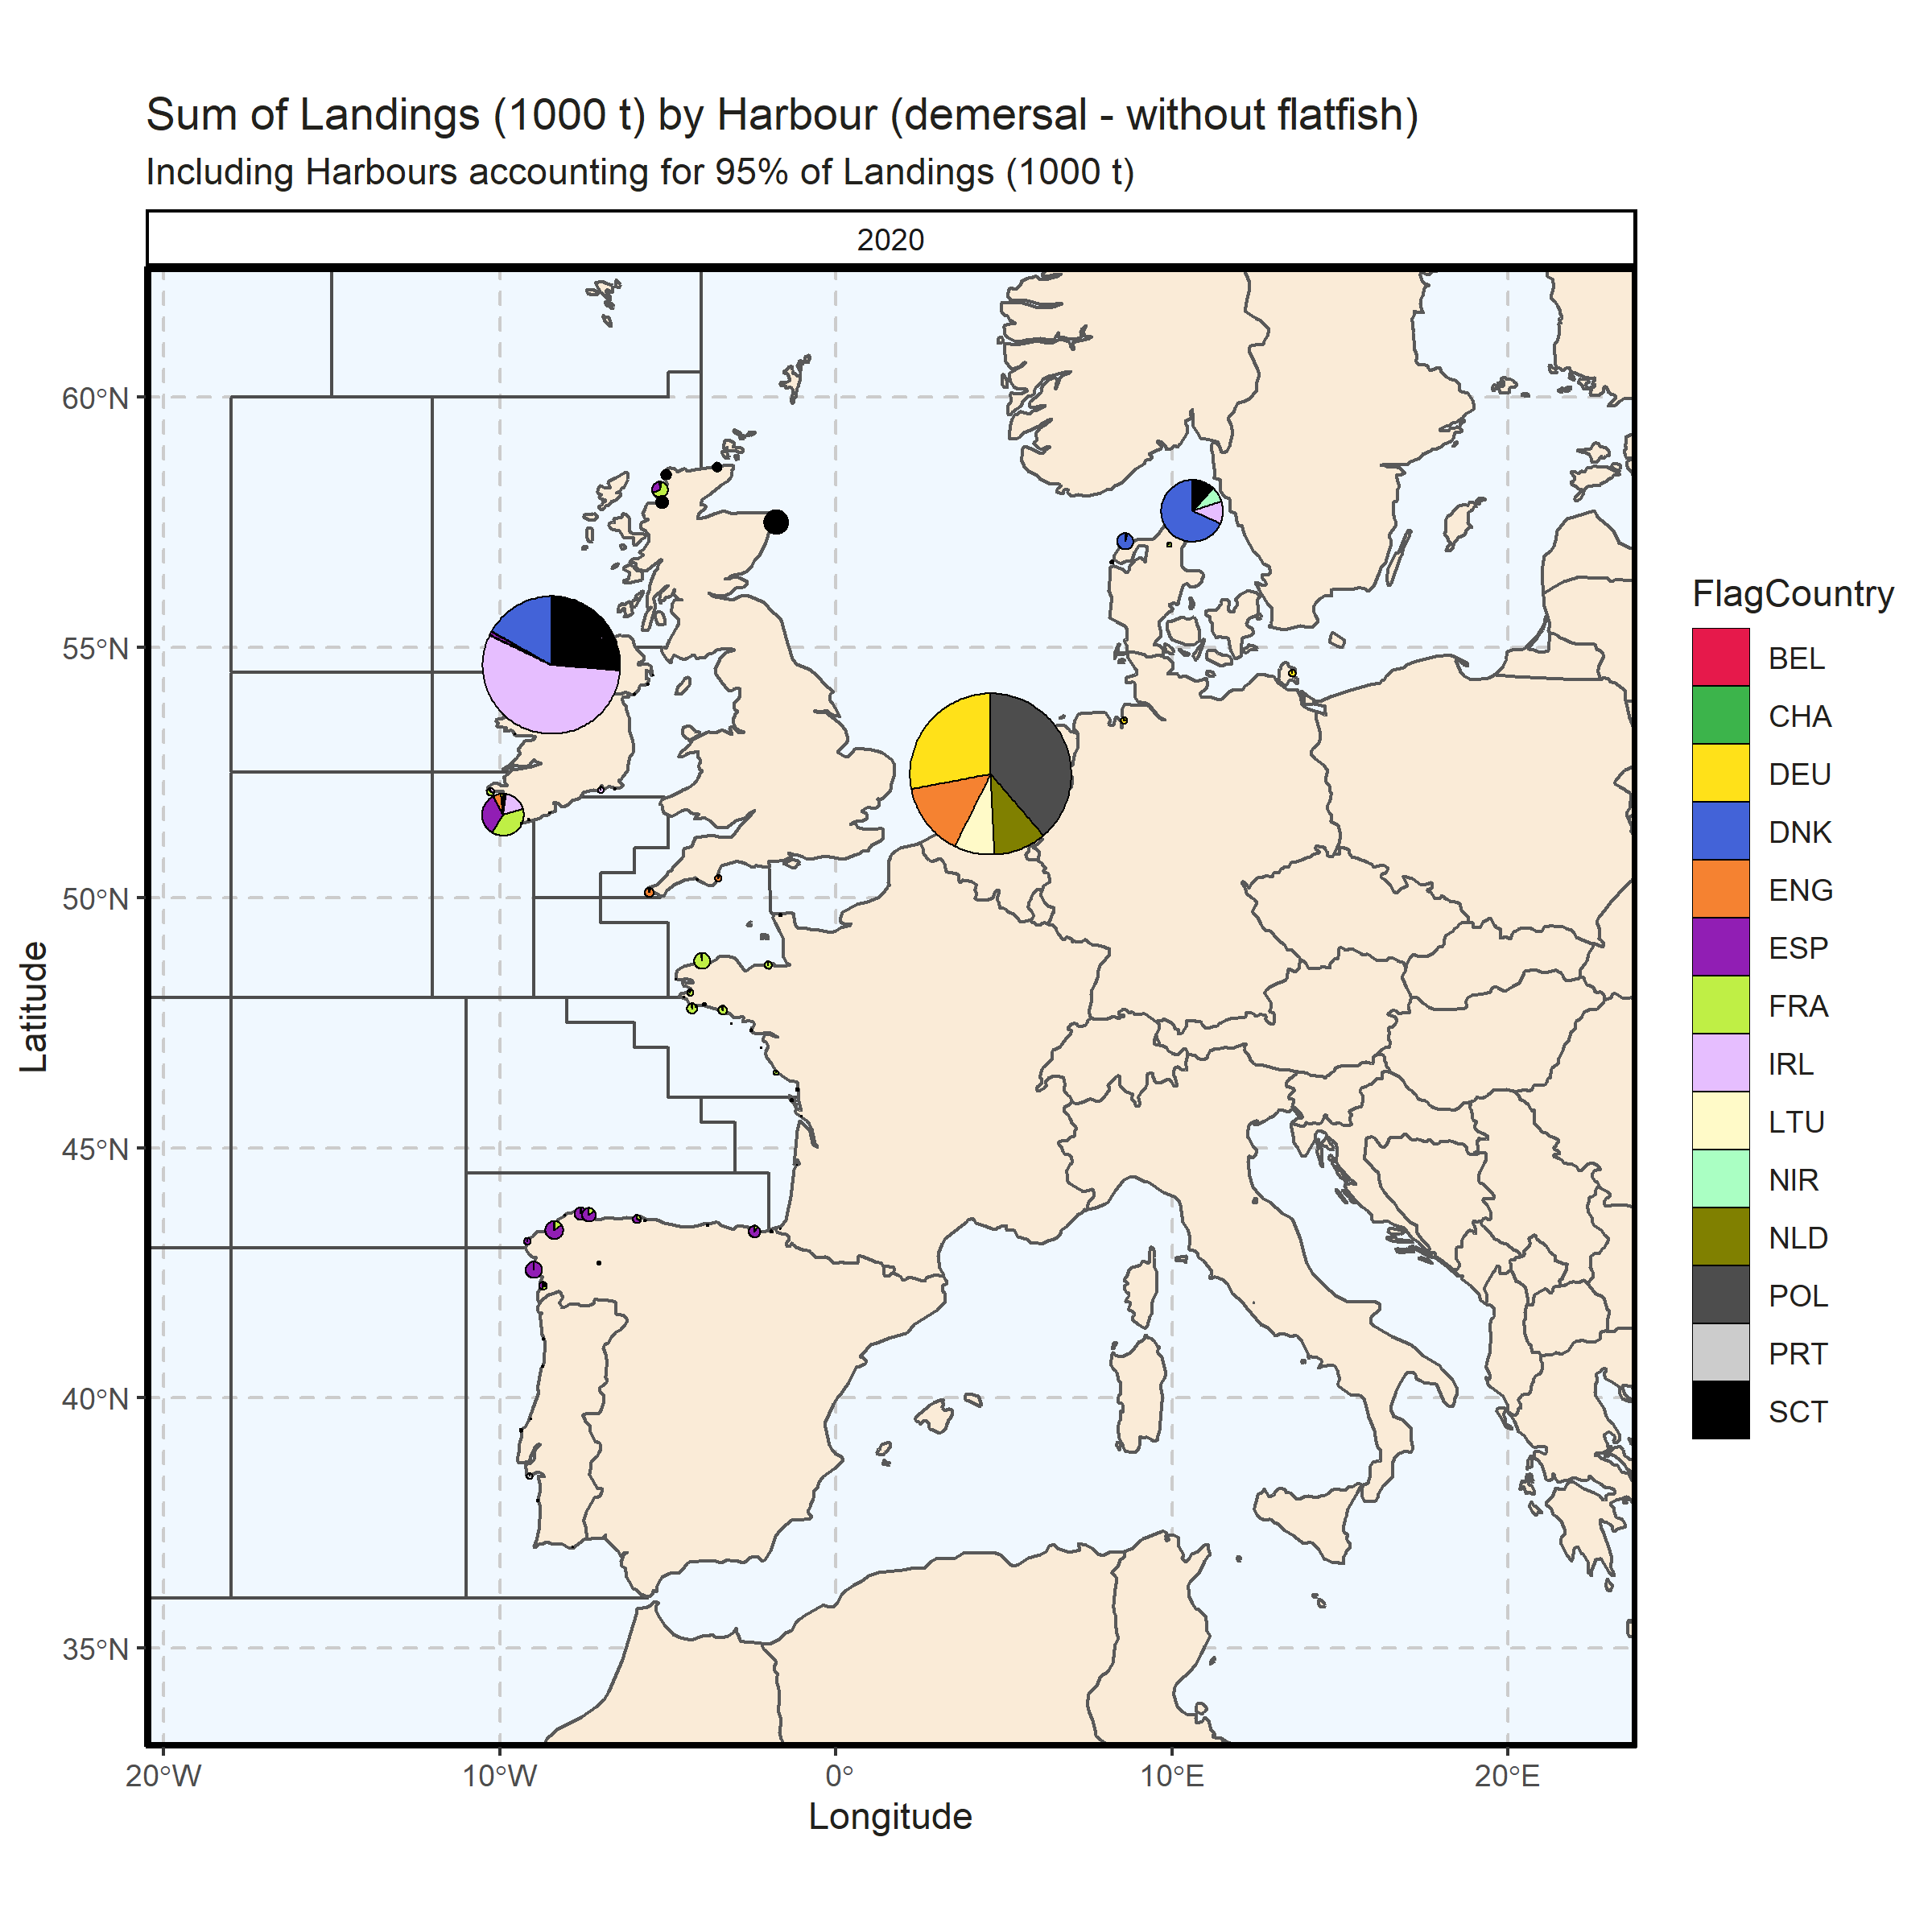 Figure 3.3.6.4. Sum of Landings (1000 t) by Harbour (demersal - without flatfish). Including Harbours accounting for 95% of Landings (1000 t). 0% of Landings (1000 t) - reported for missing Harbour. 3 Harbour with missing coordinates (5.06% of Landings (1000 t)) - not presented on the map.

### Landings abroad, demersal (without flatfish)

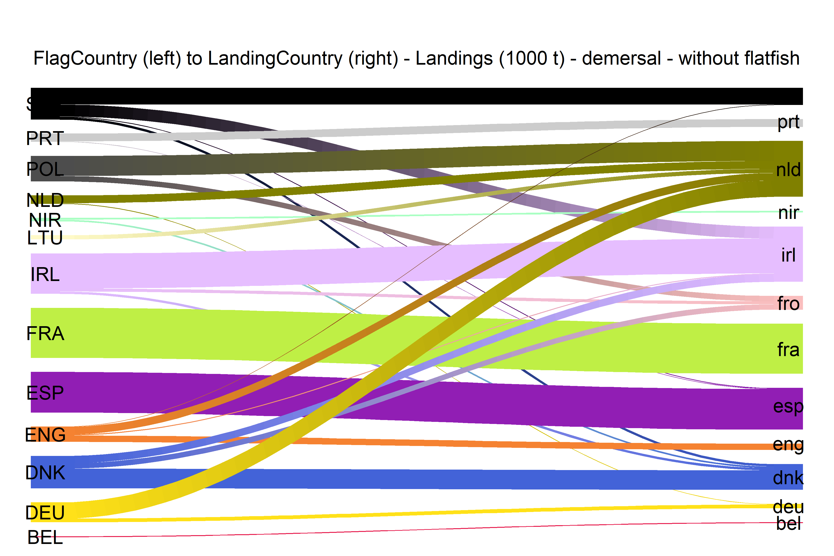  
Figure 3.3.7.1.River plot of Landings (1000 t) between Country (left) and Landing Country (right). Width of line is proportional to landings

### Spatial distribution of landings, demersal (without flatfish)

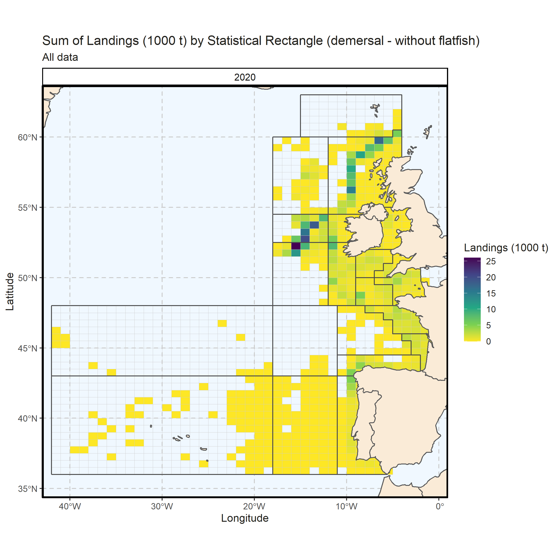 Figure 3.3.8.1. Sum of Landings (1000 t) by Statistical Rectangle (demersal - without flatfish). All data. 4.46% of Landings (1000 t) - reported for missing Statistical Rectangle. 2 Statistical Rectangle with missing coordinates (1.9% of Landings (1000 t)) - not presented on the map.

## Flatfish landings

### Landings by country, flatfish

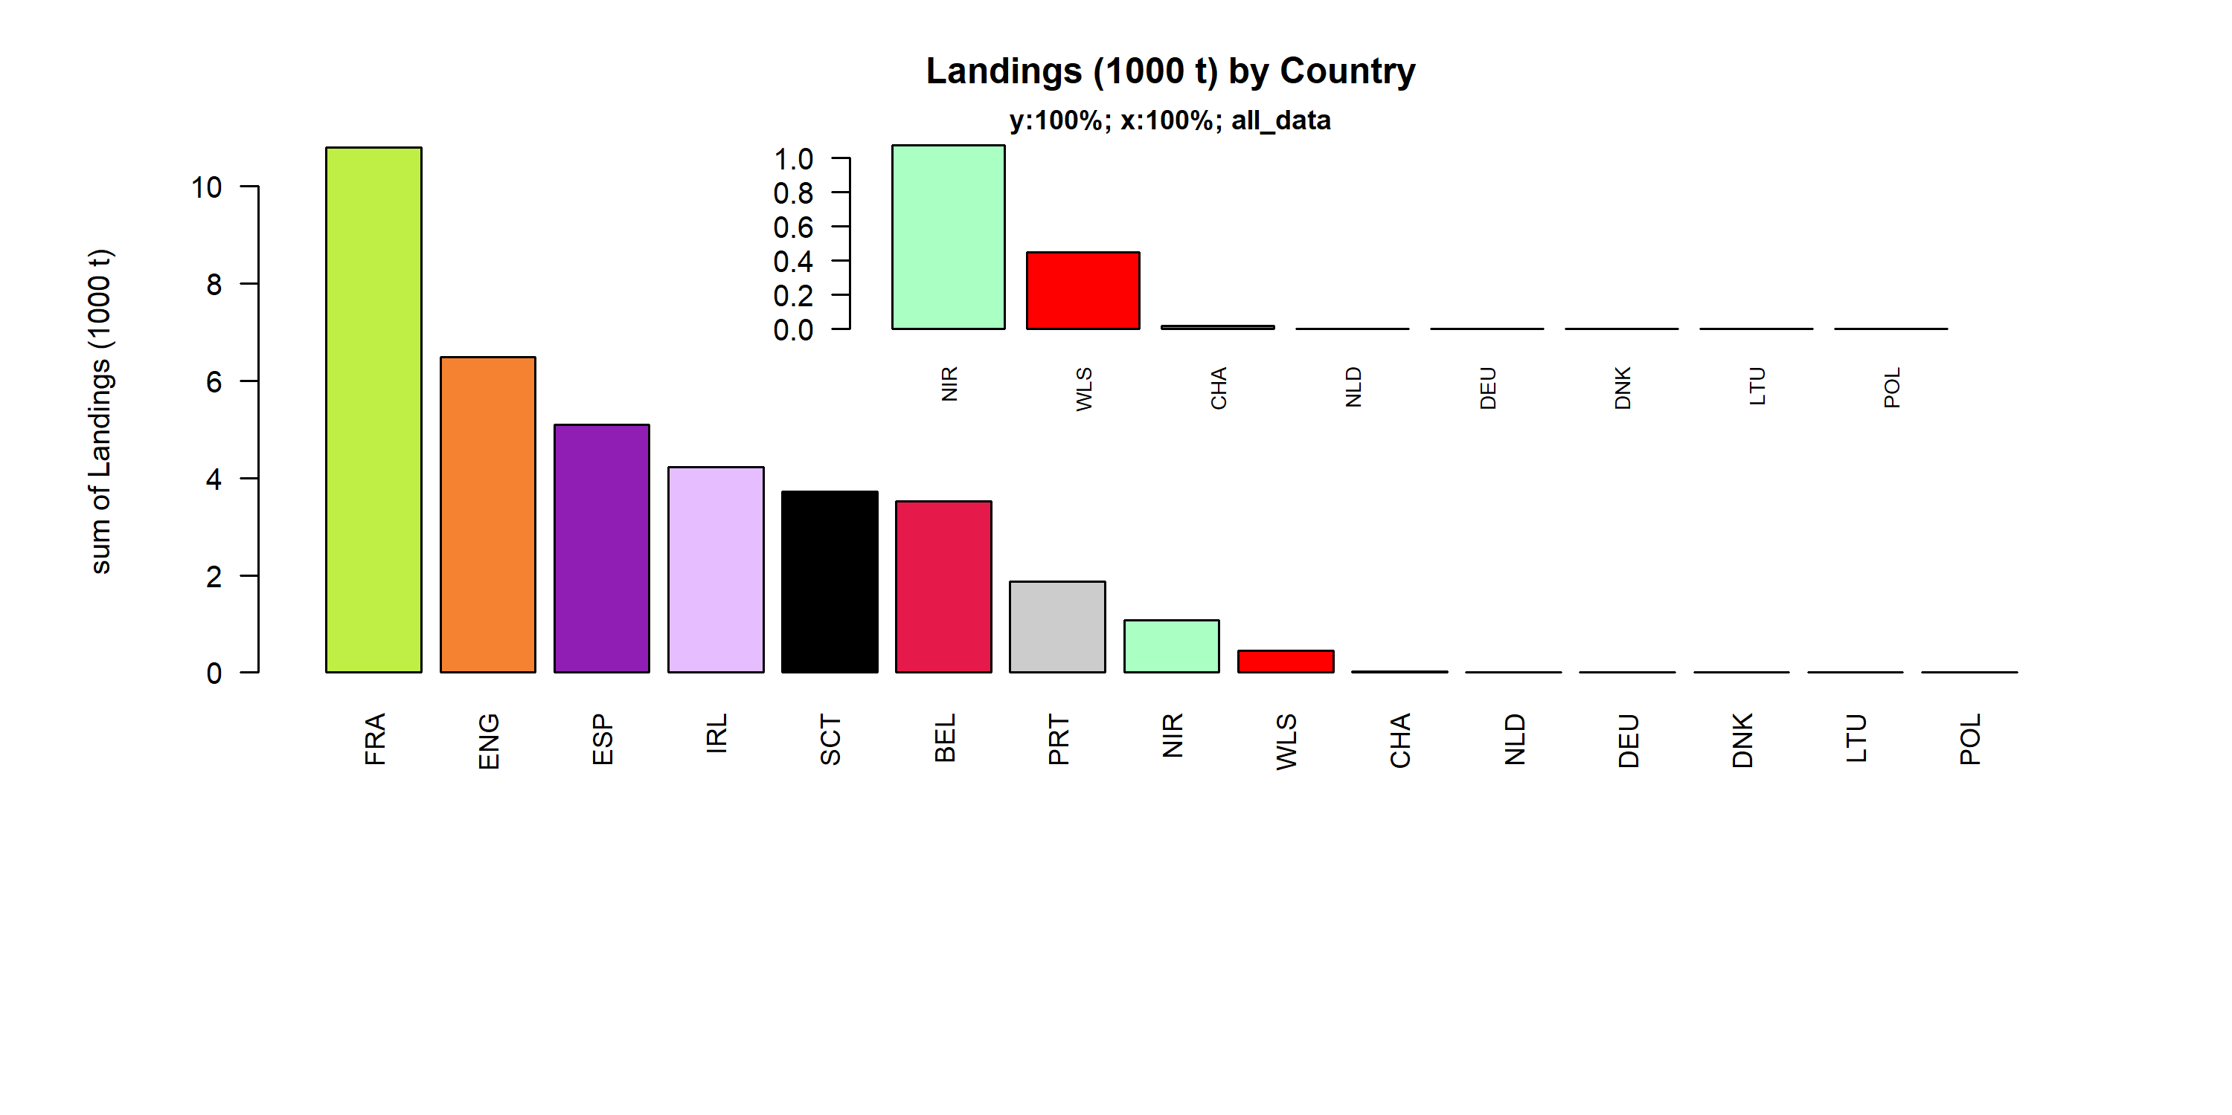 Figure 3.4.1.1. Landings (1000 t) of flatfish by Country.

### Landings by species, flatfish

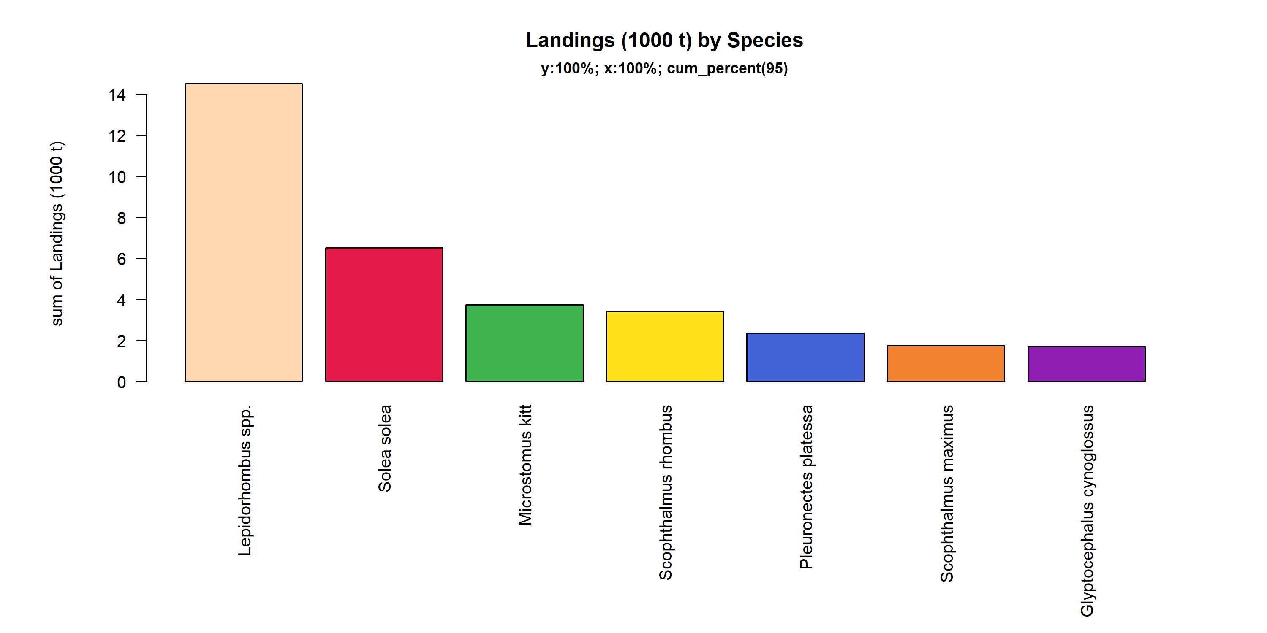 Figure 3.4.2.1. Landings (1000 t) of flatfish by Species. Species displayed comprise 95% of the total Landings (1000 t).

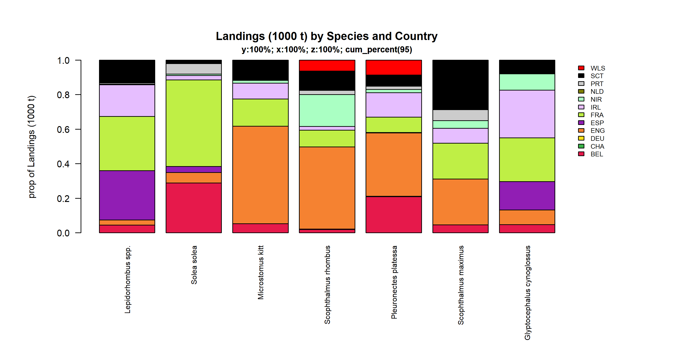 Figure 3.4.2.2. Landings (1000 t) of flatfish by Species and Country . Species and Country displayed comprise 95 % of the total Landings (1000 t) .

### Landings by fleet, flatfish

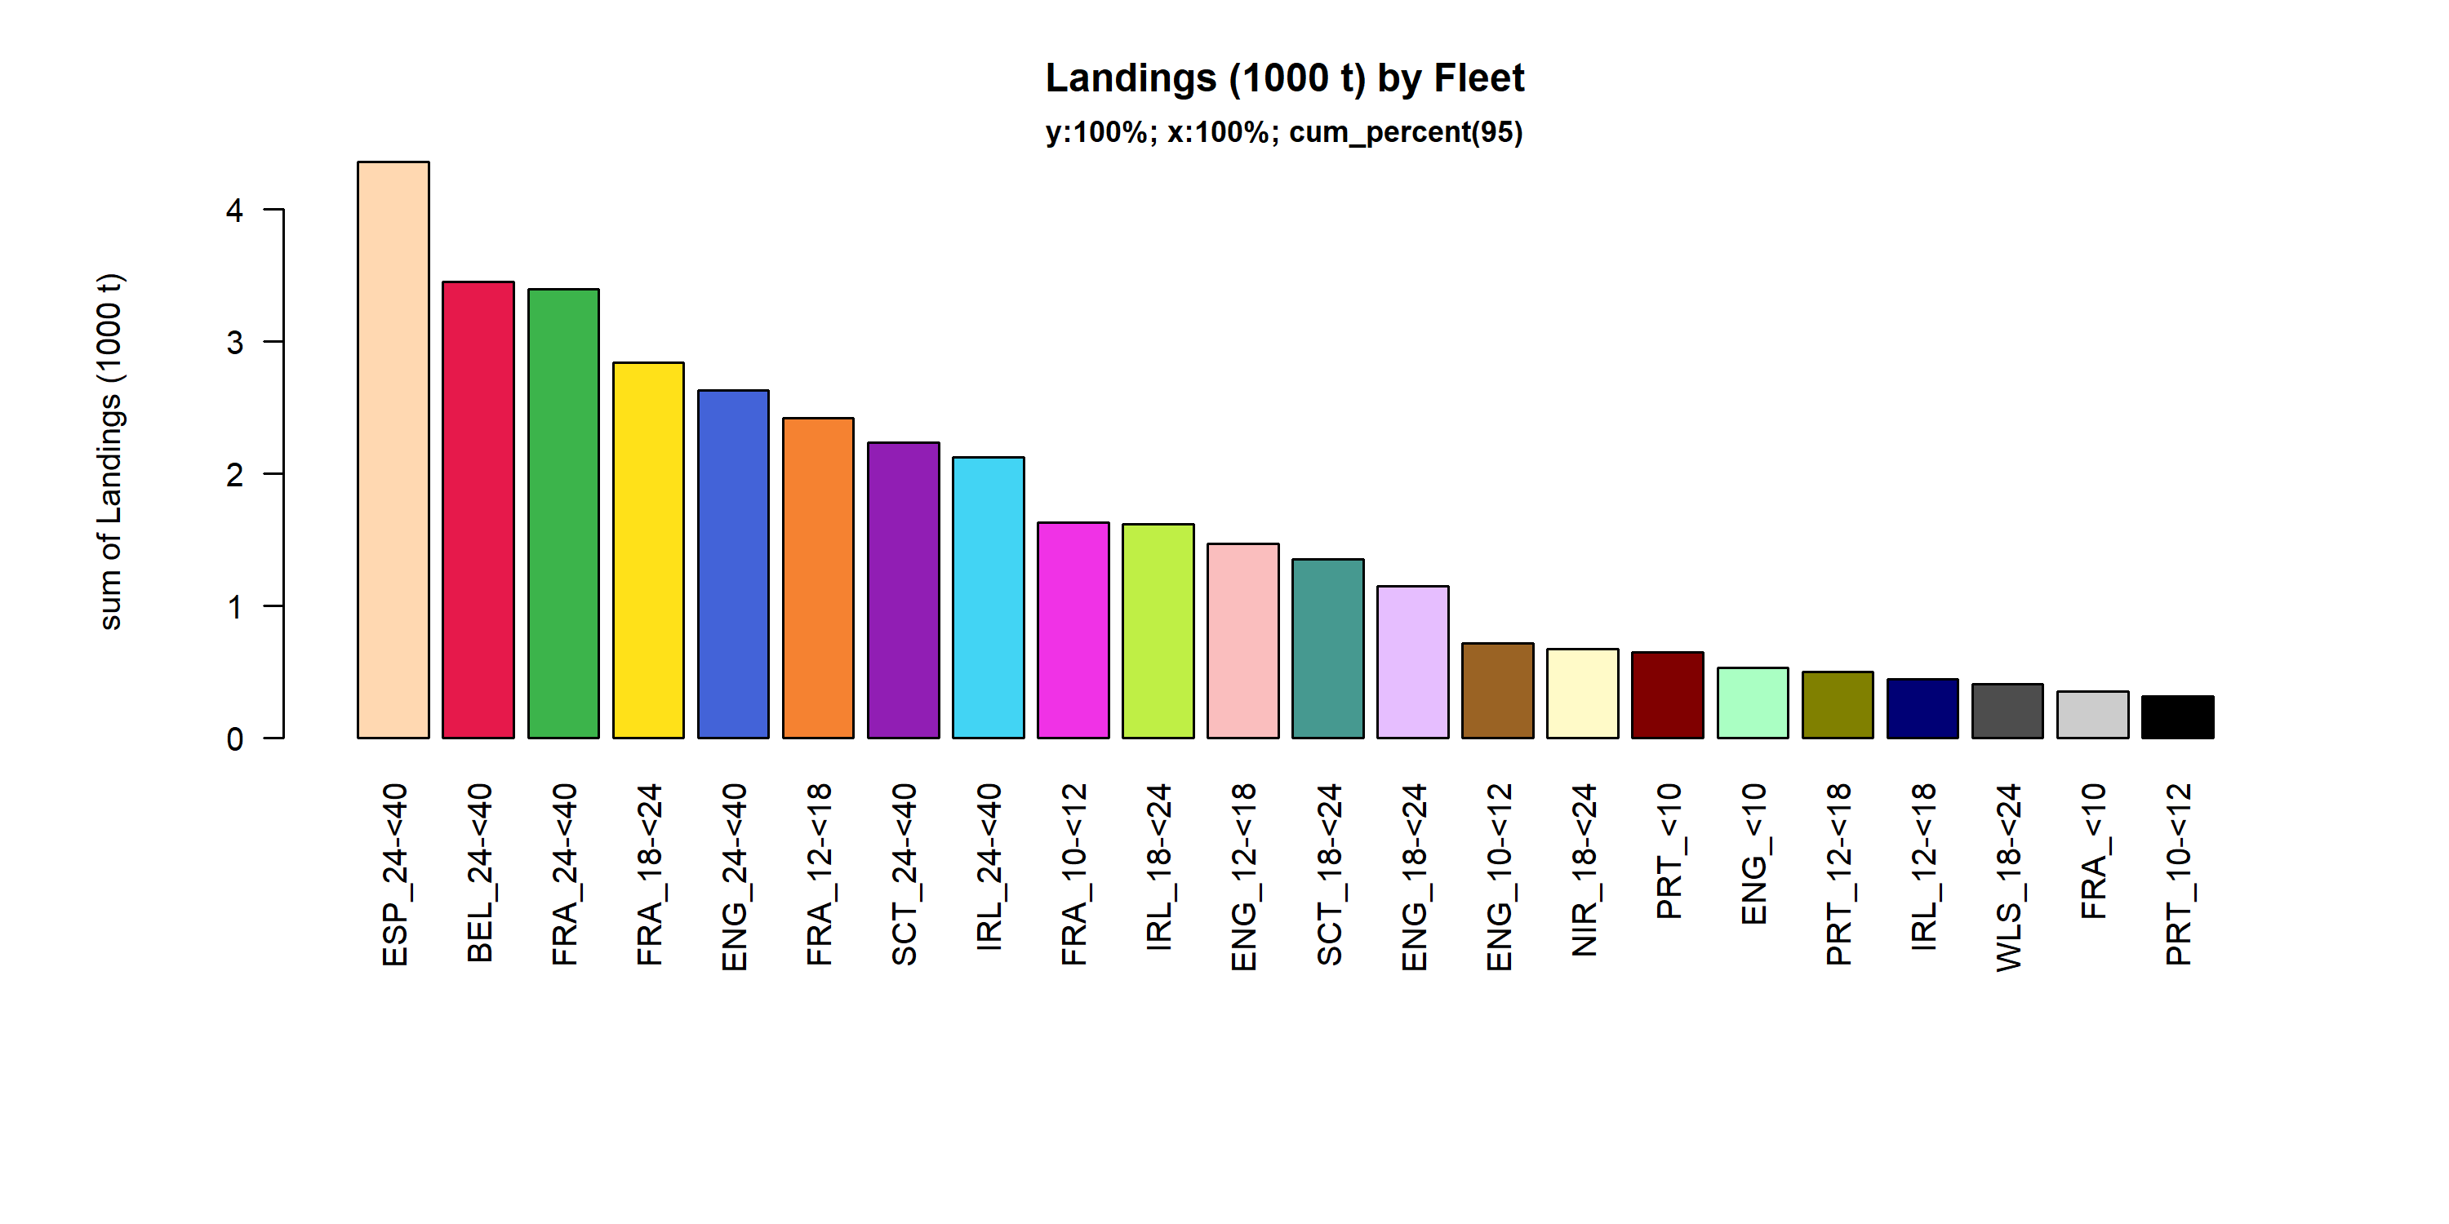 Figure 3.4.3.1. Landings (1000 t) of flatfish by Fleet. Fleet displayed comprise 95% of the total Landings (1000 t).

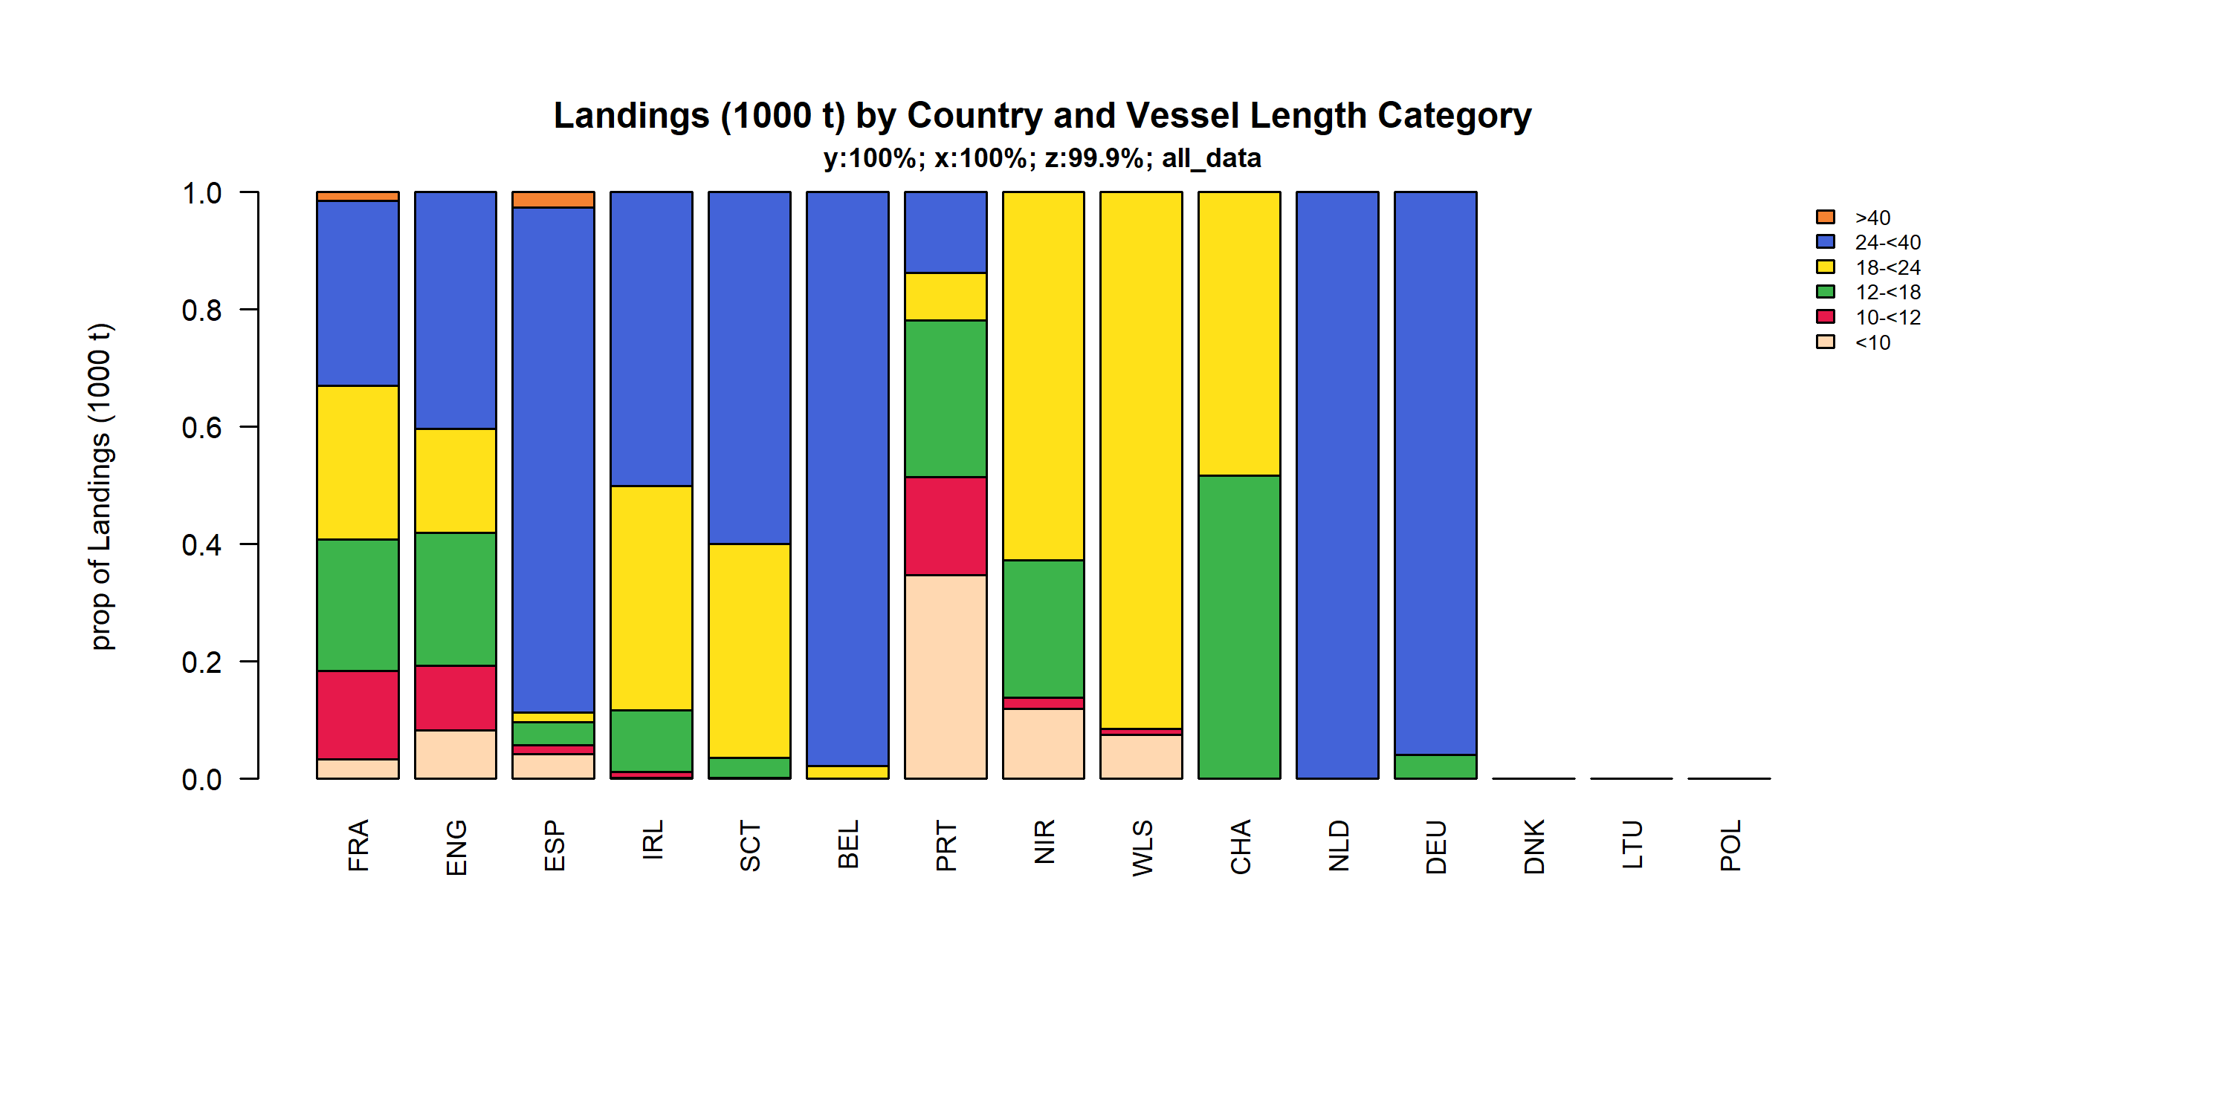 Figure 3.4.3.2. Landings (1000 t) of flatfish by Country and Vessel Length Category. TheVessel Length Category was given for 99.9% of observations.

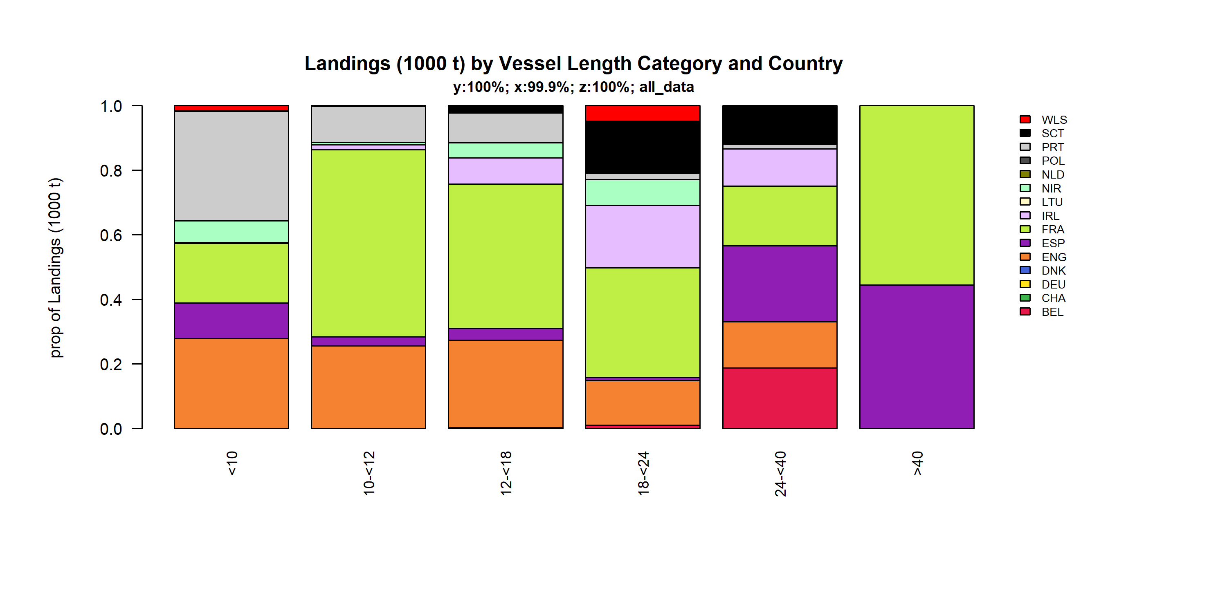 Figure 3.4.3.3. Landings (1000 t) of flatfish by Vessel Length Category and Country. TheVessel Length Category was given for 99.9% of observations.

### Landings by area, flatfish

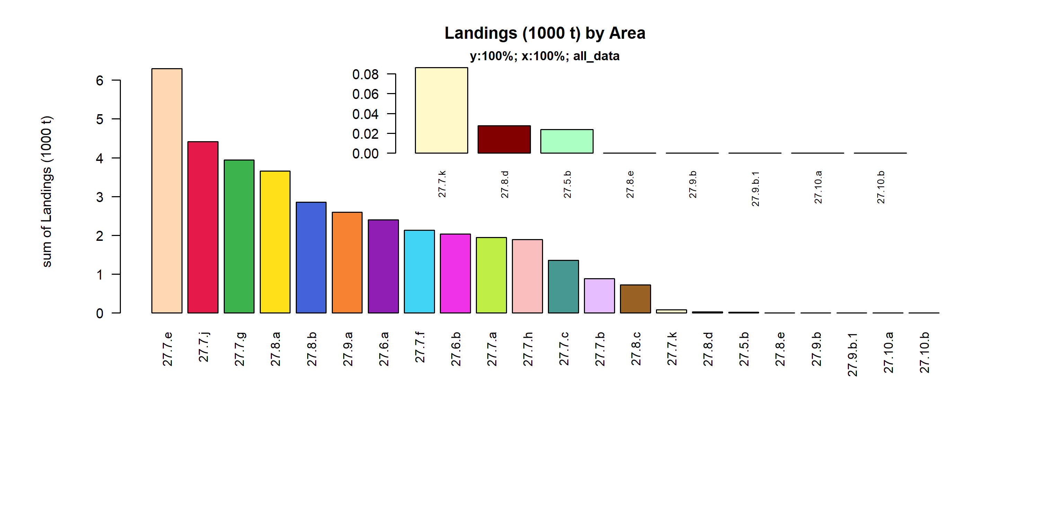 Figure 3.4.4.1. Landings (1000 t) of flatfish by Area.

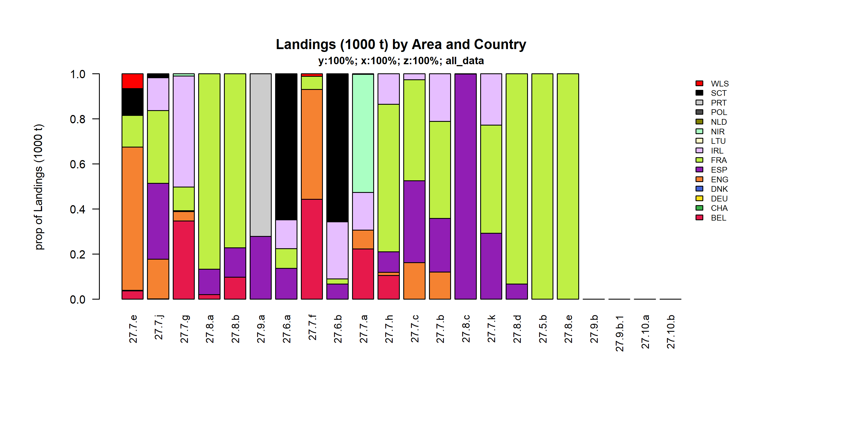 Figure 3.4.4.2. Landings (1000 t) of flatfish by Area and Country.

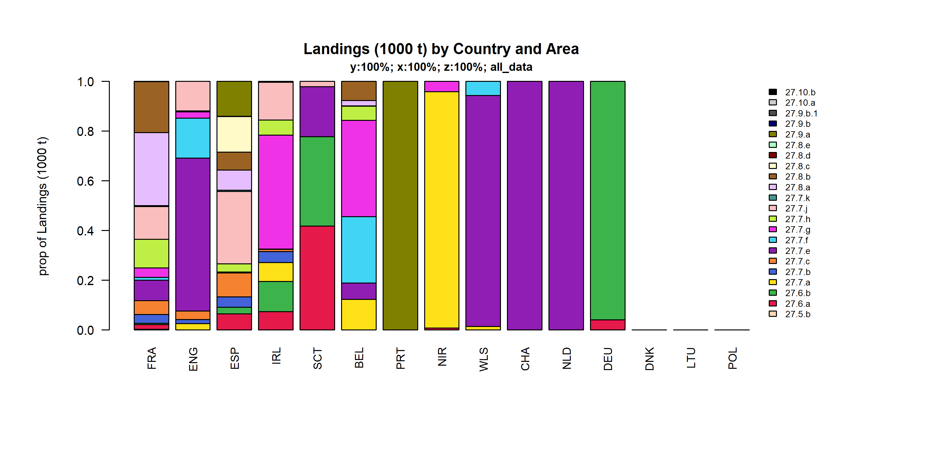 Figure 3.4.4.3. Landings (1000 t) of flatfish by Country and Area.

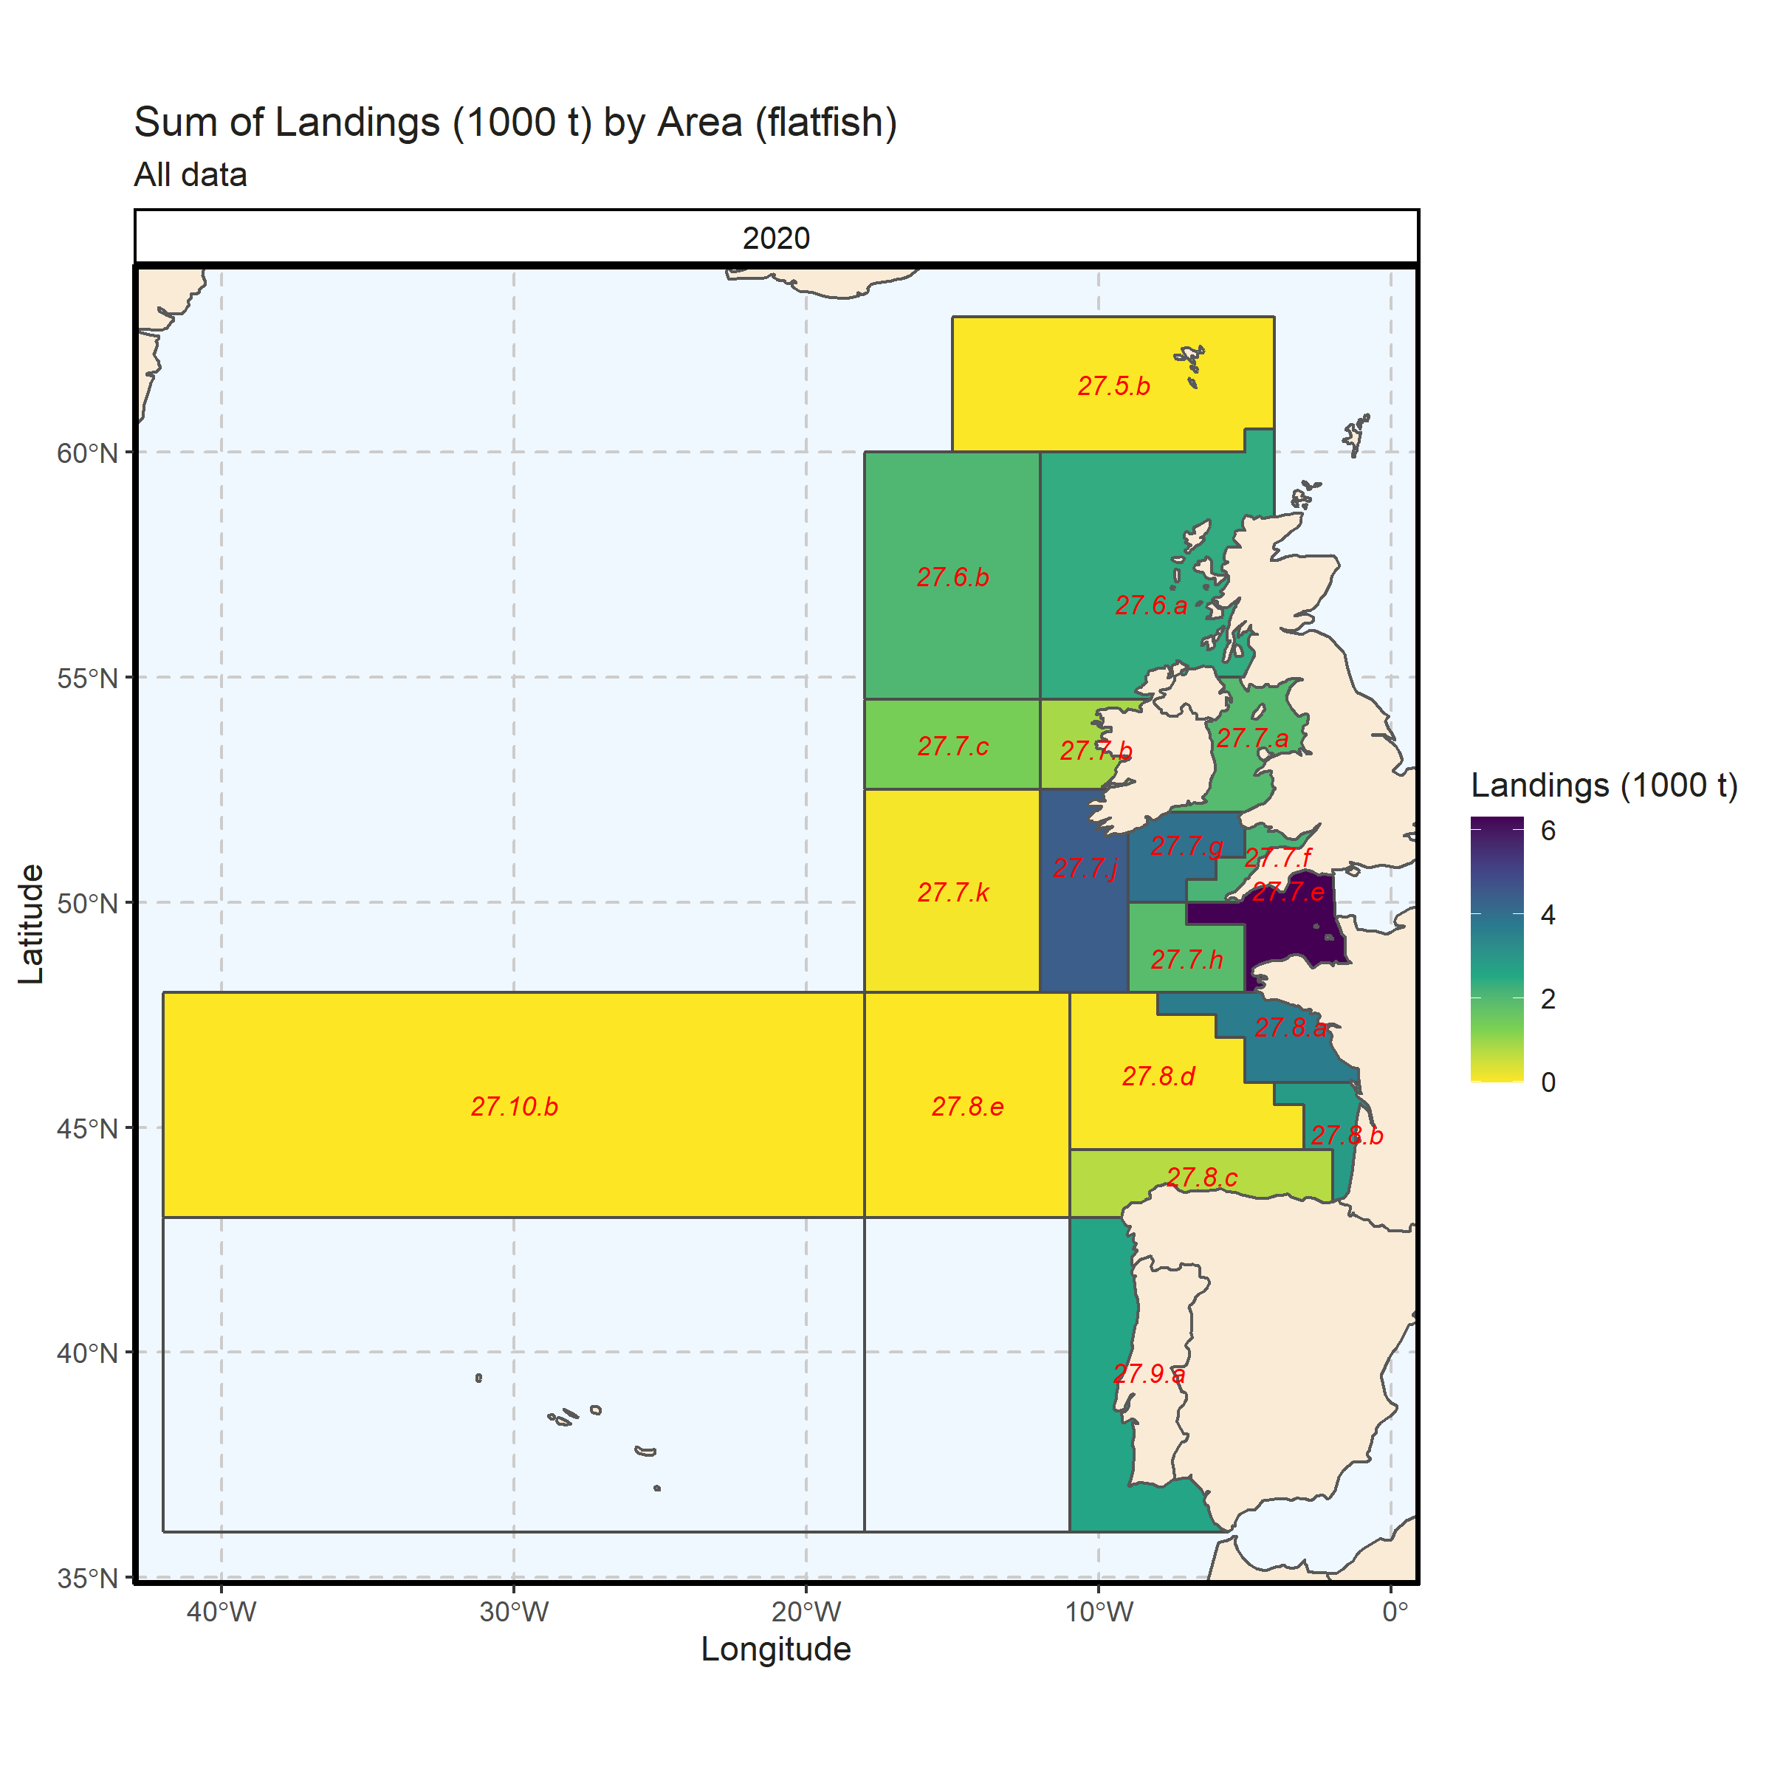 Figure 3.4.4.4. Sum of Landings (1000 t) by Area (flatfish). All data. 0% of Landings (1000 t) - reported for missing Area.

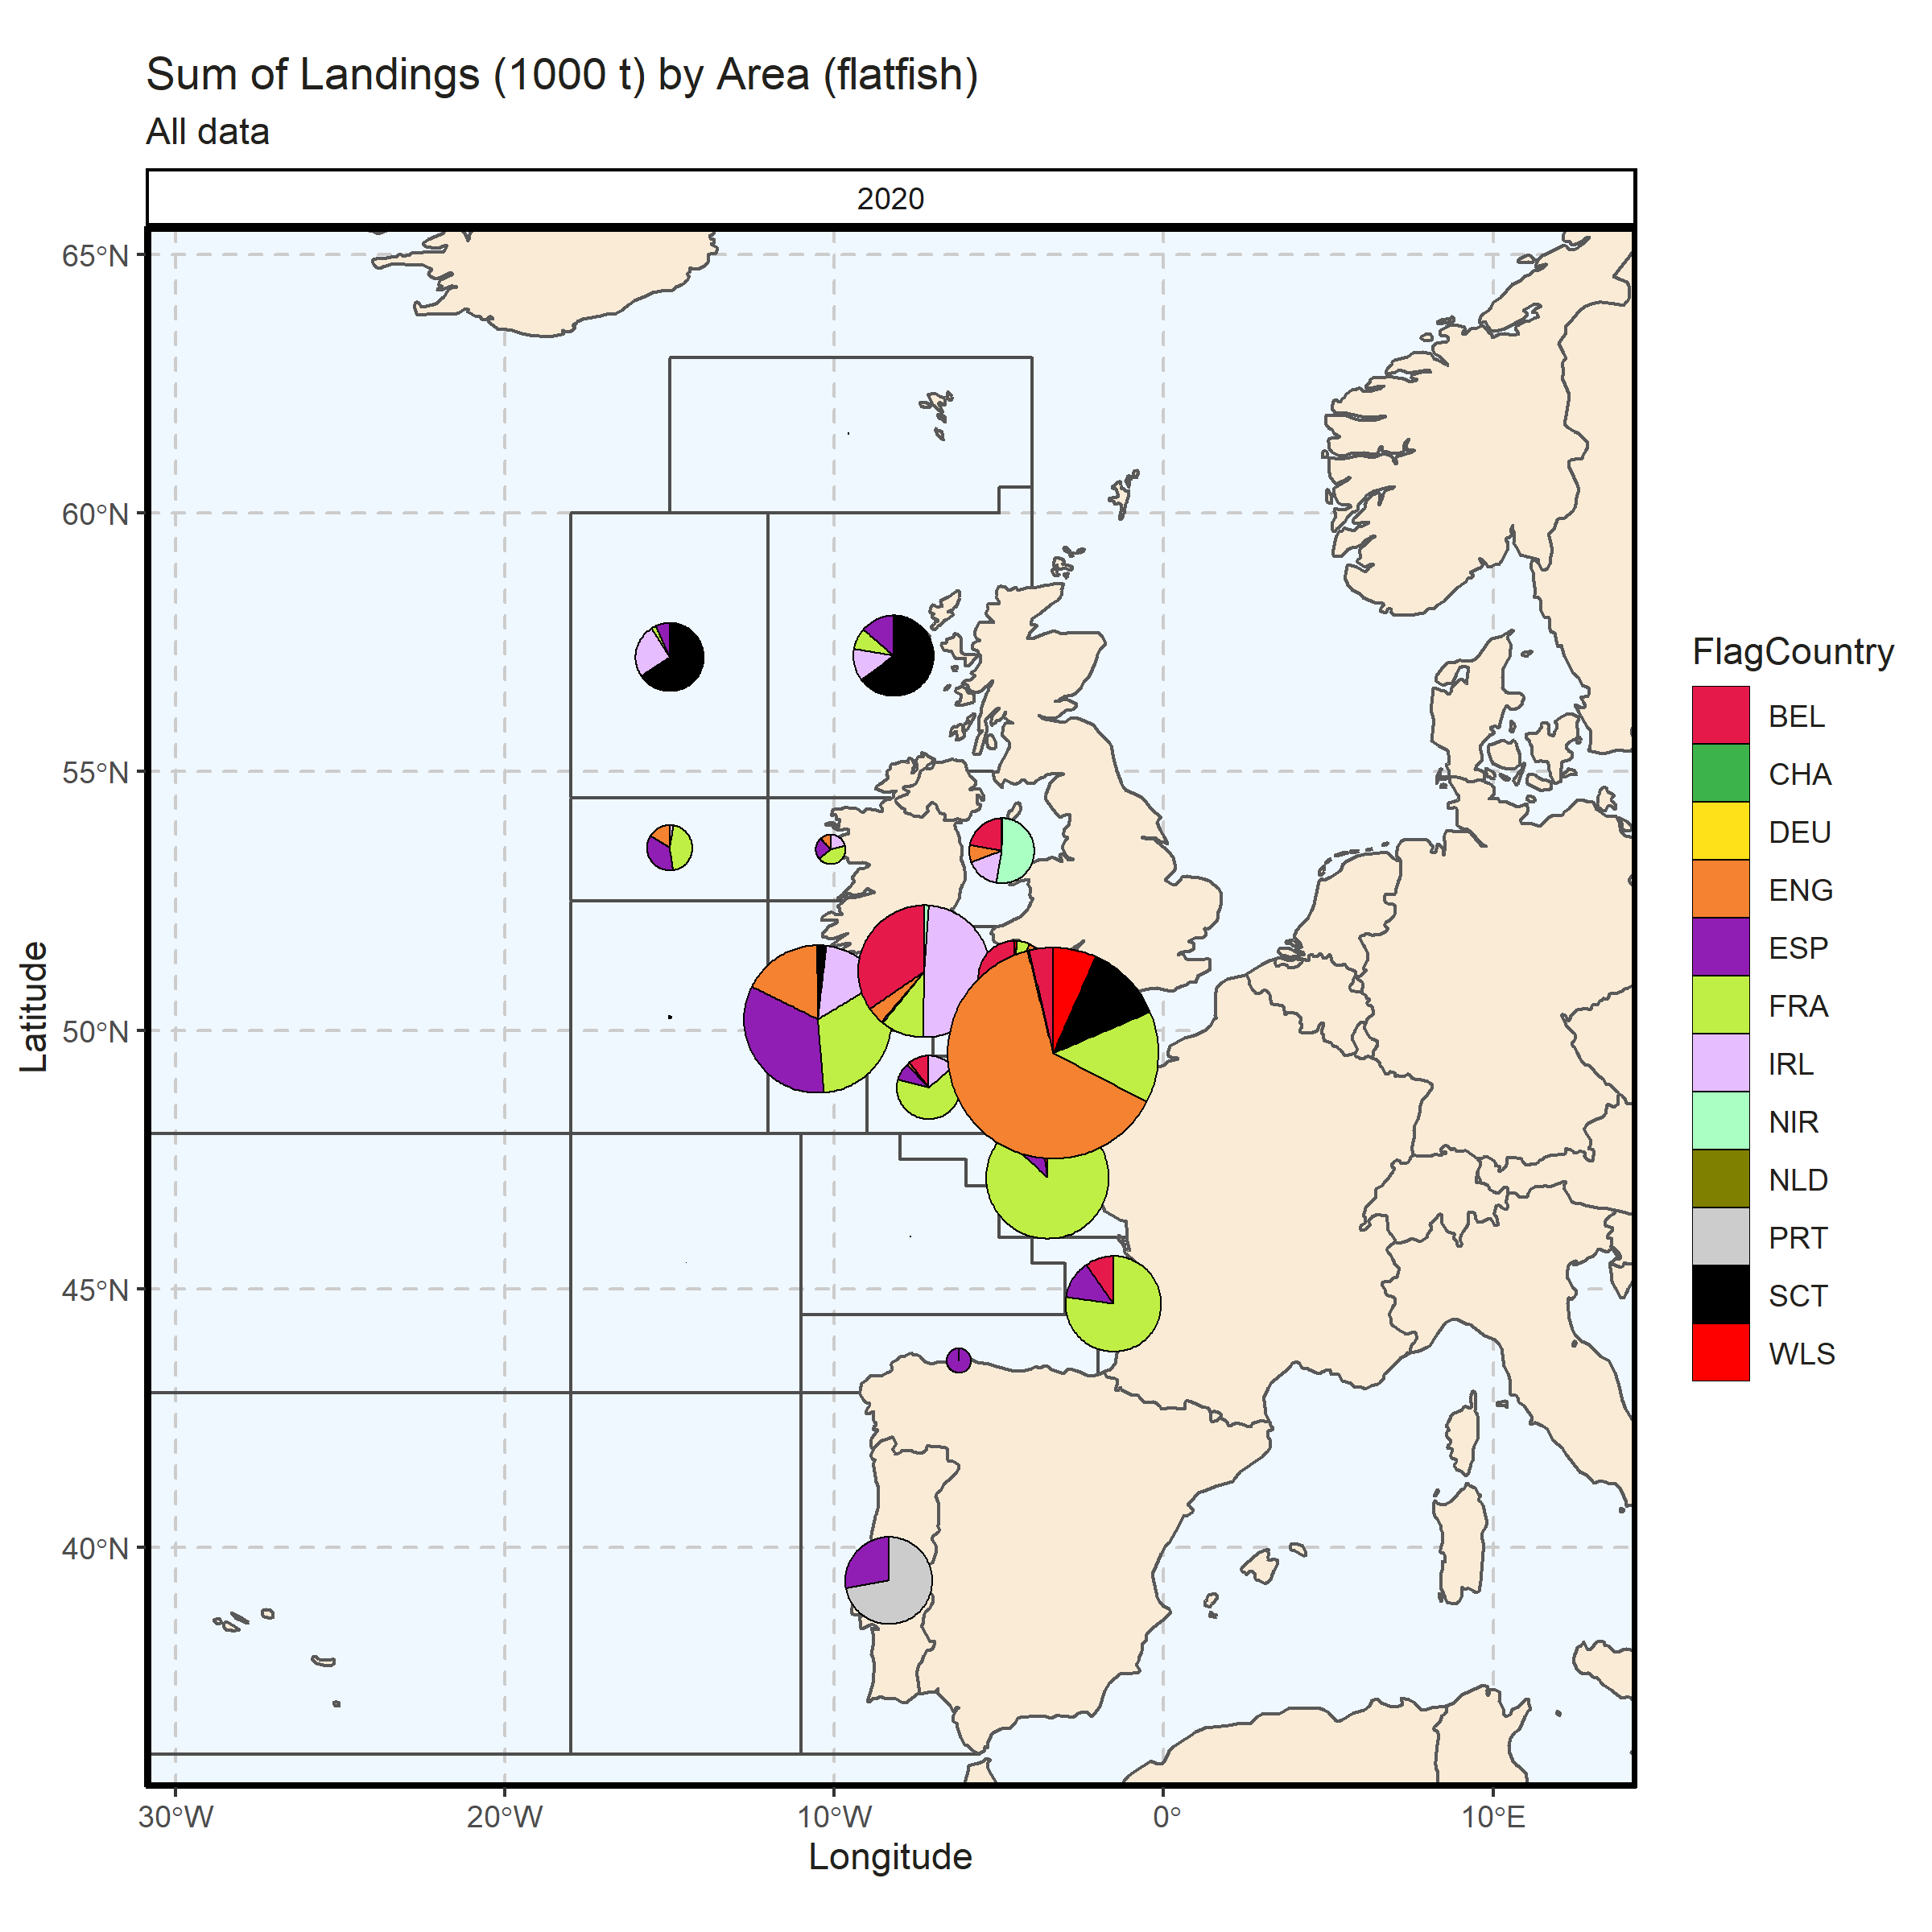 Figure 3.4.4.5. Sum of Landings (1000 t) by Area (flatfish). All data. 0% of Landings (1000 t) - reported for missing Area.

### Landings by metier, flatfish

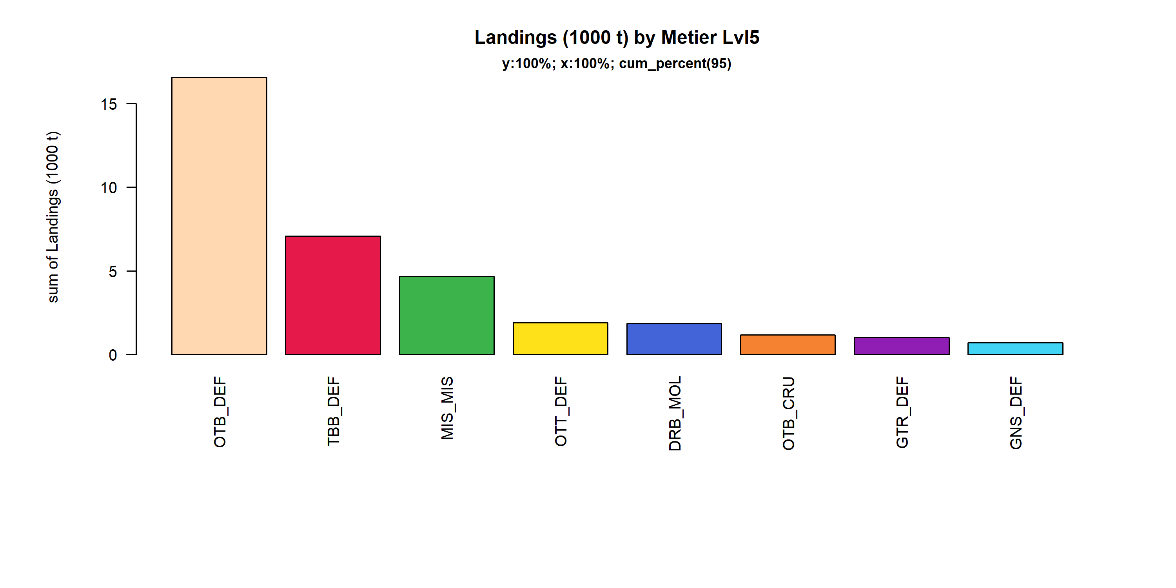 Figure 3.4.5.1. Landings (1000 t) of flatfish by Metier Lvl5. Metier Lvl5 displayed comprise 95% of the total Landings (1000 t).

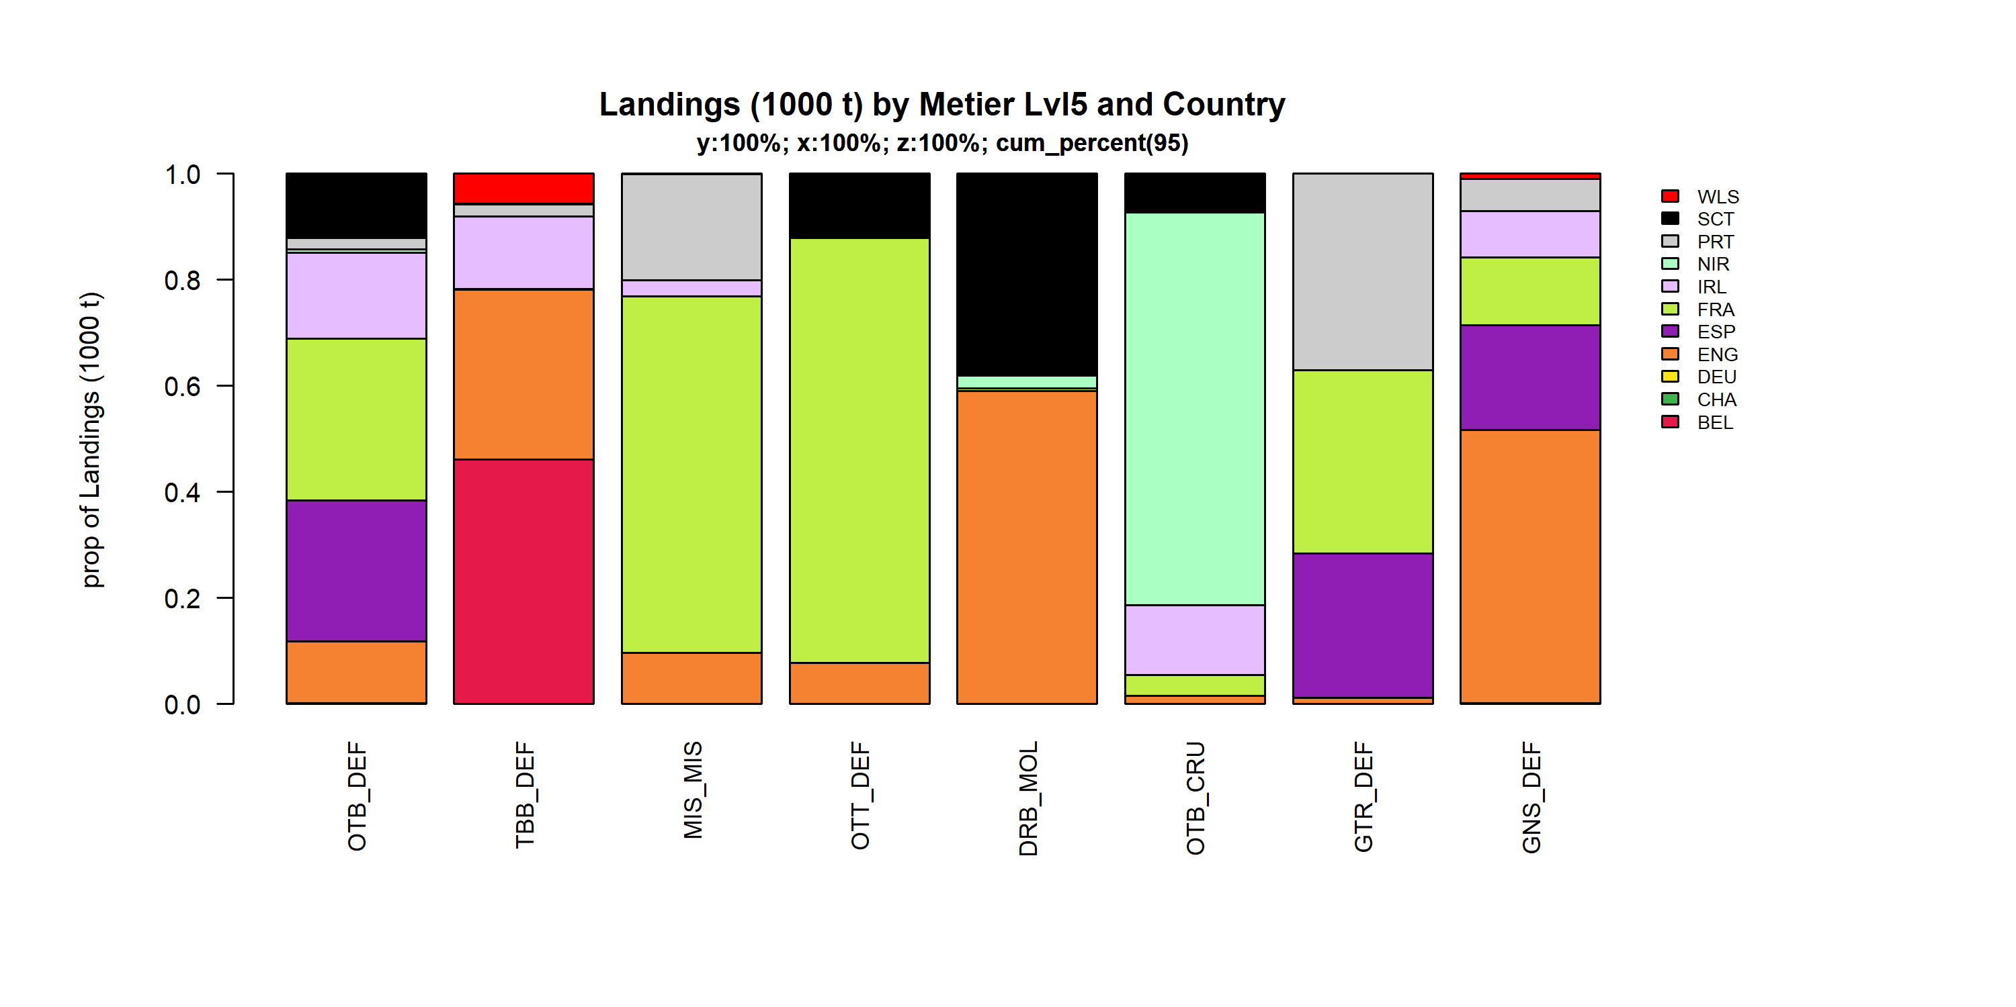 Figure 3.4.5.2. Landings (1000 t) of flatfish by Metier Lvl5 and Country . Metier Lvl5 and Country displayed comprise 95 % of the total Landings (1000 t) .

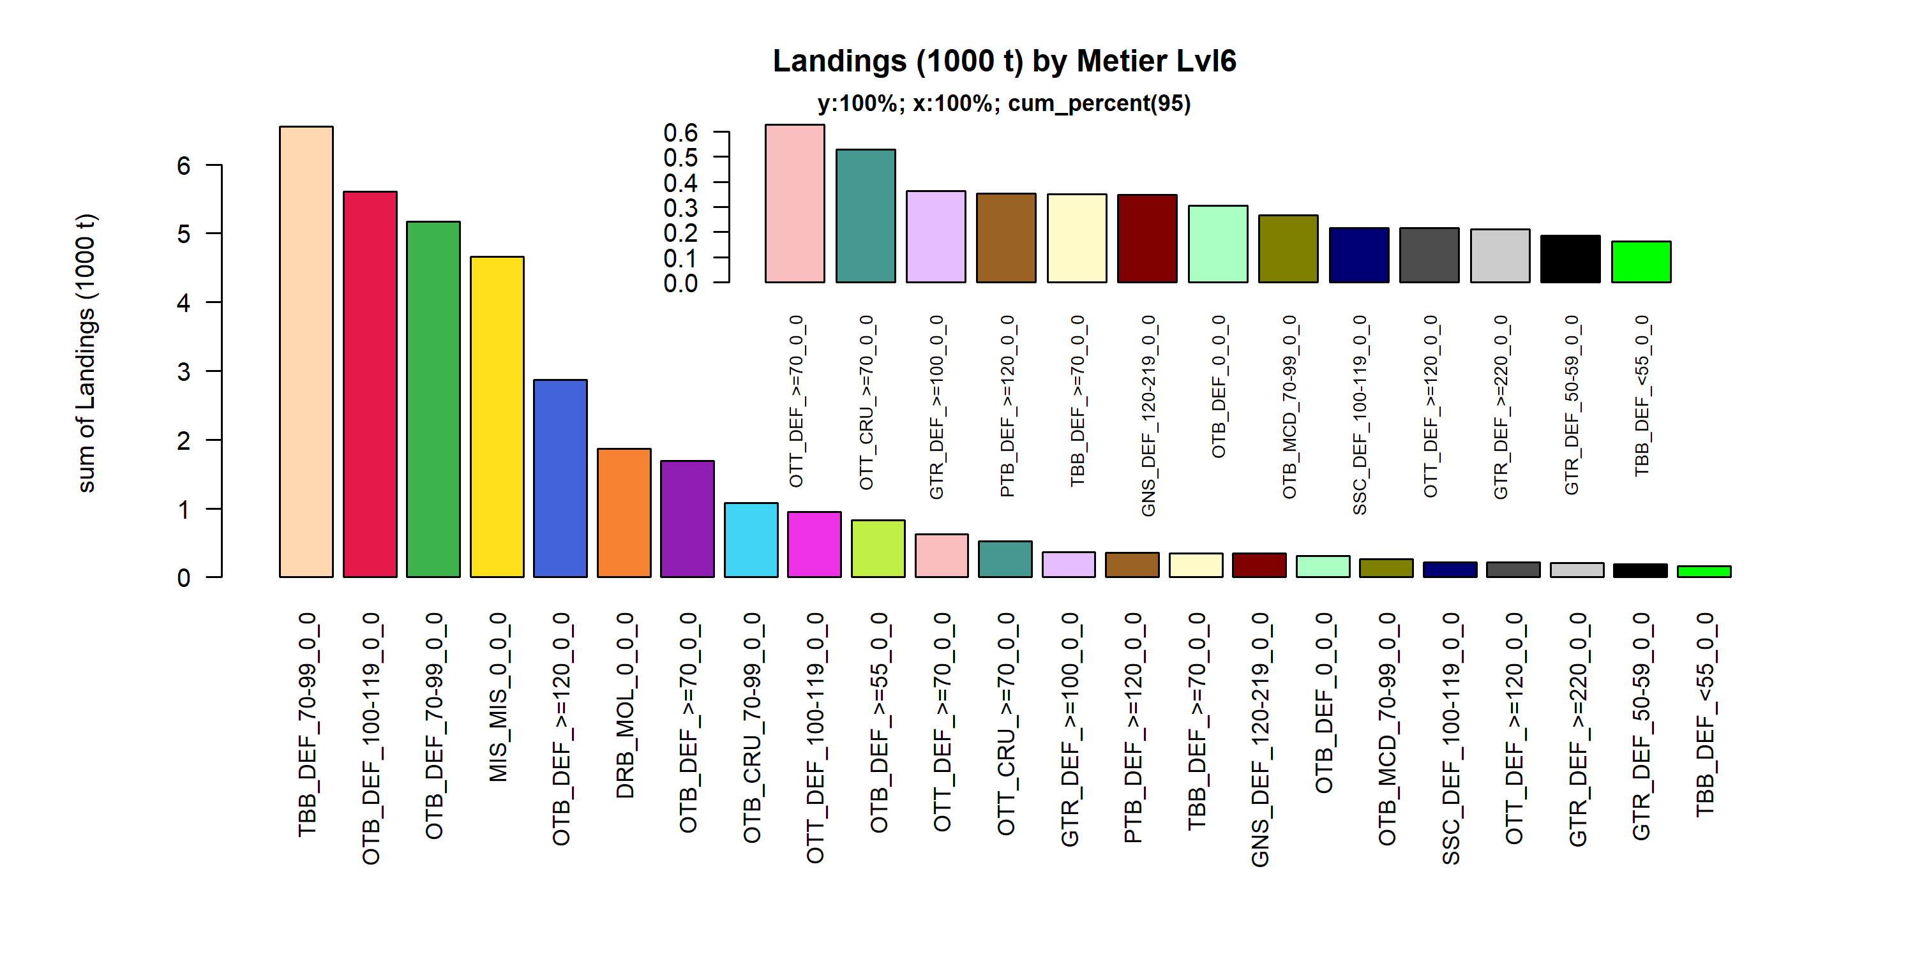 Figure 3.4.5.3. Landings (1000 t) of flatfish by Metier Lvl6. Metier Lvl6 displayed comprise 95% of the total Landings (1000 t).

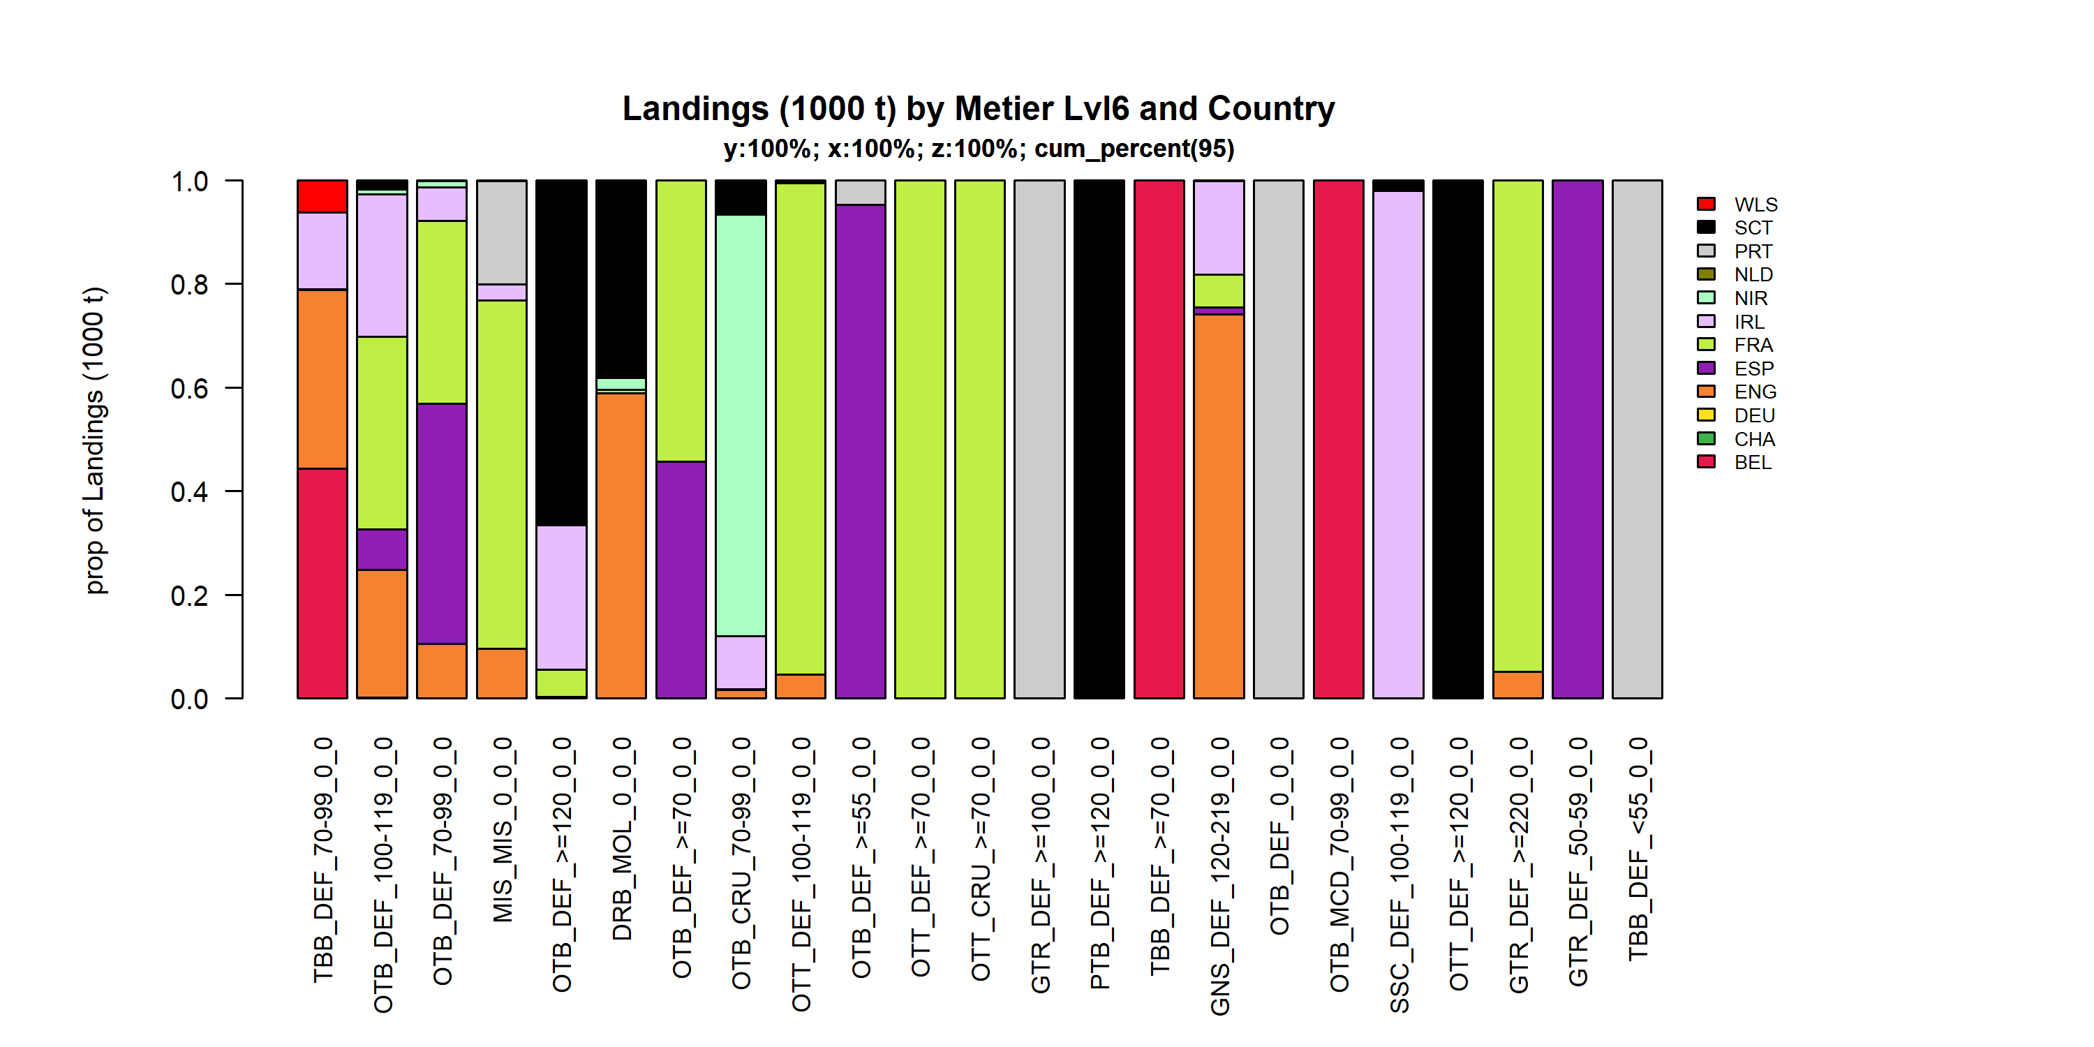 Figure 3.4.5.4. Landings (1000 t) of flatfish by Metier Lvl6 and Country . Metier Lvl6 and Country displayed comprise 95 % of the total Landings (1000 t) .

### Landings by harbour, flatfish

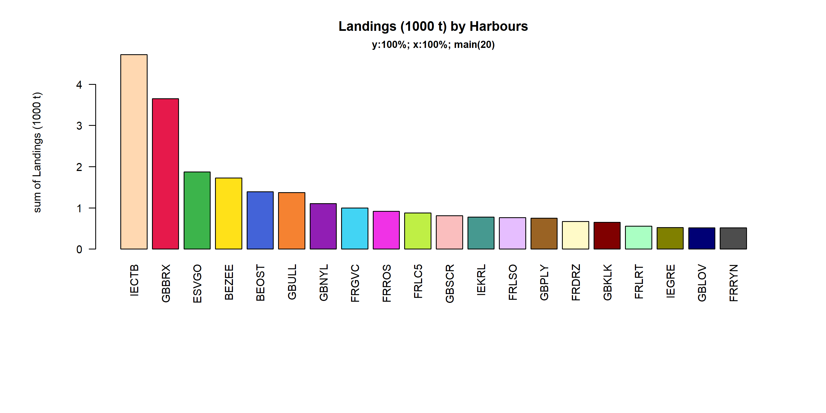 Figure 3.4.6.1. Landings (1000 t) of flatfish in the 20 main Harbours (100% of rows entering analysis had known Harbours).

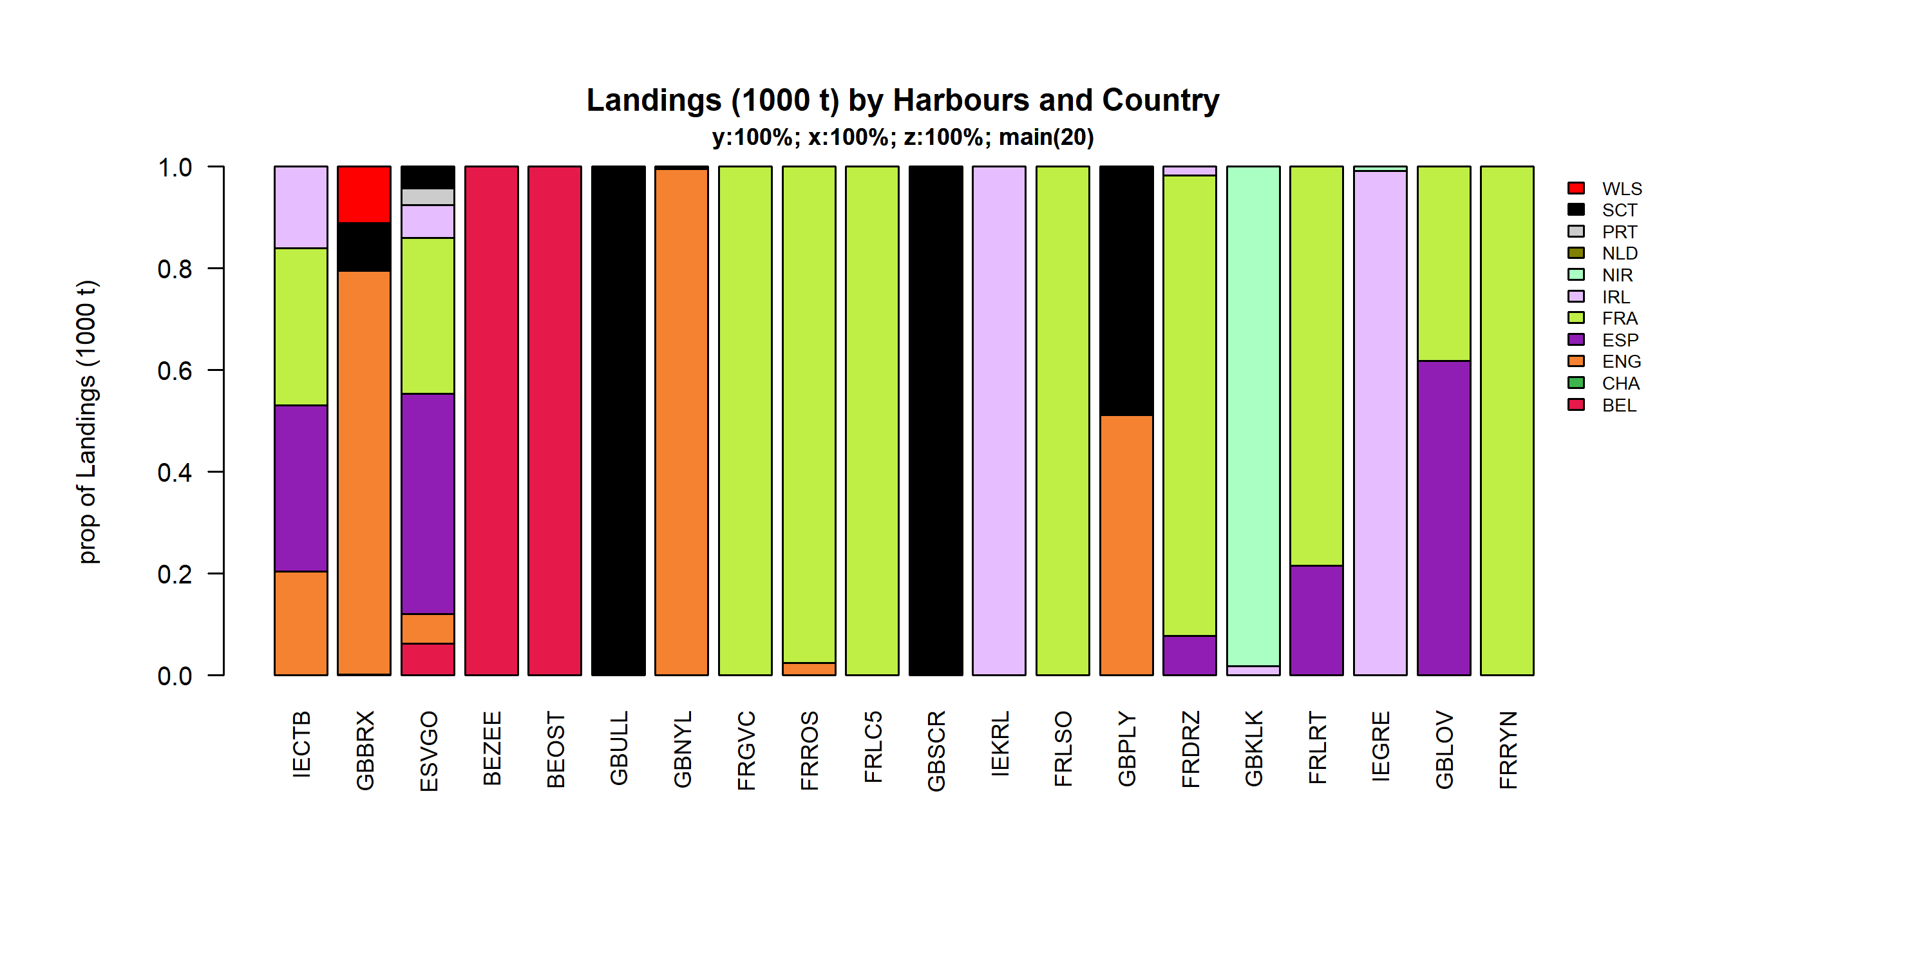 Figure 3.4.6.2. Landings (1000 t) of flatfish by 20 main Harbours and Country .

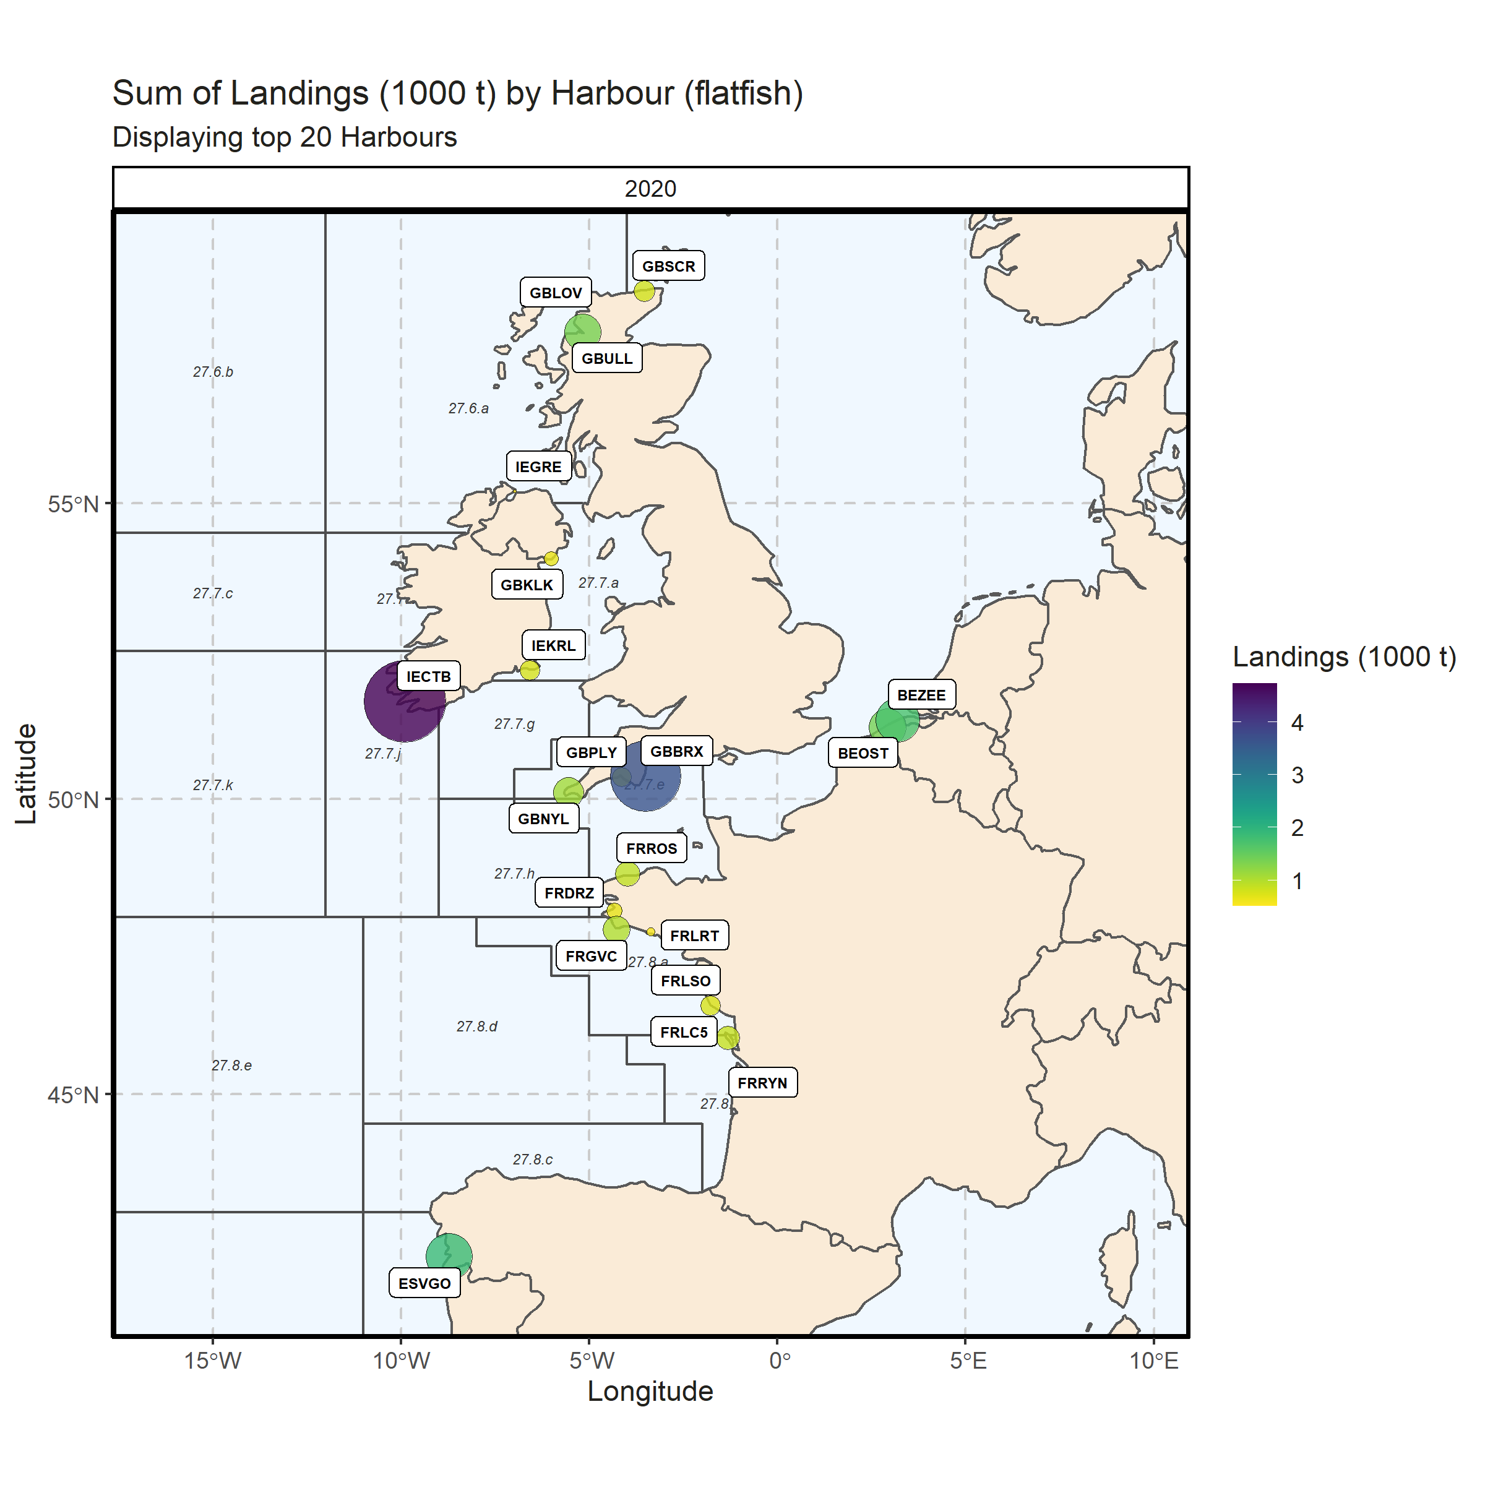 Figure 3.4.6.3. Sum of Landings (1000 t) by Harbour (flatfish). Displaying top 20 Harbours. 0% of Landings (1000 t) - reported for missing Harbour

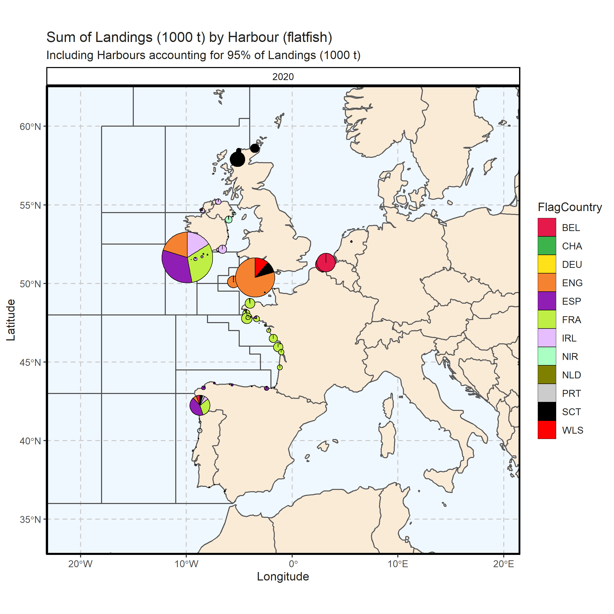 Figure 3.4.6.4. Sum of Landings (1000 t) by Harbour (flatfish). Including Harbours accounting for 95% of Landings (1000 t). 0% of Landings (1000 t) - reported for missing Harbour. 1 Harbour with missing coordinates (0.38% of Landings (1000 t)) - not presented on the map.

### Landings abroad, flatfish

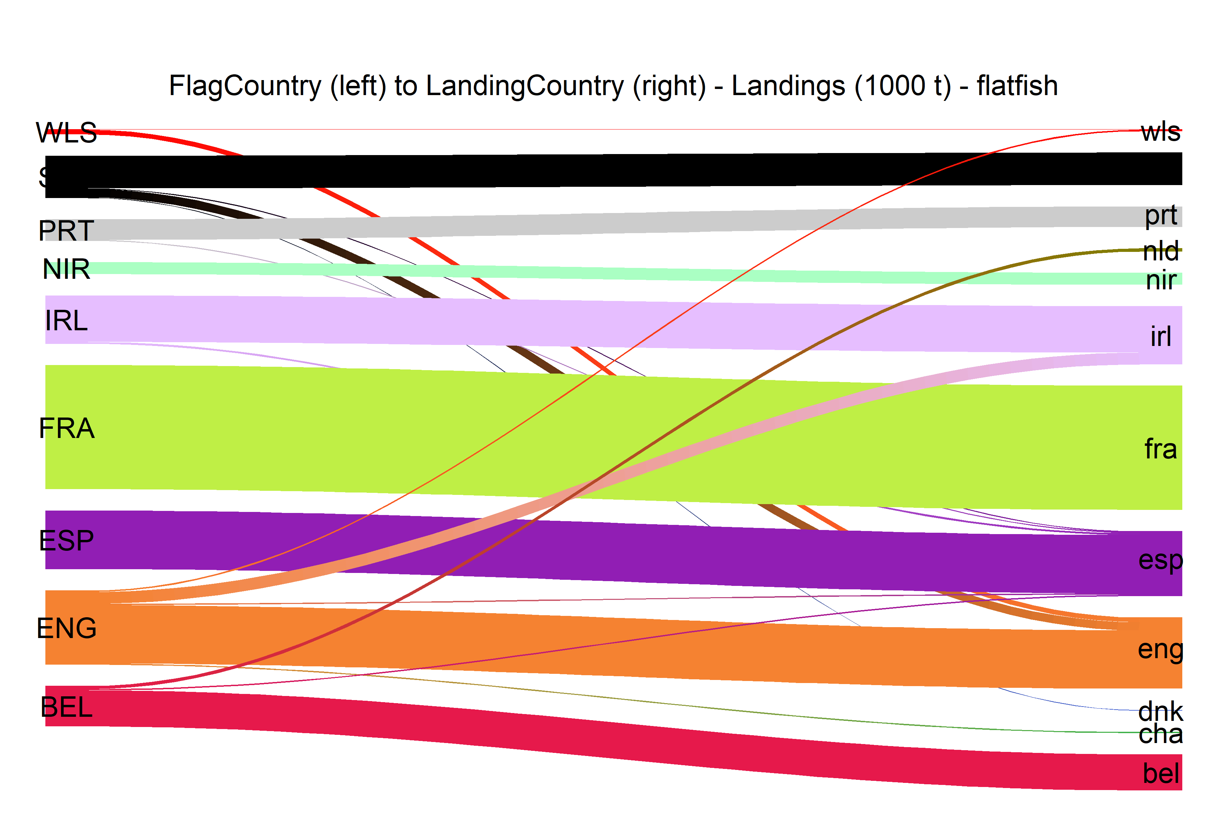  
Figure 3.4.7.1.River plot of Landings (1000 t) between Country (left) and Landing Country (right). Width of line is proportional to landings

### Spatial distribution of landings, flatfish

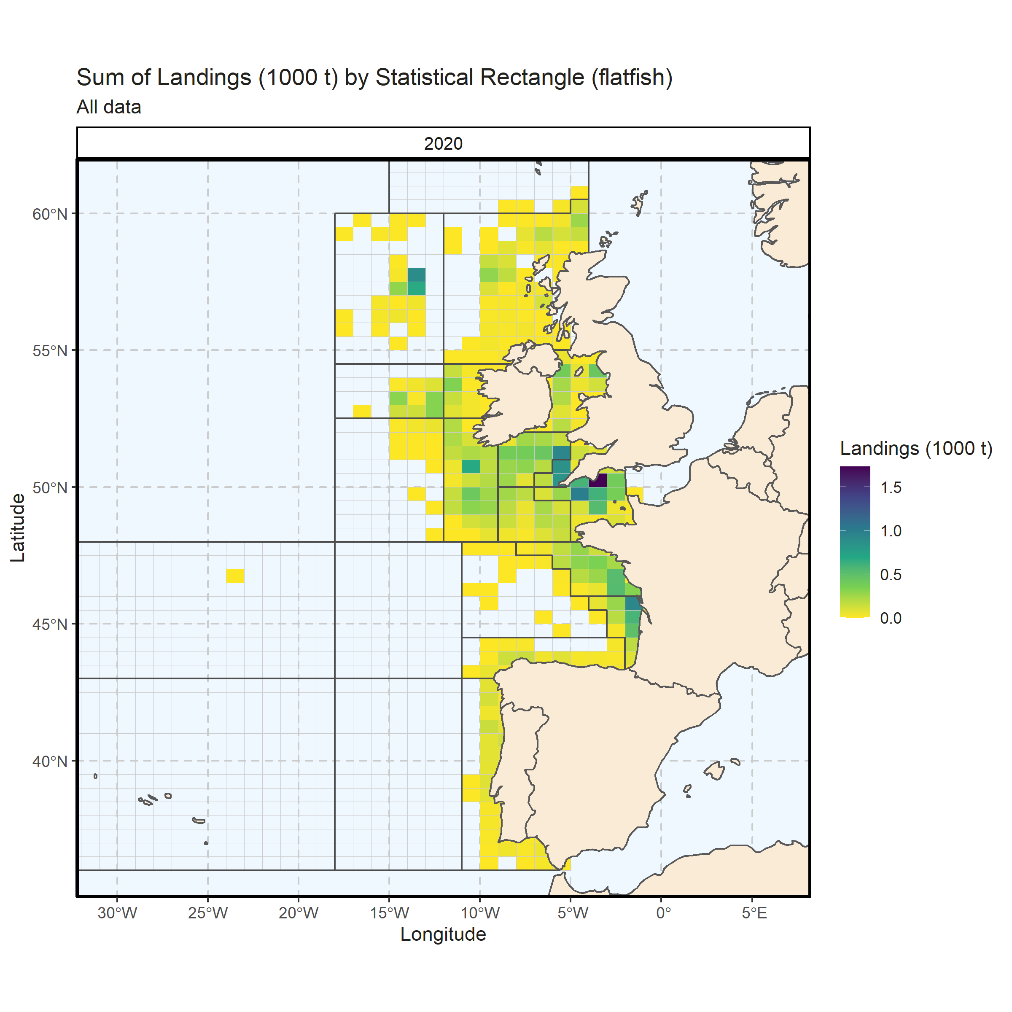 Figure 3.4.8.1. Sum of Landings (1000 t) by Statistical Rectangle (flatfish). All data. 0.19% of Landings (1000 t) - reported for missing Statistical Rectangle. 1 Statistical Rectangle with missing coordinates (3.77% of Landings (1000 t)) - not presented on the map.

# Effort (CE)

## Effort by country

### Overall

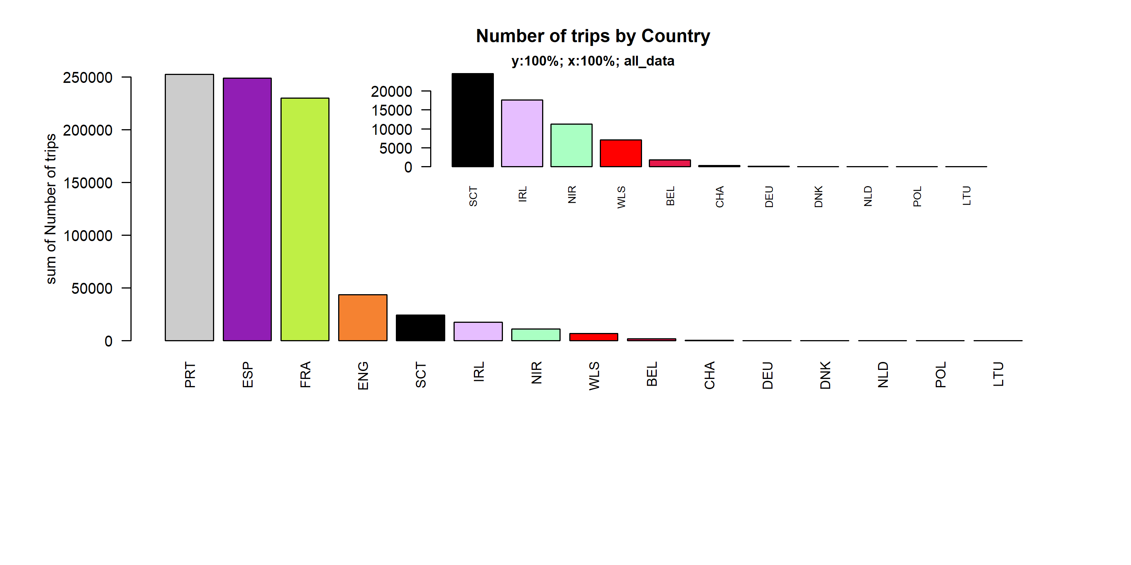 Figure 4.1.1.1. Number of trips by Country.

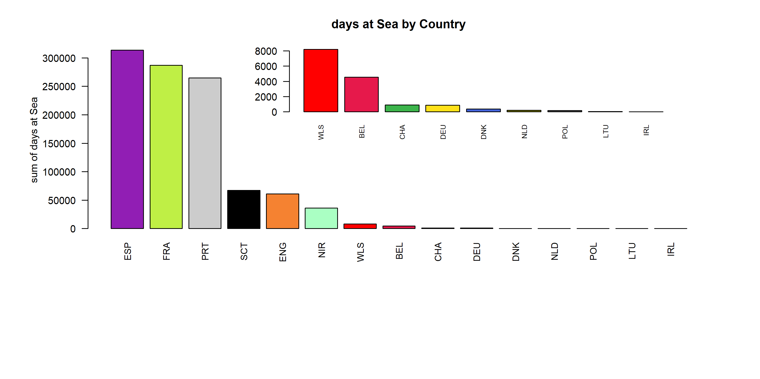 Figure 4.1.1.2. days at Sea by Country ( represent 87.53 % of all days at Sea )

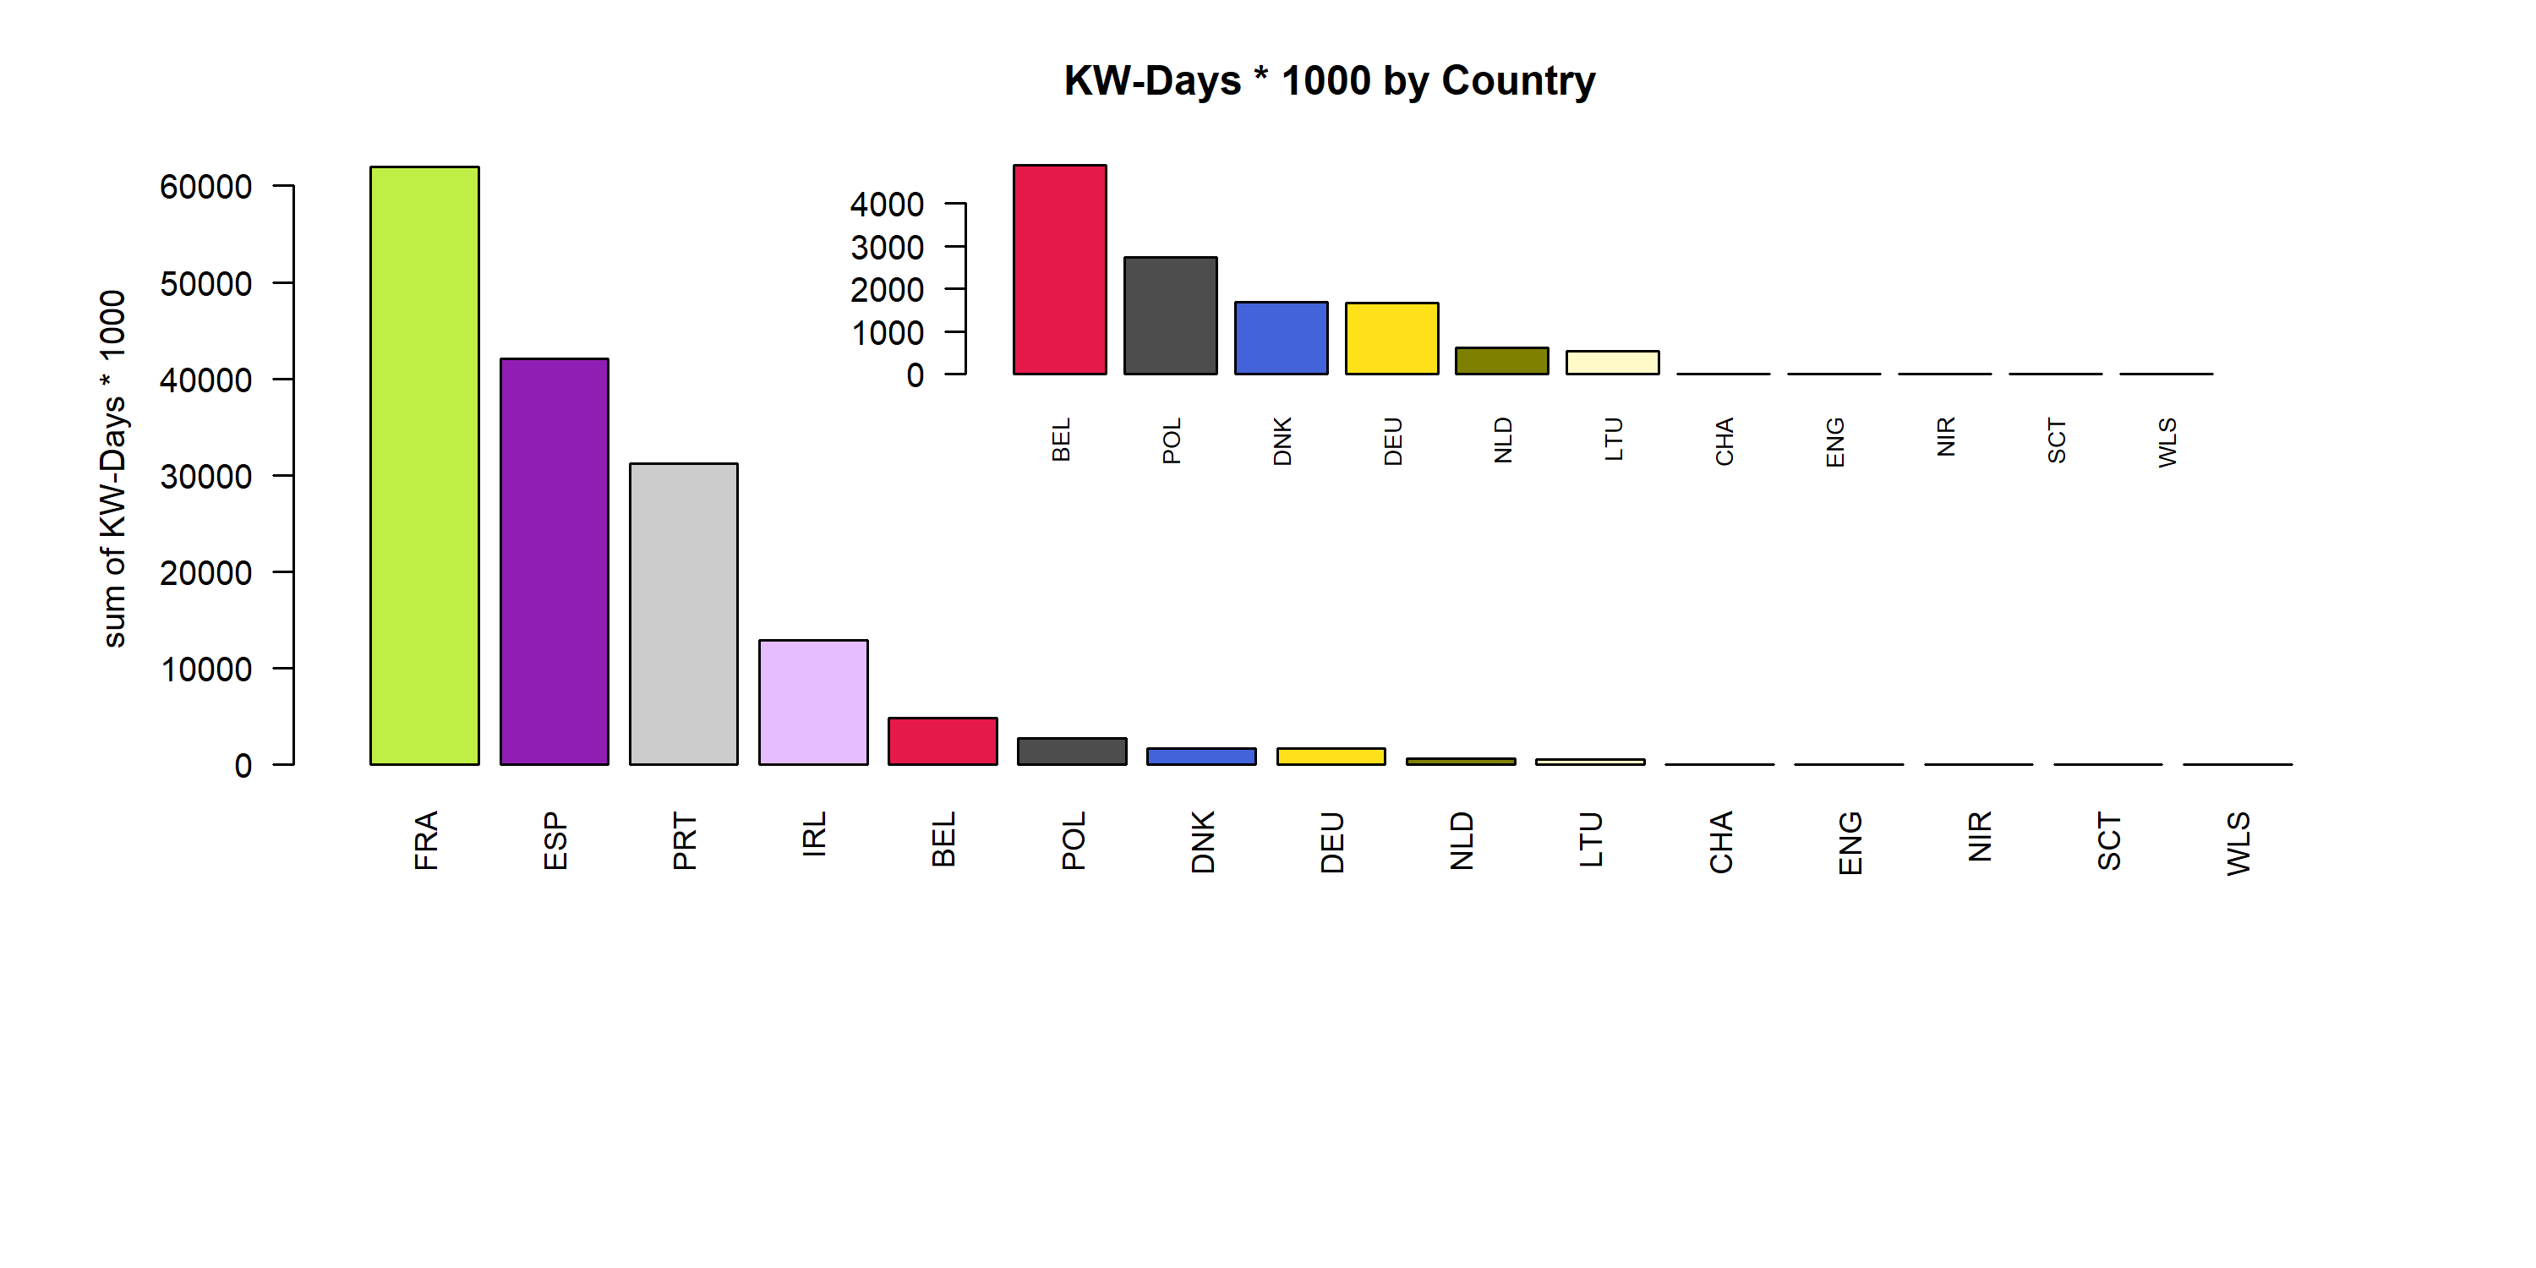 Figure 4.1.1.3. KW-Days * 1000 by Country ( represent 77.83 % of all KW-Days * 1000 )

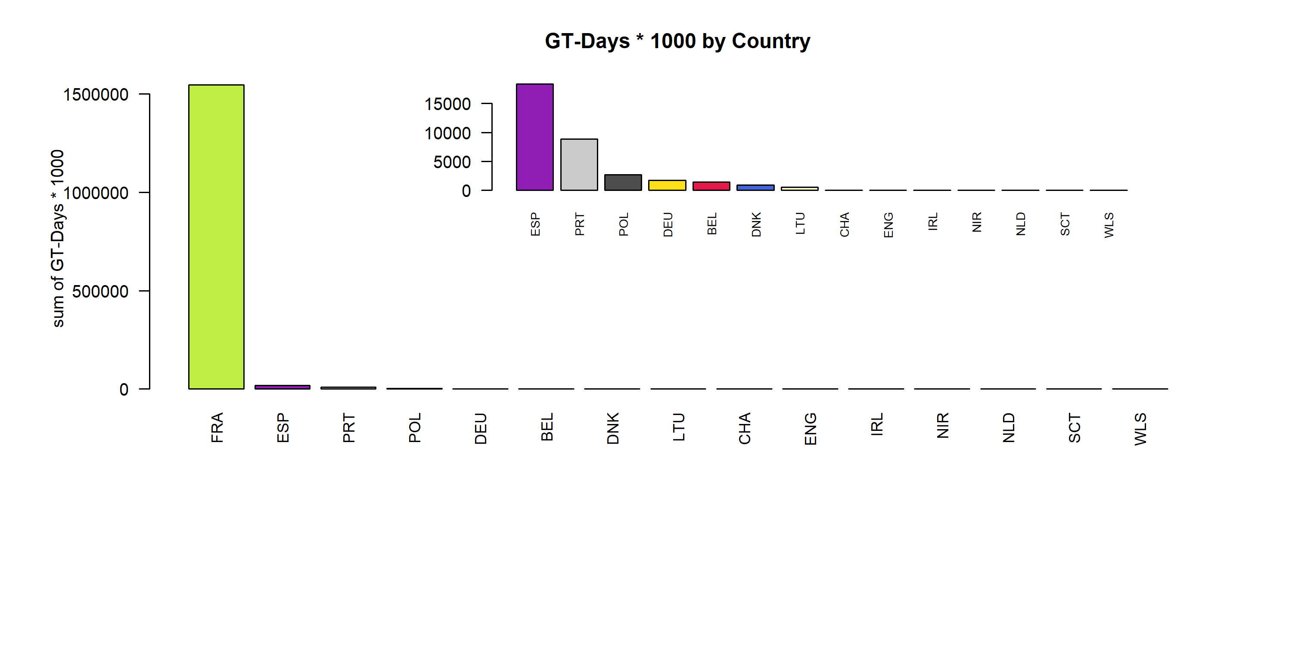 Figure 4.1.1.4. GT-Days * 1000 by Country ( represent 69.11 % of all GT-Days * 1000 )

## Effort by fleet

### Overall

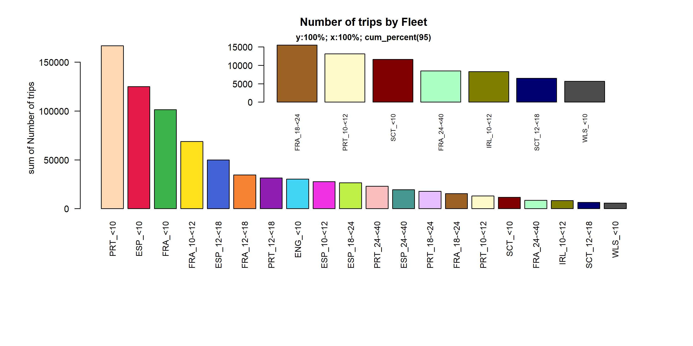 Figure 4.2.1.1. Number of trips by Fleet. Fleet displayed comprise 95% of the total Number of trips.

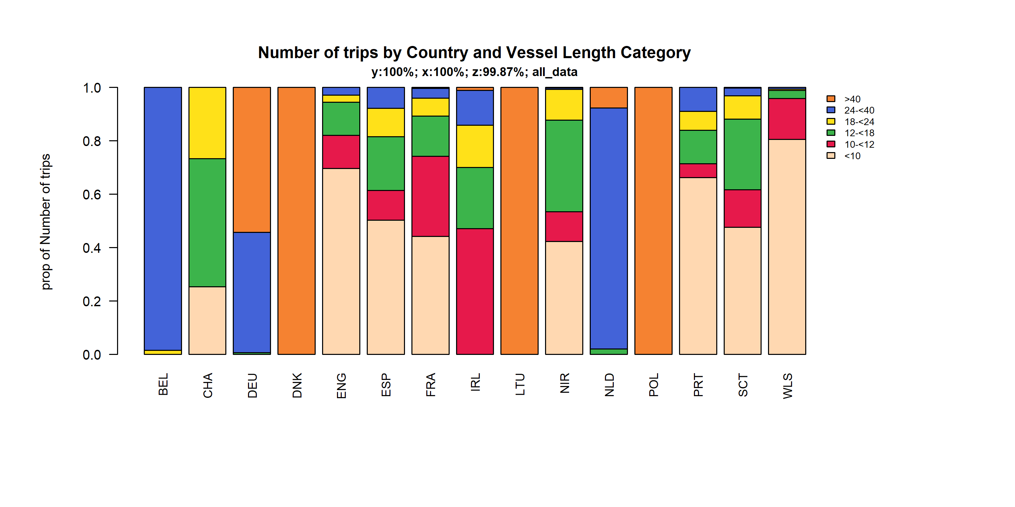 Figure 4.2.1.2. Number of trips by Country and Vessel Length Category. TheVessel Length Category was given for 99.87% of observations.

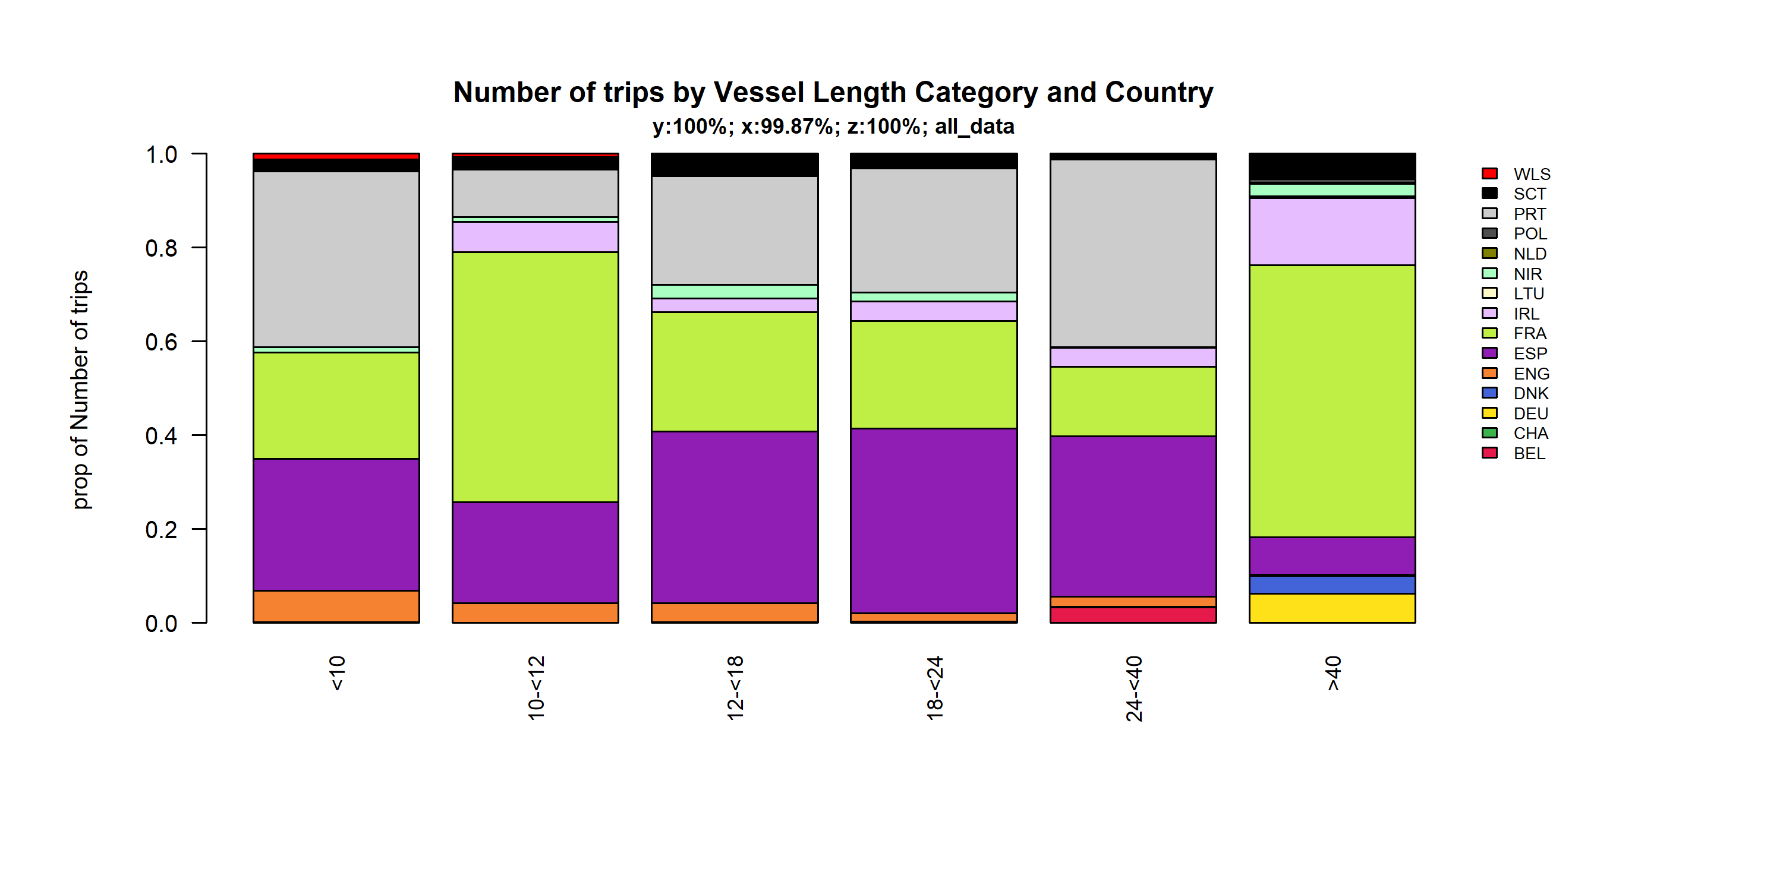 Figure 4.2.1.3. Number of trips by Vessel Length Category and Country. TheVessel Length Category was given for 99.87% of observations.

## Effort by area

### Below 10 meters

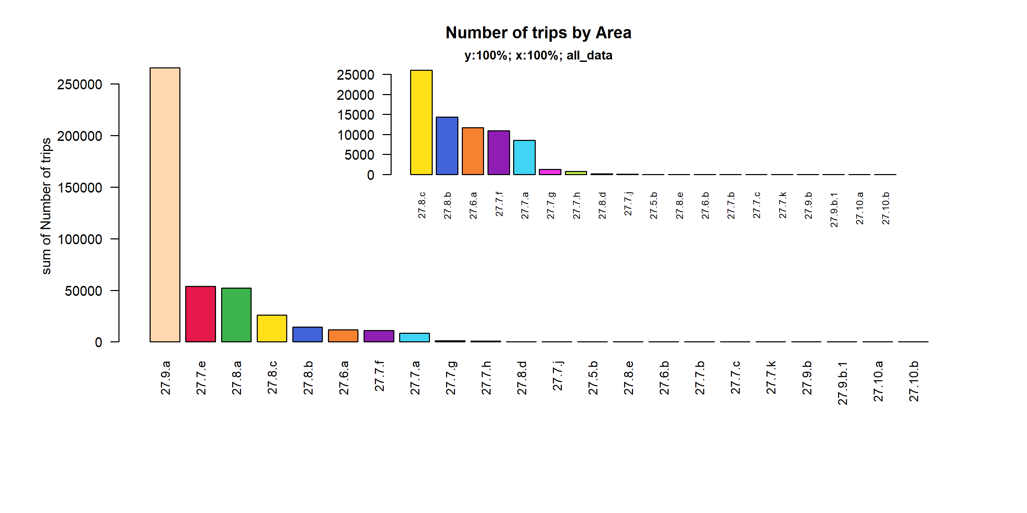 Figure 4.3.1.1. Number of trips by Area.

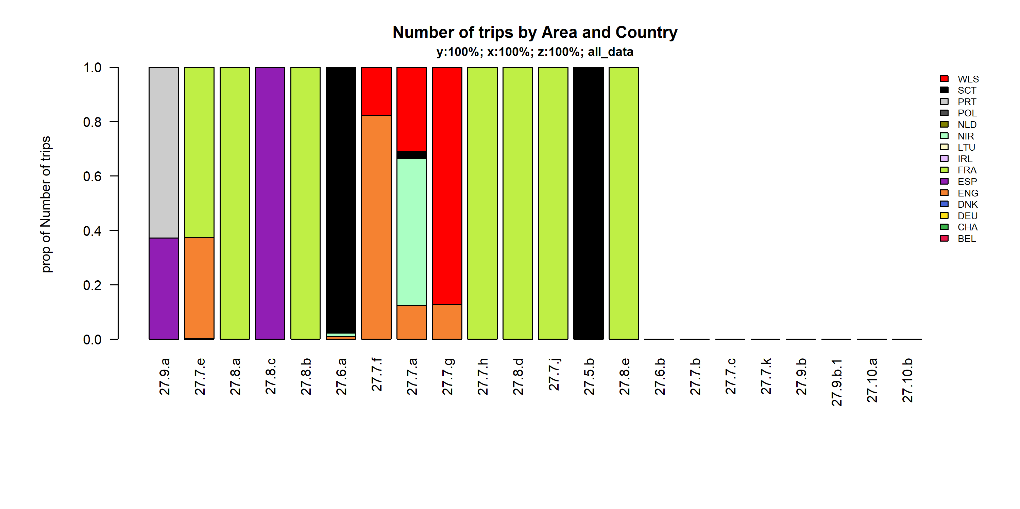 Figure 4.3.1.2. Number of trips by Area and Country.

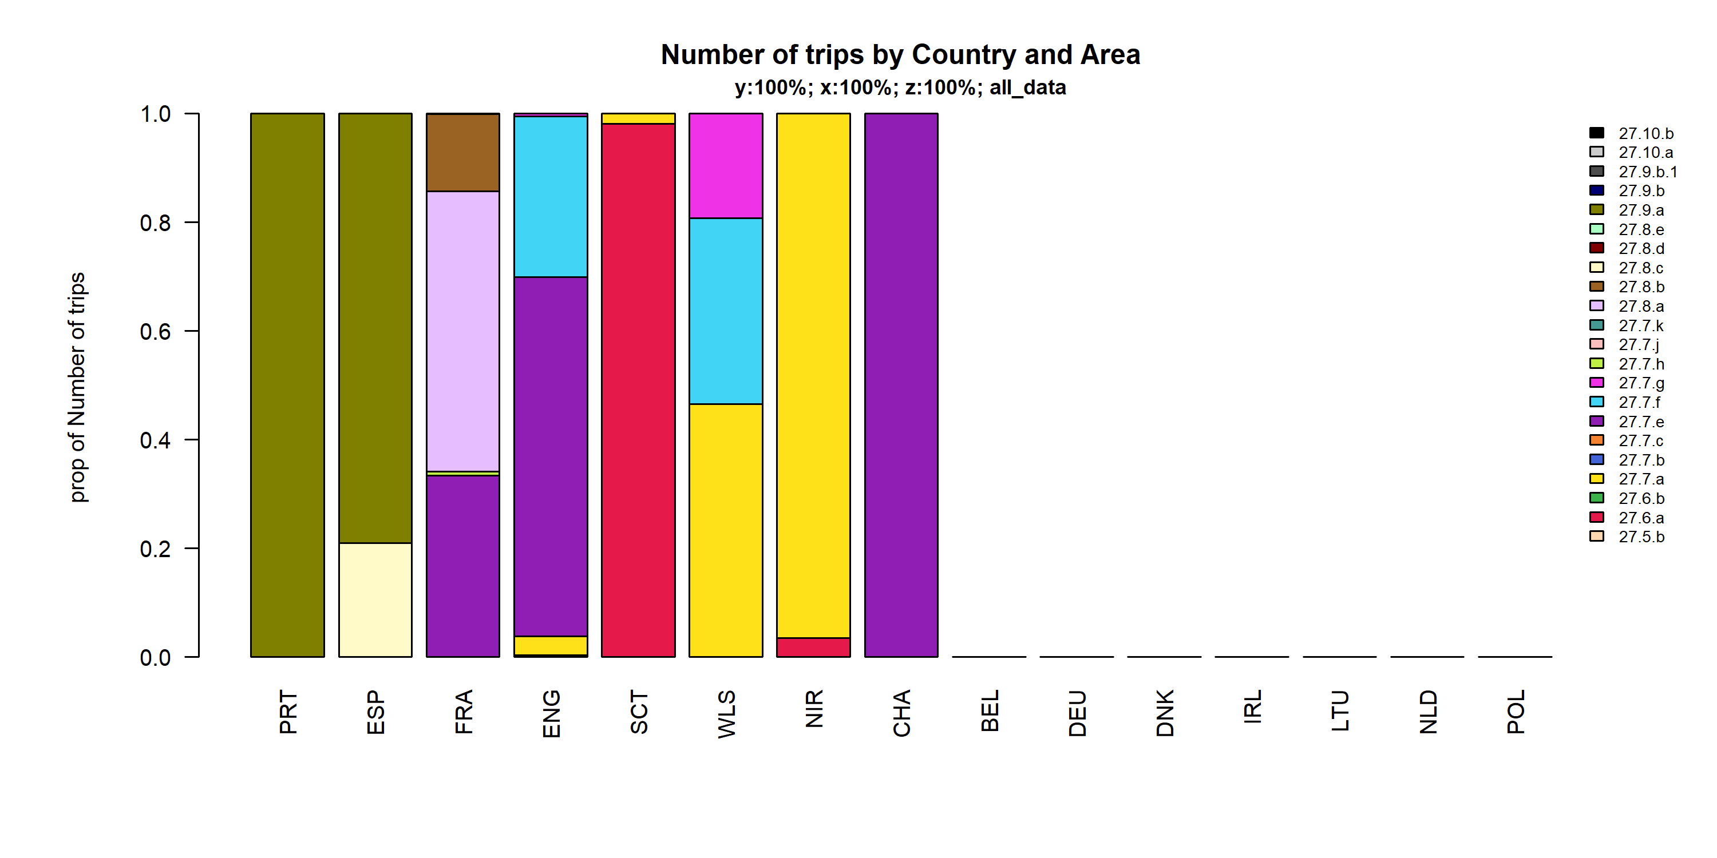 Figure 4.3.1.3. Number of trips by Country and Area.

### 10 meter and above

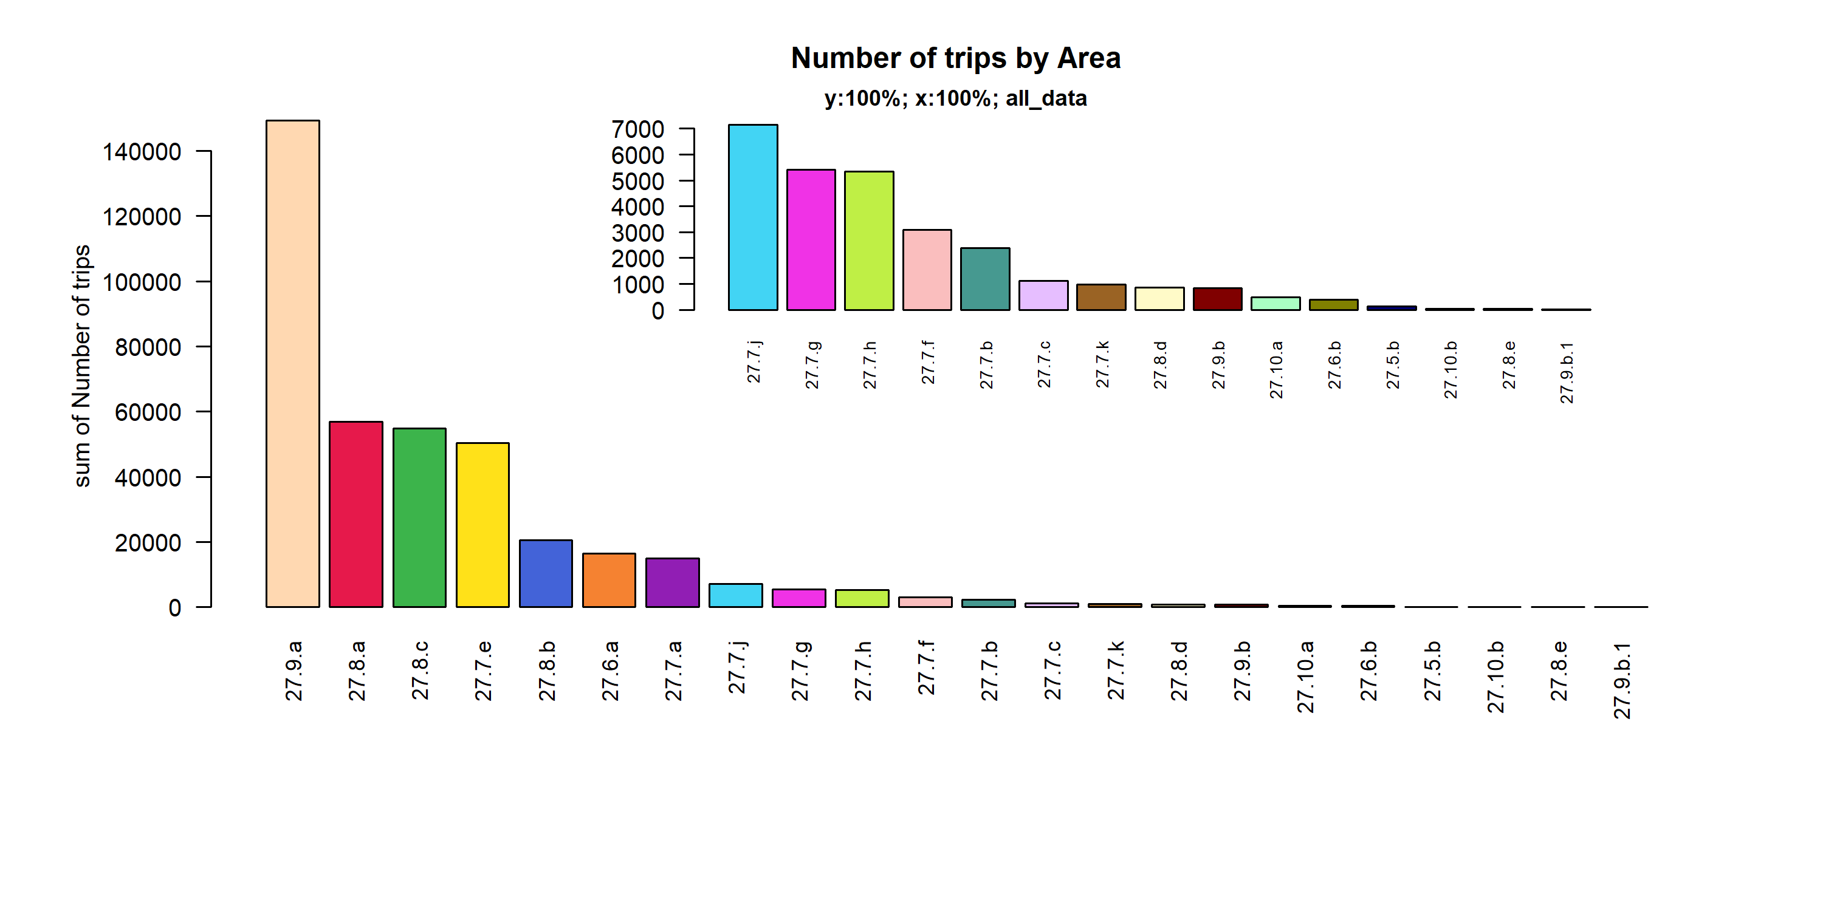 Figure 4.3.2.1. Number of trips by Area.

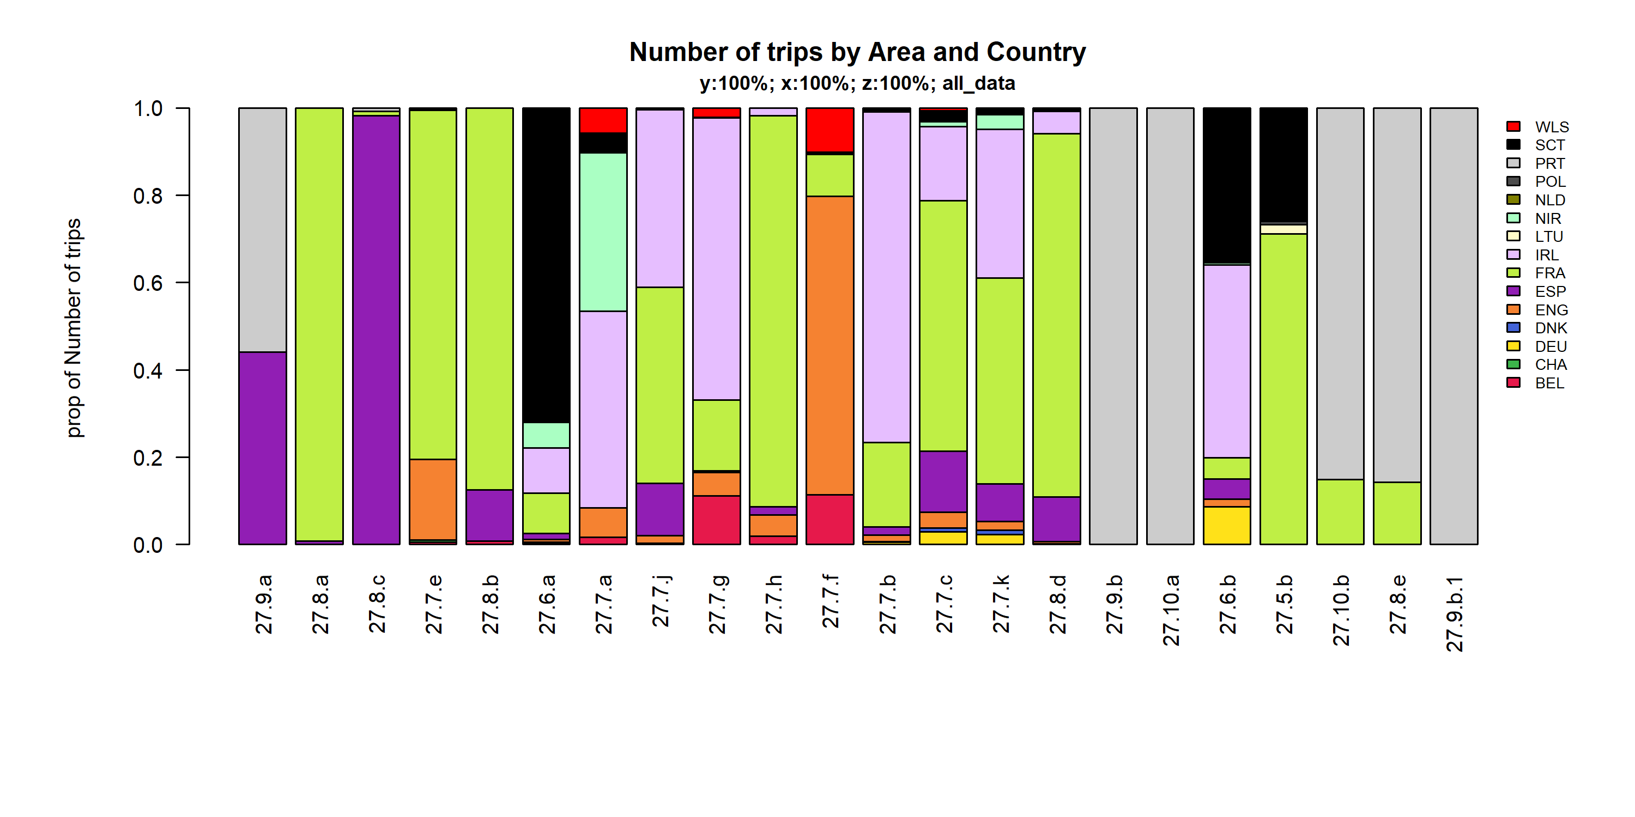 Figure 4.3.2.2. Number of trips by Area and Country.

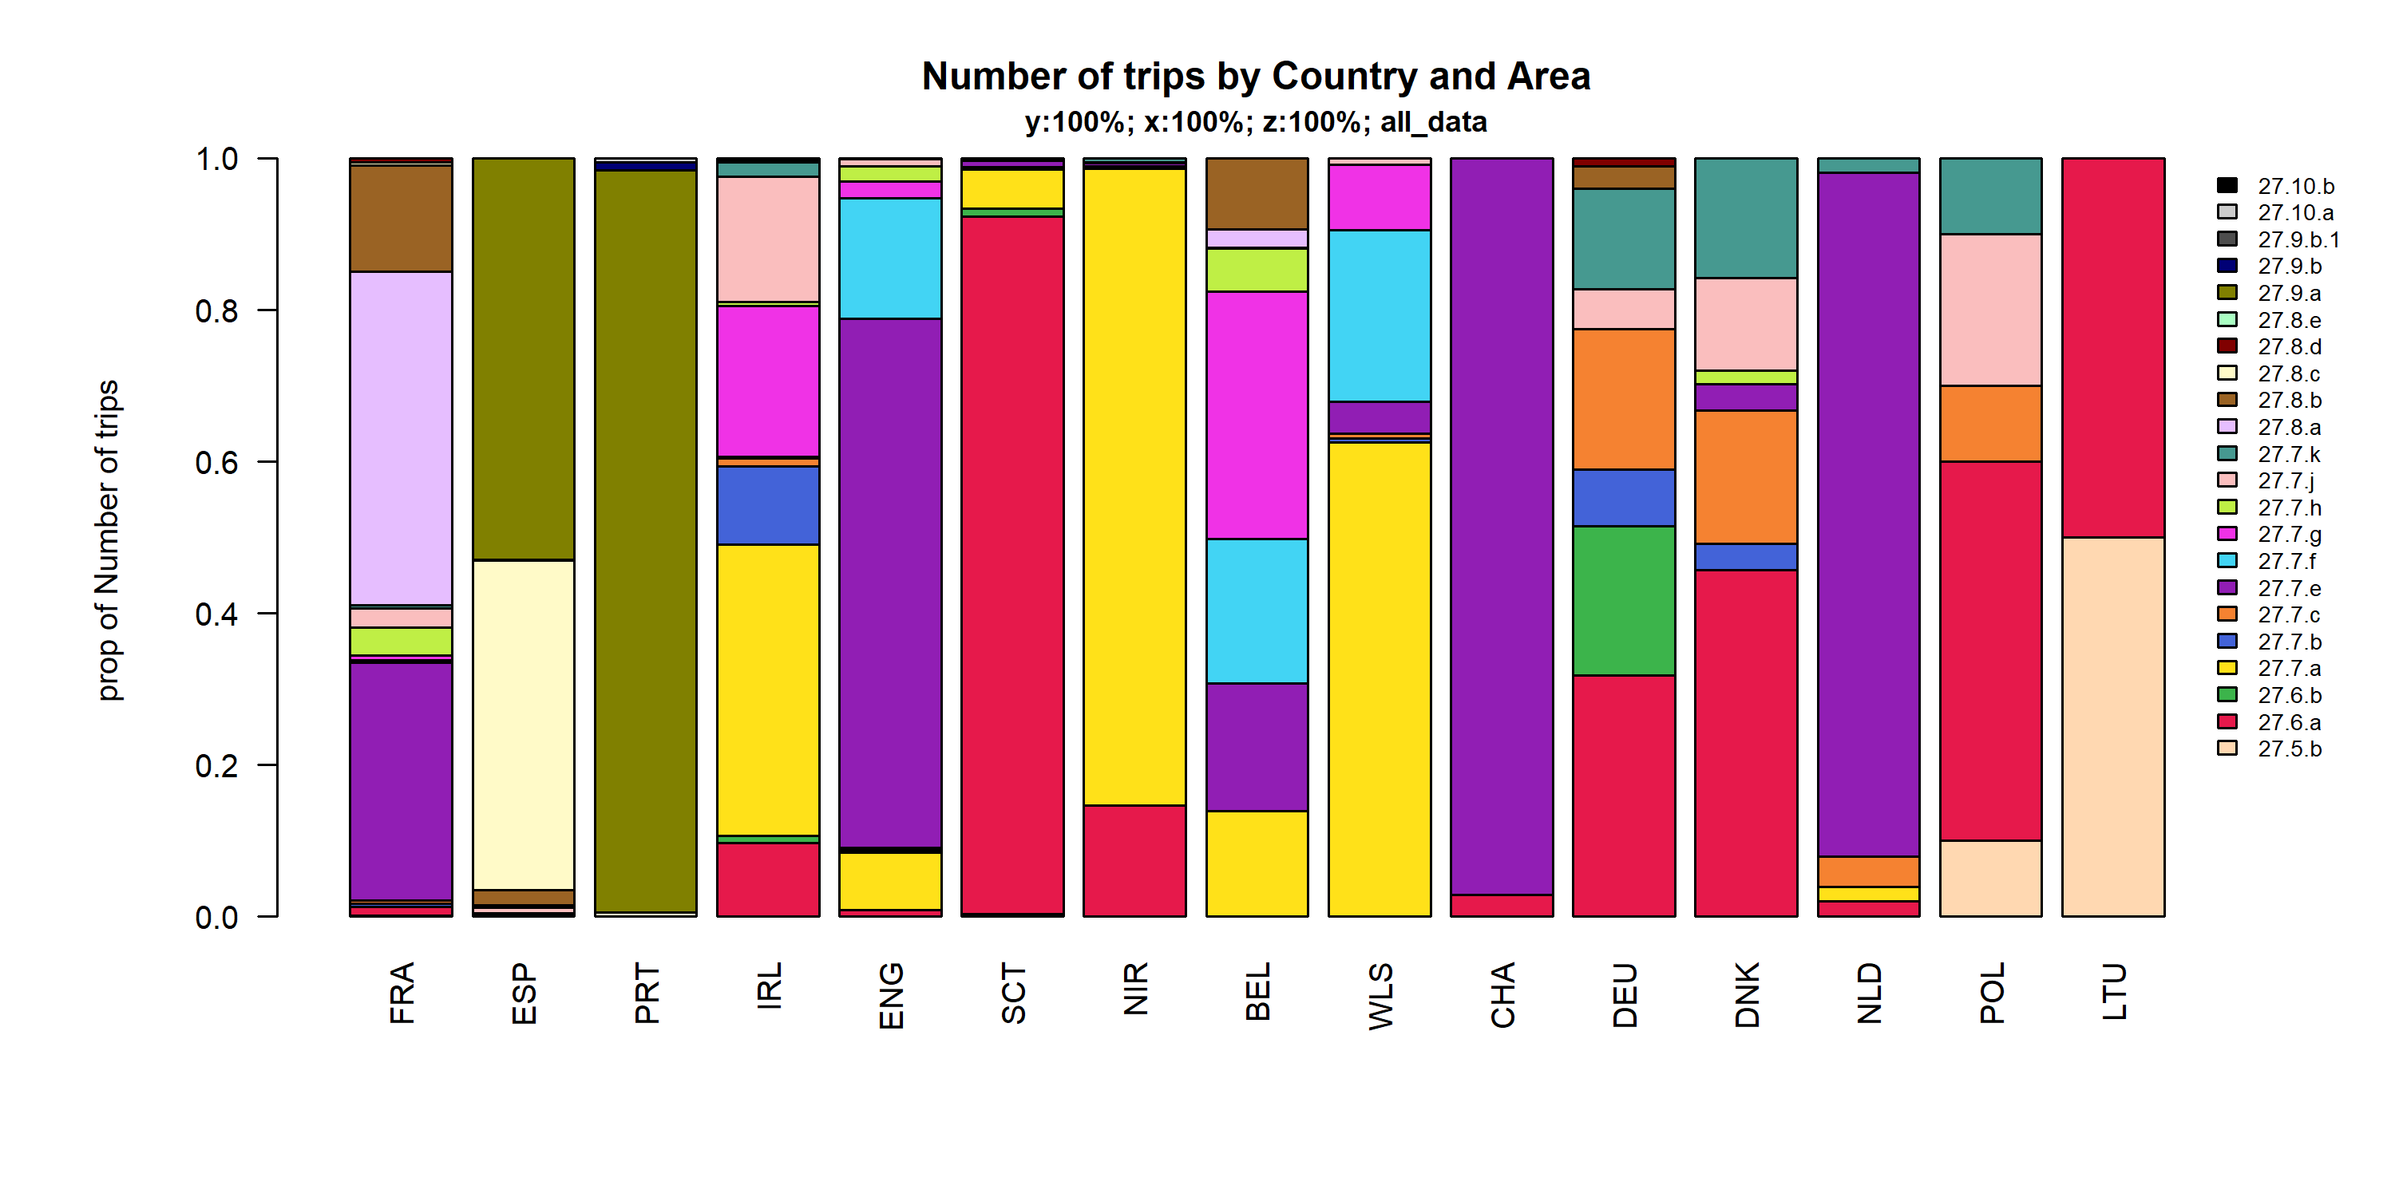 Figure 4.3.2.3. Number of trips by Country and Area.

## Effort by metier

### Below 10 meters

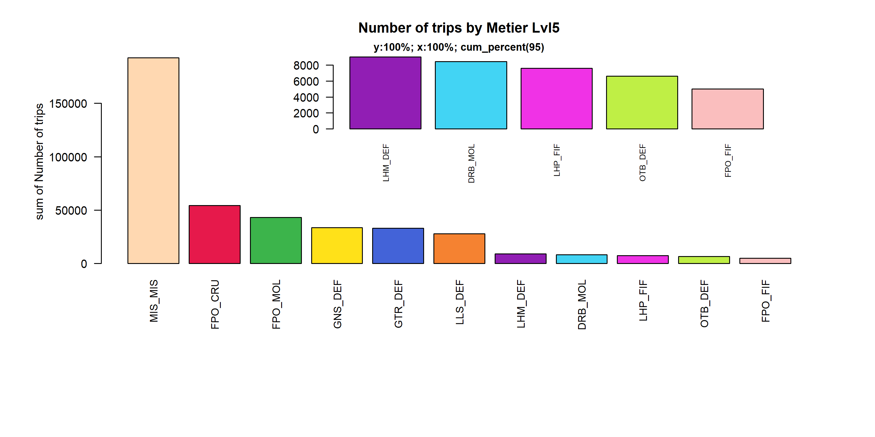 Figure 4.4.1.1. Number of trips by Metier Lvl5. Metier Lvl5 displayed comprise 95% of the total Number of trips.

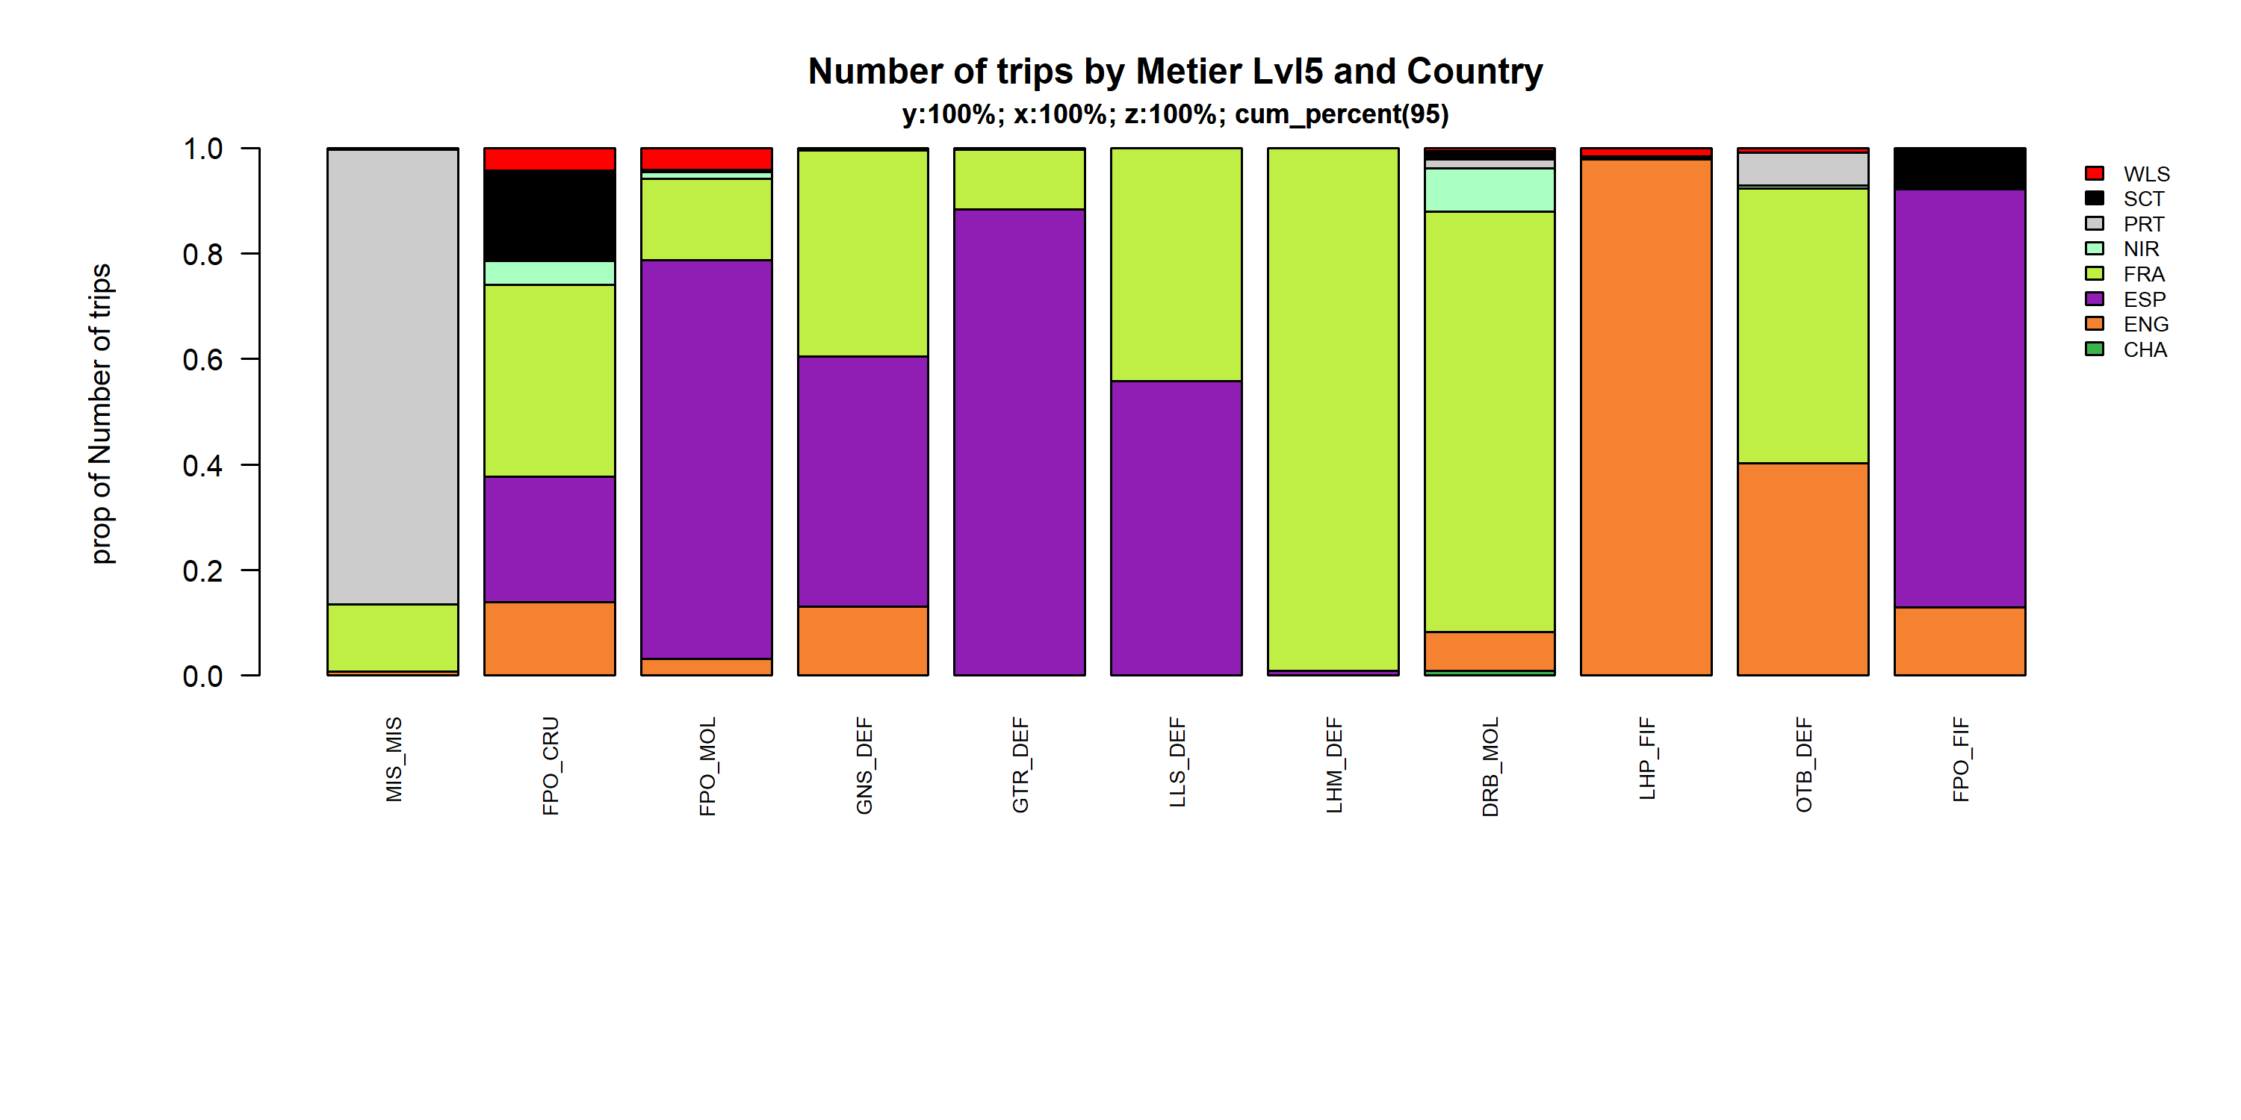 Figure 4.4.1.2. Number of trips by Metier Lvl5 and Country . Metier Lvl5 and Country displayed comprise 95 % of the total Number of trips .

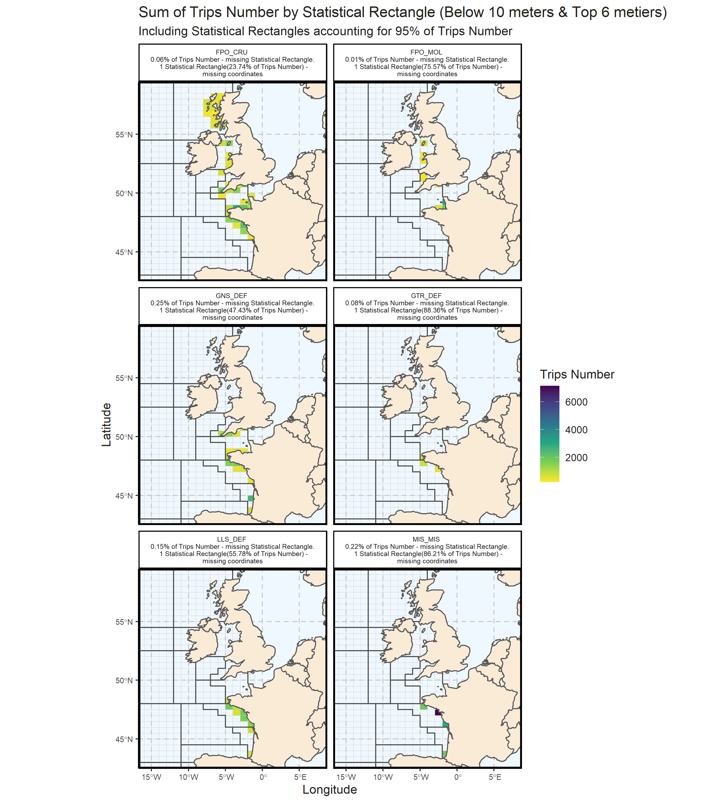 Figure 4.4.1.3. Sum of Trips Number by Statistical Rectangle (Below 10 meters & Top 6 metiers) . Including Statistical Rectangles accounting for 95% of Trips Number .

### 10 meter and above

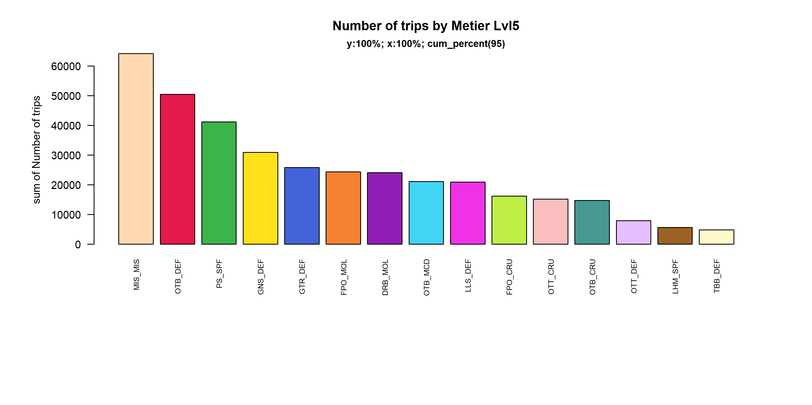 Figure 4.4.2.1. Number of trips by Metier Lvl5. Metier Lvl5 displayed comprise 95% of the total Number of trips.

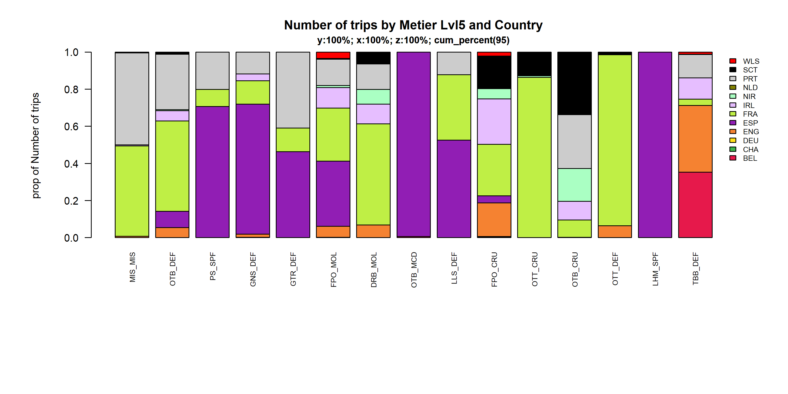 Figure 4.4.2.2. Number of trips by Metier Lvl5 and Country . Metier Lvl5 and Country displayed comprise 95 % of the total Number of trips .

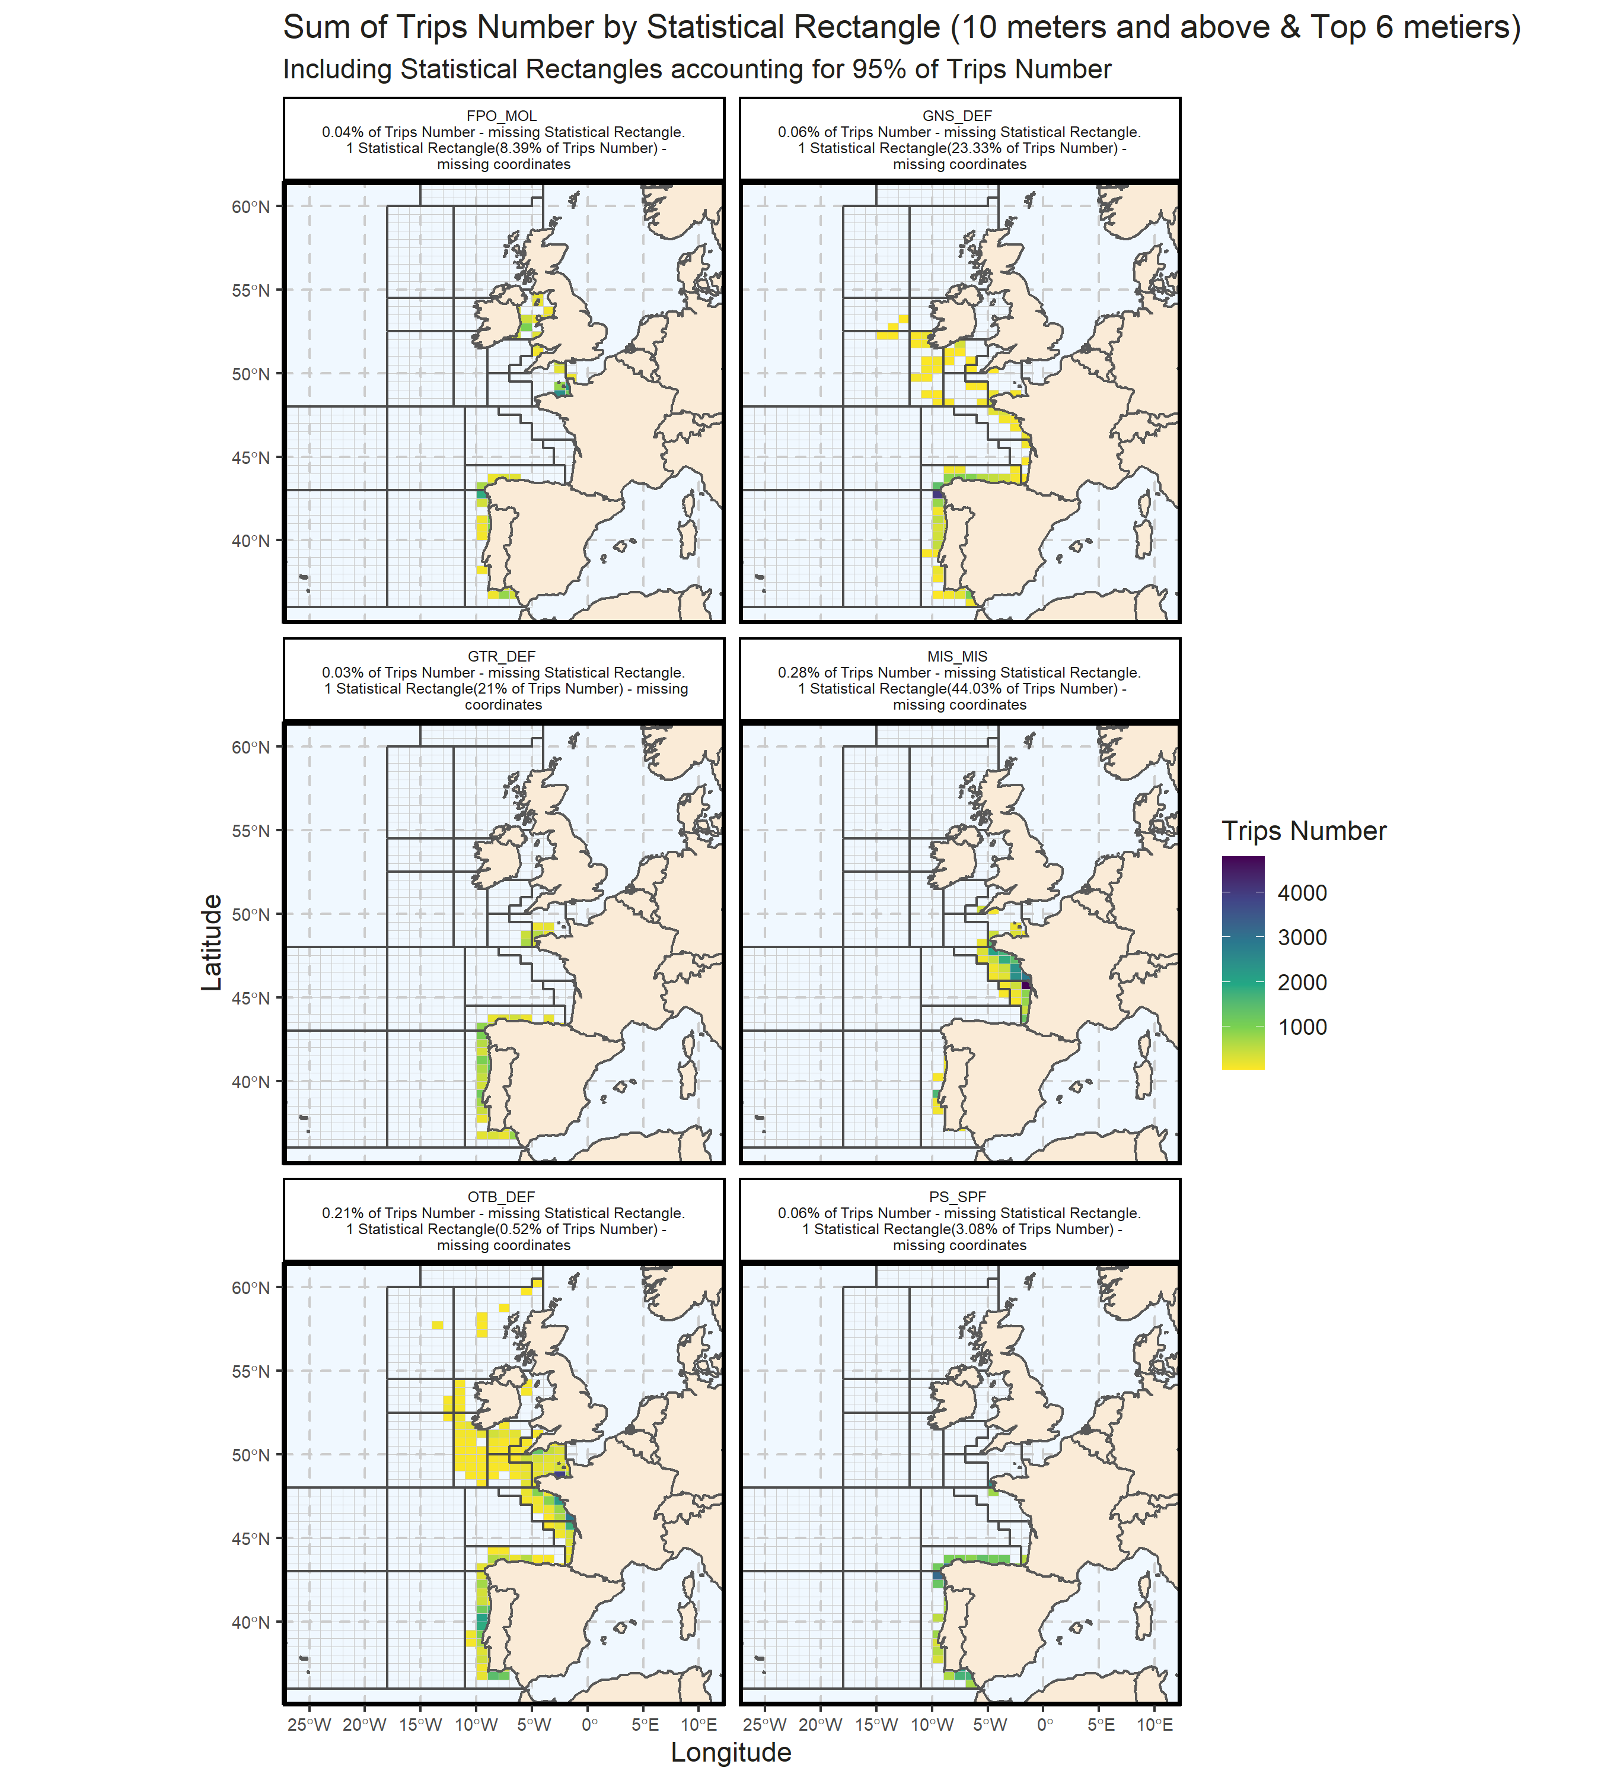 Figure 4.4.2.3. Sum of Trips Number by Statistical Rectangle (10 meters and above & Top 6 metiers) . Including Statistical Rectangles accounting for 95% of Trips Number .

## Effort by harbour

### Below 10 meters

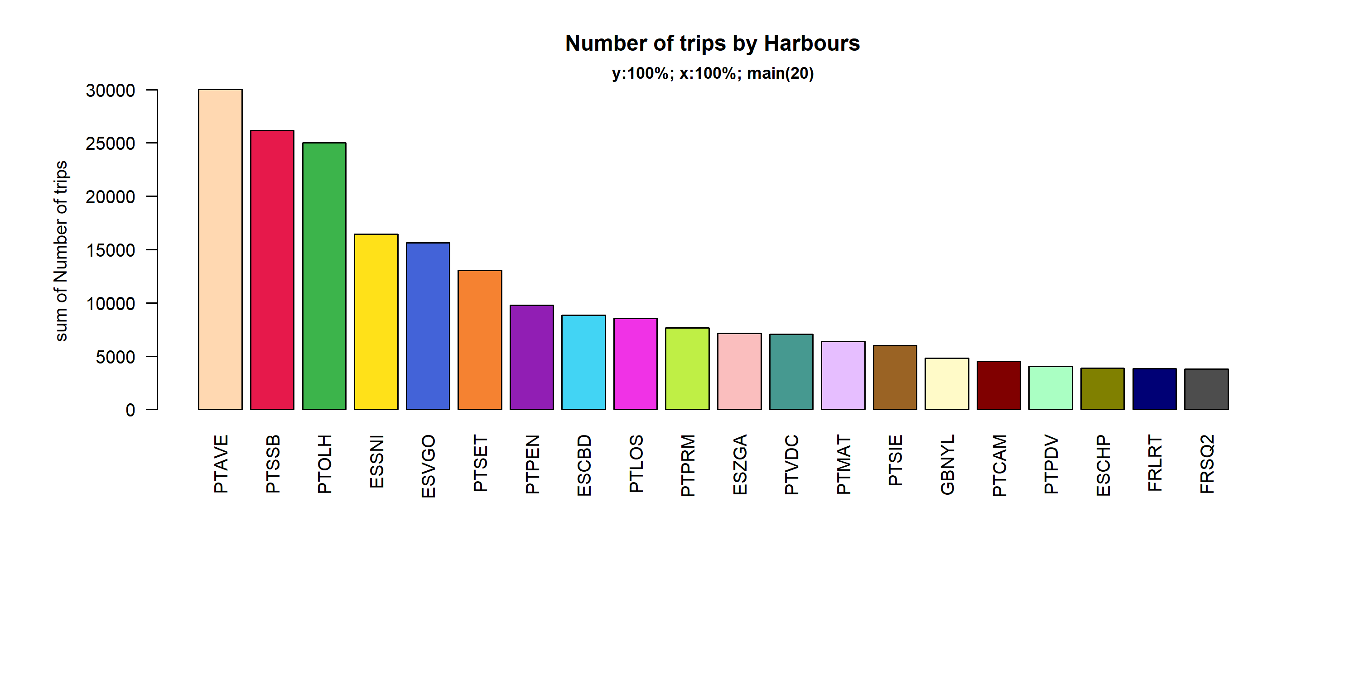 Figure 4.5.1.1. Number of trips in the 20 main Harbours ( 100% of rows entering analysis had known Harbours).

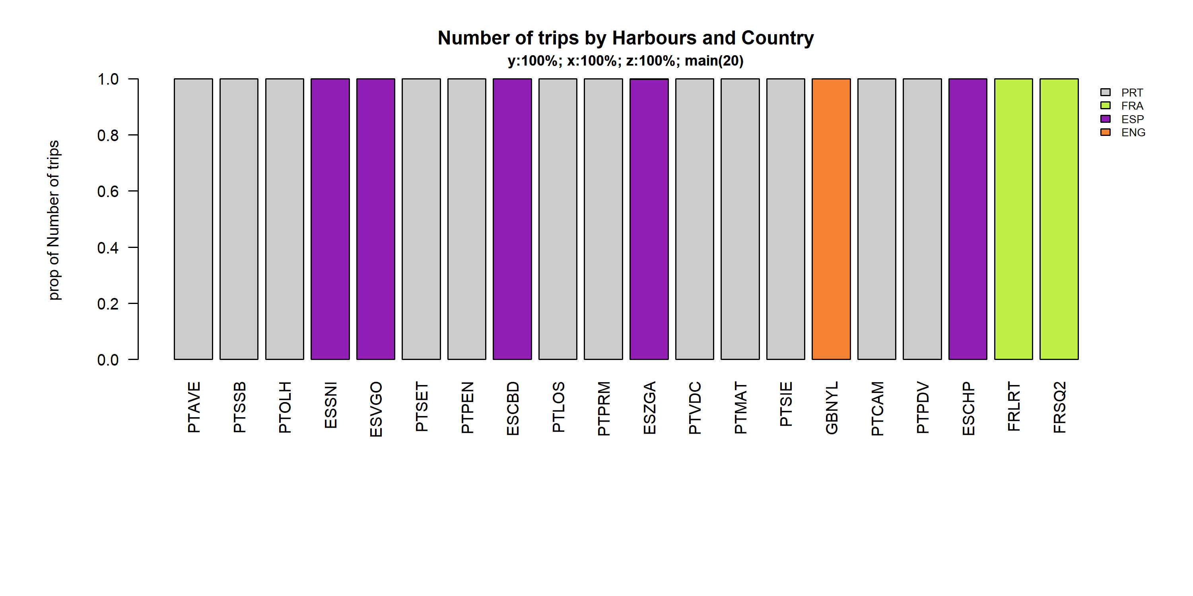 Figure 4.5.1.2. Number of trips by 20 main Harbours and Country .

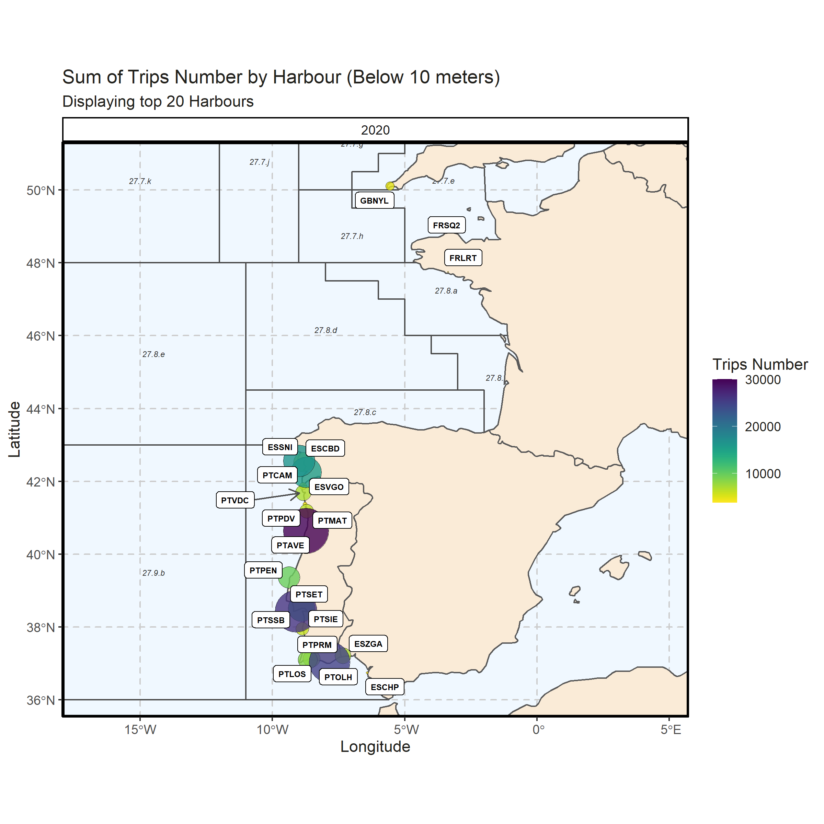 Figure 4.5.1.3. Sum of Trips Number by Harbour (Below 10 meters). Displaying top 20 Harbours. 0% of Trips Number - reported for missing Harbour

### 10 meter and above

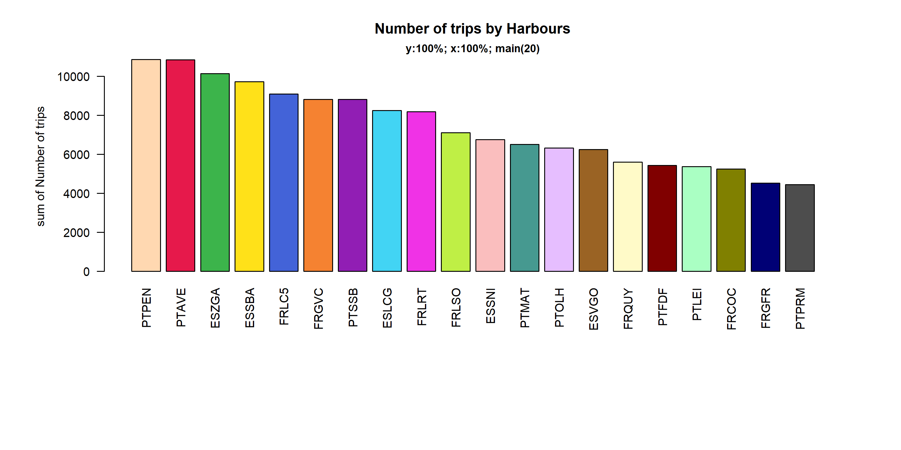 Figure 4.5.2.1. Number of trips in the 20 main Harbours ( 100% of rows entering analysis had known Harbours).

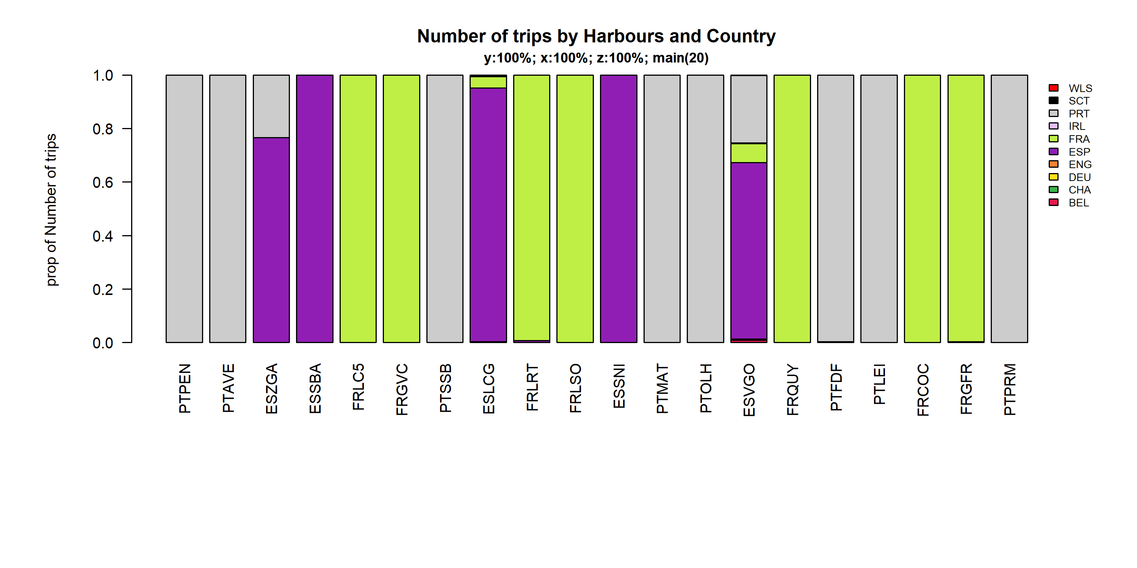 Figure 4.5.2.2. Number of trips by 20 main Harbours and Country .

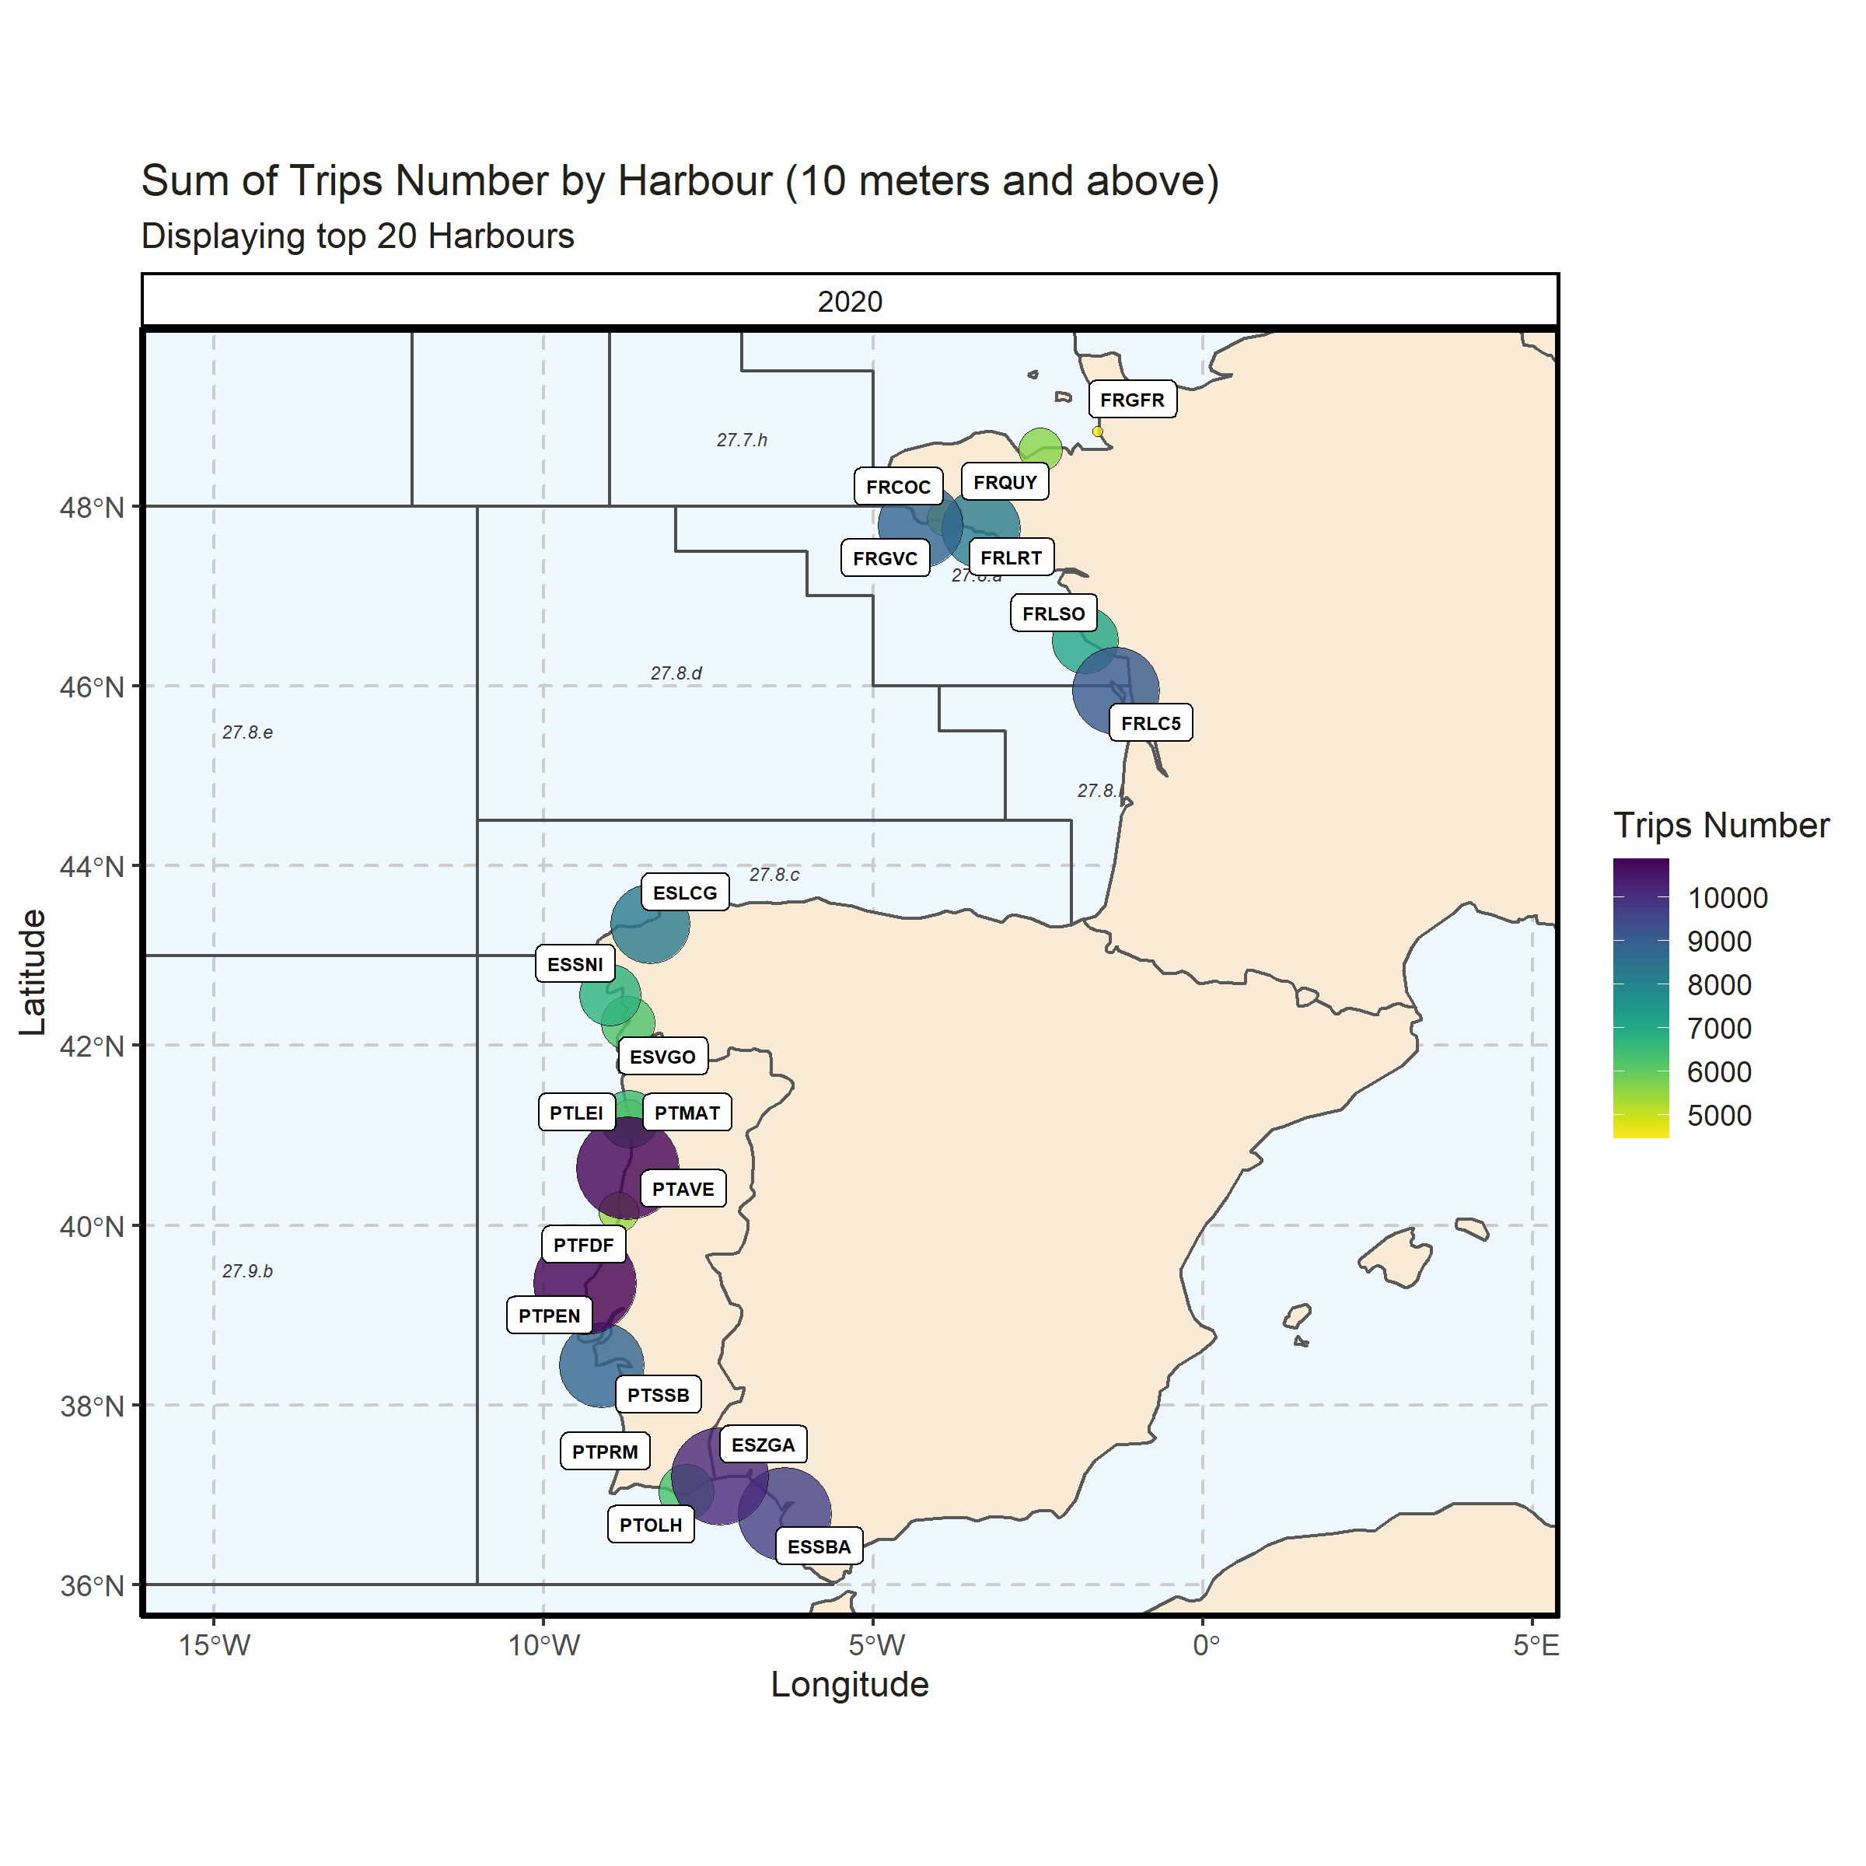 Figure 4.5.2.3. Sum of Trips Number by Harbour (10 meters and above). Displaying top 20 Harbours. ~0% of Trips Number - reported for missing Harbour

## Spatial distribution of effort

### Below 10 meters

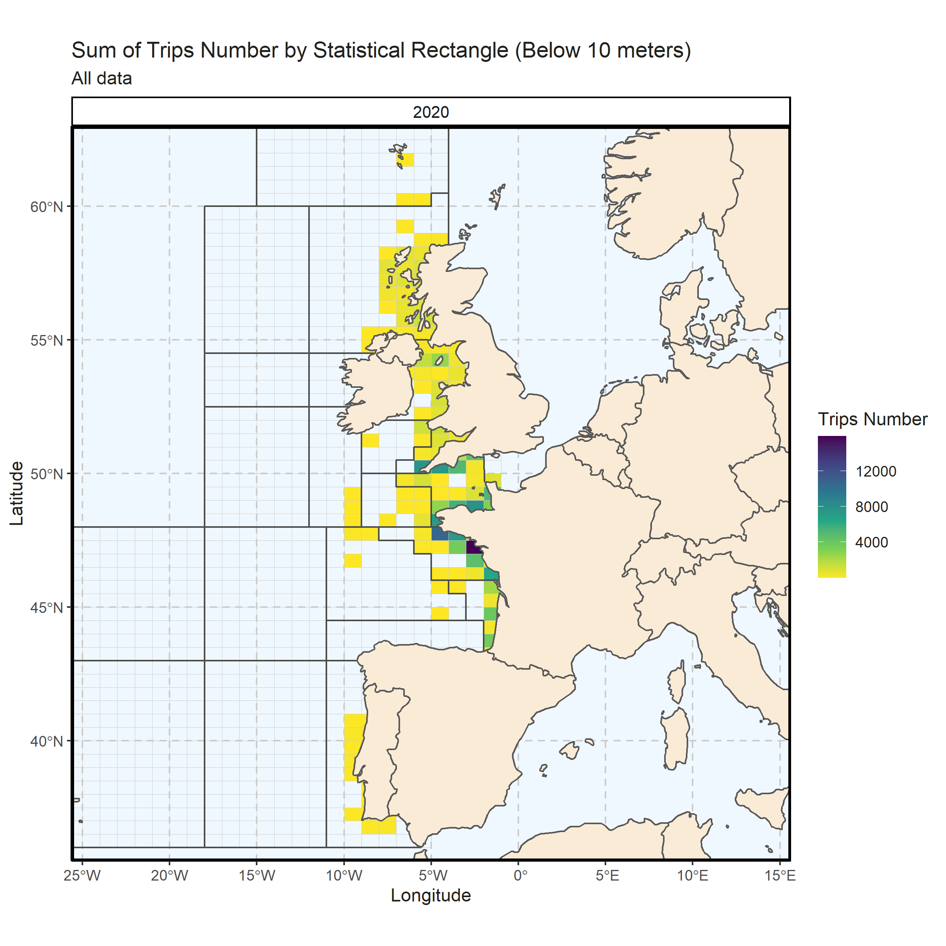 Figure 4.6.1.1. Sum of Trips Number by Statistical Rectangle (Below 10 meters). All data. 0.17% of Trips Number - reported for missing Statistical Rectangle. 1 Statistical Rectangle with missing coordinates (65.31% of Trips Number) - not presented on the map.

### 10 meter and above

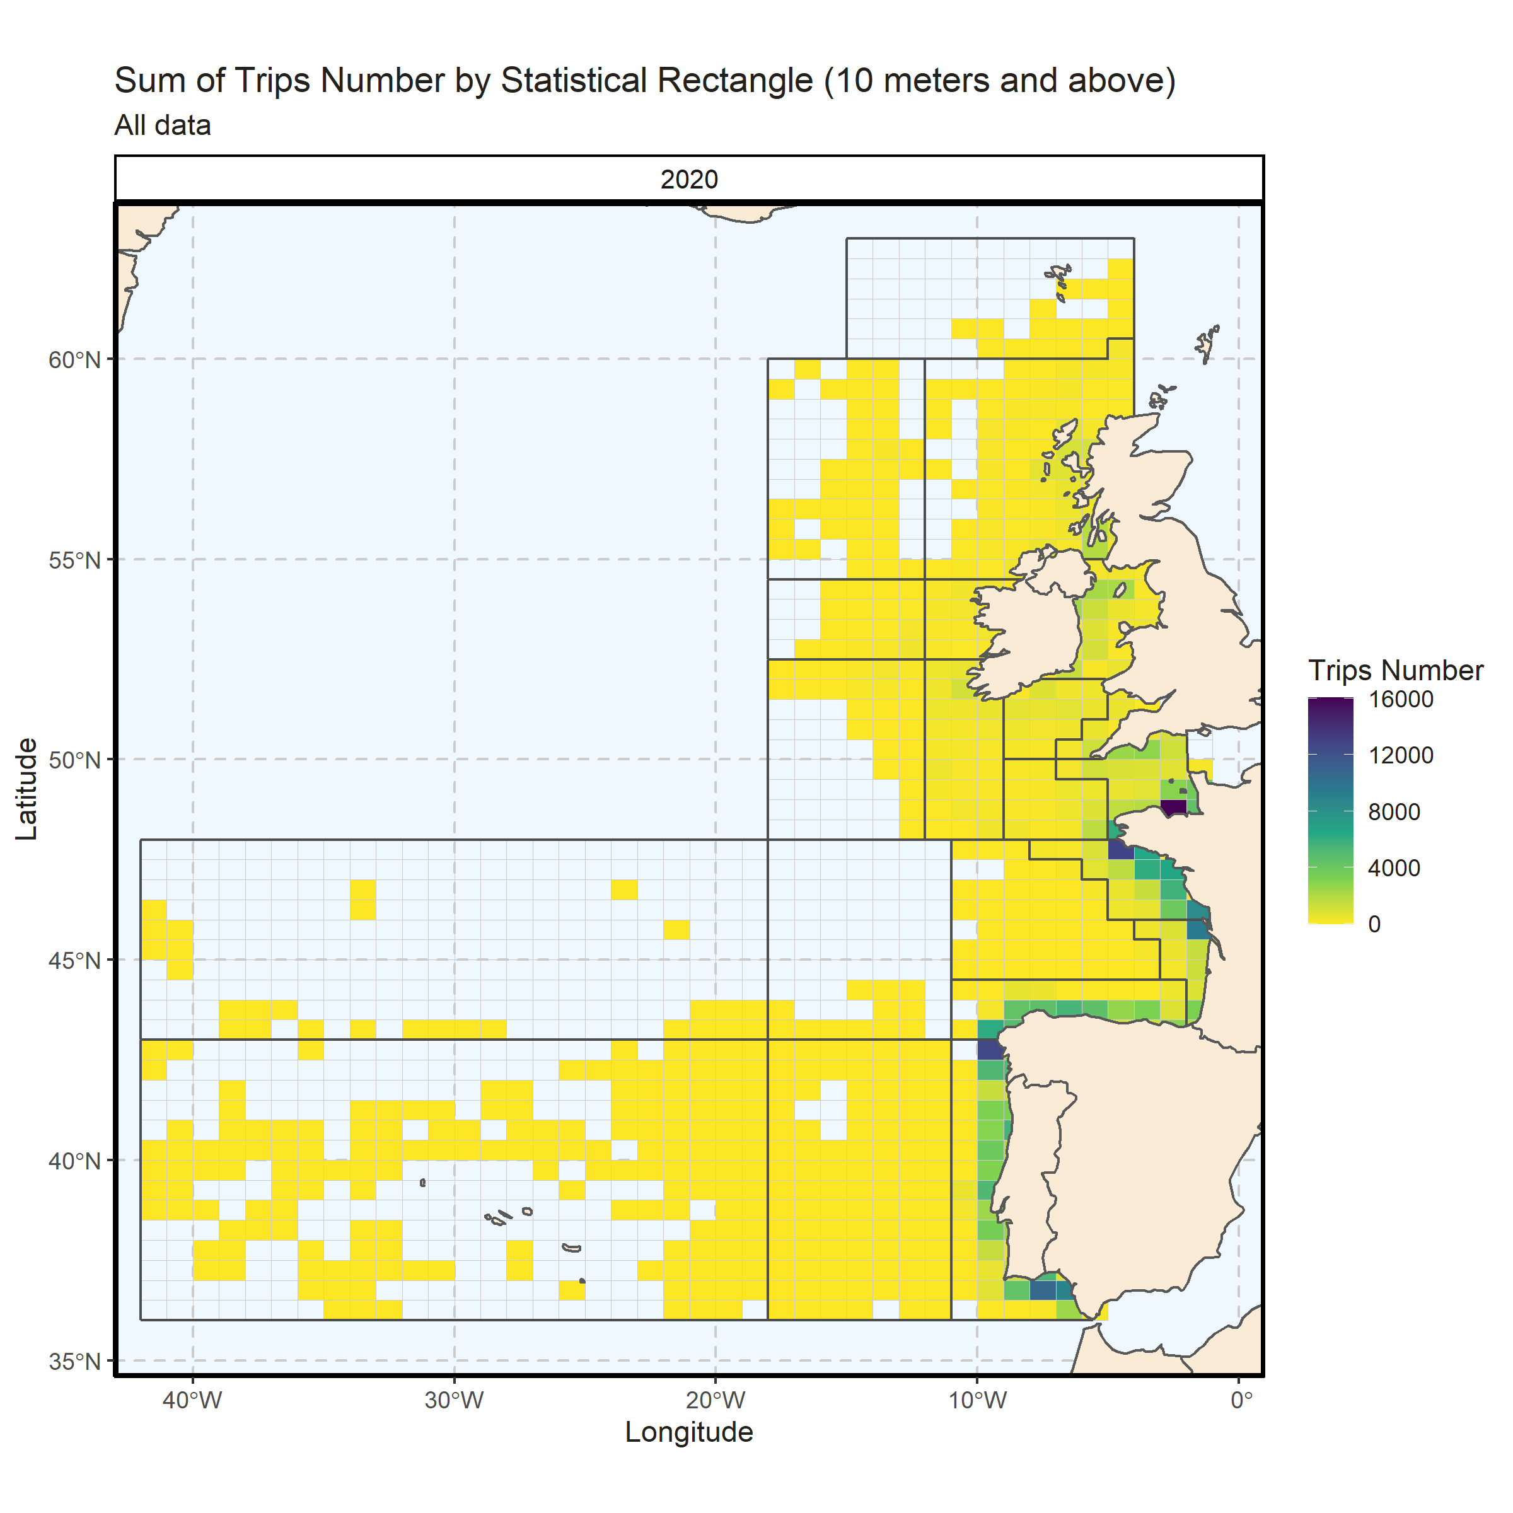 Figure 4.6.2.1. Sum of Trips Number by Statistical Rectangle (10 meters and above). All data. 0.15% of Trips Number - reported for missing Statistical Rectangle. 2 Statistical Rectangle with missing coordinates (14.45% of Trips Number) - not presented on the map.

###### Page break

#### Dates of data extraction

The data referring to the present year was collected under the RCG 2021 data call for the 2020 data for the Baltic Sea, North Sea, Eastern Arctic and the North Atlantic regions and downloaded from the system on the 24th of April 2021 with the exception of information detailed in section “2. Overall Fleet Evolution” which was extracted from the EU Fleet Register (<https://webgate.ec.europa.eu/fleet-europa/index_en>) on the 14th of April 2021.

#### Catch groups

| Region | Period | Species | Catch_group | tons |
| --- | --- | --- | --- | --- |
| NA | 2020 | Aristaeomorpha foliacea | crustaceans | 2 |
| NA | 2020 | Aristaeopsis edwardsiana | crustaceans | 45 |
| NA | 2020 | Aristeus antennatus | crustaceans | 103 |
| NA | 2020 | Brachyura | crustaceans | 12 |
| NA | 2020 | Callinectes sapidus | crustaceans | 1 |
| NA | 2020 | Cancer pagurus | crustaceans | 14065 |
| NA | 2020 | Carcinus maenas | crustaceans | 851 |
| NA | 2020 | Chaceon affinis | crustaceans | 120 |
| NA | 2020 | Crangon crangon | crustaceans | 273 |
| NA | 2020 | Crustacea | crustaceans | 3 |
| NA | 2020 | Dendrobranchiata | crustaceans | 0 |
| NA | 2020 | Galatheidae | crustaceans | 35 |
| NA | 2020 | Homarus gammarus | crustaceans | 4225 |
| NA | 2020 | Lithodes maja | crustaceans | 8 |
| NA | 2020 | Maja squinado | crustaceans | 8210 |
| NA | 2020 | Metapenaeus monoceros | crustaceans | 0 |
| NA | 2020 | Necora puber | crustaceans | 1400 |
| NA | 2020 | Nephrops norvegicus | crustaceans | 17280 |
| NA | 2020 | Paguridae | crustaceans | 0 |
| NA | 2020 | Palaemon longirostris | crustaceans | 12 |
| NA | 2020 | Palaemon serratus | crustaceans | 303 |
| NA | 2020 | Palaemonidae | crustaceans | 234 |
| NA | 2020 | Palinuridae | crustaceans | 3 |
| NA | 2020 | Palinurus | crustaceans | 777 |
| NA | 2020 | Palinurus elephas | crustaceans | 43 |
| NA | 2020 | Palinurus mauritanicus | crustaceans | 2 |
| NA | 2020 | Pandalus | crustaceans | 12 |
| NA | 2020 | Pandalus borealis | crustaceans | 19 |
| NA | 2020 | Panulirus regius | crustaceans | 0 |
| NA | 2020 | Parapenaeus longirostris | crustaceans | 2192 |
| NA | 2020 | Penaeus | crustaceans | 2 |
| NA | 2020 | Penaeus japonicus | crustaceans | 0 |
| NA | 2020 | Penaeus kerathurus | crustaceans | 198 |
| NA | 2020 | Plesionika | crustaceans | 0 |
| NA | 2020 | Plesionika edwardsii | crustaceans | 1 |
| NA | 2020 | Pollicipes pollicipes | crustaceans | 1 |
| NA | 2020 | Polybius henslowii | crustaceans | 119 |
| NA | 2020 | Portunidae | crustaceans | 0 |
| NA | 2020 | Portunus | crustaceans | 44 |
| NA | 2020 | Scyllarides latus | crustaceans | 0 |
| NA | 2020 | Scyllarus arctus | crustaceans | 1 |
| NA | 2020 | Squilla mantis | crustaceans | 459 |
| NA | 2020 | Acantholabrus palloni | demersal | 0 |
| NA | 2020 | Alepocephalus bairdii | demersal | 46 |
| NA | 2020 | Anarhichas | demersal | 281 |
| NA | 2020 | Anarhichas lupus | demersal | 1 |
| NA | 2020 | Anthias anthias | demersal | 3 |
| NA | 2020 | Aphanopus carbo | demersal | 3911 |
| NA | 2020 | Argentina | demersal | 20 |
| NA | 2020 | Argentina silus | demersal | 4526 |
| NA | 2020 | Argentina sphyraena | demersal | 1619 |
| NA | 2020 | Argyrosomus regius | demersal | 1113 |
| NA | 2020 | Ariidae | demersal | 0 |
| NA | 2020 | Balistes capriscus | demersal | 111 |
| NA | 2020 | Balistidae | demersal | 7 |
| NA | 2020 | Beryx | demersal | 80 |
| NA | 2020 | Beryx decadactylus | demersal | 12 |
| NA | 2020 | Beryx splendens | demersal | 6 |
| NA | 2020 | Blenniidae | demersal | 0 |
| NA | 2020 | Boops boops | demersal | 4101 |
| NA | 2020 | Boreogadus saida | demersal | 0 |
| NA | 2020 | Brachypterois serrulata | demersal | 0 |
| NA | 2020 | Brosme brosme | demersal | 340 |
| NA | 2020 | Brotula barbata | demersal | 0 |
| NA | 2020 | Caproidae | demersal | 14712 |
| NA | 2020 | Capros aper | demersal | 5550 |
| NA | 2020 | Centroberyx affinis | demersal | 0 |
| NA | 2020 | Centrolabrus exoletus | demersal | 51 |
| NA | 2020 | Centrolabrus trutta | demersal | 0 |
| NA | 2020 | Centrolophus niger | demersal | 0 |
| NA | 2020 | Cepola macrophthalma | demersal | 0 |
| NA | 2020 | Chelidonichthys cuculus | demersal | 289 |
| NA | 2020 | Chelidonichthys lucerna | demersal | 708 |
| NA | 2020 | Chelidonichthys obscurus | demersal | 1 |
| NA | 2020 | Chelon labrosus | demersal | 246 |
| NA | 2020 | Chromis chromis | demersal | 0 |
| NA | 2020 | Conger | demersal | 5 |
| NA | 2020 | Conger conger | demersal | 7472 |
| NA | 2020 | Coryphaenoides rupestris | demersal | 331 |
| NA | 2020 | Cynoscion regalis | demersal | 39 |
| NA | 2020 | Dentex | demersal | 63 |
| NA | 2020 | Dentex dentex | demersal | 10 |
| NA | 2020 | Dentex macrophthalmus | demersal | 0 |
| NA | 2020 | Dentex maroccanus | demersal | 0 |
| NA | 2020 | Dicentrarchus | demersal | 0 |
| NA | 2020 | Dicentrarchus labrax | demersal | 3973 |
| NA | 2020 | Dicentrarchus punctatus | demersal | 109 |
| NA | 2020 | Diplodus | demersal | 561 |
| NA | 2020 | Diplodus annularis | demersal | 47 |
| NA | 2020 | Diplodus cervinus | demersal | 5 |
| NA | 2020 | Diplodus puntazzo | demersal | 9 |
| NA | 2020 | Diplodus sargus | demersal | 491 |
| NA | 2020 | Diplodus vulgaris | demersal | 265 |
| NA | 2020 | Epigonus telescopus | demersal | 24 |
| NA | 2020 | Epinephelus | demersal | 0 |
| NA | 2020 | Epinephelus aeneus | demersal | 1 |
| NA | 2020 | Epinephelus marginatus | demersal | 2 |
| NA | 2020 | Eutrigla gurnardus | demersal | 386 |
| NA | 2020 | Gadiformes | demersal | 29 |
| NA | 2020 | Gadus morhua | demersal | 3967 |
| NA | 2020 | Gaidropsarus | demersal | 12 |
| NA | 2020 | Gaidropsarus guttatus | demersal | 4 |
| NA | 2020 | Gobius | demersal | 0 |
| NA | 2020 | Gymnothorax maderensis | demersal | 0 |
| NA | 2020 | Halobatrachus didactylus | demersal | 20 |
| NA | 2020 | Helicolenus dactylopterus | demersal | 1182 |
| NA | 2020 | Hoplostethus atlanticus | demersal | 0 |
| NA | 2020 | Hoplostethus mediterraneus | demersal | 23 |
| NA | 2020 | Labridae | demersal | 61 |
| NA | 2020 | Labrus bergylta | demersal | 247 |
| NA | 2020 | Labrus mixtus | demersal | 1 |
| NA | 2020 | Lepidocybium flavobrunneum | demersal | 101 |
| NA | 2020 | Lepidopus caudatus | demersal | 95 |
| NA | 2020 | Lepidotrigla cavillone | demersal | 197 |
| NA | 2020 | Lithognathus mormyrus | demersal | 53 |
| NA | 2020 | Liza aurata | demersal | 22 |
| NA | 2020 | Liza ramada | demersal | 229 |
| NA | 2020 | Lophiidae | demersal | 39758 |
| NA | 2020 | Lutjanus | demersal | 0 |
| NA | 2020 | Macrourus berglax | demersal | 3 |
| NA | 2020 | Macruronus magellanicus | demersal | 0 |
| NA | 2020 | Melanogrammus aeglefinus | demersal | 12949 |
| NA | 2020 | Merlangius merlangus | demersal | 8095 |
| NA | 2020 | Merluccius merluccius | demersal | 73536 |
| NA | 2020 | Merluccius senegalensis | demersal | 0 |
| NA | 2020 | Micromesistius australis | demersal | 0 |
| NA | 2020 | Micromesistius poutassou | demersal | 282678 |
| NA | 2020 | Molva dypterygia | demersal | 1946 |
| NA | 2020 | Molva macrophthalma | demersal | 9 |
| NA | 2020 | Molva molva | demersal | 8917 |
| NA | 2020 | Mora moro | demersal | 95 |
| NA | 2020 | Moridae | demersal | 3 |
| NA | 2020 | Mugil | demersal | 63 |
| NA | 2020 | Mugil cephalus | demersal | 107 |
| NA | 2020 | Mugilidae | demersal | 63 |
| NA | 2020 | Mullus | demersal | 336 |
| NA | 2020 | Mullus barbatus | demersal | 10 |
| NA | 2020 | Mullus surmuletus | demersal | 1676 |
| NA | 2020 | Muraena helena | demersal | 18 |
| NA | 2020 | Muraenidae | demersal | 11 |
| NA | 2020 | Mycteroperca fusca | demersal | 0 |
| NA | 2020 | Oblada melanura | demersal | 2 |
| NA | 2020 | Ophidion barbatum | demersal | 0 |
| NA | 2020 | Pagellus acarne | demersal | 676 |
| NA | 2020 | Pagellus bellottii | demersal | 27 |
| NA | 2020 | Pagellus bogaraveo | demersal | 232 |
| NA | 2020 | Pagellus erythrinus | demersal | 504 |
| NA | 2020 | Pagrus | demersal | 0 |
| NA | 2020 | Pagrus auriga | demersal | 4 |
| NA | 2020 | Pagrus caeruleostictus | demersal | 1 |
| NA | 2020 | Pagrus pagrus | demersal | 170 |
| NA | 2020 | Parapristipoma octolineatum | demersal | 0 |
| NA | 2020 | Phycis | demersal | 2 |
| NA | 2020 | Phycis blennoides | demersal | 2615 |
| NA | 2020 | Phycis phycis | demersal | 390 |
| NA | 2020 | Plectorhinchus mediterraneus | demersal | 132 |
| NA | 2020 | Pollachius pollachius | demersal | 3210 |
| NA | 2020 | Pollachius virens | demersal | 2795 |
| NA | 2020 | Polyprion americanus | demersal | 102 |
| NA | 2020 | Pomadasys | demersal | 0 |
| NA | 2020 | Pomadasys incisus | demersal | 0 |
| NA | 2020 | Pomadasys jubelini | demersal | 5 |
| NA | 2020 | Pontinus kuhlii | demersal | 3 |
| NA | 2020 | Pseudotolithus | demersal | 23 |
| NA | 2020 | Pseudotolithus senegalensis | demersal | 3 |
| NA | 2020 | Pseudupeneus prayensis | demersal | 1 |
| NA | 2020 | Ruvettus pretiosus | demersal | 26 |
| NA | 2020 | Sarpa salpa | demersal | 544 |
| NA | 2020 | Schedophilus ovalis | demersal | 0 |
| NA | 2020 | Scorpaena | demersal | 32 |
| NA | 2020 | Scorpaena scrofa | demersal | 5 |
| NA | 2020 | Scorpaenidae | demersal | 204 |
| NA | 2020 | Sebastes | demersal | 113 |
| NA | 2020 | Sebastes norvegicus | demersal | 2 |
| NA | 2020 | Serranus | demersal | 8 |
| NA | 2020 | Serranus atricauda | demersal | 0 |
| NA | 2020 | Serranus cabrilla | demersal | 2 |
| NA | 2020 | Sparidae | demersal | 490 |
| NA | 2020 | Sparus aurata | demersal | 988 |
| NA | 2020 | Spicara | demersal | 8 |
| NA | 2020 | Spicara smaris | demersal | 0 |
| NA | 2020 | Spondyliosoma cantharus | demersal | 1974 |
| NA | 2020 | Stenotomus chrysops | demersal | 0 |
| NA | 2020 | Synodus saurus | demersal | 0 |
| NA | 2020 | Thyrsites atun | demersal | 0 |
| NA | 2020 | Trachinus | demersal | 7 |
| NA | 2020 | Trachinus draco | demersal | 216 |
| NA | 2020 | Trachyscorpia cristulata | demersal | 2 |
| NA | 2020 | Trichiurus lepturus | demersal | 4 |
| NA | 2020 | Trigla | demersal | 8 |
| NA | 2020 | Trigla lyra | demersal | 10 |
| NA | 2020 | Triglidae | demersal | 1089 |
| NA | 2020 | Trisopterus | demersal | 1331 |
| NA | 2020 | Trisopterus luscus | demersal | 4497 |
| NA | 2020 | Trisopterus minutus | demersal | 0 |
| NA | 2020 | Umbrina canariensis | demersal | 58 |
| NA | 2020 | Umbrina cirrosa | demersal | 0 |
| NA | 2020 | Uranoscopus | demersal | 3 |
| NA | 2020 | Urophycis chuss | demersal | 0 |
| NA | 2020 | Urophycis tenuis | demersal | 9 |
| NA | 2020 | Zeidae | demersal | 0 |
| NA | 2020 | Zenopsis conchifer | demersal | 15 |
| NA | 2020 | Zeus faber | demersal | 4030 |
| NA | 2020 | Alosa | diadromous | 8 |
| NA | 2020 | Alosa alosa | diadromous | 79 |
| NA | 2020 | Alosa fallax | diadromous | 34 |
| NA | 2020 | Anguilla anguilla | diadromous | 61 |
| NA | 2020 | Morone americana | diadromous | 0 |
| NA | 2020 | Morone saxatilis | diadromous | 0 |
| NA | 2020 | Oncorhynchus mykiss | diadromous | 0 |
| NA | 2020 | Osmerus eperlanus | diadromous | 20 |
| NA | 2020 | Petromyzon marinus | diadromous | 48 |
| NA | 2020 | Salmo salar | diadromous | 4 |
| NA | 2020 | Salmo trutta | diadromous | 3 |
| NA | 2020 | Aetomylaeus bovinus | elasmobranchs | 5 |
| NA | 2020 | Alopias vulpinus | elasmobranchs | 58 |
| NA | 2020 | Amblyraja radiata | elasmobranchs | 0 |
| NA | 2020 | Apristurus | elasmobranchs | 0 |
| NA | 2020 | Bathyraja brachyurops | elasmobranchs | 0 |
| NA | 2020 | Carcharias taurus | elasmobranchs | 0 |
| NA | 2020 | Centrophorus granulosus | elasmobranchs | 0 |
| NA | 2020 | Centroscyllium fabricii | elasmobranchs | 0 |
| NA | 2020 | Centroscymnus coelolepis | elasmobranchs | 0 |
| NA | 2020 | Centroscymnus crepidater | elasmobranchs | 0 |
| NA | 2020 | Cetorhinus maximus | elasmobranchs | 1 |
| NA | 2020 | Chimaera monstrosa | elasmobranchs | 31 |
| NA | 2020 | Dalatias licha | elasmobranchs | 0 |
| NA | 2020 | Dasyatis | elasmobranchs | 0 |
| NA | 2020 | Dasyatis centroura | elasmobranchs | 0 |
| NA | 2020 | Dasyatis pastinaca | elasmobranchs | 5 |
| NA | 2020 | Dipturus batis | elasmobranchs | 7 |
| NA | 2020 | Dipturus linteus | elasmobranchs | 0 |
| NA | 2020 | Dipturus nidarosiensis | elasmobranchs | 1 |
| NA | 2020 | Dipturus oxyrinchus | elasmobranchs | 3 |
| NA | 2020 | Elasmobranchii | elasmobranchs | 12 |
| NA | 2020 | Etmopterus | elasmobranchs | 0 |
| NA | 2020 | Etmopterus spinax | elasmobranchs | 0 |
| NA | 2020 | Galeocerdo cuvier | elasmobranchs | 0 |
| NA | 2020 | Galeorhinus galeus | elasmobranchs | 284 |
| NA | 2020 | Galeus atlanticus | elasmobranchs | 93 |
| NA | 2020 | Galeus melastomus | elasmobranchs | 80 |
| NA | 2020 | Gymnura altavela | elasmobranchs | 4 |
| NA | 2020 | Heptranchias perlo | elasmobranchs | 0 |
| NA | 2020 | Hexanchus griseus | elasmobranchs | 0 |
| NA | 2020 | Hydrolagus affinis | elasmobranchs | 130 |
| NA | 2020 | Isurus oxyrinchus | elasmobranchs | 153 |
| NA | 2020 | Isurus paucus | elasmobranchs | 0 |
| NA | 2020 | Lamna nasus | elasmobranchs | 2 |
| NA | 2020 | Leucoraja circularis | elasmobranchs | 112 |
| NA | 2020 | Leucoraja fullonica | elasmobranchs | 226 |
| NA | 2020 | Leucoraja naevus | elasmobranchs | 2726 |
| NA | 2020 | Mustelus | elasmobranchs | 1619 |
| NA | 2020 | Mustelus asterias | elasmobranchs | 21 |
| NA | 2020 | Mustelus mustelus | elasmobranchs | 224 |
| NA | 2020 | Myliobatidae | elasmobranchs | 1 |
| NA | 2020 | Myliobatis aquila | elasmobranchs | 11 |
| NA | 2020 | Oxynotus centrina | elasmobranchs | 5 |
| NA | 2020 | Prionace glauca | elasmobranchs | 2489 |
| NA | 2020 | Raja | elasmobranchs | 345 |
| NA | 2020 | Raja asterias | elasmobranchs | 55 |
| NA | 2020 | Raja brachyura | elasmobranchs | 4247 |
| NA | 2020 | Raja clavata | elasmobranchs | 3352 |
| NA | 2020 | Raja microocellata | elasmobranchs | 237 |
| NA | 2020 | Raja miraletus | elasmobranchs | 0 |
| NA | 2020 | Raja montagui | elasmobranchs | 1550 |
| NA | 2020 | Raja undulata | elasmobranchs | 287 |
| NA | 2020 | Rajella fyllae | elasmobranchs | 1 |
| NA | 2020 | Rajidae | elasmobranchs | 64 |
| NA | 2020 | Rajiformes | elasmobranchs | 26 |
| NA | 2020 | Rostroraja alba | elasmobranchs | 8 |
| NA | 2020 | Scyliorhinidae | elasmobranchs | 303 |
| NA | 2020 | Scyliorhinus | elasmobranchs | 167 |
| NA | 2020 | Scyliorhinus canicula | elasmobranchs | 3312 |
| NA | 2020 | Scyliorhinus stellaris | elasmobranchs | 833 |
| NA | 2020 | Scymnodon ringens | elasmobranchs | 0 |
| NA | 2020 | Selachii | elasmobranchs | 0 |
| NA | 2020 | Sphyrna zygaena | elasmobranchs | 0 |
| NA | 2020 | Squalidae | elasmobranchs | 28 |
| NA | 2020 | Squaliformes | elasmobranchs | 0 |
| NA | 2020 | Squalus | elasmobranchs | 55 |
| NA | 2020 | Squalus acanthias | elasmobranchs | 182 |
| NA | 2020 | Squalus blainville | elasmobranchs | 145 |
| NA | 2020 | Squalus uyato | elasmobranchs | 0 |
| NA | 2020 | Torpedo | elasmobranchs | 38 |
| NA | 2020 | Torpedo marmorata | elasmobranchs | 22 |
| NA | 2020 | Torpedo torpedo | elasmobranchs | 0 |
| NA | 2020 | Triakidae | elasmobranchs | 1 |
| NA | 2020 | Arnoglossus laterna | flatfish | 5 |
| NA | 2020 | Bothidae | flatfish | 70 |
| NA | 2020 | Brachirus niger | flatfish | 1 |
| NA | 2020 | Buglossidium luteum | flatfish | 0 |
| NA | 2020 | Citharus linguatula | flatfish | 0 |
| NA | 2020 | Cynoglossus | flatfish | 0 |
| NA | 2020 | Dicologlossa cuneata | flatfish | 1459 |
| NA | 2020 | Glyptocephalus cynoglossus | flatfish | 1716 |
| NA | 2020 | Hippoglossoides platessoides | flatfish | 0 |
| NA | 2020 | Hippoglossus hippoglossus | flatfish | 27 |
| NA | 2020 | Limanda limanda | flatfish | 471 |
| NA | 2020 | Microchirus | flatfish | 259 |
| NA | 2020 | Microchirus variegatus | flatfish | 120 |
| NA | 2020 | Microstomus kitt | flatfish | 3739 |
| NA | 2020 | Pegusa lascaris | flatfish | 449 |
| NA | 2020 | Platichthys flesus | flatfish | 95 |
| NA | 2020 | Pleuronectes platessa | flatfish | 2380 |
| NA | 2020 | Pleuronectiformes | flatfish | 14 |
| NA | 2020 | Reinhardtius hippoglossoides | flatfish | 119 |
| NA | 2020 | Scophthalmus maximus | flatfish | 1751 |
| NA | 2020 | Scophthalmus rhombus | flatfish | 3429 |
| NA | 2020 | Solea | flatfish | 97 |
| NA | 2020 | Solea senegalensis | flatfish | 51 |
| NA | 2020 | Solea solea | flatfish | 6519 |
| NA | 2020 | Lepidorhombus spp. | flatfish | 14524 |
| NA | 2020 | Auxis | large pelagic | 80 |
| NA | 2020 | Auxis rochei | large pelagic | 5 |
| NA | 2020 | Auxis thazard | large pelagic | 0 |
| NA | 2020 | Brama brama | large pelagic | 20 |
| NA | 2020 | Coryphaena hippurus | large pelagic | 1 |
| NA | 2020 | Euthynnus alletteratus | large pelagic | 3 |
| NA | 2020 | Istiophoridae | large pelagic | 0 |
| NA | 2020 | Istiophorus albicans | large pelagic | 14 |
| NA | 2020 | Kajikia audax | large pelagic | 4 |
| NA | 2020 | Katsuwonus pelamis | large pelagic | 8 |
| NA | 2020 | Lampris guttatus | large pelagic | 0 |
| NA | 2020 | Lichia amia | large pelagic | 0 |
| NA | 2020 | Makaira nigricans | large pelagic | 0 |
| NA | 2020 | Mola mola | large pelagic | 0 |
| NA | 2020 | Orcynopsis unicolor | large pelagic | 1 |
| NA | 2020 | Pomatomus saltatrix | large pelagic | 13 |
| NA | 2020 | Sarda sarda | large pelagic | 600 |
| NA | 2020 | Scomberomorus | large pelagic | 1 |
| NA | 2020 | Seriola dumerili | large pelagic | 0 |
| NA | 2020 | Seriola lalandi | large pelagic | 1 |
| NA | 2020 | Sphyraena | large pelagic | 3 |
| NA | 2020 | Sphyraena sphyraena | large pelagic | 0 |
| NA | 2020 | Thunnus alalunga | large pelagic | 7802 |
| NA | 2020 | Thunnus albacares | large pelagic | 0 |
| NA | 2020 | Thunnus atlanticus | large pelagic | 0 |
| NA | 2020 | Thunnus obesus | large pelagic | 77 |
| NA | 2020 | Thunnus thynnus | large pelagic | 676 |
| NA | 2020 | Xiphias gladius | large pelagic | 1544 |
| NA | 2020 | Aequipecten opercularis | molluscs | 4561 |
| NA | 2020 | Alloteuthis | molluscs | 138 |
| NA | 2020 | Alloteuthis subulata | molluscs | 11 |
| NA | 2020 | Arcopagia crassa | molluscs | 0 |
| NA | 2020 | Bivalvia | molluscs | 14 |
| NA | 2020 | Bolinus brandaris | molluscs | 7 |
| NA | 2020 | Buccinum undatum | molluscs | 22136 |
| NA | 2020 | Callista chione | molluscs | 285 |
| NA | 2020 | Cardiidae | molluscs | 0 |
| NA | 2020 | Cephalopoda | molluscs | 6 |
| NA | 2020 | Cerastoderma edule | molluscs | 3614 |
| NA | 2020 | Chamelea gallina | molluscs | 52 |
| NA | 2020 | Charonia lampas | molluscs | 22 |
| NA | 2020 | Corbicula fluminea | molluscs | 6 |
| NA | 2020 | Crassostrea | molluscs | 0 |
| NA | 2020 | Donax | molluscs | 600 |
| NA | 2020 | Dosinia exoleta | molluscs | 0 |
| NA | 2020 | Eledone | molluscs | 892 |
| NA | 2020 | Eledone cirrhosa | molluscs | 175 |
| NA | 2020 | Ensis ensis | molluscs | 4 |
| NA | 2020 | Ensis siliqua | molluscs | 552 |
| NA | 2020 | Gibbula | molluscs | 0 |
| NA | 2020 | Glycymeris glycymeris | molluscs | 1914 |
| NA | 2020 | Haliotis | molluscs | 0 |
| NA | 2020 | Haliotis tuberculata | molluscs | 11 |
| NA | 2020 | Illex | molluscs | 1220 |
| NA | 2020 | Illex illecebrosus | molluscs | 69 |
| NA | 2020 | Laevicardium crassum | molluscs | 10 |
| NA | 2020 | Littorina | molluscs | 10 |
| NA | 2020 | Littorina littorea | molluscs | 0 |
| NA | 2020 | Loliginidae | molluscs | 1623 |
| NA | 2020 | Loligo | molluscs | 1863 |
| NA | 2020 | Loligo vulgaris | molluscs | 587 |
| NA | 2020 | Mactra | molluscs | 0 |
| NA | 2020 | Murex | molluscs | 14 |
| NA | 2020 | Mytilidae | molluscs | 4 |
| NA | 2020 | Mytilus edulis | molluscs | 344 |
| NA | 2020 | Octopodidae | molluscs | 1057 |
| NA | 2020 | Octopus | molluscs | 160 |
| NA | 2020 | Octopus vulgaris | molluscs | 6221 |
| NA | 2020 | Ommastrephes bartramii | molluscs | 55 |
| NA | 2020 | Ommastrephidae | molluscs | 3043 |
| NA | 2020 | Ostrea edulis | molluscs | 7 |
| NA | 2020 | Pecten maximus | molluscs | 21271 |
| NA | 2020 | Ruditapes decussatus | molluscs | 34 |
| NA | 2020 | Ruditapes philippinarum | molluscs | 36 |
| NA | 2020 | Scrobicularia plana | molluscs | 0 |
| NA | 2020 | Sepia officinalis | molluscs | 6519 |
| NA | 2020 | Sepia orbignyana | molluscs | 24 |
| NA | 2020 | Sepiidae | molluscs | 1827 |
| NA | 2020 | Solen | molluscs | 444 |
| NA | 2020 | Solen marginatus | molluscs | 14 |
| NA | 2020 | Solenidae | molluscs | 237 |
| NA | 2020 | Spisula | molluscs | 757 |
| NA | 2020 | Spisula solida | molluscs | 1769 |
| NA | 2020 | Todarodes sagittatus | molluscs | 408 |
| NA | 2020 | Venus verrucosa | molluscs | 574 |
| NA | 2020 | Actinopterygii | other | 88 |
| NA | 2020 | Cyprinus carpio | other | 0 |
| NA | 2020 | Echinoidea | other | 44 |
| NA | 2020 | Esox lucius | other | 1 |
| NA | 2020 | Holothuroidea | other | 3 |
| NA | 2020 | Perciformes | other | 2 |
| NA | 2020 | Sander lucioperca | other | 0 |
| NA | 2020 | Scombridae | other | 2 |
| NA | 2020 | Scyphozoa | other | 0 |
| NA | 2020 | Silurus glanis | other | 0 |
| NA | 2020 | Strongylocentrotus | other | 0 |
| NA | 2020 | Ammodytes | small pelagic | 78 |
| NA | 2020 | Atherina presbyter | small pelagic | 22 |
| NA | 2020 | Atherinidae | small pelagic | 22 |
| NA | 2020 | Belone belone | small pelagic | 90 |
| NA | 2020 | Caranx | small pelagic | 8 |
| NA | 2020 | Caranx rhonchus | small pelagic | 4 |
| NA | 2020 | Clupea harengus | small pelagic | 8344 |
| NA | 2020 | Engraulis encrasicolus | small pelagic | 42607 |
| NA | 2020 | Exocoetidae | small pelagic | 0 |
| NA | 2020 | Mallotus villosus | small pelagic | 0 |
| NA | 2020 | Sardina pilchardus | small pelagic | 65909 |
| NA | 2020 | Scomber colias | small pelagic | 33817 |
| NA | 2020 | Scomber japonicus | small pelagic | 217 |
| NA | 2020 | Scomber scombrus | small pelagic | 180223 |
| NA | 2020 | Selar crumenophthalmus | small pelagic | 0 |
| NA | 2020 | Sprattus sprattus | small pelagic | 15551 |
| NA | 2020 | Stromateus fiatola | small pelagic | 24 |
| NA | 2020 | Trisopterus esmarkii | small pelagic | 2 |
| NA | 2020 | Trachurus spp. | small pelagic | 85013 |

#### Mean Landings per stock, 2018-2020

Landings per year, stock, species, area and vessel flag country can be found in “landings_per_stock_2018_2020.csv” for 2018-2020.

Warning: This stock allocation represents variable stock from the RDB and does not represent the currently assessed stock units. The stock variable in the RDB is currently being updated.

| Region | Stock | BEL | CHA | DEU | DNK | ENG | ESP | FRA | IRL | LTU | NIR | NLD | POL | PRT | SCT | SWE | WLS |
| --- | --- | --- | --- | --- | --- | --- | --- | --- | --- | --- | --- | --- | --- | --- | --- | --- | --- |
| NA | Amblyraja radiata-P | - | - | - | - | 1 | - | - | - | - | - | - | - | - | - | - | - |
| NA | anb-8c9a | - | - | - | - | - | - | - | - | - | - | - | - | 279 | - | - | - |
| NA | ane-pore | - | - | - | - | - | 6056 | - | - | - | - | - | - | 7885 | - | - | - |
| NA | anp-78ab | - | - | - | - | - | - | - | 0 | - | - | 1 | - | - | - | - | - |
| NA | anp-8c9a | - | - | - | - | - | - | - | - | - | - | - | - | 179 | - | - | - |
| NA | arg-5b6a | - | - | 780 | - | 1164 | 0 | 7 | - | 38 | - | 1380 | 48 | - | - | - | - |
| NA | Clupea harengus-P | 0 | - | - | - | 30 | - | 141 | 1483 | - | - | 0 | - | - | - | - | 1 |
| NA | cod-7e-k | 37 | 0 | - | - | 617 | 14 | 412 | 542 | - | 32 | 1 | - | - | 3 | - | 5 |
| NA | cod-iris | 7 | - | - | - | 17 | - | 0 | 137 | - | 835 | - | - | - | - | - | 0 |
| NA | cod-rock | - | - | - | - | - | 0 | 0 | 13 | - | - | - | - | - | 54 | - | - |
| NA | cod-scow | - | - | 0 | 0 | 45 | 21 | 131 | 41 | - | 3 | - | - | - | 1262 | - | - |
| NA | Crangon crangon-P | - | - | - | - | 11 | - | 1 | 35 | - | 4 | - | - | - | 0 | - | - |
| NA | dab-7afh | 38 | - | - | - | 70 | - | 0 | 1 | - | 0 | - | - | - | - | - | 1 |
| NA | dab-7de | 1 | 1 | - | - | 279 | - | 3 | 0 | - | - | 0 | - | - | 12 | - | 0 |
| NA | Esox lucius-P | - | - | - | - | - | - | - | - | - | - | - | - | 2 | - | - | - |
| NA | Eutrigla gurnardus-P | 10 | - | - | - | 42 | - | 26 | 1 | - | 0 | - | - | - | - | - | 0 |
| NA | Gadus morhua-P | - | - | - | - | 4 | 1 | 7 | 25 | - | - | - | - | - | - | - | - |
| NA | ggu-7de | 0 | - | - | - | - | - | 13 | - | - | - | 2 | - | - | - | - | - |
| NA | had-7b-k | 93 | - | 1 | 1 | 679 | 88 | 4242 | 1950 | - | 38 | 17 | - | - | 152 | - | 0 |
| NA | had-faro | - | - | - | - | - | - | 1 | - | - | - | - | - | - | 50 | - | - |
| NA | had-iris | 6 | - | - | - | - | - | 0 | 1115 | - | 746 | - | - | - | 12 | - | 0 |
| NA | had-rock | - | - | - | - | - | - | 4 | 677 | - | - | - | - | - | 1049 | - | - |
| NA | had-scow | - | - | 0 | 5 | 2237 | 38 | 66 | 607 | - | 36 | 2 | - | - | 1409 | - | - |
| NA | her-67bc | - | - | 6 | 37 | 342 | - | 10 | 1184 | - | 1127 | 3 | - | - | 110 | - | - |
| NA | her-irls | - | - | - | - | - | - | - | 31 | - | - | - | - | - | - | - | - |
| NA | her-nirs | - | - | - | - | 358 | - | - | 2155 | - | 4623 | - | - | - | - | - | - |
| NA | hke-nrtn | 8 | - | - | 0 | 20 | 7271 | 14947 | 1 | - | - | 0 | - | 0 | 48 | - | - |
| NA | hke-soth | - | - | - | - | - | 6733 | 39 | - | - | - | - | - | 1819 | - | - | - |
| NA | hom-soth | - | - | - | - | - | - | 0 | - | - | - | - | - | 15534 | - | - | - |
| NA | hom-west | - | - | 2054 | 6757 | - | - | 3250 | 1 | - | - | 2459 | 376 | - | - | - | - |
| NA | Lepidopus caudatus-P | - | - | - | - | - | 9 | 0 | - | - | - | - | - | 50 | - | - | - |
| NA | Lepidorhombus boscii-P | - | - | - | - | 0 | - | - | - | - | - | - | - | - | - | - | - |
| NA | Lepidorhombus whiffiagonis-P | - | - | - | - | - | - | 0 | - | - | - | - | - | - | - | - | - |
| NA | Limanda limanda-P | 0 | - | - | - | - | - | 1 | 1 | - | - | - | - | - | - | - | - |
| NA | Loligo vulgaris-P | - | - | - | - | - | - | - | - | - | - | 0 | - | 328 | - | - | - |
| NA | Lophius piscatorius-P | - | - | - | - | - | - | - | - | - | - | - | - | 0 | - | - | - |
| NA | Merlangius merlangus-P | - | - | - | 0 | - | 1 | 5 | 348 | - | - | - | - | - | - | - | - |
| NA | Merluccius merluccius-P | - | - | - | - | 6 | 985 | 338 | 1 | - | - | - | - | 0 | 11 | - | - |
| NA | mgb-8c9a | - | - | - | - | - | - | - | - | - | - | - | - | 38 | - | - | - |
| NA | mgw-78 | - | - | - | - | - | - | 2349 | - | - | - | 0 | - | - | - | - | - |
| NA | mgw-8c9a | - | - | - | - | - | - | 0 | - | - | - | - | - | 43 | - | - | - |
| NA | Mullus barbatus-P | 0 | - | - | - | 0 | - | 0 | 5 | - | - | - | - | - | - | - | - |
| NA | nop-scow | - | - | - | 1 | 0 | - | - | - | - | - | - | - | - | - | - | - |
| NA | Pagellus bogaraveo-P | - | - | - | - | - | - | - | - | - | - | - | - | 0 | - | - | - |
| NA | Parapenaeus longirostris-P | - | - | - | - | - | 1471 | 5 | - | - | - | - | - | 775 | - | - | - |
| NA | ple-7b-c | - | - | - | - | - | 0 | 1 | 7 | - | - | - | - | - | - | - | - |
| NA | ple-7e | 96 | 5 | - | - | 656 | - | 96 | 1 | - | 0 | 1 | - | - | 12 | - | 65 |
| NA | ple-7h-k | 10 | - | - | - | 3 | 1 | 21 | 25 | - | 2 | - | - | - | - | - | - |
| NA | ple-celt | 266 | - | - | - | 251 | 0 | 86 | 78 | - | 0 | 0 | - | - | - | - | 6 |
| NA | ple-iris | 102 | - | - | - | 37 | - | 0 | 249 | - | 99 | - | - | - | 39 | - | 1 |
| NA | sai-faro | - | - | - | - | - | - | 31 | - | - | - | - | 2 | - | 29 | - | - |
| NA | Sander lucioperca-P | - | - | - | - | - | - | 0 | - | - | - | - | - | - | - | - | - |
| NA | sar-soth | - | - | - | - | - | 5333 | 16 | - | - | - | - | - | 11981 | - | - | - |
| NA | Sardina pilchardus-P | 0 | - | 73 | 1072 | 5161 | 5687 | 26112 | 40 | 0 | - | 1 | 1 | - | - | - | - |
| NA | sbr-comb | - | - | - | - | - | 16 | - | - | - | - | - | - | 38 | - | - | - |
| NA | sbs-all | 7 | 18 | - | - | 913 | - | 193 | - | - | 0 | 2 | - | - | 2 | - | 60 |
| NA | Schedophilus ovalis-P | - | - | - | - | - | - | - | - | - | - | - | - | 0 | - | - | - |
| NA | sol-7b-c | - | - | - | - | - | 1 | 2 | 15 | - | - | - | - | - | - | - | - |
| NA | sol-7h-k | 87 | - | - | - | 60 | 4 | 95 | 71 | - | 0 | - | - | - | 9 | - | - |
| NA | sol-celt | 848 | - | - | - | 177 | 0 | 44 | 38 | - | 0 | - | - | - | 7 | - | 15 |
| NA | sol-echw | 58 | 1 | - | - | 621 | - | 206 | 0 | - | 0 | 0 | - | - | 92 | - | 0 |
| NA | sol-iris | 213 | - | - | - | 19 | - | 0 | 40 | - | 29 | - | - | - | 73 | - | 2 |
| NA | Solea solea-P | - | - | - | - | - | 109 | - | - | - | - | - | - | 413 | - | - | - |
| NA | spr-ech | - | - | 9 | 23 | 1149 | - | 0 | - | - | - | - | - | - | 0 | - | - |
| NA | Sprattus sprattus-P | - | - | - | 3 | - | - | - | 8767 | - | - | - | - | - | 0 | - | - |
| NA | Trachurus trachurus-P | - | - | - | - | - | - | - | - | - | - | - | - | 4 | - | - | - |
| NA | whg-7e-k | 86 | 1 | 0 | 1 | 905 | 0 | 3177 | 3021 | - | 1 | 59 | 0 | - | 7 | - | 3 |
| NA | whg-iris | 3 | - | - | - | 0 | - | 0 | 78 | - | 258 | - | - | - | - | - | 0 |
| NA | whg-rock | - | - | - | - | - | - | 0 | 16 | - | - | - | - | - | - | - | - |
| NA | whg-scow | - | - | - | 23 | 150 | 0 | 6 | 121 | - | 5 | 2 | - | - | 91 | - | - |
| NA | NA | 4761 | 861 | 45218 | 77618 | 57296 | 195835 | 166211 | 169468 | 2521 | 34407 | 34174 | 31022 | 74422 | 134153 | 268 | 5351 |